Precalculus 1
An Investigation of Functions
Chapters 1-4

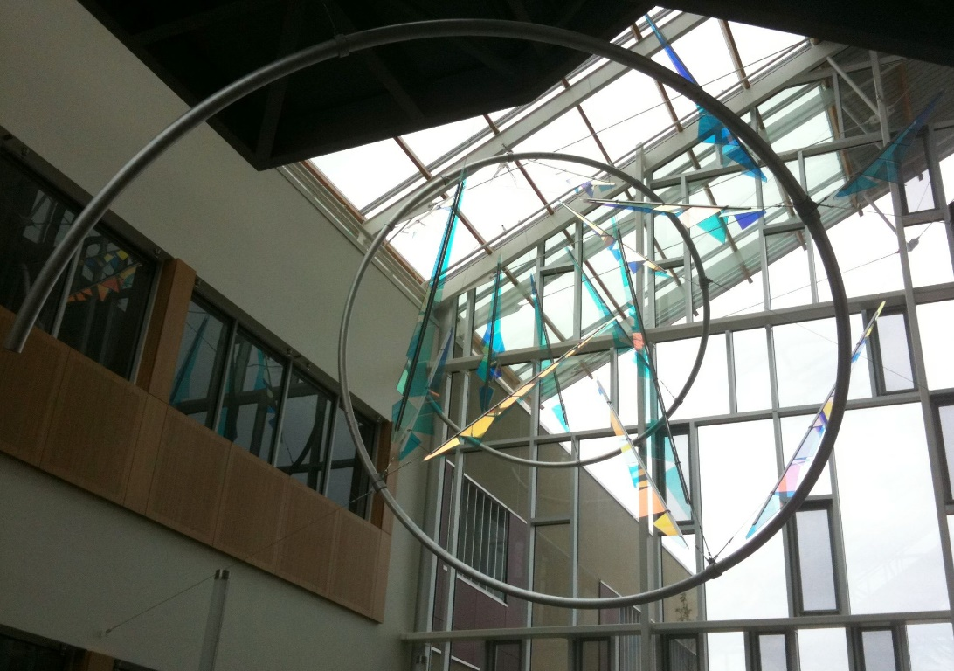

Edition 2.3

David Lippman
Melonie Rasmussen

This book is also available to read free online at http://www.opentextbookstore.com/precalc/
If you want a printed copy, buying from the bookstore is cheaper than printing yourself.
Copyright © 2022 David Lippman and Melonie Rasmussen

This text is licensed under the Creative Commons Attribution-Share Alike 4.0 International License.

To view a copy of this license, visit http://creativecommons.org/licenses/by-sa/4.0/ or send a letter to Creative Commons, PO Box 1866, Mountain View, CA 94042, USA.

You are free:
to Share — copy and redistribute the material in any medium or format
to Adapt — remix, transform, and build upon the material for any purpose

Under the following conditions:
Attribution. You must give appropriate credit, provide a link to the license, and indicate if changes were made. You may do so in any reasonable manner, but not in any way that suggests the licensor endorses you or your use.
Share Alike. If you remix, transform, or build upon the material, you must distribute your contributions under the same license as the original
No additional restrictions. You may not apply legal terms or technological measures that legally restrict others from doing anything the license permits.

In addition to these rights, we give explicit permission to remix small portions of this book (less than 10% cumulative) into works that are CC-BY, CC-BY-SA-NC, or GFDL licensed.

Selected exercises were remixed from Precalculus by D.H. Collingwood and K.D. Prince, originally licensed under the GNU Free Document License, with permission from the authors. These are marked in the book as [UW].

Portions of chapter 3 were remixed from College Algebra by Carl Stitz and Jeff Zeager, originally licensed under a Creative Commons Attribution ShareAlike Non-Commercial license, used with permission from the authors.

Portions of chapter 9 were remixed from work by Lara Michaels, and contains content remixed from Precalculus by OpenStax, originally licensed under a Creative Commons Attribution license. The original version is available online for free at OpenStax.org.

Cover photos by Ralph Morasch and David Lippman, of artwork by John Rogers.
Lituus, 2010. Dichromatic glass and aluminum.
Washington State Arts Commission in partnership with Pierce College

A screen reader friendly HTML version of the book can be found on LibreTexts.

About the Authors

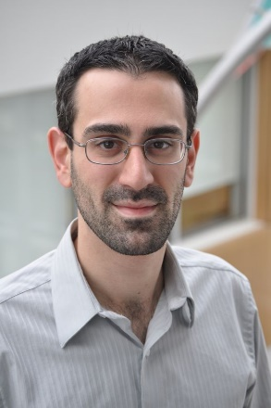
David Lippman received his master’s degree in mathematics from Western Washington University and has been teaching at Pierce College since Fall 2000.

Melonie Rasmussen also received her master’s degree in mathematics from Western Washington University and has been teaching at Pierce College since Fall 2002. Prior to this Melonie taught for the Puyallup School district for 6 years after receiving her teaching credentials from Pacific Lutheran University.

We have both been long time advocates of open learning, open materials, and basically any idea that will reduce the cost of education for students. It started by supporting the college’s calculator rental program, and running a book loan scholarship program. Eventually the frustration with the escalating costs of commercial text books and the online homework systems that charged for access led them to take action.

First, David developed IMathAS, open source online math homework software that runs WAMAP.org and MyOpenMath.com. Through this platform, we became integral parts of a vibrant sharing and learning community of teachers from around Washington State that support and contribute to WAMAP. Our pioneering efforts, supported by dozens of other dedicated faculty and financial support from the WA-SBCTC, have led to a system used by thousands of students every quarter, saving hundreds of thousands of dollars over comparable commercial offerings.

David continued further and wrote his first open textbook, Math in Society, a math for liberal arts majors book, after being frustrated by students having to pay $100+ for a textbook for a terminal course. Together, frustrated by both cost and the style of commercial texts, we began writing PreCalculus: An Investigation of Functions in 2010. Since then, David has contributed to several other open texts.

Acknowledgements

We would like to thank the following for their generous support and feedback.

- The community of WAMAP users and developers for creating a majority of the homework content used in our online homework sets.

- Pierce College students in our Fall 2010 - Summer 2011 Math 141 and Math 142 classes for helping correct typos, identifying videos related to the homework, and being our willing test subjects.

- The Open Course Library Project for providing the support needed to produce a full course package for these courses.

- Mike Kenyon, Chris Willett, Tophe Anderson, and Vauhn Foster-Grahler for reviewing the course and giving feedback and suggestions.

- Our Pierce College colleagues for providing their suggestions.

- Tophe Anderson, James Gray, and Lawrence Morales for their feedback and suggestions in content and examples.

- Jeff Eldridge for extensive proofreading and suggestions for clarification.

- James Sousa for developing videos associated with the online homework.

- Kevin Dimond for his work on indexing the book and creating PowerPoint slides.

- Faculty at Green River Community College and the Maricopa College District for their feedback and suggestions.

- Lara Michaels for contributing the basis for a conics chapter.

- The dozens of instructors who have sent us typos or suggestions over the years.

Preface

Over the years, when reviewing books we found that many had been mainstreamed by the publishers in an effort to appeal to everyone, leaving them with very little character. There were only a handful of books that had the conceptual and application driven focus we liked, and most of those were lacking in other aspects we cared about, like providing students sufficient examples and practice of basic skills. The largest frustration, however, was the never ending escalation of cost and being forced into new editions every three years. We began researching open textbooks, however the ability for those books to be adapted, remixed, or printed were often limited by the types of licenses, or didn’t approach the material the way we wanted.

This book is available online for free, in both Word and PDF format. You are free to change the wording, add materials and sections or take them away. We welcome feedback, comments and suggestions for future development at precalc@opentextbookstore.com. Additionally, if you add a section, chapter or problems, we would love to hear from you and possibly add your materials so everyone can benefit.

In writing this book, our focus was on the story of functions. We begin with function notation, a basic toolkit of functions, and the basic operation with functions: composition and transformation. Building from these basic functions, as each new family of functions is introduced we explore the important features of the function: its graph, domain and range, intercepts, and asymptotes. The exploration then moves to evaluating and solving equations involving the function, finding inverses, and culminates with modeling using the function.

The "rule of four" is integrated throughout - looking at the functions verbally, graphically, numerically, as well as algebraically. We feel that using the “rule of four” gives students the tools they need to approach new problems from various angles. Often the “story problems of life” do not always come packaged in a neat equation. Being able to think critically, see the parts and build a table or graph a trend, helps us change the words into meaningful and measurable functions that model the world around us.

There is nothing we hate more than a chapter on exponential equations that begins "Exponential functions are functions that have the form f(x)=a^{x}." As each family of functions is introduced, we motivate the topic by looking at how the function arises from life scenarios or from modeling. Also, we feel it is important that precalculus be the bridge in level of thinking between algebra and calculus. In algebra, it is common to see numerous examples with very similar homework exercises, encouraging the student to mimic the examples. Precalculus provides a link that takes students from the basic plug & chug of formulaic calculations towards building an understanding that equations and formulas have deeper meaning and purpose. While you will find examples and similar exercises for the basic skills in this book, you will also find examples of multistep problem solving along with exercises in multistep problem solving. Often times these exercises will not exactly mimic the exercises, forcing the students to employ their critical thinking skills and apply the skills they've learned to new situations. By developing students’ critical thinking and problem solving skills this course prepares students for the rigors of Calculus.

While we followed a fairly standard ordering of material in the first half of the book, we took some liberties in the trig portion of the book. It is our opinion that there is no need to separate unit circle trig from triangle trig, and instead integrated them in the first chapter. Identities are introduced in the first chapter, and revisited throughout. Likewise, solving is introduced in the second chapter and revisited more extensively in the third chapter. As with the first part of the book, an emphasis is placed on motivating the concepts and on modeling and interpretation.

About the Second Edition

About 4 years and several minor typo revisions after the original release of this book, we started contemplating creating a second edition. We didn’t want to change much; we’ve always found it very annoying when new editions change things just for the sake of making it seem different. However, in talking with instructors from around the country, we knew there were a few topics that we had left out that other schools need. We didn’t want to suffer the same “content bloat” that many commercial books do, but we also wanted to make it easier for more schools to adopt open resources.

We put our plans for a new revision on hold after OpenStax started working on a precalculus book, using the first edition of this text as a base. After the final product came out, though, we felt it had strayed a bit far from our original vision. We had written this text, not to be an encyclopedic reference text, but to be a concise, easy-to-read, student-friendly approach to precalculus. We valued contextual motivation and conceptual understanding over procedural skills. Our book took, in places, a non-traditional approach to topics and content ordering. Ultimately, we decided to go ahead with this second edition.

The primary changes in the second edition are:
- New, higher resolution graphs throughout
- New sections added to Chapter 3:
  - 3.4 Factor theorem (includes long division of polynomials)
  - 3.5 Real zeros of polynomials (using rational roots theorem)
  - 3.6 Complex zeros of polynomials
- Coverage of oblique asymptotes added to the rational equations section (now 3.7)
- A new section 8.5 on dot product of vectors
- A new chapter 9 on conic sections

There were many additional refinements, some new examples added, and Try it Now answers expanded, but most of the book remains unchanged.

Instructor Resources

As part of the Washington Open Course Library project, we developed a full course package to accompany this text. The course shell was built for the IMathAS online homework platform, and is available for Washington State faculty at www.wamap.org and mirrored for others at www.myopenmath.com. It contains:

- Online homework for each section (algorithmically generated, free response), most with video help associated.
- Video lessons for each section. The videos were mostly created and selected by James Sousa, of Mathispower4u.
- A selection of printable class worksheets, activities, and handouts
- Support materials for an example course (does not include all sections):
  - Suggested syllabus and Day by day course guide
  - Instructor guide with lecture outlines and examples
  - Discussion forums
  - Diagnostic review
  - Chapter review problems
  - Sample quizzes and sample chapter exams
The course shell was designed to follow Quality Matters (QM) guidelines, but has not yet been formally reviewed.

Getting Started

To get started using this textbook and the online supplementary materials,
- Request an instructor account on WAMAP (in Washington) or MyOpenMath (outside Washington).
- Review the table of contents of the text, and compare it to your course outcomes or student learning objectives. Determine which sections you will need to cover, and which to omit. If there are topics in your outcomes that are not in the text, explore other sources like the Stitz/Zeager Precalc or OpenStax Precalc to supplement from. Also check the book’s website, as we may offer additional online-only topics.
- Once your instructor account is approved, log in, and click Add New Course
- From the “Use content from a template course”, select “Precalculus – Lippman/Rasmussen 2nd Ed”. Note that you might also see two half-book templates, one covering chapters 1 – 4, and the other covering chapters 5 – 9.
- Once you have copied the course, go through and remove any sections you don’t need for your course. Refer to the Training Course Quickstart videos in MyOpenMath and WAMAP for more details on how to make those changes.

How To Be Successful In This Course
This is not a high school math course, although for some of you the content may seem familiar. There are key differences to what you will learn here, how quickly you will be required to learn it and how much work will be required of you.

You will no longer be shown a technique and be asked to mimic it repetitively as the only way to prove learning. Not only will you be required to master the technique, but you will also be required to extend that knowledge to new situations and build bridges between the material at hand and the next topic, making the course highly cumulative.

As a rule of thumb, for each hour you spend in class, you should expect this course will require an average of 2 hours of out-of-class focused study. This means that some of you with a stronger background in mathematics may take less, but if you have a weaker background or any math anxiety it will take you more.

Notice how this is the equivalent of having a part time job, and if you are taking a fulltime load of courses as many college students do, this equates to more than a full time job. If you must work, raise a family and take a full load of courses all at the same time, we recommend that you get a head start & get organized as soon as possible. We also recommend that you spread out your learning into daily chunks and avoid trying to cram or learn material quickly before an exam.

To be prepared, read through the material before it is covered in class and note or highlight the material that is new or confusing. The instructor’s lecture and activities should not be the first exposure to the material. As you read, test your understanding with the Try it Now problems in the book. If you can’t figure one out, try again after class, and ask for help if you still can’t get it.

As soon as possible after the class session recap the day’s lecture or activities into a meaningful format to provide a third exposure to the material. You could summarize your notes into a list of key points, or reread your notes and try to work examples done in class without referring back to your notes. Next, begin any assigned homework. The next day, if the instructor provides the opportunity to clarify topics or ask questions, do not be afraid to ask. If you are afraid to ask, then you are not getting your money’s worth! If the instructor does not provide this opportunity, be prepared to go to a tutoring center or build a peer study group. Put in quality effort and time and you can get quality results.

Lastly, if you feel like you do not understand a topic. Don’t wait, ASK FOR HELP!

ASK: Ask a teacher or tutor, Search for ancillaries, Keep a detailed list of questions
FOR: Find additional resources, Organize the material, Research other learning options
HELP: Have a support network, Examine your weaknesses, List specific examples & Practice

Best of luck learning! We hope you like the course & love the price.
David & Melonie

Table of Contents

About the Authors i
Acknowledgements ii
Preface iii
About the Second Edition iv
Instructor Resources v
How To Be Successful In This Course vi
Table of Contents vii

Chapter 1: Functions 1
Section 1.1 Functions and Function Notation 1
Section 1.2 Domain and Range 22
Section 1.3 Rates of Change and Behavior of Graphs 36
Section 1.4 Composition of Functions 51
Section 1.5 Transformation of Functions 64
Section 1.6 Inverse Functions 93
Chapter 2: Linear Functions 101
Section 2.1 Linear Functions 101
Section 2.2 Graphs of Linear Functions 114
Section 2.3 Modeling with Linear Functions 129
Section 2.4 Fitting Linear Models to Data 141
Section 2.5 Absolute Value Functions 140
Chapter 3: Polynomial and Rational Functions 159
Section 3.1 Power Functions & Polynomial Functions 159
Section 3.2 Quadratic Functions 167
Section 3.3 Graphs of Polynomial Functions 181
Section 3.4 Factor Theorem and Remainder Theorem 194
Section 3.5 Real Zeros of Polynomials 203
Section 3.6 Complex Zeros 210
Section 3.7 Rational Functions 218
Section 3.8 Inverses and Radical Functions 239
Chapter 4: Exponential and Logarithmic Functions 249
Section 4.1 Exponential Functions 249
Section 4.2 Graphs of Exponential Functions 267
Section 4.3 Logarithmic Functions 277
Section 4.4 Logarithmic Properties 289
Section 4.5 Graphs of Logarithmic Functions 300
Section 4.6 Exponential and Logarithmic Models 308
Section 4.7 Fitting Exponential Models to Data 328
Chapter 5: Trigonometric Functions of Angles 337
Section 5.1 Circles 337
Section 5.2 Angles 347
Section 5.3 Points on Circles Using Sine and Cosine 362
Section 5.4 The Other Trigonometric Functions 375
Section 5.5 Right Triangle Trigonometry 385
Chapter 6: Periodic Functions 395
Section 6.1 Sinusoidal Graphs 395
Section 6.2 Graphs of the Other Trig Functions 412
Section 6.3 Inverse Trig Functions 422
Section 6.4 Solving Trig Equations 430
Section 6.5 Modeling with Trigonometric Functions 441
Chapter 7: Trigonometric Equations and Identities 453
Section 7.1 Solving Trigonometric Equations with Identities 453
Section 7.2 Addition and Subtraction Identities 461
Section 7.3 Double Angle Identities 477
Section 7.4 Modeling Changing Amplitude and Midline 495
Chapter 8: Further Applications of Trigonometry 497
Section 8.1 Non-Right Triangles: Laws of Sines and Cosines 497
Section 8.2 Polar Coordinates 514
Section 8.3 Polar Form of Complex Numbers 528
Section 8.4 Vectors 541
Section 8.5 Dot Product 555
Section 8.6 Parametric Equations 564
Chapter 9: Conics 579
Section 9.1 Ellipses 579
Section 9.2 Hyperbolas 597
Section 9.3 Parabolas and Non-Linear Systems 617
Section 9.4 Conics in Polar Coordinates 630
Answers to Selected Exercises 641
Index 691

NOTE: This printed text only contains Chapters 1-4 of the book. The remainder of the book can be read online at http://www.opentextbookstore.com/precalc/ or purchased as a separated printed text.

