# Chapter 9: Conics

Section 9.1 Ellipses 579

Section 9.2 Hyperbolas 598

Section 9.3 Parabolas and Non-Linear Systems 618

Section 9.4 Conics in Polar Coordinates 631

In this chapter, we will explore a set of shapes defined by a common characteristic: they can all be formed by slicing a cone with a plane. These families of curves have a broad range of applications in physics and astronomy, from describing the shape of your car headlight reflectors to describing the orbits of planets and comets.

## A photo of the oval-shaped National Statuary HallSection 9.1 Ellipses

The National Statuary Hall[1] in Washington, D.C. is an oval-shaped room called a whispering chamber because the shape makes it possible for sound to reflect from the walls in a special way. Two people standing in specific places are able to hear each other whispering even though they are far apart. To determine where they should stand, we will need to better understand ellipses.

An ellipse is a type of **conic section**, a shape resulting from intersecting a plane with a cone and looking at the curve where they intersect. They were discovered by the Greek mathematician Menaechmus over two millennia ago.

The figure below[2] shows two types of conic sections. When a plane is perpendicular to the axis of the cone, the shape of the intersection is a circle. A slightly titled plane creates an oval-shaped conic section called an **ellipse**.

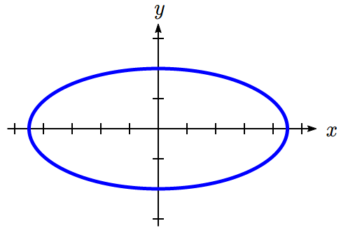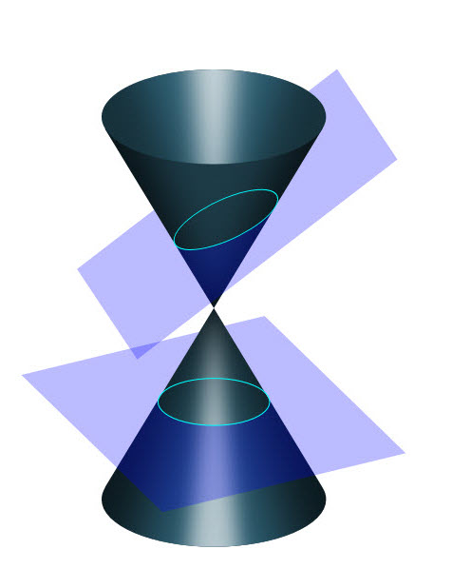

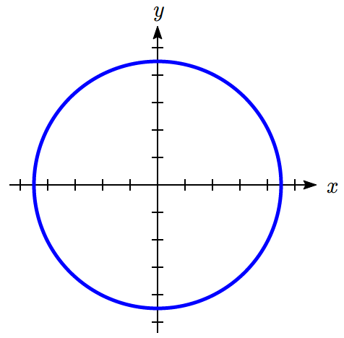

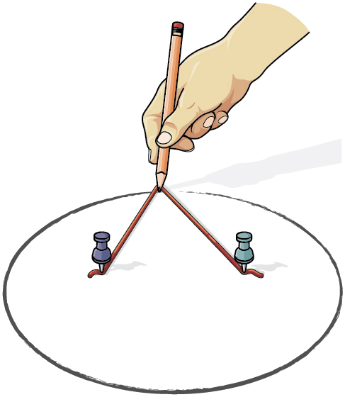An ellipse can be drawn by placing two thumbtacks in a piece of cardboard then cutting a piece of string longer than the distance between the thumbtacks. Tack each end of the string to the cardboard, and trace a curve with a pencil held taught against the string. An ellipse is the set of all points where the sum of the distances from two fixed points is constant. The length of the string is the constant, and the two thumbtacks are the fixed points, called foci.

Ellipse Definition and Vocabulary

An **ellipse** is the set of all points  for which the sum of the distance to two fixed points  and , called the **foci** (plural of focus), is a constant *k*: .

*x*

*y*

*d(Q,F1)*

*d(Q,F2)*

*Q*

*F2*

*F1*

The **major axis** is the line passing through the foci.

**Vertices** are the points on the ellipse which intersect the major axis.

The **major axis length** is the length of the line segment between the vertices.

The **center**is the midpoint between the vertices (or the midpoint between the foci).

The **minor axis** is the line perpendicular to the minor axis passing through the center.

**Minor axis endpoints** are the points on the ellipse which intersect the minor axis.

The minor axis endpoints are also sometimes called **co-vertices**.

The **minor axis length** is the length of the line segment between minor axis endpoints.

*y*

*x*

Vertices

Minor axis

endpoints

Foci

Major axis

Minor axis

Note that which axis is major and which is minor will depend on the orientation of the ellipse. In the ellipse shown at right, the foci lie on the *y* axis, so that is the major axis, and the *x* axis is the minor axis. Because of this, the vertices are the endpoints of the ellipse on the *y* axis, and the minor axis endpoints (co-vertices) are the endpoints on the *x* axis.

**Ellipses Centered at the Origin**

From the definition above we can find an equation for an ellipse. We will find it for a ellipse centered at the origin  with foci at  and  where *c* > 0.

Suppose is some point on the ellipse. The distance from *F1* to *Q* is



Likewise, the distance from *F2* to *Q* is



From the definition of the ellipse, the sum of these distances should be constant:

 so that



If we label one of the vertices , it should satisfy the equation above since it is a point on the ellipse. This allows us to write *k* in terms of *a*.



 Since *a* > c, these will be positive





Substituting that into our equation, we will now try to rewrite the equation in a friendlier form.

 Move one radical

 Square both sides

 Expand

 Expand more



Combining like terms and isolating the radical leaves

 Divide by 4

 Square both sides again

 Expand

 Distribute

 Combine like terms

 Factor common terms



Let . Since *a* > *c*, we know *b* > 0. Substituting for  leaves

 Divide both sides by 



This is the standard equation for an ellipse. We typically swap *a* and *b* when the major axis of the ellipse is vertical.

Equation of an Ellipse Centered at the Origin in Standard Form

The standard form of an equation of an ellipse centered at the origin  depends on whether the major axis is horizontal or vertical. The table below gives the standard equation, vertices, minor axis endpoints, foci, and graph for each.

|  |  |  |
| --- | --- | --- |
| Major Axis | Horizontal | Vertical |
| Standard Equation |  |  |
| Vertices | (−*a*, 0) and (*a*, 0) | (0, −*a*) and (0, *a*) |
| Minor Axis Endpoints | (0, −*b*) and (0, *b*) | (−*b*, 0) and (*b*, 0) |
| Foci | (−*c*, 0) and (*c*, 0)  where | (0, −*c*) and (0, *c*)  where |
| Graph | *x*  *y*  (*a*,0)  (-*a*,0)  (0,*b*)  (0,-*b*)  (*c,0*)  (-*c,0*) | *x*  *y*  (*b*,0)  (-*b*,0)  (0,*a*)  (0,-*a*)  (0,*c*)  (0,-*c*) |

Example 1

Put the equation of the ellipse  in standard form. Find the vertices, minor axis endpoints, length of the major axis, and length of the minor axis. Sketch the graph, then check using a graphing utility.

The standard equation has a 1 on the right side, so this equation can be put in standard form by dividing by 9:



Since the *y*-denominator is greater than the *x*-denominator, the ellipse has a vertical major axis. Comparing to the general standard form equation , we see the value of  and the value of .

The vertices lie on the *y*-axis at (0,±*a*) = (0, ±3).

The minor axis endpoints lie on the *x*-axis at (±*b,* 0) = (±1, 0).

The length of the major axis is .

The length of the minor axis is .

To sketch the graph we plot the vertices and the minor axis endpoints. Then we sketch the ellipse, rounding at the vertices and the minor axis endpoints.

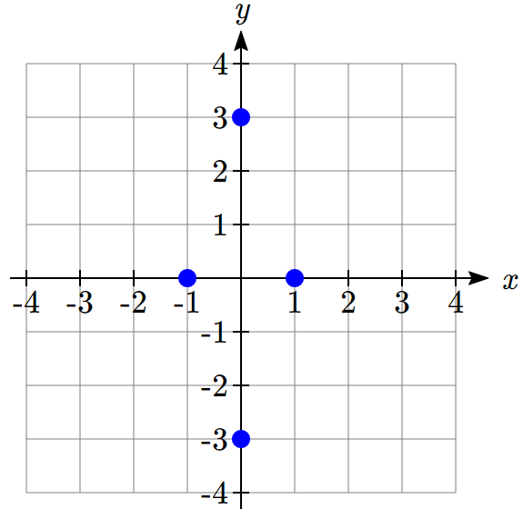 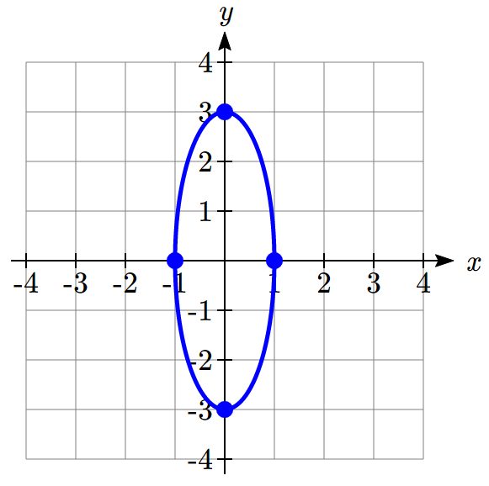

To check on a graphing utility, we must solve the equation for *y*. Isolating  gives us



Taking the square root of both sides we get



Under **Y=** on your graphing utility enter the two halves of the ellipse as  and . Set the window to a comparable scale to the sketch with xmin = -5, xmax = 5, ymin= -5, and ymax = 5.

Here’s an example output on a TI-84 calculator:

|  |  |  |
| --- | --- | --- |
| Image of TI-84 Plus window for y= with ellipse equations. | Image of TI-84 Plus window of window with x and y scale values. | Image of TI-84 Plus window for graph with ellipse. |

Sometimes we are given the equation. Sometimes we need to find the equation from a graph or other information.

Example 2

Find the standard form of the equation for an ellipse centered at (0,0) with horizontal major axis length 28 and minor axis length 16.

Since the center is at (0,0) and the major axis is horizontal, the ellipse equation has the standard form . The major axis has length  or *a* = 14. The minor axis has length  or *b* = 8. Substituting gives  or .

Try it Now

1. Find the standard form of the equation for an ellipse with horizontal major axis length 20 and minor axis length 6.

Example 3

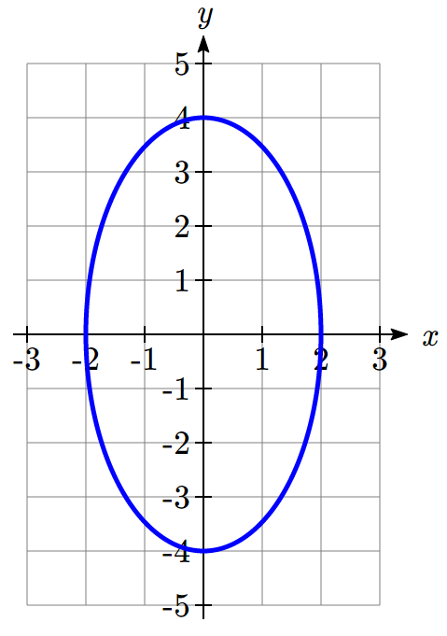Find the standard form of the equation for the ellipse graphed here.

The center is at (0,0) and the major axis is vertical, so the standard form of the equation will be .

From the graph we can see the vertices are (0,4) and (0,-4), giving *a* = 4.

The minor-axis endpoints are (2,0) and (-2,0), giving *b* = 2.

The equation will be  or .

**Ellipses Not Centered at the Origin**

Not all ellipses are centered at the origin. The graph of such an ellipse is a shift of the graph centered at the origin, so the standard equation for one centered at (*h, k*) is slightly different. We can shift the graph right *h* units and up *k* units by replacing *x* with *x* – *h* and *y* with *y* – *k*, similar to what we did when we learned transformations.

Equation of an Ellipse Centered at (*h, k*) in Standard Form

The standard form of an equation of an ellipse centered at the point *C* depends on whether the major axis is horizontal or vertical. The table below gives the standard equation, vertices, minor axis endpoints, foci, and graph for each.

|  |  |  |
| --- | --- | --- |
| Major Axis | Horizontal | Vertical |
| Standard Equation |  |  |
| Vertices | ( *h ± a*, *k* ) | (*h*, *k ± a*) |
| Minor Axis Endpoints | ( *h*, *k ± b* ) | ( *h ± b*, *k* ) |
| Foci | ( *h ± c*, *k* )  where  *b2 = a2 – c*2 | (*h*, *k ± c*)  where  *b2 = a2 – c*2 |
| Graph | *x*  *y*  (*h*+*a*,*k*)  (*h*-*a*,*k*)  (*h*,*k*+*b*)  (*h*,*k*-*b*)  (*h*-*c,k*)  (*h,k*)  (*h*+*c,k*) | *x*  *y*  (*h*+*b*,*k*)  (*h*-*b*,*k*)  (*h*,*k*+*a*)  (*h*, *k*-*a*)  (*h*,*k+c*)  (*h*, *k*-*c*)  (*h*,*k*) |

Example 4

Put the equation of the ellipse  in standard form. Find the vertices, minor axis endpoints, length of the major axis, and length of the minor axis. Sketch the graph.

To rewrite this in standard form, we will need to complete the square, twice.

Looking at the *x* terms, , we like to have something of the form . Notice that if we were to expand this, we’d get , so in order for the coefficient on *x* to match, we’ll need . However, we don’t have a +1 on the left side of the equation to allow this factoring. To accommodate this, we will add 1 to both sides of the equation, which then allows us to factor the left side as a perfect square:





Repeating the same approach with the *y* terms, first we’ll factor out the 4. 

Now we want to be able to write  as .

For the coefficient of *y* to match, *n* will have to -3, giving .

To allow this factoring, we can add 36 to both sides of the equation.







Dividing by 4 gives the standard form of the equation for the ellipse



Since the *x*-denominator is greater than the *y*-denominator, the ellipse has a horizontal major axis. From the general standard equation  we see the value of  and the value of .

The center is at (*h, k*) = (-1, 3).

The vertices are at (*h*±*a, k*) or (-3, 3) and (1,3).

The minor axis endpoints are at (*h, k*±*b*) or (-1, 2) and (-1,4).

The length of the major axis is .

The length of the minor axis is .

To sketch the graph we plot the vertices and the minor axis endpoints. Then we sketch the ellipse, rounding at the vertices and the minor axis endpoints.

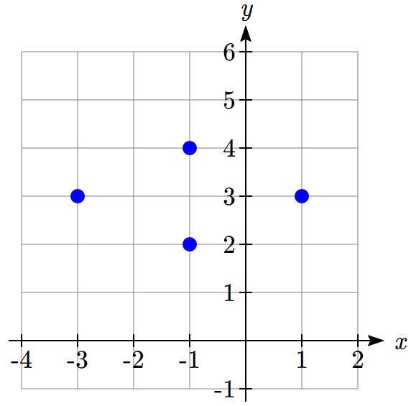 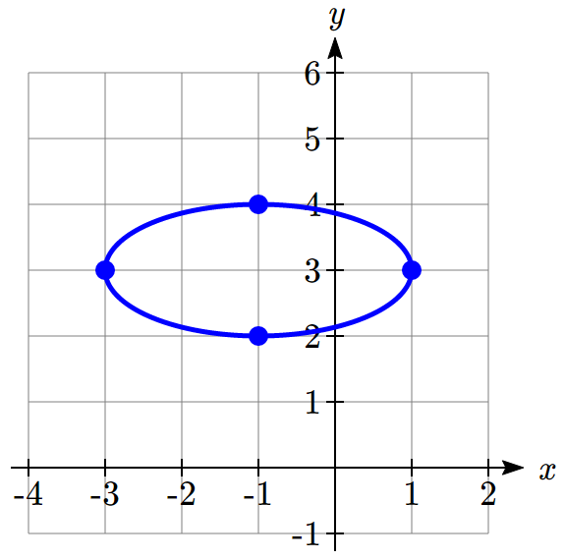

Example 5

Find the standard form of the equation for an ellipse centered at (-2,1), a vertex at (-2,4) and passing through the point (0,1).

The center at (-2,1) and vertex at (-2,4) means the major axis is vertical since the *x*-values are the same. The ellipse equation has the standard form .

The value of *a* = 4-1=3. Substituting *a* = 3, *h* = -2, and *k* = 1 gives . Substituting for *x* and *y* using the point (0,1) gives .

Solving for *b* gives *b*=2.

The equation of the ellipse in standard form is  or .

Try it Now

1. Find the center, vertices, minor axis endpoints, length of the major axis, and length of the minor axis for the ellipse .

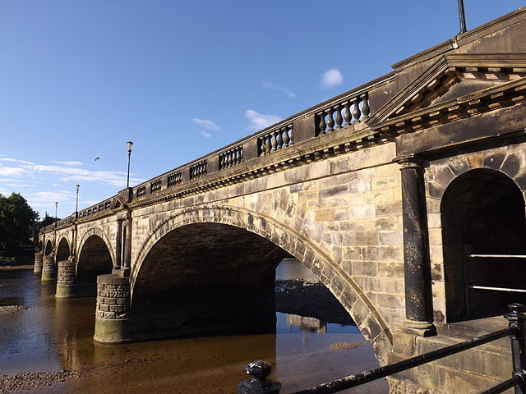**Bridges with Semielliptical Arches**

Arches have been used to build bridges for centuries, like in the Skerton Bridge in England which uses five semielliptical arches for support[3]. Semielliptical arches can have engineering benefits such as allowing for longer spans between supports.

Example 6

A bridge over a river is supported by a single semielliptical arch. The river is 50 feet wide. At the center, the arch rises 20 feet above the river. The roadway is 4 feet above the center of the arch. What is the vertical distance between the roadway and the arch 15 feet from the center?

Put the center of the ellipse at (0,0) and make the span of the river the major axis.

*x*

*y*

50ft

20ft

4ft

Since the major axis is horizontal, the equation has the form .

The value of  and the value of *b* = 20, giving .

Substituting *x* = 15 gives . Solving for *y*, .

The roadway is 20 + 4 = 24 feet above the river. The vertical distance between the roadway and the arch 15 feet from the center is 24 − 16 = 8 feet.

**Ellipse Foci**

The location of the foci can play a key role in ellipse application problems. Standing on a focus in a whispering gallery allows you to hear someone whispering at the other focus. To find the foci, we need to find the length from the center to the foci, *c*, using the equation . It looks similar to, but is not the same as, the Pythagorean Theorem.

Example 7

The National Statuary Hall whispering chamber is an elliptical room 46 feet wide and 96 feet long. To hear each other whispering, two people need to stand at the foci of the ellipse. Where should they stand?

We could represent the hall with a horizontal ellipse centered at the origin. The major axis length would be 96 feet, so , and the minor axis length would be 46 feet, so . To find the foci, we can use the equation .





 ft.

To hear each other whisper, two people would need to stand 2(42) = 84 feet apart along the major axis, each about 48 – 42 = 6 feet from the wall.

Example 8

Find the foci of the ellipse .

The ellipse is vertical with an equation of the form .

The center is at (*h*, *k*) = (2, −3). The foci are at (*h*, *k ± c*).

To find length *c* we use .

Substituting gives  or .

The ellipse has foci (2,−3 *±* 5), or (2, −8) and (2, 2).

Example 9

Find the standard form of the equation for an ellipse with foci (-1,4) and (3,4) and major axis length 10.

Since the foci differ in the *x* -coordinates, the ellipse is horizontal with an equation of the form .

The center is at the midpoint of the foci .

The value of *a* is half the major axis length: .

The value of *c* is half the distance between the foci: .

To find length *b* we use . Substituting *a* and *c* gives  = 21.

The equation of the ellipse in standard form is  or .

Try it Now

1. Find the standard form of the equation for an ellipse with focus (2,4), vertex (2,6), and center (2,1).

**Planetary Orbits**

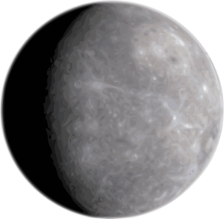

It was long thought that planetary orbits around the sun were circular. Around 1600, Johannes Kepler discovered they were actually elliptical[4]. His first law of planetary motion says that planets travel around the sun in an elliptical orbit with the sun as one of the foci. The length of the major axis can be found by measuring the planet’s aphelion, its greatest distance from the sun, and perihelion, its shortest distance from the sun, and summing them together.

Example 10

Mercury’s aphelion is 35.98 million miles and its perihelion is 28.58 million miles. Write an equation for Mercury’s orbit.

Let the center of the ellipse be (0,0) and its major axis be horizontal so the equation will have form .

The length of the major axis is  giving  and .

Since the perihelion is the distance from the focus to one vertex, we can find the distance between the foci by subtracting twice the perihelion from the major axis length:  giving .

Substitution of *a* and *c* into  yields .

The equation is .

Important Topics of This Section

Ellipse Definition

Ellipse Equations in Standard Form

Ellipse Foci

Applications of Ellipses

Try it Now Answers

1. 2*a* = 20, so *a* =10. 2*b* = 6, so *b* = 3. 

2. Center (4, -2). Vertical ellipse with *a* = 2, *b* = 1.   
Vertices at (4, -2±2) = (4,0) and (4,-4),   
minor axis endpoints at (4±1, -2) = (3,-2) and (5,-2),   
major axis length 4, minor axis length 2

3. Vertex, center, and focus have the same *x*­-value, so it’s a vertical ellipse.  
Using the vertex and center, *a* = 6 – 1 = 5  
Using the center and focus, *c* = 4 – 1 = 3  
. *b* = 4.  


## Section 9.1 Exercises

In problems 1–4, match each graph with one of the equations A–D.

A.  B.  C.  D. 

1. 2. 3. 4.

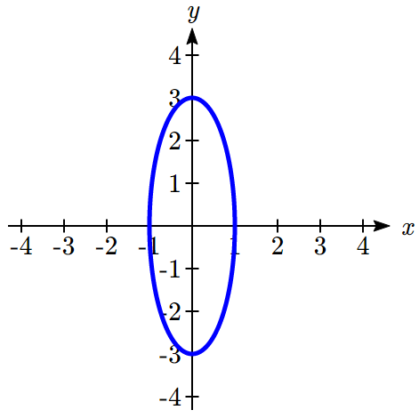 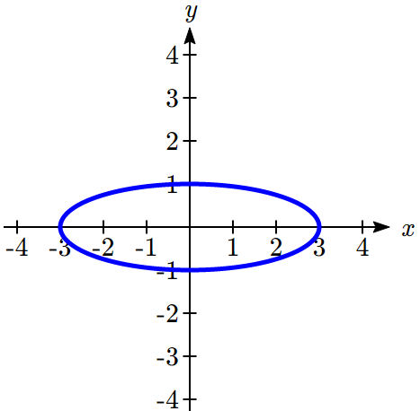 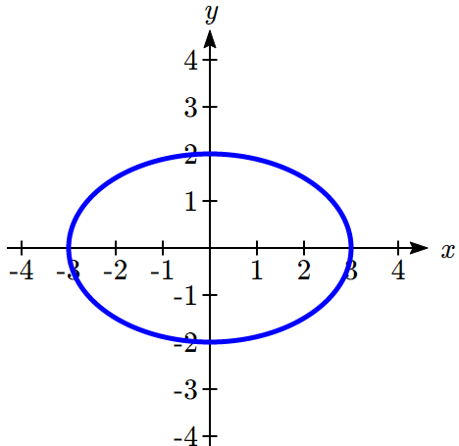 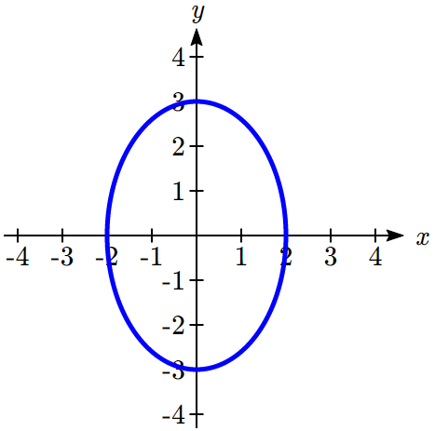

In problems 5–14, find the vertices, the minor axis endpoints, length of the major axis, and length of the minor axis. Sketch the graph. Check using a graphing utility.

5.  6.  7.  8. 

9.  10.  11. 

12.  13.  14. 

In problems 15–16, write an equation for the graph.

15. 16.

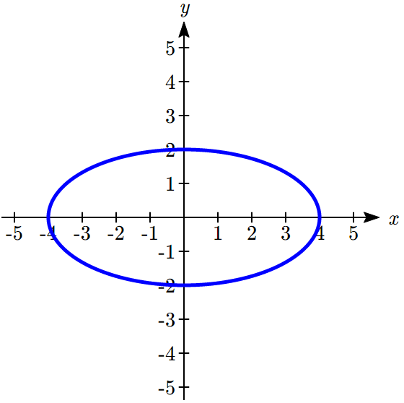 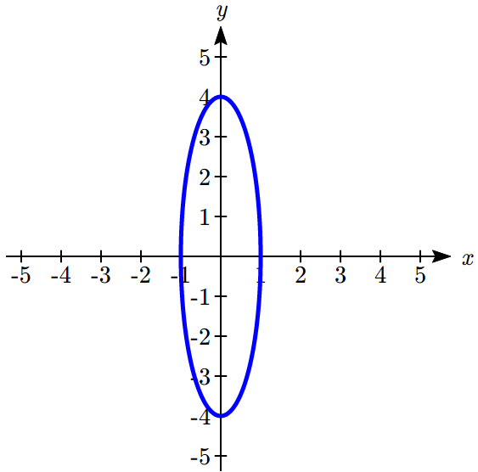

In problems 17–20, find the standard form of the equation for an ellipse satisfying the given conditions.

17. Center (0,0), horizontal major axis length 64, minor axis length 14

18. Center (0,0), vertical major axis length 36, minor axis length 18

19. Center (0,0), vertex (0,3), 

20. Center (0,0), vertex (4,0), 

In problems 21–28, match each graph to equations A-H.

A.  E. 

B.  F. 

C.  G. 

D.  H. 

21. 22. 23. 24.

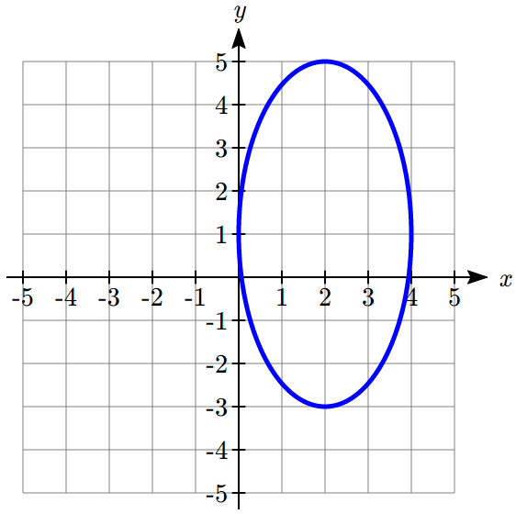 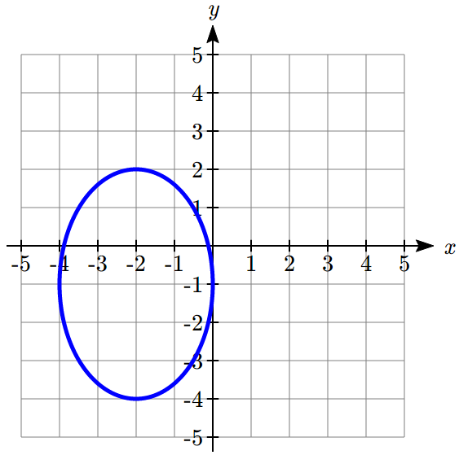 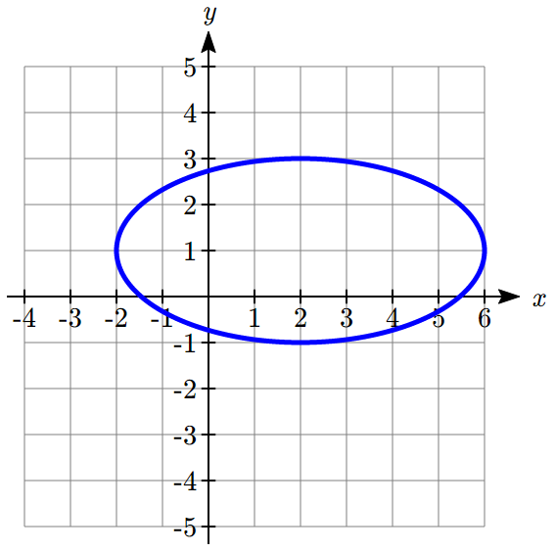 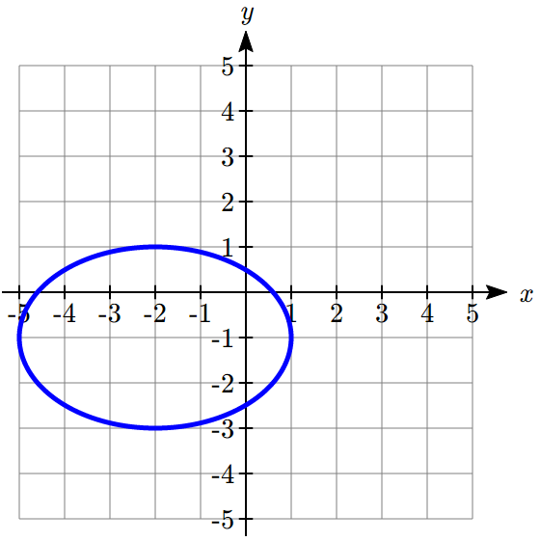

25. 26. 27. 28.

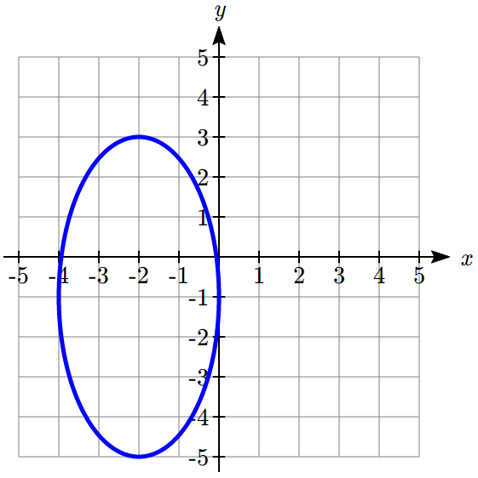 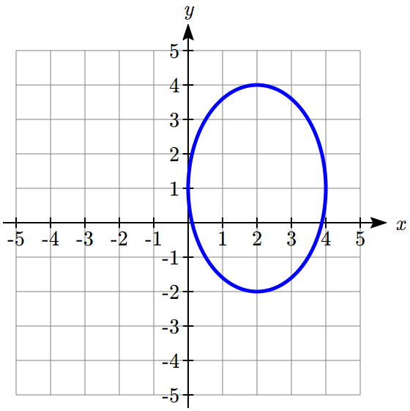 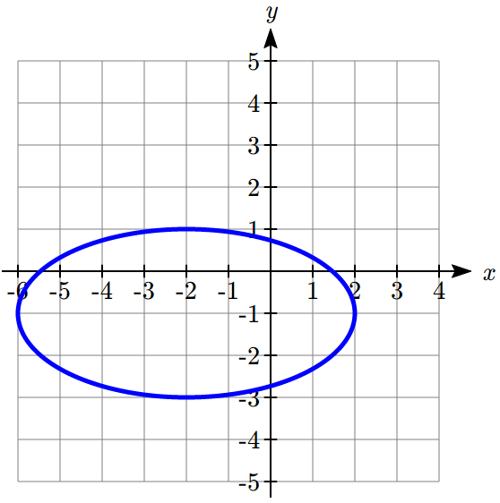 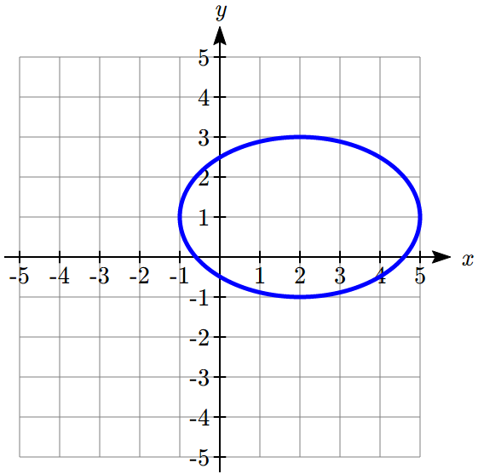

In problems 29–38, find the vertices, the minor axis endpoints, length of the major axis, and length of the minor axis. Sketch the graph. Check using a graphing utility.

29.  30. 

31.  32. 

33.  34. 

35.  36. 

37.  38. 

In problems 39–40, write an equation for the graph.

39. 40.

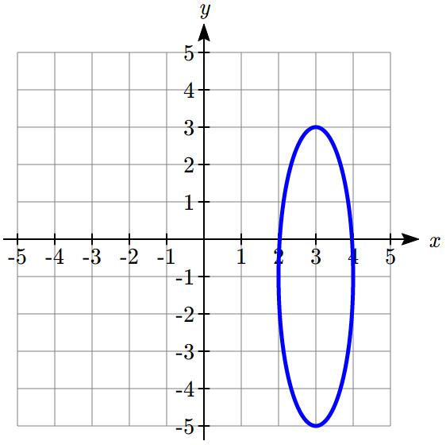 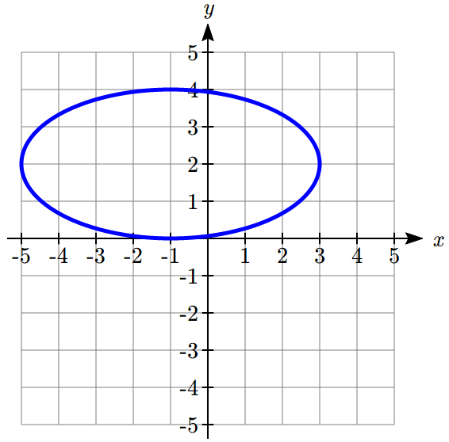

In problems 41–42, find the standard form of the equation for an ellipse satisfying the given conditions.

41. Center (-4,3), vertex(-4,8), point on the graph (0,3)

42. Center (1,-2), vertex(-5,-2), point on the graph (1,0)

43. **Window** A window in the shape of a semiellipse is 12 feet wide and 4 feet high. What is the height of the window above the base 5 feet from the center ?

44. **Window** A window in the shape of a semiellipse is 16 feet wide and 7 feet high. What is the height of the window above the base 4 feet from the center?

45. **Bridge** A bridge over a river is supported by a semielliptical arch. The river is 150 feet wide. At the center, the arch rises 60 feet above the river. The roadway is 5 feet above the center of the arch. What is the vertical distance between the roadway and the arch 45 feet from the center?

46. **Bridge** A bridge over a river is supported by a semielliptical arch. The river is 1250 feet wide. At the center, the arch rises 175 feet above the river. The roadway is 3 feet above the center of the arch. What is the vertical distance between the roadway and the arch 600 feet from the center?

47. **Racetrack** An elliptical racetrack is 100 feet long and 90 feet wide. What is the width of the racetrack 20 feet from a vertex on the major axis?

48. **Racetrack** An elliptical racetrack is 250 feet long and 150 feet wide. What is the width of the racetrack 25 feet from a vertex on the major axis?

In problems 49-52, find the foci.

49.  50. 

51.  52. 

In problems 53-72, find the standard form of the equation for an ellipse satisfying the given conditions.

53. Major axis vertices (±3,0), c=2 54. Major axis vertices (0,±7), c=4

55. Foci (0,±5) and major axis length 12

56. Foci (±3,0) and major axis length 8

57. Foci (±5,0), vertices (±7,0) 58. Foci (0,±2), vertices (0,±3)

59. Foci (0,±4) and x-intercepts (±2,0)

60. Foci (±3,0) and y-intercepts (0,±1)

61. Center (0,0), major axis length 8, foci on x-axis, passes through point 

62. Center (0,0), major axis length 12, foci on y-axis, passes through point 

63. Center (-2,1), vertex (-2,5), focus (-2,3)

64. Center (-1,-3), vertex (-7,-3), focus (-4,-3)

65. Foci (8,2) and (-2,2), major axis length 12

66. Foci (-1,5) and (-1,-3), major axis length 14

67. Vertices (3,4) and (3,-6), c= 2

68. Vertices (2,2) and (-4,2), c= 2

69. Center (1,3), focus (0,3), passes through point (1,5)

70. Center (-1,-2), focus (1,-2), passes through point (2,-2)

71. Focus (-15,-1), vertices (-19,-1) and (15,-1)

72. Focus (-3,2), vertices (-3,4) and (-3,-8)

73. **Whispering Gallery** If an elliptical whispering gallery is 80 feet long and 25 feet wide, how far from the center of room should someone stand on the major axis of the ellipse to experience the whispering effect? Round to two decimal places.

74. **Billiards** Some billiards tables are elliptical and have the foci marked on the table. If such a one is 8 feet long and 6 feet wide, how far are the foci from the center of the ellipse? Round to two decimal places.

75. **Planetary Orbits** The orbits of planets around the sun are approximately elliptical with the sun as a focus. The ***aphelion*** is a planet’s greatest distance from the sun and the ***perihelion*** is its shortest. The length of the major axis is the sum of the aphelion and the perihelion. Earth’s aphelion is 94.51 million miles and its perihelion is 91.40 million miles. Write an equation for Earth’s orbit.

76. **Satellite Orbits** The orbit of a satellite around Earth is elliptical with Earth’s center as a focus. The satellite’s maximum height above the Earth is 170 miles and its minimum height above the Earth is 90 miles. Write an equation for the satellite’s orbit. Assume Earth is spherical and has a radius of 3960 miles.

77. **Eccentricity** *e* of an ellipse is the ratio  where *c* is the distance of a focus from the center and *a* is the distance of a vertex from the center. Write an equation for an ellipse with eccentricity 0.8 and foci at (-4,0) and (4,0).

78. **Confocal** ellipses have the same foci. Show that, for *k* > 0, all ellipses of the form  are confocal.

79. The **latus rectum** of an ellipse is a line segment with endpoints on the ellipse that passes through a focus and is perpendicular to the major axis. Show thatis the length of the latus rectum of  where *a* > *b*.

## Section 9.2 Hyperbolas



In the last section, we learned that planets have approximately elliptical orbits around the sun. When an object like a comet is moving quickly, it is able to escape the gravitational pull of the sun and follows a path with the shape of a **hyperbola**. Hyperbolas are curves that can help us find the location of a ship, describe the shape of cooling towers, or calibrate seismological equipment.

The hyperbola is another type of conic section created by intersecting a plane with a double cone, as shown below[5].

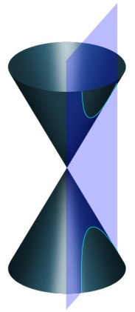 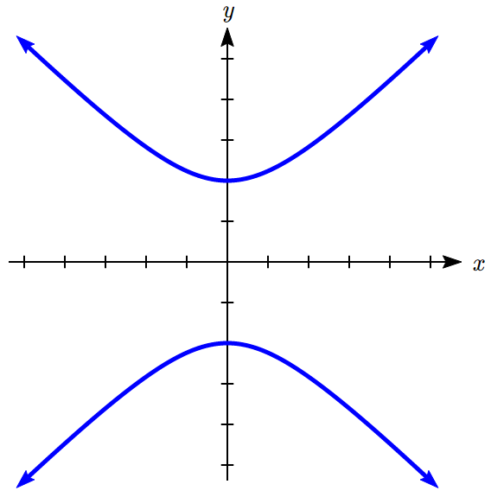

The word “hyperbola” derives from a Greek word meaning “excess.” The English word “hyperbole” means exaggeration. We can think of a hyperbola as an excessive or exaggerated ellipse, one turned inside out.

We defined an ellipse as the set of all points where the sum of the distances from that point to two fixed points is a constant. A hyperbola is the set of all points where the absolute value of the difference of the distances from the point to two fixed points is a constant.

Hyperbola Definition

A **hyperbola** is the set of all points  for which the absolute value of the difference of the distances to two fixed points  and  called the **foci**(plural for focus) is a constant *k*: .

*x*

*y*

*d(Q,F1)*

*d(Q,F2)*

*Q*

*F1*

*F2*

*x*

*y*

*d(Q,F2)*

*d(Q,F1)*

*Q*

*F2*

*F1*

The **transverse axis** is the line passing through the foci.

**Vertices**are the points on the hyperbola which intersect the transverse axis.

The **transverse axis length** is the length of the line segment between the vertices.

The **center**is the midpoint between the vertices (or the midpoint between the foci).

The other axis of symmetry through the center is the **conjugate axis**.

The two disjoint pieces of the curve are called **branches**.

A hyperbola has two **asymptotes**.

Which axis is the transverse axis will depend on the orientation of the hyperbola. As a helpful tool for graphing hyperbolas, it is common to draw a **central rectangle** as a guide. This is a rectangle drawn around the center with sides parallel to the coordinate axes that pass through each vertex and co-vertex. The asymptotes will follow the diagonals of this rectangle.

*x*

*y*

Vertex

Focus

Asymptote

Center

Co-vertex

Transverse axis

Conjugate axis

**Hyperbolas Centered at the Origin**

From the definition above we can find an equation of a hyperbola. We will find it for a hyperbola centered at the origin  opening horizontally with foci at  and  where *c* > 0.

Suppose  is a point on the hyperbola. The distances from *Q* to *F*1 and *Q* to *F*2 are:



.

From the definition, the absolute value of the difference should be constant:



Substituting in one of the vertices , we can determine *k* in terms of *a*:



 Since *c* > *a*, 





Using  and removing the absolute values,

 Move one radical

 Square both sides

 Expand



Combining like terms leaves

 Divide by 4

 Isolate the radical

 Square both sides again

 Expand and distribute

 Combine like terms

 Factor common terms



Let . Since *c* > *a*, *b* > 0.Substituting  for  leaves

 Divide both sides by 

 Rewrite



We can see from the graphs of the hyperbolas that the branches appear to approach asymptotes as *x* gets large in the negative or positive direction. The equations of the horizontal hyperbola asymptotes can be derived from its standard equation.

 Solve for *y*

 Rewrite 1 as 

 Factor out 

 Take the square root



As *x* → ±∞ the quantity  → 0 and  → 1, so the asymptotes are .

Similarly, for vertical hyperbolas the asymptotes are .

The standard form of an equation of a hyperbola centered at the origin *C* depends on whether it opens horizontally or vertically. The following table gives the standard equation, vertices, foci, asymptotes, construction rectangle vertices, and graph for each.

Equation of a Hyperbola Centered at the Origin in Standard Form

|  |  |  |
| --- | --- | --- |
| Opens | Horizontally | Vertically |
| Standard Equation |  |  |
| Vertices | (-*a*, 0) and (*a*, 0) | (0, -*a*) and (0, *a*) |
| Foci | (-*c*, 0) and (*c*, 0)  where | (0, -*c*) and (0, *c*)  Where |
| Asymptotes |  |  |
| Construction Rectangle  Vertices | (*a*, *b*), (-*a*, *b*), ( *a*,-*b*), (*-a*, *-b*) | (*b*, *a*)*,* (-*b*, *a*), (*b*, -*a*), (*-b*, *-a*) |
| Graph | *x*  *y*  (0,*b*)  (-*c*,0)  (0,-*b*)  (*c*,0)  (*a*,0)  (-*a*,0) | *x*  *y*  (0,*a*)  (0,*c*)  (-*b*,0)  (0,-*a*)  (0,-*c*)  (*b*,0) |

Example 1

Put the equation of the hyperbola  in standard form. Find the vertices, length of the transverse axis, and the equations of the asymptotes. Sketch the graph. Check using a graphing utility.

The equation can be put in standard form  by dividing by 4.

Comparing to the general standard equation  we see that  and .

Since the *x* term is subtracted, the hyperbola opens vertically and the vertices lie on the *y*-axis at (0,±*a*) = (0, ±2).

The length of the transverse axis is .

Equations of the asymptotes are  or .

To sketch the graph we plot the vertices of the construction rectangle at (±*b*,±*a*) or

(-1,-2), (-1,2), (1,-2), and (1,2). The asymptotes are drawn through the diagonals of the rectangle and the vertices plotted. Then we sketch in the hyperbola, rounded at the vertices and approaching the asymptotes.

|  |  |  |
| --- | --- | --- |
| A graph showing a box drawn around the origin, with corners at negative 1 comma 2, 1 comma 2, 1 comma negative 2, and negative 1 comma negative 2. | A graph showing a box drawn around the origin, with corners at negative 1 comma 2, 1 comma 2, 1 comma negative 2, and negative 1 comma negative 2.  Lines indicating the asymptotes are drawn through the diagonals of of the box, and dots are placed for the vertices at 0 comma 2 and 0 comma negative 2. | A graph showing a box drawn around the origin, with corners at negative 1 comma 2, 1 comma 2, 1 comma negative 2, and negative 1 comma negative 2.  Lines indicating the asymptotes are drawn through the diagonals of of the box, and dots are placed for the vertices at 0 comma 2 and 0 comma negative 2.  Above the box, a U-shaped curve is drawn touching the vertex at 0 comma 2, and approaching the slanted asymptotes on the sides.  Below the box, an inverted U-shaped curve is drawn touching the vertex at 0 comma negative 2, and approaching the slanted asymptotes on the sides. |

To check on a graphing utility, we must solve the equation for *y*. Isolating *y*2 gives us.

Taking the square root of both sides we find .

Under **Y=** enter the two halves of the hyperbola and the two asymptotes as , , , and . Set the window to a comparable scale to the sketch with xmin = -4, xmax = 4, ymin= -3, and ymax = 3.

|  |  |  |
| --- | --- | --- |
| Image of TI-84 Plus window for y= with hyperbola and asymptote equations. | Image of TI-84 Plus window of window with x and y scale values. | Image of TI-84 Plus window for graph with hyperbola and asymptotes. |

Sometimes we are given the equation. Sometimes we need to find the equation from a graph or other information.

Example 2

Find the standard form of the equation for a hyperbola with vertices at (-6,0) and (6,0) and asymptote .

Since the vertices lie on the *x*-axis with a midpoint at the origin, the hyperbola is horizontal with an equation of the form . The value of *a* is the distance from the center to a vertex. The distance from (6,0) to (0,0) is 6, so *a* = 6.

The asymptotes follow the form . From  we see  and substituting *a* = 6 give us . Solving yields *b* = 8.

The equation of the hyperbola in standard form is  or .

Try it Now

1. Find the standard form of the equation for a hyperbola with vertices at (0,-8) and (0,8) and asymptote 

Example 3

Find the standard form of the equation for a hyperbola with vertices at (0, 9) and (0,-9) and passing through the point (8,15).

Since the vertices lie on the *y*-axis with a midpoint at the origin, the hyperbola is vertical with an equation of the form . The value of *a* is the distance from the center to a vertex. The distance from (0,9) to (0,0) is 9, so *a* = 9.

Substituting *a* = 9 and the point (8,15) gives . Solving for *b* yields.

The standard equation for the hyperbola is  or .

**Hyperbolas Not Centered at the Origin**

Not all hyperbolas are centered at the origin. The standard equation for one centered at (*h, k*) is slightly different.

Equation of a Hyperbola Centered at (*h, k*) in Standard Form

The standard form of an equation of a hyperbola centered at *C* depends on whether it opens horizontally or vertically. The table below gives the standard equation, vertices, foci, asymptotes, construction rectangle vertices, and graph for each.

|  |  |  |
| --- | --- | --- |
| Opens | Horizontally | Vertically |
| Standard Equation |  |  |
| Vertices | ( *h ± a*, *k* ) | (*h*, *k ± a*) |
| Foci | ( *h ± c*, *k* )  where  *b2 = c2 – a*2 | (*h*, *k ± c*)  where  *b2 = c2 – a*2 |
| Asymptotes |  |  |
| Construction Rectangle  Vertices | ( *h ± a*, *k* ± *b* ) | ( *h ± b*, *k* ± *a* ) |
| Graph | *x*  *y*  (*h*,*k*+*b*)  (*h*-*c*,*k*)  (*h*+*a*,*k*)  (*h*-*a*,*k*)  (*h*,*k*)  (*h*,*k*-*b*)  (*h*+*c*,*k*) | *x*  *y*  (*h*-*b*,*k*)  (*h*,*k*-*a*)  (*h+b*,*k*)  (*h*,*k*)  (*h*,*k*-*c*)  (*h*,*k*+*c*)  (*h*,*k*+*a*) |

Example 4

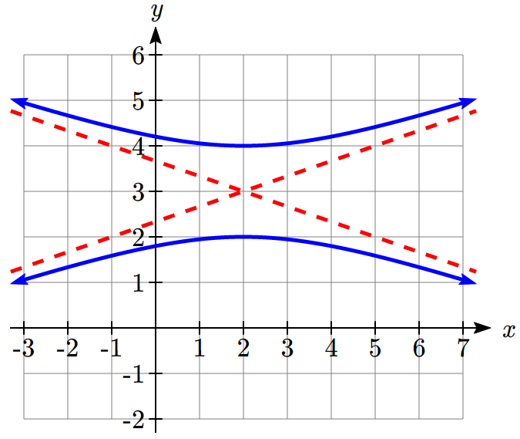Write an equation for the hyperbola in the graph shown.

The center is at (2,3), where the asymptotes cross. It opens vertically, so the equation will look like .

The vertices are at (2,2) and (2,4). The distance from the center to a vertex is .

If we were to draw in the construction rectangle, it would extend from *x* = -1 to *x* = 5. The distance from the center to the right side of the rectangle gives .

The standard equation of this hyperbola is , or .

Example 5

Put the equation of the hyperbola  in standard form. Find the center, vertices, length of the transverse axis, and the equations of the asymptotes. Sketch the graph, then check on a graphing utility.

To rewrite the equation, we complete the square for both variables to get





Dividing by 36 gives the standard form of the equation, 

Comparing to the general standard equation  we see that  and .

Since the *y* term is subtracted, the hyperbola opens horizontally.

The center is at (*h, k*) = (-1, 2).

The vertices are at (*h*±*a, k*) or (-3, 2) and (1,2).

The length of the transverse axis is .

Equations of the asymptotes are  or .

To sketch the graph we plot the corners of the construction rectangle at (*h*±*a*, *k*±*b*) or (1, 5), (1, -1), (-3,5), and (-3,-1). The asymptotes are drawn through the diagonals of the rectangle and the vertices plotted. Then we sketch in the hyperbola rounded at the vertices and approaching the asymptotes.

|  |  |  |
| --- | --- | --- |
| A graph showing a box drawn with corners at negative 3 comma 5, 1 comma 5, 1 comma negative 1, and negative 3 comma negative 1. | A graph showing a box drawn with corners at negative 3 comma 5, 1 comma 5, 1 comma negative 1, and negative 3 comma negative 1.  Lines indicating the asymptotes are drawn through the diagonals of the box.  Vertices are plotted at negative 3 comma 2 and 1 comma 2. | A graph showing a box drawn with corners at negative 3 comma 5, 1 comma 5, 1 comma negative 1, and negative 3 comma negative 1.  Lines indicating the asymptotes are drawn through the diagonals of the box.  The hyperbola is drawn in two segements, both parts are U-shaped, one rotated to open left and the other rotated to open right.  The one opening to the left has vertex at negative 3 comma 2; the one opening to the right has vertex at 1 comma 2. |

|  |  |  |
| --- | --- | --- |
|  |  |  |

To check on a graphing utility, we must solve the equation for *y*.   
.

Under **Y=** enter the two halves of the hyperbola and the two asymptotes as , , , and . Set the window to a comparable scale to the sketch, then graph. Note that the gaps you see on the calculator are not really there; they’re a limitation of the technology.

|  |  |  |
| --- | --- | --- |
| TI-84 Plus window for y= with hyperbola and asymptote equations. | TI-84 Plus window of window with x and y scale values. | TI-84 Plus window for graph with hyperbola and asymptotes. |

Example 6

Find the standard form of the equation for a hyperbola with vertices at  and , and asymptote .

Since the vertices differ in the *y* -coordinates, the hyperbola opens vertically with an equation of the form  and asymptote equations of the form .

The center will be halfway between the vertices, at .

The value of *a* is the distance from the center to a vertex. The distance from  to  is 6, so *a* = 6.

While our asymptote is not given in the form , notice this equation would have slope . We can compare that to the slope of the given asymptote equation to find *b*. Setting  and substituting *a* = 6 gives us *b* = 4.

The equation of the hyperbola in standard form is  or .

Try it Now

2. Find the center, vertices, length of the transverse axis, and equations of the asymptotes for the hyperbola .

**Hyperbola Foci**

The location of the foci can play a key role in hyperbola application problems. To find them, we need to find the length from the center to the foci, *c*, using the equation . It looks similar to, but is not the same as, the Pythagorean Theorem.

Compare this with the equation to find length *c* for ellipses, which is . If you remember that for the foci to be inside the ellipse they have to come before the vertices , it’s clear why we would calculate  minus . To be inside a hyperbola, the foci have to go beyond the vertices , so we can see for hyperbolas we need  minus , the opposite.

Example 7

Find the foci of the hyperbola .

The hyperbola is vertical with an equation of the form .

The center is at (*h*, *k*) = (3, -1). The foci are at (*h*, *k ± c*).

To find length *c* we use . Substituting gives  or .

The hyperbola has foci (3, -4) and (3, 2).

Example 8

Find the standard form of the equation for a hyperbola with foci (5, -8) and (-3, -8) and vertices (4, -8) and (-2, -8).

Since the vertices differ in the *x* -coordinates, the hyperbola opens horizontally with an equation of the form .

The center is at the midpoint of the vertices .

The value of *a* is the horizontal length from the center to a vertex, or .

The value of *c* is the horizontal length from the center to a focus, or .

To find length *b* we use . Substituting gives .

The equation of the hyperbola in standard form is  or .

Try it Now

3. Find the standard form of the equation for a hyperbola with focus (1,9), vertex (1,8), center (1,4).

**LORAN**

Before GPS, the Long Range Navigation (LORAN) system was used to determine a ship’s location. Two radio stations A and B simultaneously sent out a signal to a ship. The difference in time it took to receive the signal was computed as a distance locating the ship on the hyperbola with the A and B radio stations as the foci. A second pair of radio stations C and D sent simultaneous signals to the ship and computed its location on the hyperbola with C and D as the foci. The point P where the two hyperbolas intersected gave the location of the ship.



A

B

C

D

P

Example 9

Stations A and B are 150 kilometers apart and send a simultaneous radio signal to the ship. The signal from B arrives 0.0003 seconds before the signal from A. If the signal travels 300,000 kilometers per second, find the equation of the hyperbola on which the ship is positioned.

Stations A and B are at the foci, so the distance from the center to one focus is half the distance between them, giving  km.

By letting the center of the hyperbola be at (0,0) and placing the foci at (±75,0), the equation  for a hyperbola centered at the origin can be used.

The difference of the distances of the ship from the two stations is . From our derivation of the hyperbola equation we determined *k* = 2*a*, so .

Substituting *a* and *c* into  yields .

The equation of the hyperbola in standard form is  or .

To determine the position of a ship using LORAN, we would need an equation for the second hyperbola and would solve for the intersection. We will explore how to do that in the next section.

Important Topics of This Section

Hyperbola Definition

Hyperbola Equations in Standard Form

Hyperbola Foci

Applications of Hyperbolas

Intersections of Hyperbolas and Other Curves

Try it Now Answers

1. The vertices are on the *y* axis so this is a vertical hyperbola.   
The center is at the origin.  
*a* = 8  
Using the asymptote slope, , so *b* = 4.  


2. Center (-5, 2). This is a horizontal hyperbola. *a* = 3. *b* = 6.  
transverse axis length 6,   
Vertices will be at (-5±3,2) = (-2,2) and (-8,2),   
Asymptote slope will be . Asymptotes: 

3. Focus, vertex, and center have the same *x* value so this is a vertical hyperbola.  
Using the vertex and center, *a* = 9 – 4 = 5  
Using the focus and center, *c* = 8 – 4 = 4  
. *b* = 3.  
 

## Section 9.2 Exercises

In problems 1–4, match each graph to equations A–D.

A.  B.  C.  D. 

1. 2. 3. 4.

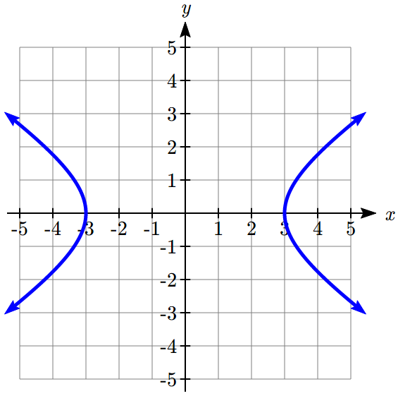 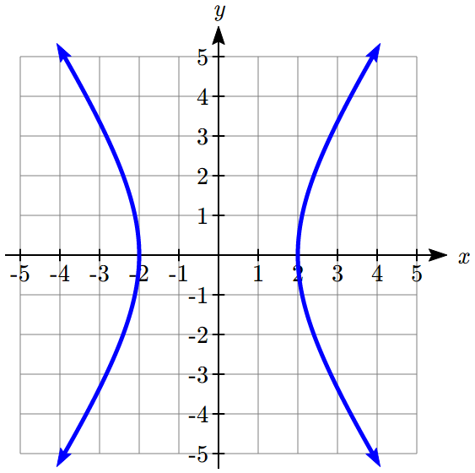 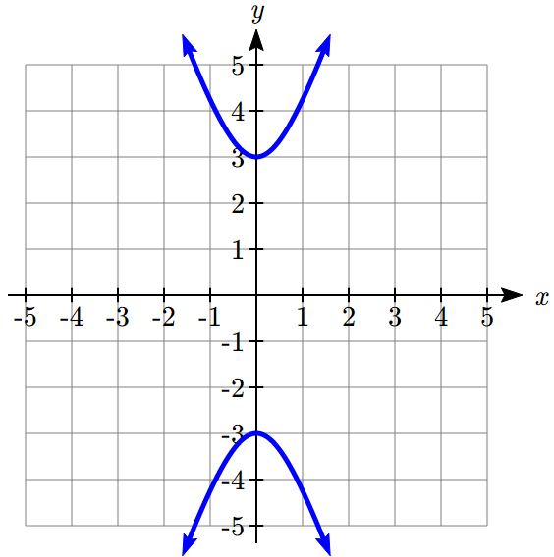 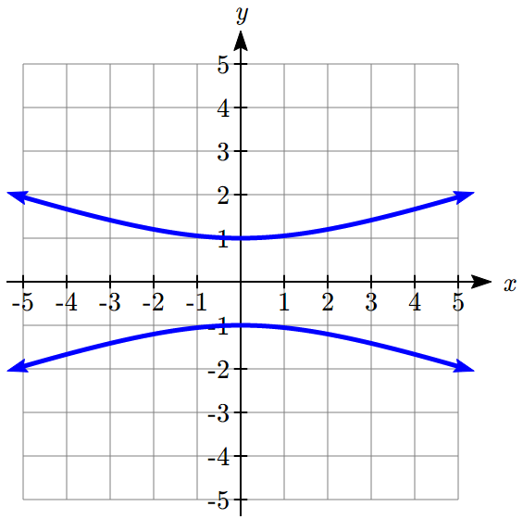

In problems 5–14, find the vertices, length of the transverse axis, and equations of the asymptotes. Sketch the graph. Check using a graphing utility.

5.  6.  7.  8. 

9.  10.  11. 

12.  13.  14. 

In problems 15–16, write an equation for the graph.

15. 16.

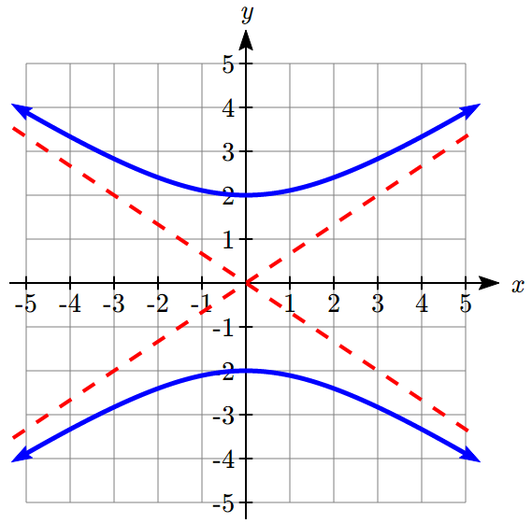 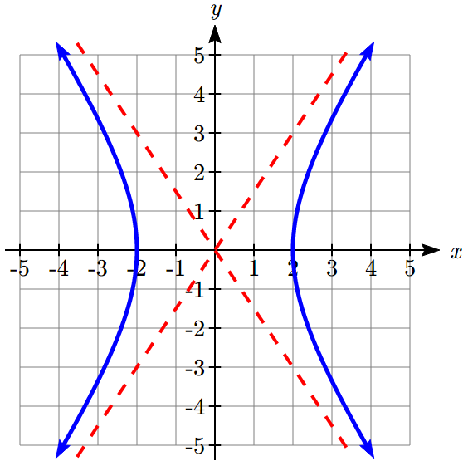

In problems 17–22, find the standard form of the equation for a hyperbola satisfying the given conditions.

17. Vertices at (0,4) and (0, -4); asymptote 

18. Vertices at (-6,0) and (6,0); asymptote 

19. Vertices at (-3,0) and (3,0); passes through (5,8)

20. Vertices at (0, 4) and (0, -4); passes through (6, 5)

21. Asymptote y = x; passes through (5, 3)

22. Asymptote y = x; passes through (12, 13)

In problems 23–30, match each graph to equations A–H.

A.  E. 

B.  F. 

C.  G. 

D.  H. 

23. 24. 25. 26.

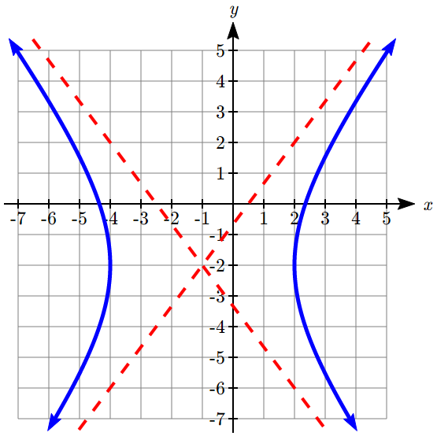 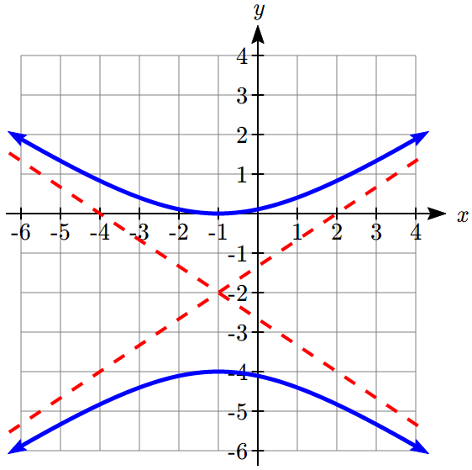 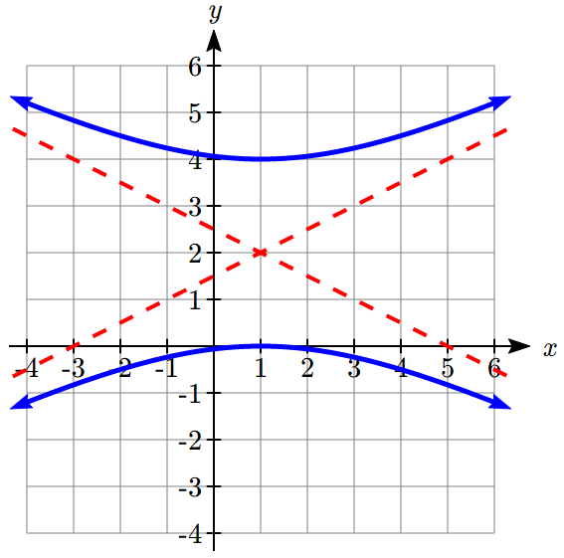 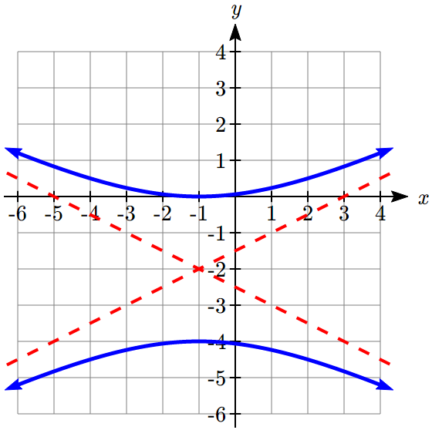

27. 28. 29. 30.   
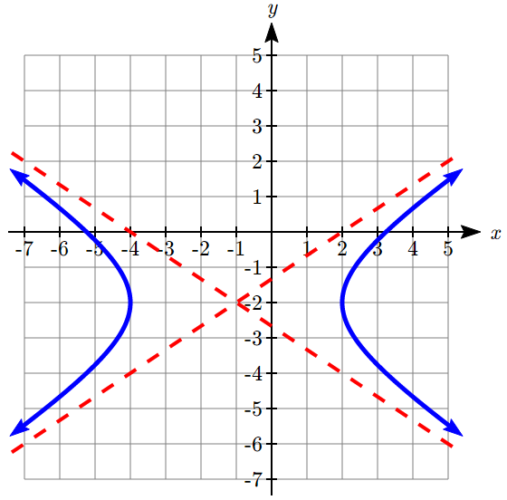 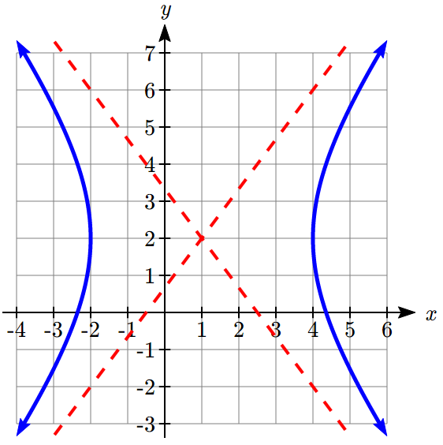 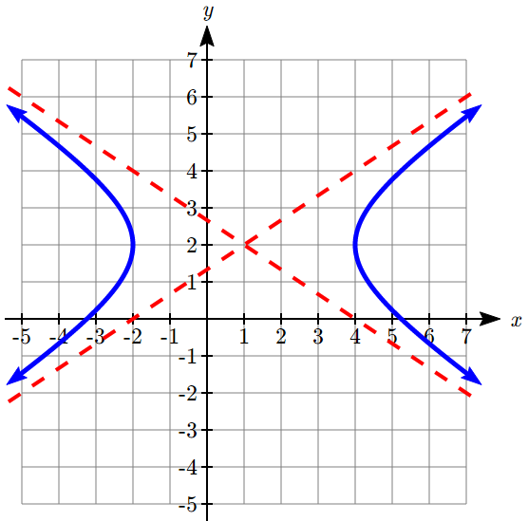 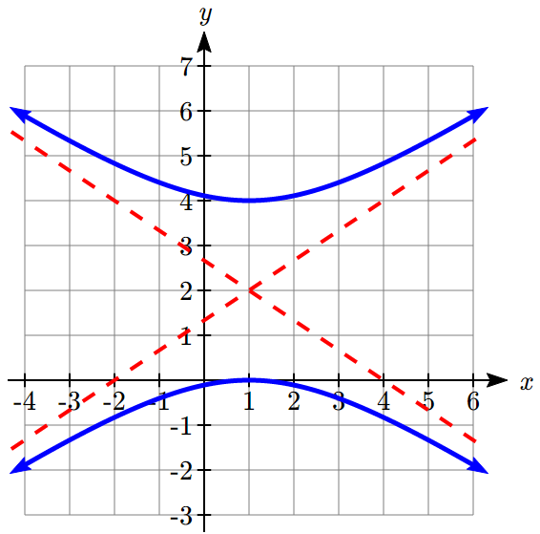

In problems 31–40, find the center, vertices, length of the transverse axis, and equations of the asymptotes. Sketch the graph. Check using a graphing utility.

31.  32. 

33.  34. 

35.  36. 

37.  38. 

39.  40. 

In problems 41–42, write an equation for the graph.

41. 42.

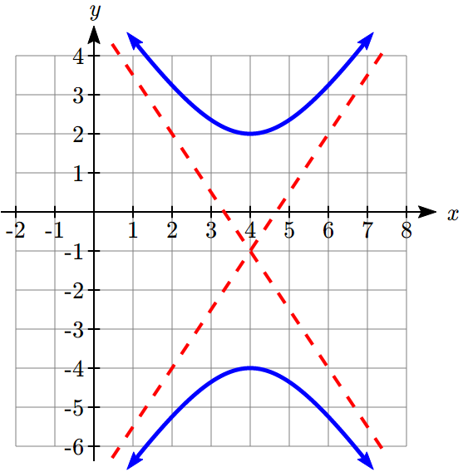 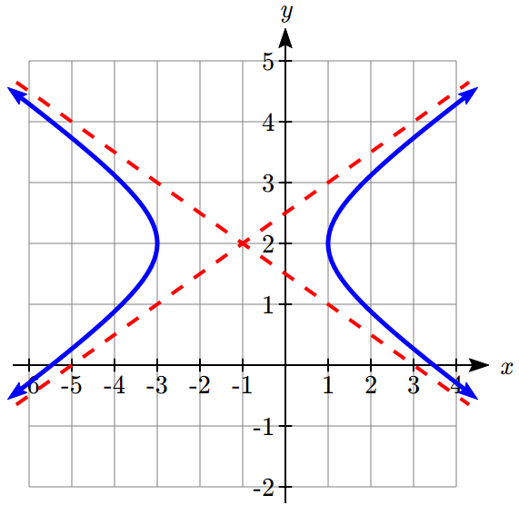

In problems 43–44, find the standard form of the equation for a hyperbola satisfying the given conditions.

43. Vertices (-1,-2) and (-1,6); asymptote 

44. Vertices (-3,-3) and (5,-3); asymptote 

In problems 45–48, find the center, vertices, length of the transverse axis, and equations of the asymptotes. Sketch the graph. Check using a graphing utility.

45.  46. 

47.  48. 

In problems 49–54, find the foci.

49.  50. 

51.  52. 

53.  54. 

In problems 55–66, find the standard form of the equation for a hyperbola satisfying the given conditions.

55. Foci (5,0) and (-5,0), vertices (4,0) and (4,0)

56. Foci (0,26) and (0, -26), vertices (0,10) and (0,-10)

57. Focus (0, 13), vertex (0,12), center (0,0)

58. Focus (15, 0), vertex (12, 0), center (0,0)

59. Focus (17, 0) and (-17,0), asymptotes  and 

60. Focus (0, 25) and (0, 25), asymptotes  and 

61. Focus (10, 0) and (-10, 0), transverse axis length 16

62. Focus (0, 34) and (0, -34), transverse axis length 32

63. Foci (1, 7) and (1, -3), vertices (1, 6) and (1,-2)

64. Foci (4, -2) and (-6, -2), vertices (2, -2) and (-4, -2)

65. Focus (12, 3), vertex (4, 3), center (-1, 3)

66. Focus (-3, 15), vertex (-3, 13), center (-3, -2)

67. **LORAN** Stations A and B are 100 kilometers apart and send a simultaneous radio signal to a ship. The signal from A arrives 0.0002 seconds before the signal from B. If the signal travels 300,000 kilometers per second, find an equation of the hyperbola on which the ship is positioned if the foci are located at A and B.

68. **Thunder and Lightning** Anita and Samir are standing 3050 feet apart when they see a bolt of light strike the ground. Anita hears the thunder 0.5 seconds before Samir does. Sound travels at 1100 feet per second. Find an equation of the hyperbola on which the lighting strike is positioned if Anita and Samir are located at the foci.

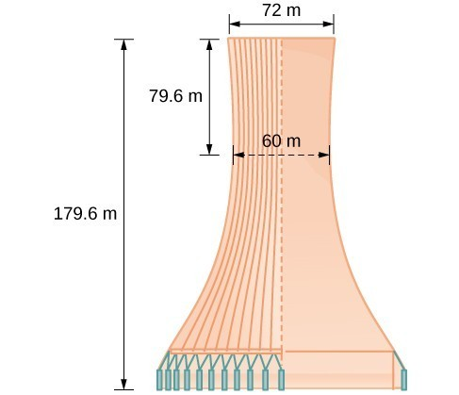

69. **Cooling Tower The cooling tower for a power plant has sides in the shape of a hyperbola. The tower stands 179.6 meters tall. The diameter at the top is 72 meters. At their closest, the sides of the tower are 60 meters apart. Find an equation that models the sides of the cooling tower.**

70. **Calibration** A seismologist positions two recording devices 340 feet apart at points A and B. To check the calibration, an explosive is detonated between the devices 90 feet from point A. The time the explosions register on the devices is noted and the difference calculated. A second explosion will be detonated east of point A. How far east should the second explosion be positioned so that the measured time difference is the same as for the first explosion?

71. **Target Practice** A gun at point A and a target at point B are 200 feet apart. A person at point C hears the gun fire and hit the target at exactly the same time. Find an equation of the hyperbola on which the person is standing if the foci are located at A and B. A fired bullet has a velocity of 2000 feet per second. The speed of sound is 1100 feet per second.

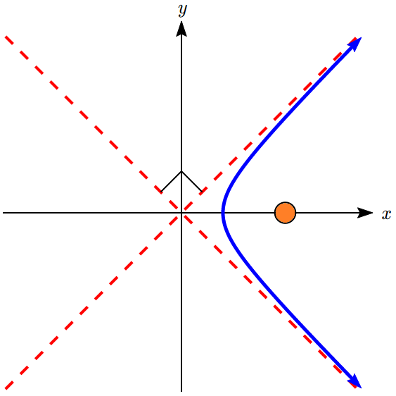

3×108

72. **Comet Trajectories** A comet passes through the solar system following a hyperbolic trajectory with the sun as a focus. The closest it gets to the sun is 3×108 miles. The figure shows the trajectory of the comet, whose path of entry is at a right angle to its path of departure. Find an equation for the comet’s trajectory. Round to two decimal places.

73. The **conjugate** of the hyperbola  is . Show that  is the conjugate of .

74. The **eccentricity** *e* of a hyperbola is the ratio , where *c* is the distance of a focus from the center and *a* is the distance of a vertex from the center. Find the eccentricity of .

75. An **equilateral hyperbola** is one for which *a* = *b*. Find the eccentricity of an equilateral hyperbola.

76. The **latus rectum** of a hyperbola is a line segment with endpoints on the hyperbola that passes through a focus and is perpendicular to the transverse axis. Show thatis the length of the latus rectum of .

77. **Confocal** hyperbolas have the same foci. Show that, for 0 < *k* < 6, all hyperbolas of the form  are confocal.

## Section 9.3 Parabolas and Non-Linear Systems

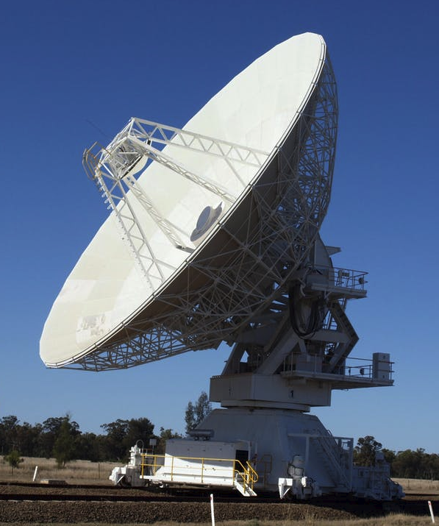

To listen for signals from space, a radio telescope uses a dish in the shape of a parabola to focus and collect the signals in the receiver.

While we studied parabolas earlier when we explored quadratics, at the time we didn’t discuss them as a conic section. A parabola is the shape resulting from when a plane parallel to the side of the cone intersects the cone[6].

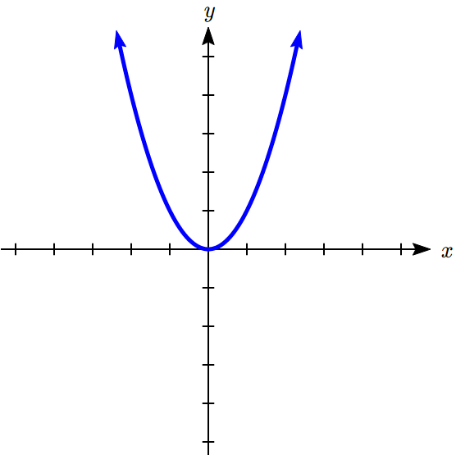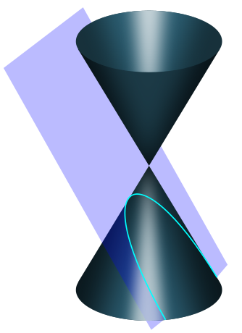

Parabola Definition and Vocabulary

A **parabola** with vertex at the origin can be defined by placing a fixed point at  called the **focus**, and drawing a line at , called the **directrix**. The parabola is the set of all points  that are an equal distance between the fixed point and the directrix.

*x*

*y*

(0,*p*)

*y=-p*

*Q*

*x*

*y*

Focus

Directrix

Vertex

Axis of symmetry

For general parabolas,

The **axis of symmetry** is the line passing through the foci, perpendicular to the directrix.

The **vertex** is the point where the parabola crosses the axis of symmetry.

The distance from the vertex to the focus, *p*, is the **focal length**.

**Equations for Parabolas with Vertex at the Origin**

From the definition above we can find an equation of a parabola. We will find it for a parabola with vertex at the origin, , opening upward with focus at  and directrix at .

Suppose is some point on the parabola. The distance from *Q* to the focus is



The distance from the point *Q* to the directrix is the difference of the *y*-values:



From the definition of the parabola, these distances should be equal:

 Square both sides

 Expand

 Combine like terms



This is the standard conic form of a parabola that opens up or down (vertical axis of symmetry), centered at the origin. Note that if we divided by 4*p*, we would get a more familiar equation for the parabola, . We can recognize this as a transformation of the parabola , vertically compressed or stretched by .

Using a similar process, we could find an equation of a parabola with vertex at the origin opening left or right. The focus will be at (*p*,0) and the graph will have a horizontal axis of symmetry and a vertical directrix. The standard conic form of its equation will be , which we could also write as .

Example 1

Write the standard conic equation for a parabola with vertex at the origin and focus at (0, -2).

With focus at (0, -2), the axis of symmetry is vertical, so the standard conic equation is . Since the focus is (0, -2), *p* = -2.

The standard conic equation for the parabola is , or



For parabolas with vertex not at the origin, we can shift these equations, leading to the equations summarized next.

Equation of a Parabola with Vertex at (*h, k*) in Standard Conic Form

The standard conic form of an equation of a parabola with vertex at the point  depends on whether the axis of symmetry is horizontal or vertical. The table below gives the standard equation, vertex, axis of symmetry, directrix, focus, and graph for each.

|  |  |  |
| --- | --- | --- |
|  | Horizontal | Vertical |
| Standard Equation |  |  |
| Vertex | (*h*, *k*) | (*h*, *k*) |
| Axis of symmetry | *y* = *k* | *x* = *h* |
| Directrix | *x* = *h - p* | *y* = *k - p* |
| Focus | (*h + p*, *k*) | (*h*, *k + p*) |
| Graph | An example with *p* < 0  *x*  *y*  (*h+p*,*k)*  *x=h-p*  (*h*,*k*)  *y=k* | An example with *p* > 0  *x*  *y*  (*h*,*k+p)*  *y=k-p*  (*h*,*k*)  *x=h* |

Since you already studied quadratics in some depth earlier, we will primarily explore the new concepts associated with parabolas, particularly the focus.

Example 2

Put the equation of the parabola  in standard conic form. Find the vertex, focus, and axis of symmetry.

From your earlier work with quadratics, you may already be able to identify the vertex as (1,2), but we’ll go ahead and put the parabola in the standard conic form. To do so, we need to isolate the squared factor.

 Subtract 2 from both sides

 Divide by 8



This matches the general form for a vertical parabola, , where . Solving this tells us . The standard conic form of the equation is

.

The vertex is at (1,2). The axis of symmetry is at *x* = 1.

The directrix is at .

The focus is at .

Example 3

A parabola has its vertex at (1,5) and focus at (3,5). Find an equation for the parabola.

Since the vertex and focus lie on the line *y* = 5, that is our axis of symmetry.

The vertex (1,5) tells us *h* = 1 and *k* = 5.

Looking at the distance from the vertex to the focus, *p* = 3 – 1 = 2.

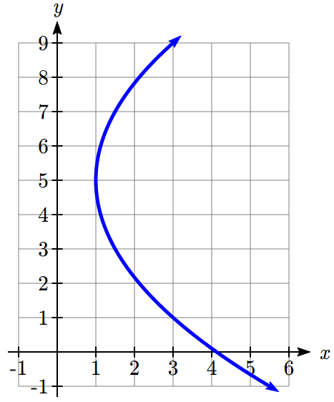

Substituting these values into the standard conic form of an equation for a horizontal parabola gives the equation





Note this could also be rewritten by solving for *x*, resulting in



Try it Now

1. A parabola has its vertex at (-2,3) and focus at (-2,2). Find an equation for this parabola.

**Applications of Parabolas**

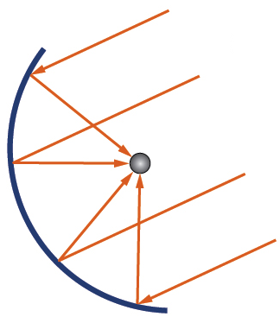In an earlier section, we learned that ellipses have a special property that a ray eminating from one focus will be reflected back to the other focus, the property that enables the whispering chamber to work. Parabolas also have a special property, that any ray eminating from the focus will be reflected parallel to the axis of symmetry. Reflectors in flashlights take advantage of this property to focus the light from the bulb into a collimated beam. The same property can be used in reverse, taking parallel rays of sunlight or radio signals and directing them all to the focus.

Example 4

A solar cooker is a parabolic dish that reflects the sun’s rays to a central point allowing you to cook food. If a solar cooker has a parabolic dish 16 inches in diameter and 4 inches tall, where should the food be placed?

*x*

*y*

4

8

We need to determine the location of the focus, since that’s where the food should be placed. Positioning the base of the dish at the origin, the shape from the side looks like:

The standard conic form of an equation for the parabola would be . The parabola passes through (8, 4), so substituting that into the equation, we can solve for *p*:





The focus is 4 inches above the vertex. This makes for a very convenient design, since then a grate could be placed on top of the dish to hold the food.

Try it Now

1. A radio telescope is 100 meters in diameter and 20 meters deep. Where should the receiver be placed?

**Non-Linear Systems of Equations**

In many applications, it is necessary to solve for the intersection of two curves. Many of the techniques you may have used before to solve systems of linear equations will work for non-linear equations as well, particularly substitution. You have already solved some examples of non-linear systems when you found the intersection of a parabola and line while studying quadratics, and when you found the intersection of a circle and line while studying circles.

Example 4

Find the points where the ellipse  intersects the circle .

To start, we might multiply the ellipse equation by 100 on both sides to clear the fractions, giving .

A common approach for finding intersections is substitution. With these equations, rather than solving for *x* or *y*, it might be easier to solve for  or . Solving the circle equation for  gives . We can then substitute that expression for  into the ellipse equation.

 Substitute 

 Distribute

 Combine like terms

 Divide by -21

 Use the square root to solve



We can substitute each of these *y* values back in to  to find *x*

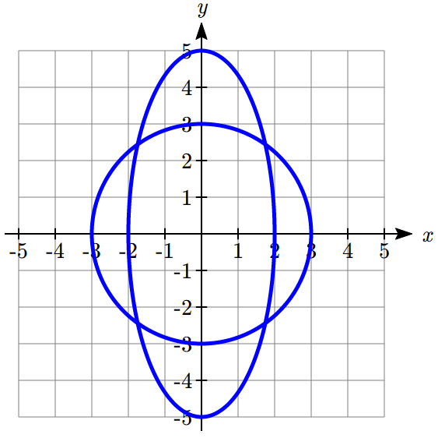



There are four points of intersection: .

It’s worth noting there is a second technique we could have used in the previous example, called elimination. If we multiplied the circle equation by -4 to get , we can then add it to the ellipse equation, eliminating the variable *y*.



 Add the left sides, and add the right sides

 Solve for *x*



Example 5

Find the points where the hyperbola  intersects the parabola .

We can solve this system of equations by substituting  into the hyperbola equation.

 Simplify

 Simplify, and multiply by 9

 Move the 9 to the left



While this looks challenging to solve, we can think of it as a “quadratic in disguise,” since . Letting , the equation becomes

 Solve using the quadratic formula

 Solve for *x*

 But , so

 This leads to two real solutions

*x* ≈ 1.028, -1.028

Substituting these into , we can find the corresponding *y* values.

The curves intersect at the points (1.028, 2.114) and (-1.028, 2.114).

Try it Now

1. Find the points where the line  intersect the ellipse 

Solving for the intersection of two hyperbolas allows us to utilize the LORAN navigation approach described in the last section.



A

B

C

D

P

In our example, stations A and B are 150 kilometers apart and send a simultaneous radio signal to the ship. The signal from B arrives 0.0003 seconds before the signal from A. We found the equation of the hyperbola in standard form would be 

Example 6

Continuing the situation from the last section, suppose stations C and D are located 200 km due south of stations A and B and 100 km apart. The signal from D arrives 0.0001 seconds before the signal from C, leading to the equation . Find the position of the ship.

To solve for the position of the boat, we need to find where the hyperbolas intersect. This means solving the system of equations. To do this, we could start by solving both equations for . With the first equation from the previous example,

 Move the *y* term to the right

 Multiply both sides by 2025

 Simplify



With the second equation, we repeat the same process

 Move the *y* term to the right and multiply by 225

 Simplify



Now set these two expressions for  equal to each other and solve.

 Subtract 225 from both sides

 Divide by 9

 Multiply both sides by 

 Expand and distribute

 Combine like terms on one side

 Solve using the quadratic formula

 123.11 km or -37.78 km

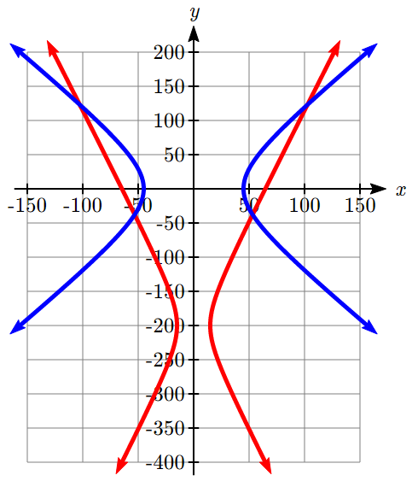We can find the associated *x* values by substituting these *y*-values into either hyperbola equation. When *y* ≈ 123.11,





When *y* ≈ -37.78km,





This provides 4 possible locations for the ship. Two can be immediately discarded, as they’re on land. Navigators would use other navigational techniques to decide between the two remaining locations.

Important Topics of This Section

Parabola Definition

Parabola Equations in Standard Form

Applications of Parabolas

Solving Non-Linear Systems of Equations

Try it Now Answers

1. Axis of symmetry is vertical, and the focus is below the vertex.  
 *p =* 2 – 3 = -1.   
, or .

2. The standard conic form of the equation is .   
Using (50,20), we can find that , so *p* = 31.25 meters.   
The receiver should be placed 31.25 meters above the vertex.

3. Substituting  gives . Simplify  
. Multiply by 16 to get   
  
  
Substituting those into  gives the corresponding *y* values.  
The curves intersect at (0.504, 2.016) and (-0.504, -2.016).

## Section 9.3 Exercises

In problems 1–4, match each graph with one of the equations A–D.

A.  B.  C.  D. 

1. 2. 3. 4.

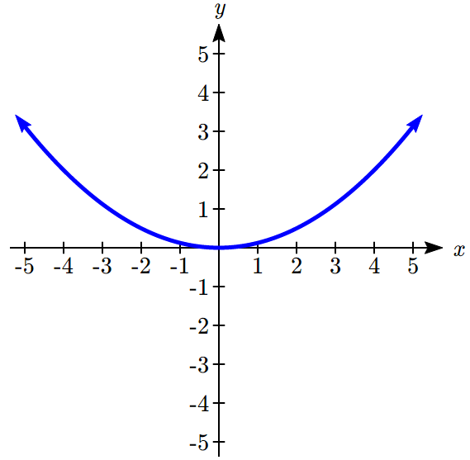 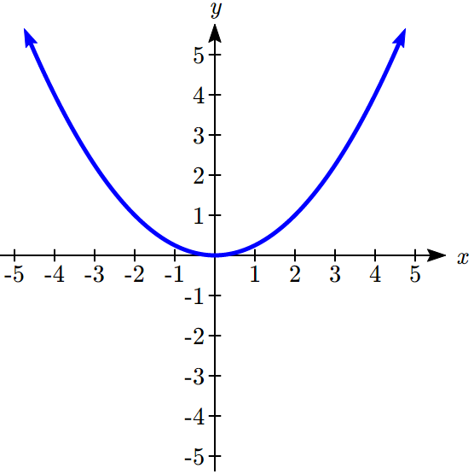 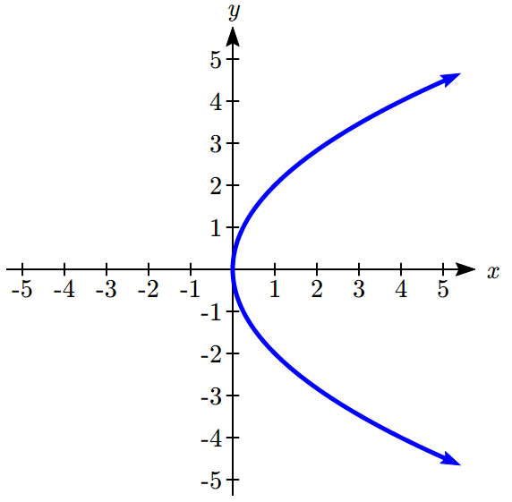 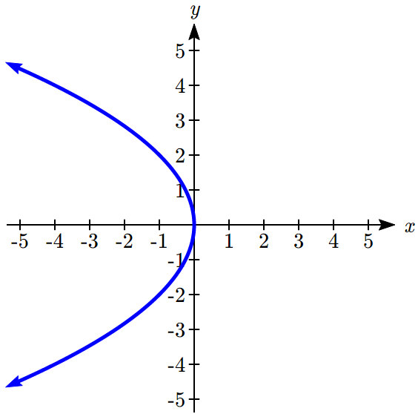

In problems 5–14, find the vertex, axis of symmetry, directrix, and focus of the parabola.

5.  6.  7.  8. 

9.  10.  11. 

12.  13.  14. 

In problems 15–16, write an equation for the graph.

15. 16.

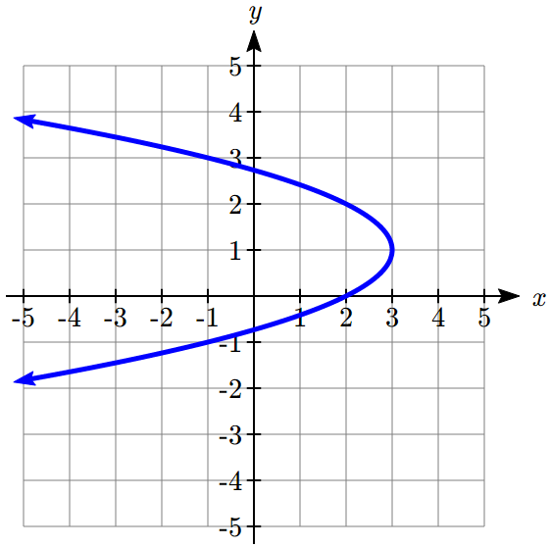 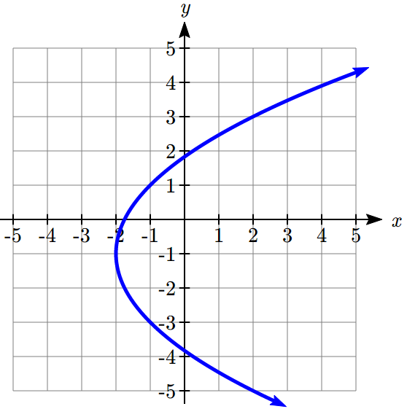

In problems 17-20, find the standard form of the equation for a parabola satisfying the given conditions.

17. Vertex at (2,3), opening to the right, focal length 3

18. Vertex at (-1,2), opening down, focal length 1

19. Vertex at (0,3), focus at (0,4)

20. Vertex at (1,3), focus at (0,3)

21. The mirror in an automobile headlight has a parabolic cross-section with the light bulb at the focus. On a schematic, the equation of the parabola is given as .  At what coordinates should you place the light bulb?

22. If we want to construct the mirror from the previous exercise so that the focus is located at (0,0.25), what should the equation of the parabola be?

23. A satellite dish is shaped like a paraboloid of revolution. This means that it can be formed by rotating a parabola around its axis of symmetry. The receiver is to be located at the focus. If the dish is 12 feet across at its opening and 4 feet deep at its center, where should the receiver be placed?

24. Consider the satellite dish from the previous exercise. If the dish is 8 feet across at the opening and 2 feet deep, where should we place the receiver?

25. A searchlight is shaped like a paraboloid of revolution. A light source is located 1 foot from the base along the axis of symmetry. If the opening of the searchlight is 2 feet across, find the depth.

26. If the searchlight from the previous exercise has the light source located 6 inches from the base along the axis of symmetry and the opening is 4 feet wide, find the depth.

In problems 27–34, solve each system of equations for the intersections of the two curves.

27.  28. 

29.  30. 

31.  32. 

33.  34. 

35. A LORAN system has transmitter stations A, B, C, and D at (-125,0), (125,0), (0, 250), and (0,-250), respectively. A ship in quadrant two computes the difference of its distances from A and B as 100 miles and the difference of its distances from C and D as 180 miles. Find the *x*- and *y*-coordinates of the ship’s location. Round to two decimal places.

36. A LORAN system has transmitter stations A, B, C, and D at (-100,0), (100,0), (-100, -300), and (100,-300), respectively. A ship in quadrant one computes the difference of its distances from A and B as 80 miles and the difference of its distances from C and D as 120 miles. Find the *x*- and *y*-coordinates of the ship’s location. Round to two decimal places.

## Section 9.4 Conics in Polar Coordinates

In the preceding sections, we defined each conic in a different way, but each involved the distance between a point on the curve and the focus. In the previous section, the parabola was defined using the focus and a line called the directrix. It turns out that all conic sections (circles, ellipses, hyperbolas, and parabolas) can be defined using a single relationship.

Conic Sections General Definition

A **conic section** can be defined by placing a fixed point at the origin, , called the **focus**, and drawing a line *L* called the **directrix** at  or . The conic section is the set of all points  for which the ratio of the distance from *Q* to *F* to the distance from *Q* to the directrix is some positive constant ***e***, called the **eccentricity**. In other words, .

*x*

*y*

*F*

*L*: *y = −p*

*Q*

*x*

*y*

*F*

*L*: *x=p*

*Q*

Warning: the eccentricity, *e*, is **not** the Euler constant *e* ≈ 2.71828 we studied with exponentials

**The Polar Form of a Conic**

To create a general equation for a conic section using the definition above, we will use polar coordinates. Represent  in polar coordinates so . For now, we’ll focus on the case of a horizontal directrix at , as in the picture above on the left.

The distance from the focus to the point *Q* in polar is just *r*.

The distance from the point *Q* to the directrix  is

The ratio of these should be the constant eccentricity *e*, so

 Substituting in the expressions for the distances,



To have a standard polar equation, we need to solve for *r*. Start by clearing the fraction. Distribute

 Move terms with *r* to the left

 Factor the *r*

 Divide



We could repeat the same approach for a directrix at  and for vertical directrices to obtain the polar equations below.

Polar Equation for a Conic Section

A **conic section** with a focus at the origin, **eccentricity** *e*, and **directrix** at  or  will have polar equation:

 when the directrix is 

 when the directrix is 

Example 1

Write the polar equation for a conic section with eccentricity 3 and directrix at .

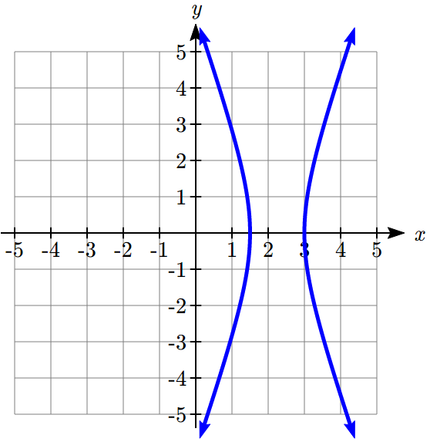We are given *e* = 3 and *p* = 2. Since the directrix is vertical and at a positive *x* value, we use the equation involving cos with the positive sign.



Graphing that using technology reveals it’s an equation for a hyperbola.

Try it Now

1. Write a polar equation for a conic with eccentricity 1 and directrix at .

**Relating the Polar Equation to the Shape**

It was probably not obvious to you that the polar equation in the last example would give the graph of a hyperbola. To explore the relationship between the polar equation and the shape, we will try to convert the polar equation into a Cartesian one. For simplicity, we will consider the case where the directrix is .

 Multiply by the denominator

 Rewrite 

 Distribute

 Isolate *r*

 Square both sides

 Rewrite  and expand  
 Move variable terms to the left

 Combine like terms



We could continue, by completing the square with the *x* terms, to eventually rewrite this in the standard form as , but happily there’s no need for us to do that.

In the equation , we can see that:

When *e* < 1, the coefficients of both  and  are positive, resulting in ellipse.

When *e* > 1, the coefficient of  is negative while the coefficient of  is positive, resulting in a hyperbola.

When *e* = 1, the  will drop out of the equation, resulting in a parabola.

Relation Between the Polar Equation of a Conic and its Shape

For a **conic section** with a focus at the origin, **eccentricity** *e*, and **directrix** at  or ,

when 0 < *e* < 1, the graph is an ellipse

when *e* = 1, the graph is a parabola

when *e* > 1, the graph is a hyperbola

A horizontal parabola with vertex to the right of the origin
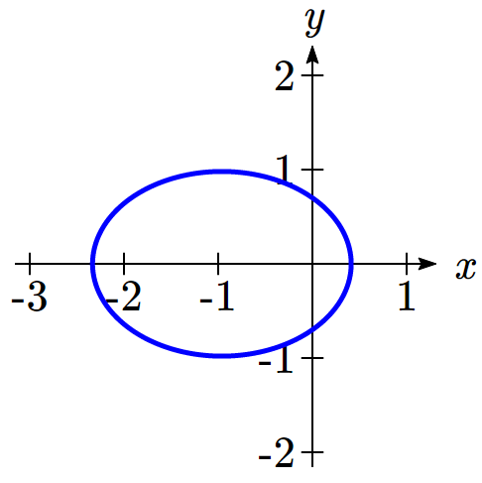Taking a more intuitive approach, notice that if *e* < 1, the denominator  will always be positive and so *r* will always be positive. This means that the radial distance *r* is defined and finite for every value of *θ*, including , with no breaks. The only conic with this characteristic is an ellipse.

If *e* = 1, the denominator will be positive for all values of *θ*, except  where the denominator is 0 and *r* is undefined. This fits with a parabola, which has a point at every angle except at the angle pointing along the axis of symmetry away from the vertex.

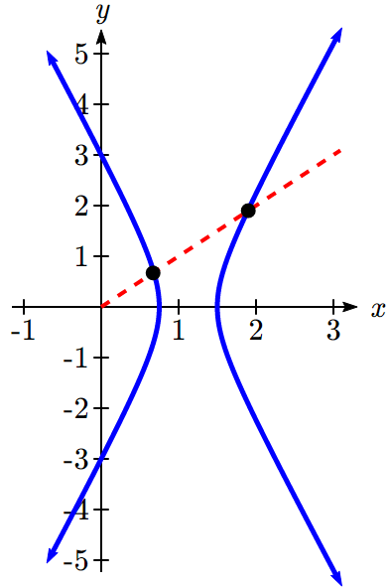



*r < 0*



*r > 0*

If *e* > 1, then the denominator will be zero at two angles other than , and *r* will be negative for a set of *θ* values. This division of positive and negative radius values would result in two distinct branches of the graph, fitting with a hyperbola.

Example 2

For each of the following conics with focus at the origin, identify the shape, the directrix, and the eccentricity.

a.  b.  c. 

a. This equation is already in standard form  for a conic with horizontal directrix at .

The eccentricity is the coefficient of , so *e* = 2.

Since *e* = 2 > 1, the shape will be a hyperbola.

Looking at the numerator, *ep* = 8, and substituting *e* = 2 gives *p* = 4. The directrix is .

b. This equation is not in standard form, since the constant in the denominator is not 1. To put it into standard form, we can multiply the numerator and denominator by 1/3.



This is the standard form for a conic with vertical directrix . The eccentricity is the coefficient on , so .

Since 0 < *e* < 1, the shape is an ellipse.

Looking at the numerator, *ep* = 2, so , giving *p* = 3. The directrix is .

c. This equation is also not in standard form. Multiplying the numerator and denominator by 1/5 will put it in standard form.



This is the standard form for a conic with horizontal directrix at .

The eccentricity is the coefficient on , so *e* = 1. The shape will be a parabola.

Looking at the numerator, . Since *e* = 1, . The directrix is .

Notice that since the directrix is above the focus at the origin, the parabola will open downward.

Try it Now

2. Identify the shape, the directrix, and the eccentricity of 

**Graphing Conics from the Polar Form**

Identifying additional features of a conic in polar form can be challenging, which makes graphing without technology likewise challenging. We can utilize our understanding of the conic shapes from earlier sections to aid us.

Example 3

Sketch a graph of  and write its Cartesian equation.

This is in standard form, and we can identify that , so the shape is an ellipse.

From the numerator, , so , giving *p* = 6. The directrix is .

To sketch a graph, we can start by evaluating the function at a few convenient *θ* values, and finding the corresponding Cartesian coordinates.

  

  

  

  

An ellipse centered at 0 comma 2, with 4 points marked: 3 comma 0, 0 comma 6, negative 3 comma 0, and 0 comma negative 2.


Plotting these points and remembering the origin is one of the foci gives an idea of the shape, which we could sketch in. To get a better understanding of the shape, we could use these features to find more.

The vertices are at (0, -2) and (0, 6), so the center must be halfway between, at  = (0, 2). Since the vertices are a distance *a* from the center, *a* = 6 – 2 = 4.

One focus is at (0, 0), a distance of 2 from the center, so *c* = 2, and the other focus must be 2 above the center, at (0, 4).

We can now solve for *b*: , so , hence . The minor axis endpoints would be at  and .

We can now use the center, *a*, and *b* to write the Cartesian equation for this curve:



Try it Now

3. Sketch a graph of  and identify the important features.

Important Topics of This Section

Polar equations for Conic Sections

Eccentricity and Directrix

Determining the shape of a polar conic section

Try it Now Answers

1. . 

2. We can convert to standard form by multiplying the top and bottom by .   
. Eccentricity = , so the shape is an ellipse.   
The numerator is . The directrix is .

3. The eccentricity is *e* = 2, so the graph of the equation is a hyperbola. The directrix is . Since the directrix is a vertical line and the focus is at the origin, the hyperbola is horizontal.  
    
    
    
  

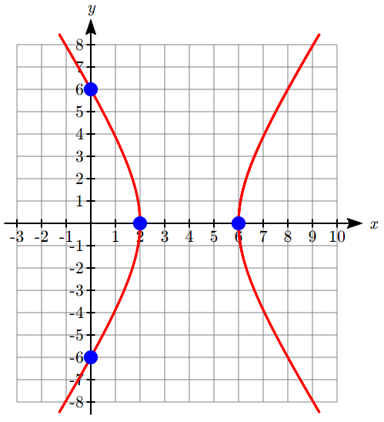Plotting those points, we can connect the three on the left with a smooth curve to form one branch of the hyperbola, and the other branch will be a mirror image passing through the last point.

The vertices are at (2,0) and (6,0).

The center of the hyperbola would be at the midpoint of the vertices, at (4,0).

The vertices are a distance *a* = 2 from the center.

The focus at the origin is a distance *c* = 4 from the center.

Solving for *b*, . .

The asymptotes would be .

The Cartesian equation of the hyperbola would be:



## Section 9.4 Exercises

In problems 1–8, find the eccentricity and directrix, then identify the shape of the conic.

1.  2. 

3.  4. 

5.  6. 

7.  8. 

In problems 9–14, find a polar equation for a conic having a focus at the origin with the given characteristics.

9. Directrix *x* = −4, eccentricity *e* = 5. 10. Directrix *y* = −2, eccentricity *e* = 3.

11. Directrix *y* = 3, eccentricity *e* = . 12. Directrix *x* = 5, eccentricity *e* = .

13. Directrix *y* = −2, eccentricity *e* = 1. 14. Directrix *x* = −3, eccentricity *e* = 1.

In problems 15–20, sketch a graph of the conic. Use the graph to help you find important features and write a Cartesian equation for the conic.

15.  16. 

17.  18. 

19.  20. 

21. At the beginning of the chapter, we defined an ellipse as the set of all points *Q* for which the sum of the distance from each focus to *Q* is constant. Mathematically, . It is not obvious that this definition and the one provided in this section involving the directrix are related. In this exercise, we will start with the definition from this section and attempt to derive the earlier formula from it.

a. Draw an ellipse with foci at  and , vertices at  and , and directrixes at  and . Label the foci  and . Label the directrixes  and . Label some point  on the ellipse *Q*.

b. Find formulas for  and  in terms of *x* and *p*.

c. From the definition of a conic in this section, . Likewise,  as well. Use these ratios, with your answers from part (b) above, to find formulas for  and  in terms of *e, x,* and *p*.

d. Show that the sum, , is constant. This establishes that the definitions are connected.

e. Let *Q* be a vertex. Find the distances  and  in terms of *a* and *c*. Then combine this with your result from part (d) to find a formula for *p* in terms of *a* and *e*.

f. Let *Q* be a vertex. Find the distances  and  in terms of *a, p,* and *c*. Use the relationship , along with your result from part (e), to find a formula for *e* in terms of *a* and *c*.

22. When we first looked at hyperbolas, we defined them as the set of all points *Q* for which the absolute value of the difference of the distances to two fixed points is constant. Mathematically, . Use a similar approach to the one in the last exercise to obtain this formula from the definition given in this section. Find a formula for *e* in terms of *a* and *c*.

1. Photo by Gary Palmer, Flickr, CC-BY, https://www.flickr.com/photos/gregpalmer/2157517950
2. Pbroks13 (<https://commons.wikimedia.org/wiki/File:Conic_sections_with_plane.svg>), “Conic sections with plane”, cropped to show only ellipse and circle by L Michaels, CC BY 3.0
3. Maxine Armstrong (<https://commons.wikimedia.org/wiki/File:Skerton_Bridge,_Lancaster,_England.JPG>), “Skerton Bridge, Lancaster, England”, CC BY-SA
4. Technically, they’re approximately elliptical. The orbits of the planets are not exactly elliptical because of interactions with each other and other celestial bodies.
5. Pbroks13 (<https://commons.wikimedia.org/wiki/File:Conic_sections_with_plane.svg>), “Conic sections with plane”, cropped to show only a hyperbola by L Michaels, CC BY 3.0
6. Pbroks13 (<https://commons.wikimedia.org/wiki/File:Conic_sections_with_plane.svg>), “Conic sections with plane”, cropped to show only parabola, CC BY 3.0