# Solutions to Selected Exercises

## Chapter 1

### Section 1.1

1. a. 

b. 2 Tons of garbage per week is produced by a city with a population of 5,000.

3. a. In 1995 there are 30 ducks in the lake

b. In 2000 there are 40 ducks in the late

5. a ,b, d, e 7. a, b 9. a, b, d

11. b 13. b, c, e, f 15.

17.  19. 

|  |  |  |  |  |  |
| --- | --- | --- | --- | --- | --- |
|  |  |  |  |  |  |
| 21. | 8 | 6 | 4 | 2 | 0 |
| 23. | 49 | 18 | 3 | 4 | 21 |
| 25. | 4 | -1 | 0 | 1 | -4 |
| 27. | 4 | 4.414 | 4.732 | 5 | 5.236 |
| 29. | -4 | -6 | -6 | -4 | 0 |
| 31. | 5 | DNE | -3 | -1 | -1/3 |
| 33. | 1/4 | 1/2 | 1 | 2 | 4 |

35. a. -6 b.-16 37. a. 5 b. 

39. a. iii b. viii c. I d. ii e. vi f. iv g. v h. vii

41. a. iv b. ii c. v d. I e. vi f. iii

43. 

45. (a) (b) (c)

*height*

*age*

*height of head*

*time*

*postage*

*weight*

47a. *t*  b. *a* c. *r* d. L: (c, t) and K: (a, p)

### Section 1.2

1. D: [-5, 3) R: [0,2] 3. D:  R: 

5. D: [0,4] R: [-3, 0] 7.  9.  11.  13. 

15.  17. 

|  |  |  |  |  |
| --- | --- | --- | --- | --- |
|  |  |  |  |  |
| 19. | -4 | 6 | 20 | 34 |
| 21. | -1 | -2 | 7 | 5 |
| 23. | -5 | 3 | 3 | 16 |

25.  27. 

29. 

31. 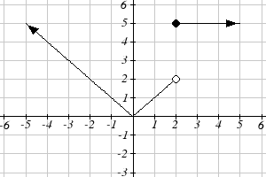 33. 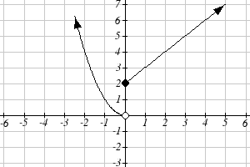

35. 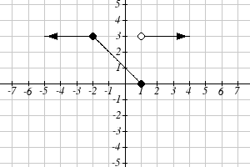

### Section 1.3

1. a) 6 million dollars per year b) 2 million dollars per year

3.  5. 6 7. 27

9.  11. 4*b*+4 13. 3

15.  17.  19. 

21. Increasing: . Decreasing: 

23. Increasing: . Decreasing:   
25. Increasing, concave up 27. Decreasing, concave down

29. Decreasing, concave up 31. Increasing, concave down

33. Concave up . Concave down . Inflection point at (1, 2)

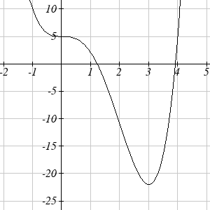35. Concave down 

37. Local minimum at (3, -22).   
Inflection points at (0,5) and (2, -11).  
Increasing on . Decreasing   
Concave up . Concave down 

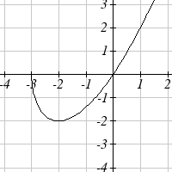

39. Local minimum at (-2, -2)  
Decreasing   
Increasing   
Concave up 

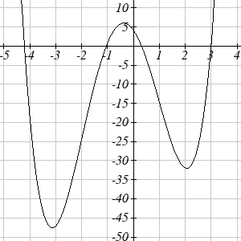

41. Local minimums at (-3.152, -47.626)   
 and (2.041, -32.041)  
Local maximum at (-0.389, 5.979)  
Inflection points at (-2, -24) and (1, -15)  
Increasing   
Decreasing   
Concave up   
Concave down 

### Section 1.4

1. . 

3. . 

5. 4 7. 9 9. 4 11. 7 13. 0 15. 4 17. 3 19. 2

21.  

23.  

25.  

27. 

29. b 31a.  b. 4.609in

33.  35.  37. 

39.  41. 

43. , or 

45a. 

b. or 

47a.  b. 

c. 

### Section 1.5

1. Horizontal shift right 49 units 3. Horizontal shift left 3 units

5. Vertical shift up 5 units 7. Vertical shift down 2 units

9. Horizontal shift right 2 units, Vertical shift up 3 units

11.  13. 

15. 

17. 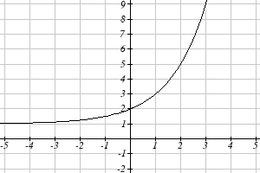 19. 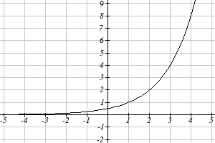

21. 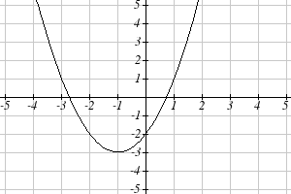 23. 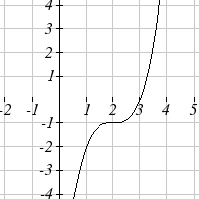

25.  27.  29. 

31. 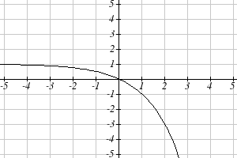

33a.  b. 

35.  37. 

39a. Even b. Neither c. Odd

41. Reflect *f(x)* about the *x*-axis

43. Vertically stretch *y* values by 4

45. Horizontally compress *x* values by 1/5

47. Horizontally stretch *x* values by 3

49. Reflect *f(x)* about the *y*-axis and vertically stretch *y* values by 3

51. 

53. 

55. 

57. Horizontal shift left 1 unit, vertical stretch y values by 4, vertical shift down 5 units 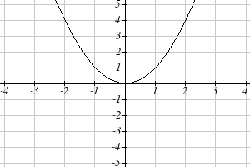 becomes 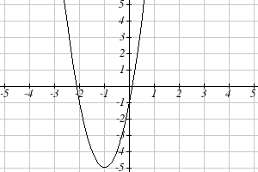

59. Horizontal shift right 4 units, vertical stretch y values by 2, reflect over x axis, vertically shift up 3 units.

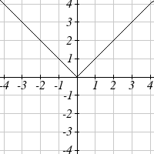 becomes 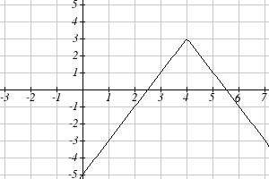

61. Vertically compress y values by ½

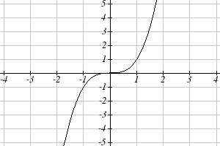 becomes 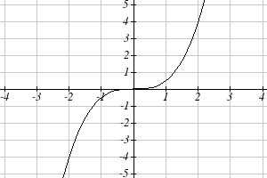

63. Horizontally stretch x values by 3, vertical shift down 3 units

 becomes 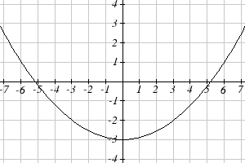

65. Reflected over the y axis, horizontally shift right 4 units 

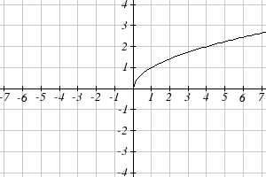 becomes 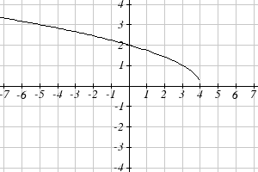

67. This function is increasing on  and decreasing on 

69. This function is decreasing on 

71. This function is concave down on and concave up on 

73. This function is concave up everywhere

75.  77.  79. 

81.  83.  85. 

87. 89.  91. 

93.  95.  97. 

99. 

101. 

103a.  d. 

### Section 1.6

1. 6 3. -4 5. ½

7a. 3 b. 2 c. 2 d. 3

9a. 0 b. 7 c. 1 d. 3

11.

|  |  |  |  |  |  |
| --- | --- | --- | --- | --- | --- |
|  | 1 | 4 | 7 | 12 | 16 |
| ) | 3 | 6 | 9 | 13 | 14 |

13.  15.  17. 

19. Restricted domain 

21. Restricted domain

23a.  b. 

c. This means that they are inverse functions (of each other)

## Chapter 2

### Section 2.1

1.  3.  5. 

7. Increasing 9. Decreasing 11. Decreasing

13. Increasing 15. Decreasing 17. 3

19.  21.  23. 

25. - mph (or 0.05 miles per hour toward her home)

27. Population is decreasing by 400 people per year

29. Monthly charge in dollars has an initial base charge of $24, and increases by $0.10 for each minute talked

31. Terry started at an elevation of 3,000 ft and is descending by 70ft per second.

33.  35.  37. 

39.  41.  43. 

45. 

47. The 1st ,3rd & 4th tables are linear: respectively

 3.  4. 

49a.  b.  c. 

### Section 2.2

1. E 3. D 5. B

7. 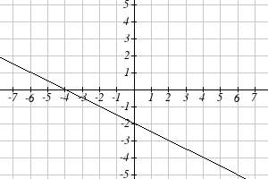 9. 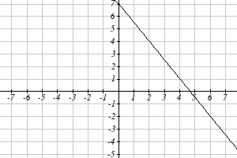

11. 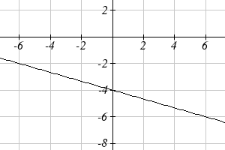 13. 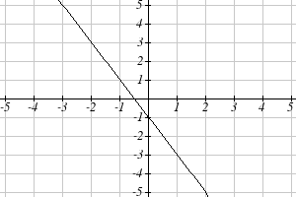

15. 17. 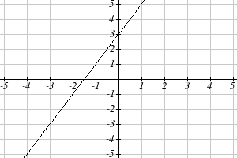

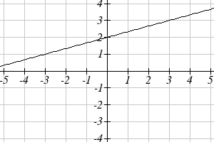

19. 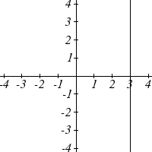 21.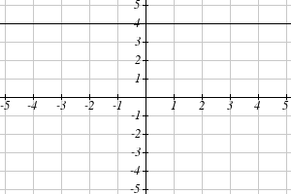

23. a.  b. ¾ c. -5/2

25. 

27. 

|  |  |  |
| --- | --- | --- |
|  | Vertical Intercept | Horizontal Intercept |
| 29. | (0,2) | (2,0) |
| 31. | (0,-5) | (5/3, 0) |
| 33. | (0,4) | (-10,0) |

35. Line 1:  Line 2:  Parallel

37. Line 1:  Line 2:  Neither

39. Line 1:  Line 2:  Perpendicular

41.  43.  45. (-1,1)

47. (1.2, 10) 49. Plan B saves money if the miles are 

51. 

### Section 2.3

1a. 696 people b. 4 years c. 174 people per year

d. 305 people e.  f. 2219 people.

3a. 

b. The flat monthly fee is $10 and there is an additional $0.15 fee for each additional minute used

c. $113.05

5a.  b. 6640 moose

7a.  b. 5.5 billion cubic feet c. During the year 2017

9. More than 133 minutes 11. More than  worth of jewelry

13. 20.012 square units 15. 6 square units

17. 

19a. Hawaii b. $80,640 c. During the year 1933

21. 26.225 miles

### Section 2.4

1.

3.  5.

7.  9. D 11. A

13. Yes, trend appears linear because *r* =0.994 and will exceed 35% near the end of the year 2019.

### Section 2.5

1. 3. 

5. 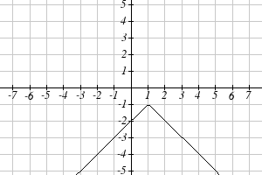 7. 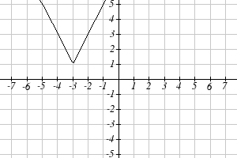 9. 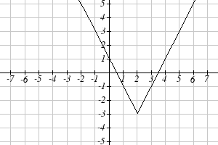

11.  13. 

15. 

|  |  |  |
| --- | --- | --- |
|  | Horizontal Intercepts | Vertical Intercept |
| 17. | (-6, 0 ) and (4, 0) | (0, -8) |
| 19. | none | (0, -7) |

21.  or 

23.  or 

25.  or 

## Chapter 3

### Section 3.1

1. As  As 

3. As  As 

5. As  As 

7. As  As 

9. 7th Degree, Leading coefficient 4

11. 2nd Degree, Leading coefficient -1

13. 4th Degree, Leading coefficient -2

15. 3rd Degree, Leading coefficient 6

17. As  As 

19. As  As 

21. intercepts: 5, turning points: 4 23. 3

25. 5 27. 3 29. 5

31. Horizontal Intercepts (1,0), (-2, 0), (3, 0) Vertical Intercept (0, 12)

33. Horizontal Intercepts (1/3, 0) (-1/2, 0) Vertical Intercept (0, 2)

### Section 3.2

1.  3.  5. 

|  |  |  |  |
| --- | --- | --- | --- |
|  | Vertex | Vertical Intercept | Horizontal Intercepts |
| 7. |  | (0,12) | (-2, 0) (-3, 0) |
| 9. |  | (0,4) | (0.438, 0) (4.562,0) |
| 11. |  | (0,-1) | (0.191, 0) (1.309, 0) |

13.  15.  17. *b* = 32 and *c* = -39

19.  21. 

23.  25. 

27a. 234m b. 2909.561 ft c. 47.735 seconds

29a. 3 ft b. 111 ft c. 72.497 ft

31. 24.91 in by 24.91 in

33.  by 

35. 24.6344 cm

37. $10.70

### Section 3.3

|  |  |  |
| --- | --- | --- |
| *C(t)* | *C*, intercepts | *t*, intercepts |
| 1. | (0,48) | (4,0), (-1,0), (6,0) |
| 3. | (0,0) | (0,0), (2,0), (-1,0) |
| 5. | (0,0) | (0,0), (1,0), (3,0) |

7. (-1.646, 0) (3.646, 0) (5,0)

9. As 

11. As 

13. 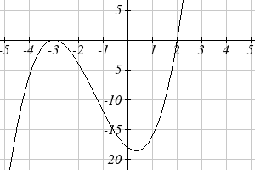 15. 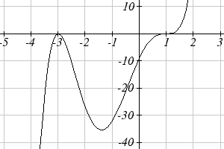

17. 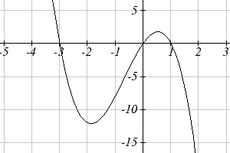

19.  21.

23.  25. 

27.  29. 

31.  33. 

35.  37. 

39.  41. 

43.  45. 

47.  49. 

51. Base 2.58, Height 3.336

### Section 3.4

1. 

3. 

5. 

7. 

9. 

11. 

13. 

15. 

17. 

19. 

21. 

23. 

25. 

27. 

### Section 3.5

1. All of the real zeros lie in the interval 

- Possible rational zeros are , , 

3. All of the real zeros lie in the interval 

- Possible rational zeros are , , , , , 

5. All of the real zeros lie in the interval 

- Possible rational zeros are , 

7. All of the real zeros lie in the interval 

- Possible rational zeros are , , , , , , , 

9. All of the real zeros lie in the interval 

- Possible rational zeros are , , , , , , , 

11. , ,  (each has mult. 1)

13.  (mult. 2),  (mult. 1),  (mult. 1)

15.  (mult. 1)

17. ,  (each has mult. 1)

19. ,  (each has mult. 1)

21. ,  (each has mult. 1)

23.  (each has mult. 1)

25.  (each has mult. 1)

27. ,  (each has mult. 1)

29. ,  (each has mult. 1)

31.  (mult. 3),  (mult. 2)

### Section 3.6

1.  3. 

5.  7. 

9.  11. 

13.  15. 

17.  19. 

21.  23. 

25. . Zeros: 

27. . Zeros: 

29. 

Zeros: 

31. . Zeros: 

33. 

Zeros: 

35. 

Zeros: 

37. 

Zeros: 

39. 

Zeros: 

41. 

Zeros: 

### Section 3.7

1. D 3. A

|  |  |  |  |  |
| --- | --- | --- | --- | --- |
|  | Vertical Asymptotes | Horizontal Asymptote | Vertical *y*-Intercept | Horizontal *x*-intercept |
| 5. |  |  | (0,-3/4) | (3/2, 0) |
| 7. |  |  | (0,1) | DNE |
| 9. |  |  | (0, 5/16) | (-1/3, 0), (5,0) |
| 11. | , hole at |  | (0,3) | (-3, 0) |
| 13. |  | none  y=2x (oblique) | (0, ¼) | (-1, 0), (1/2, 0) |
| 15. |  |  | DNE | (-2, 0), (2/3, 0) |
| 17. |  |  | (0, -15/16) | (1, 0), (-3, 0), (5, 0) |

5. 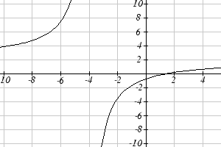 7. 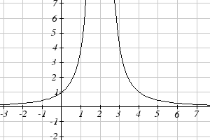

9. 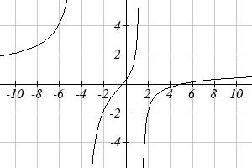 11. 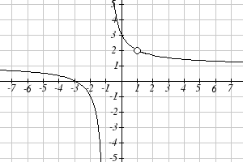

13. 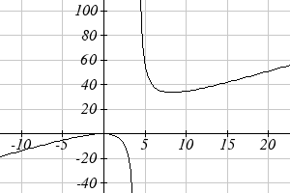 15. 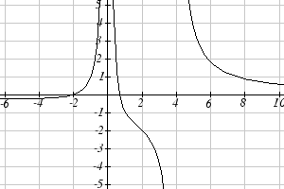

17. 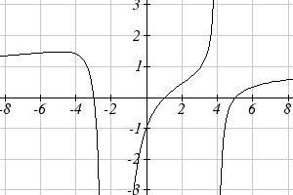

19.  21. 

23.  25. 

27.  29. 

31.  33. 

35.  37. 

39.  41. 

43. 

45. a.  b.  c. 80 mL d. as 

### Section 3.8

1. Domain  Inverse 

3. Domain  Inverse 

5. Domain  Inverse 

7.  9.  11. 13.  15.  17. 65.574 mph

19. 34.073 mph 21. 14.142 feet

## Chapter 4

### Section 4.1

1. Linear 3. Exponential 5. Neither

7.  9. 47622 Fox

11. $17561.70 13.  15. 

17.  19.  =  21. 

23. 25. 1.39%;  27. 

29. Annual  Quarterly  Monthly 

Continuously 

31.  33. 7.4 years

35a.  b.  c. Below what the model predicts 

### Section 4.2

1. B 3. A 5. E 7. D 9. C

11. 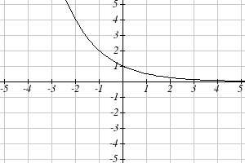 13. 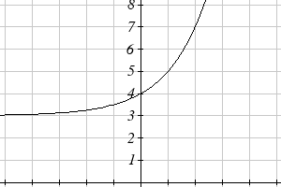 15. 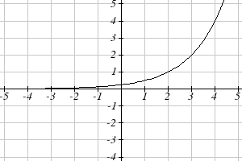

17.  19.  21. 

23. As . As 

25. As  As 

27. As  As 

29.  31. 

33.  35. 

### Section 4.3

1.  3.  5.

7. 9.  11. 

13.  15.  17. 9

19. 1/8 21. 1000 23. 

25. 2 27. -3 29. ½

31. 4 33. -3 35. -2

37. -1.398 39. 2.708 41. 

43.  45.  47. 

49.  51.  53. 

55.  57.  59. 

61.  63.  65. During the year 2013

67. During the year 2074 69.  71. 13.532 years

### Section 4.4

1.  3.  5.  7.  9. 

11.  13.  15. 

17.  19. 

21.  23. 

25. 

27.  29.  31. 

33.  35.  37. 

39.  41. . 43. or 

45.  47. 

### Section 4.5

1. Domain:  V. A. @ 

3. Domain:  V.A. @ 

5. Domain:  V.A. @ 

7. Domain:  V.A. @ 

9. 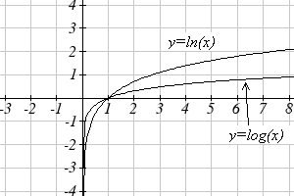 11. 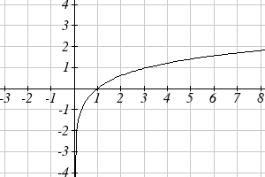

13. 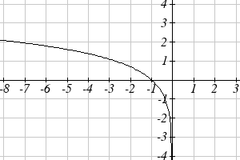 15. 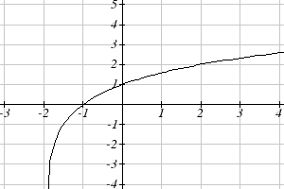

17. 19. 

21.  23. 

### Section 4.6

1. . 2 mg will remain after 22.3098 minutes

3. .  mg

5. *r* = -0.06448. Initial mass: 9.9018 mg. After 3 days: 0.01648 mg

7. . Half-life = 75.8653 minutes

9. . 60% (0.60*a*) would remain after 4222.813 years

11.  (*t* in minutes). After 2 hours = 24000.   
 After 100 minutes = 15119

13. a) 610.5143 (about 611) b) 25.6427 minutes c) 10431.21 d) 106.9642 minutes

15. 23.1914 years

17. 53.319 hours

19. . a) 134.212 deg b) 112.743 minutes

21. a) 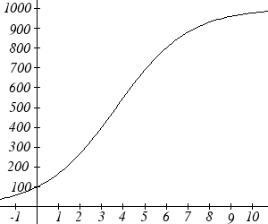 b) 100 c) 269.487 d) 7.324 years

23. . *x* = 0.3162 25. . *x* = 31.623

27.

10-6

10-5

10-4

10-3

10-2

10-7

10-8

10-9

10-10

10-1

Whisper

Vacuum

Jet

100

101

102

29. 63095.7 times more intense 31. MMS magnitude 5.817

33. a) about 1640671 b) 1.4 hours c) No, because 

d) Anja’s data predicts a continuous growth rate of 0.4116, which is much smaller than the rate 0.495105 you calculated. Our model would overestimate the number of cells.

35. a) The curve that increases rapidly at first is *M(p)*

b) *H*(100) = 0.9775

c) Myoglobin: *M*(20) = 0.9524. Hemoglobin: *H*(20) = 0.3242

d) At 20 torrs: 0.6282. At 40 torrs: 0.2060. At 60 torrs: 0.0714

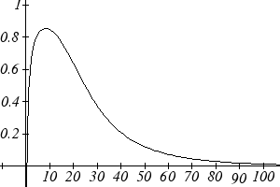 Efficiency seems to be maximized at about 8 torr

37. a) , or 

b) Volume of one cell:  cm3, so will need about  cells for a volume of 1cm3.  after 417.3 hours

39. 31.699 days

### Section 4.7

1. 3. 

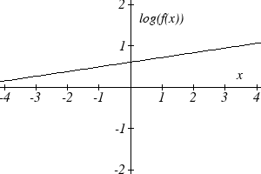 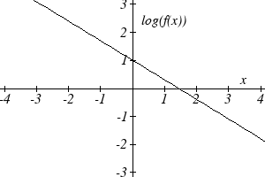 .

5. 

7. 

9.  11. 

13. Expenditures are approximately 

15. , . Using the better function, we predict electricity will be 11.157 cents per kwh

## Chapter 5

### Section 5.1

1. 10 3. 

5.  7. 

9. 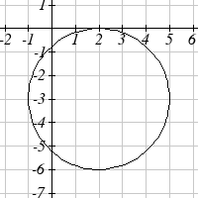

11.  and  13. (1.3416407865, 7.683281573)

15. (-1.07335, 2.8533) 17. 29.87 miles

### Section 5.2

1.

30°

70°

-135°

300°

3. π 5. 150° 7. 325°

9. 54° 11.  13. 

15. 35 miles 17. 8π cm 19. 5.7596 miles

21. 28.6479° 23. 14.1372 cm2

25. 3960 rad/min 630.254 RPM

27. 2.094 in/sec, π/12 rad/sec, 2.5 RPM

29. 75,398.22 mm/min = 1.257 m/sec

31. Angular speed: π/12 rad/hr. Linear speed: 1036.73 miles/hr

### Section 5.3

1. a. III b. II 3. 

5.  7. 

9. a. reference: 45°. Quadrant III. . 

b. reference: 60°. Quadrant IV. . 

c. reference: 45°. Quadrant II. . 

d. reference: 30°. Quadrant III. . 

11. a. reference: . Quadrant III. . 

b. reference: . Quadrant III. . 

c. reference: . Quadrant IV. . 

d. reference: . Quadrant II. . 

13. a.  

b.  

c.  

d.  

15. a.  b. 100° c. 40° d.  e. 235°

17. a.  b. 280° c. 220° d.  e. 55°

19. (-11.491, -9.642)

### Section 5.4

1. , , , 

3. , , , 

5. , , , 

7. a.  b.  c. . d. 

9. , , , , 

11. , , , , 

13. , , ,  , 

15. a. sin(0.15) = 0.1494 cos(0.15) = 0.9888 tan(0.15) = 0.1511   
b. sin(4) = -0.7568 cos(4) = -0.6536 tan(4) = 1.1578  
c. sin(70°) = 0.9397 cos(70°) = 0.3420 tan(70°) = 2.7475  
d. sin(283°) = -0.9744 cos(283°) = 0.2250 tan(283°) = -4.3315

17.  19.  21.  23.  25. 

### Section 5.5

1.   
 

3.  5. 

7.  9. 32.4987 ft

11. 836.2698 ft 13. 460.4069 ft

15. 660.35 feet 17. 28.025 ft

19. 143.0427 21. 86.6685

## Chapter 6

### Section 6.1

1. 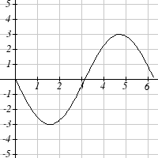 3. 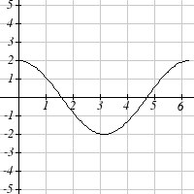

5. Amp: 3. Period= 2. Midline: *y*= -4. 

7. Amp: 2. Period= 4π. Midline: *y*= 1. 

9. Amp: 2. Period= 5. Midline: *y*= 3. 

11. Amp: 3, Period = , Shift: 4 left, Midline: *y* = 5

13. Amp: 2, Period = , Shift: 7 right, Midline: *y* = 4

15. Amp: 1, Period = 12, Shift: 6 left, Midline: *y* = -3

17. 

19. 

21. 

23 a. Amp: 12.5. Midline: *y* = 13.5. Period: 10  
 b.   
 c.  meters

### Section 6.2

1. II

3. I

5. Period: . Horizontal shift: 8 right

7. Period: 8. Horizontal shift: 1 left

9. Period: 6. Horizontal shift: 3 left

11. 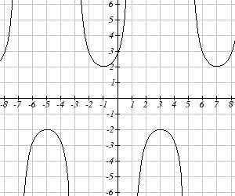 13. 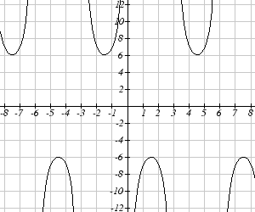

15. 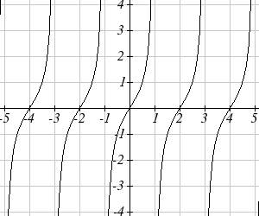

17.  19. 

21.  23. 

25.  27. 

### Section 6.3

1.  3.  5. 

7.  9.  11. 

13. 1.9823 15. -0.9273 17. 44.427°

19.  21.  23.  25. 

27.  29. 

### Section 6.4

1.  3.  5.  7. 

9. , where *k* is an integer

11. , where *k* is an integer

13. , where *k* is an integer

15. , where *k* is an integer

17. , where *k* is an integer

19. , where *k* is an integer

21. , where *k* is an integer

23. , where *k* is an integer

25. 0.2734, 2.8682 27. 3.7603, 5.6645 29. 2.1532, 4.1300

31. 0.7813, 5.5019 33. 0.04829, 0.47531 35. 0.7381, 1.3563

37. 0.9291, 3.0709 39. 1.3077, 4.6923

### Section 6.5

1. , *A* = 57.9946°, *B* = 32.0054°

3. , *A* = 27.8181°, *B* = 62.1819°

5. 

7. 

9. a.  b. 

11. 75 degrees 13. 8

15. 2.80869431742 17. 5.035 months

## Chapter 7

### Section 7.1

1.  3. 

5. , and , where *k* is an integer

7.  and , where *k* is an integer

9.  and , where *k* is an integer

11.  and , where *k* is an integer

13.  15. 0.056, 1.515, 3.197, 4.647

17.  19. 

21. 1.183, 1.958, 4.325, 5.100 23. 

25.  27. 1.823, 4.460

29. 2.301, 3.983, 0.723, 5.560 31. 3.305, 6.120

33.  35. 

37.  39. 

41. 

### Section 7.2

1.  3. 

5.  7. 

9.  11. 

13.  15. 

17.  19. 

21.  23. 

25. a. 

b. 

27.  and , where *k* is an integer

29. , where *k* is an integer

31. , , , and , where *k* is an integer

33. , , and , where *k* is an integer

35.  or 

37. ) 39. 0.3681, 3.8544

41. 0.7854, 1.8158 43. 

### Section 7.3

1. a.  b.  c.  3. 

5.  7. 

9.  11. 

13. 0.7297, 2.4119, 3.8713, 5.5535

15. 

17. a. 

19. 

21. 

23. 

25. a.  b.  c. 

### Section 7.4

1. 

3. Amplitude: 8, Period:  second, Frequency: 3 Hz (cycles per second)

5.  7. 

9.  11. 

13. a. IV b. III 15. 

17.  19. 

## Chapter 8

### Section 8.1

1. 3.

70°

50°

10

60°

12.267

11.305

120°

6

25°

35°

4.421

9.059

5. 7.

65°

5

6

49.048°

65.952°

6.046

18

40°

25

116.668°

23.222°

11.042

9. = 68°, *a* = 14.711, *c* = 20.138 11.  = 28.096°,  = 32.904°, *c* = 16.149

13. Not possible.

15.  = 64.243°,  = 72.657°, *c* = 257.328 OR =115.757°, = 21.143°, *c* = 97.238

17. 19.

60°

20

28

24.980

43.898°

76.102°

13

11

20

112.620°

30.510°

36.870°

21. 

23. 

25. 177.562 27. 978.515 ft

29. Distance to A: 565.258 ft. Distance to shore: 531.169 ft

31. 529.014 m 33. 173.877 feet

35. 4.642 km, 2.794 km 37. 757.963 ft

39. 2371.129 miles 41. 65.375 cm2

43. 7.72

### Section 8.2

1.  3. 

5.  7. 

9.  11. 

13.  15. 

17.  19. 

21.  23. 

25.  27. 

29.  31. 

33.  35. 

37. A 39. C 41. E 43. C 45. D 47. F

49. 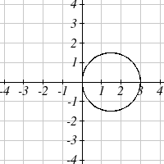 51. 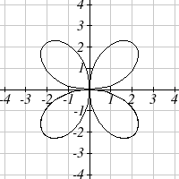 53. 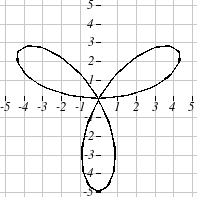

55. 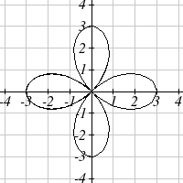 57. 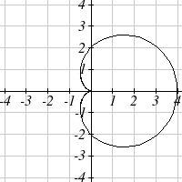 59. 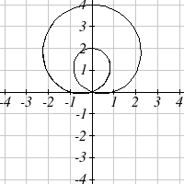

61. 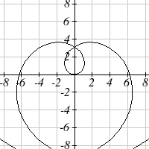 63. 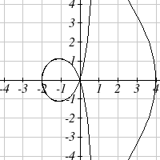 65. 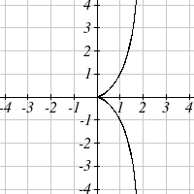

### Section 8.3

1.  3. 

5.  7. 

9.  11. 

13.  15. 

17.  19. 

21.  23. 

25.  27. 

29. 

31.  33. 

35.  37. 

39.  41. 

43.  45. 

47.  49. 

51.  53. 

55.  57. 

59.  61. 

63. 

65. 

67. 

### Section 8.4

1. 

3. 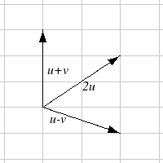 The vectors do not need to start at the same point

5.  7. 

9.  11. Magnitude: 4, Direction: 90°

13. Magnitude: 7.810, Direction: 39.806°

15. Magnitude: 2.236, Direction: 153.435°

17. Magnitude: 5.385, Direction: 291.801°

19. Magnitude: 7.211, Direction: 236.310°

21. 

23. 4.635 miles, 17.764 deg N of E

25. 17 miles. 10.318 miles

27. 

29. Distance: 2.868. Direction: 86.474° North of West, or 3.526° West of North

31. 4.924 degrees. 659 km/hr

33. 4.424 degrees

35. (0.081, 8.602)

37. 21.801 degrees, relative to the car’s forward direction

### Section 8.5

1.  3.  5. 

7.  9. 

11.  13. , *k* = -14

15.  17. 

19. The vectors are  and . The acute angle between the vectors is 34.509°

21. 14.142 pounds 23. , so 34.7296 ft-lbs

25. ft-lbs

### Section 8.6

1. C 3. E 5. F

7. 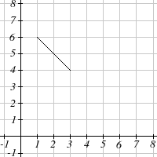

9. x(t) 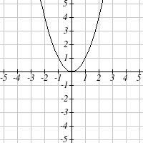 y(t)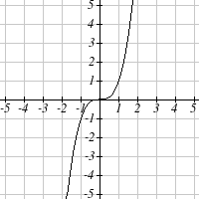

11. 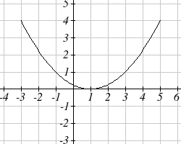

13.  15. 

17.  or  19. 

21.  23. 

25.  27. .

29.  31. 

33.  35. 

37.  39.   
41.  43. 

## Chapter 9

### Section 9.1

1. D 3. B

5. Vertices (0,±5), minor axis endpoints (±2,0), major length = 10, minor length = 4

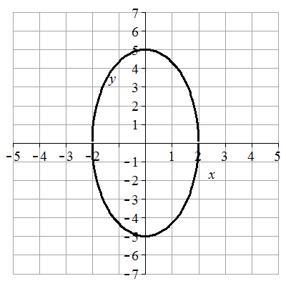

7. Vertices (±2,0), minor axis endpoints (0,±1), major length = 4, minor length = 2  
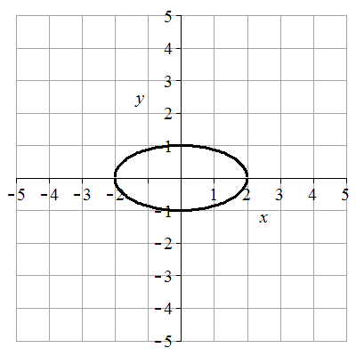

9. Vertices (±5,0), minor axis endpoints (0,±1), major length = 10, minor length = 2  
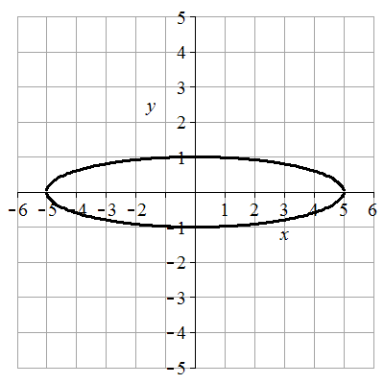

11. Vertices (0,±4), minor axis endpoints (±3,0), major length = 8, minor length = 6  
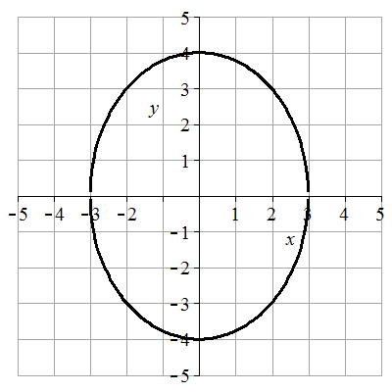

13. Vertices , minor axis endpoints, major length = , minor length =   
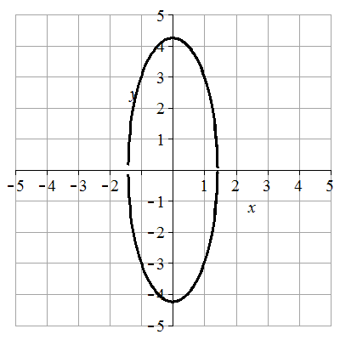

15.  17.  19. 

21. B 23. C 25. F 27. G

29. Center (1,-2), vertices (6,-2) and (-4,-2), minor axis endpoints (1,0) and (1,-4), major length= 10, minor length = 4

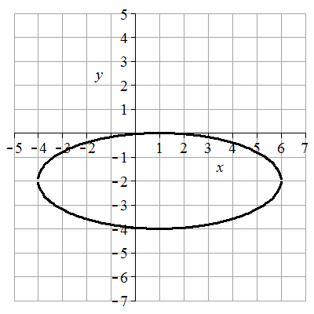

31. Center (-2,3), vertices (-2,8) and (-2,-2), minor axis endpoints (-1,3) and (-3,3), major length = 10, minor length = 2

Image of graph for answer: vertical ellipse

33. Center (-1,0), vertices (-1,4) and (-1,-4), minor axis endpoints (-1,0) and (3,0), major length = 8, minor length = 4

Image of graph for answer: vertical ellipse

35. Center (-1,-2), vertices (3,-2) and (-5,-2), minor axis endpoints (-1,0) and (-1,-4), major length = 8, minor length = 4

Image of graph for answer: horizontal ellipse 

37. Center (2,-1), vertices (2,5) and (2,-7), minor axis endpoints (6,-1) and (-2,-1), major length = 12, minor length = 8

Image of graph for answer: vertical ellipse

39.  41. 

43. 2.211083 feet 45. 17 feet 47. 64 feet 49. (±4,0) 51. (-6,6) and (-6,-4)

53.  55.  57.  59. 

61.  63.  65. 

67.  69.  71. 

73. 31.22 feet 75.  77. 

79. The center is at (0,0). Since *a* > *b*, the ellipse is horizontal. Let (c,0) be the focus on the positive x-axis. Let (c, h) be the endpoint in Quadrant 1 of the latus rectum passing through (c,0).

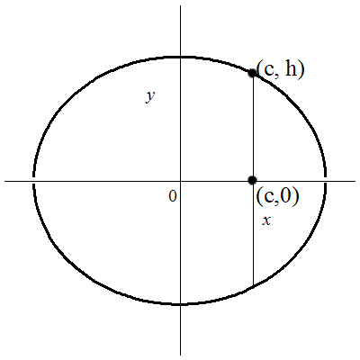

The distance between the focus and latus rectum endpoint can be found by substituting (c,0) and (c,h) into the distance formula  which yields . So *h* is half the latus rectum distance. Substituting (c,h) into the ellipse equation to find *h* gives . Solve for *h* yields . so . The distance of the latus rectum is .

### Section 9.2

1. B 3. D

5. Vertices (±2,0), transverse length = 4, asymptotes y = ±5/2x,  
 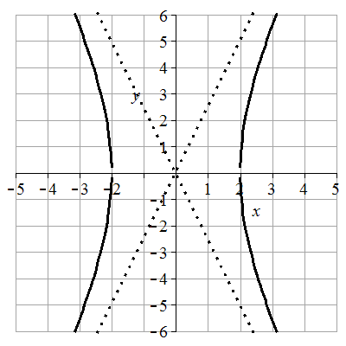

7. Vertices (0, ±1), transverse length = 2, asymptotes y = ±1/2x,   
Image of graph for answer: vertical hyperbola

9. Vertices (±3,0), transverse length = 6, asymptotes y =±1/3x,

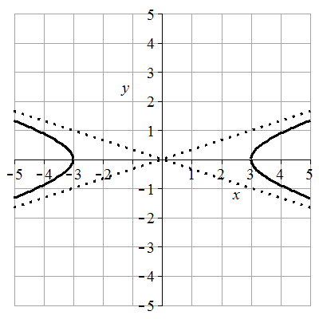

11. Vertices (0, ±4), transverse length = 8, asymptotes y =±4/3x

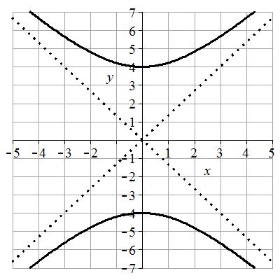

13. Vertices (±,0), transverse length = 2, asymptotes y =±3x,

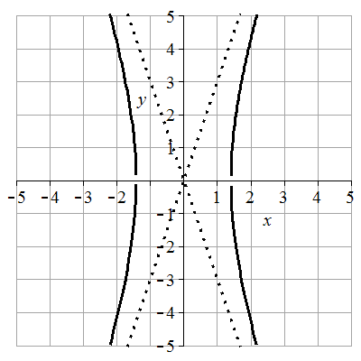

15.  17.  19.  21. 

23. C 25. H 27. B 29. A

31. Center (1,-2), vertices (6,-2) and (-4,-2), transverse length = 10, asymptotes y =±2/5(x-1)-2

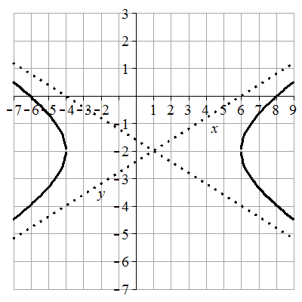

33. Center (-2,1), vertices (-2,4) and (-2,-2), transverse length = 6, asymptotes y =±3(x+2)+1

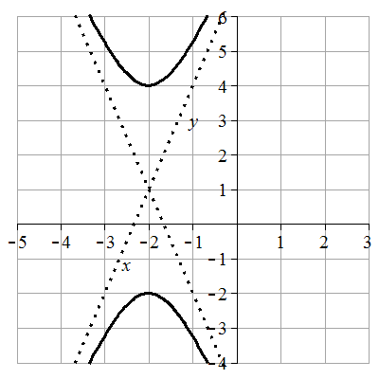

35. Center (1,0), vertices (3,0) and (-1,0), transverse length = 4, asymptotes y =±2(x-1)

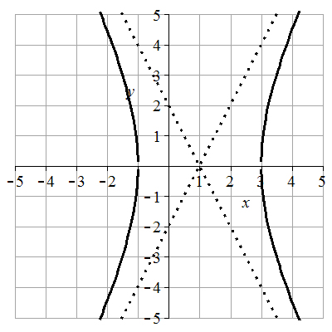

37. Center (-1,2), vertices (-1,4) and (-1,0), transverse length = 4, asymptotes y =±1/2(x+1)+2

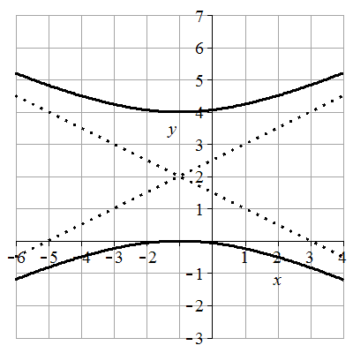

39. Center (-2,1), vertices (0,1) and (-4,1), transverse length = 4, asymptotes y =±3/2(x+2)+1

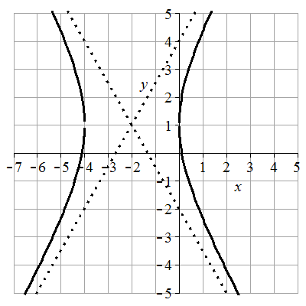

41.  43. 

45. Center (0,0), vertices (±1/3,0), transverse length = 2/3, asymptotes y = ±12x

Image of graph for answer: horizontal hyperbola

47. Center (-1,1), vertices (-1,3/2) and (-1,1/2), transverse length = 1, asymptotes y = ± 3/2 (x + 1) +1

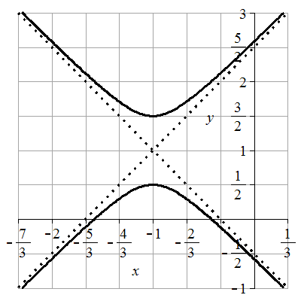

49. Foci (0,±5) 51. Foci (5,6) and (-3,6) 53. Foci (-4,6) and (-4,-4)

55.  57.  59.  61. 

63.  65.  67. 

69. 

71. 

73.  can be put in the form .  can be put in the form  showing they are conjugate.

75.  77. No matter the value of k, the foci are at 

### Section 9.3

1. C 3. A

5. Vertex: (0,0). Axis of symmetry: *y* = 0. Directrix: *x* = -4. Focus: (4,0)

7. Vertex: (0,0). Axis of symmetry: *x* = 0. Directrix: *y* = -1/8. Focus: (0,1/8)

9. Vertex: (0,0). Axis of symmetry: *y* = 0. Directrix: *x* = 1/16. Focus: (-1/16,0)

11. Vertex: (2,-1). Axis of symmetry: *x* = 2. Directrix: *y* = -3. Focus: (2,1)

13. Vertex: (-1,4). Axis of symmetry: *x* = -1. Directrix: *y* = 3. Focus: (-1,5)

15.  17.  19. 

21. At the focus, (0,1) 23. 2.25 feet above the vertex. 25. 0.25 ft

27.  29. 

31. 

33. 

35. (-64.50476622, 93.37848007) ≈ (-64.50, 93.38)

### Section 9.4

1. *e* = 3. Directrix: *x* = 4. Hyperbola. 3. *e* = 3/4. Directrix: *y* = -2/3. Ellipse.

5. *e* = 1. Directrix: *x* = -1/5. Parabola. 7. *e* = 2/7. Directrix: *x* = 2. Ellipse.

9.  11. , or 

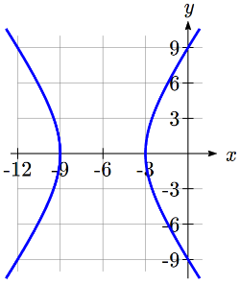13. 

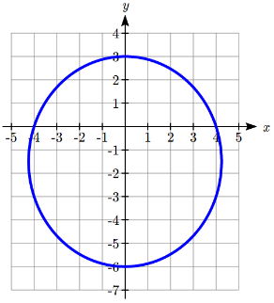15. Hyperbola. Vertices at (-9,0) and (-3,0)  
Center at (-6,0). *a* = 3. *c* = 6, so *b* =   


17. Ellipse. Vertices at (0,3) and (0,-6)  
Center at (0,-1.5). *a* = 4.5, *c* = 1.5,   


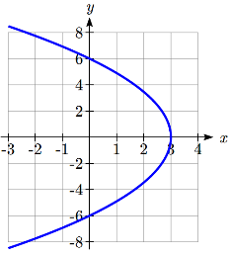

19. Parabola. Vertex at (3,0). *p* = 3.  


21. a)

*x*

*y*

*d(Q,F1)*

*d(Q,F2)*

*Q=(x,y)*

*F1*

*F2*

*L1*

*L­2*

(*c*,0)

(*a*,0)

*x* = *p*

b) , 

c) . 

d) , a constant.

e) At *Q* = (*a*, 0), , and , so  
  
Combining with the result above, , so .

f) , and    
, so .   
. Using the result from (e),  
  
  
