# Solutions to Selected Exercises

## Chapter 5

### Section 5.1

1. 10 3. 

5.  7. 

9. 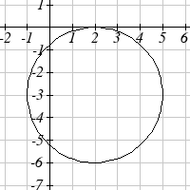

11.  and  13. (1.3416407865, 7.683281573)

15. (-1.07335, 2.8533) 17. 29.87 miles

### Section 5.2

1.

30°

70°

-135°

300°

3. π 5. 150° 7. 325°

9. 54° 11.  13. 

15. 35 miles 17. 8π cm 19. 5.7596 miles

21. 28.6479° 23. 14.1372 cm2

25. 3960 rad/min 630.254 RPM

27. 2.094 in/sec, π/12 rad/sec, 2.5 RPM

29. 75,398.22 mm/min = 1.257 m/sec

31. Angular speed: π/12 rad/hr. Linear speed: 1036.73 miles/hr

### Section 5.3

1. a. III b. II 3. 

5.  7. 

9. a. reference: 45°. Quadrant III. . 

b. reference: 60°. Quadrant IV. . 

c. reference: 45°. Quadrant II. . 

d. reference: 30°. Quadrant III. . 

11. a. reference: . Quadrant III. . 

b. reference: . Quadrant III. . 

c. reference: . Quadrant IV. . 

d. reference: . Quadrant II. . 

13. a.  

b.  

c.  

d.  

15. a.  b. 100° c. 40° d.  e. 235°

17. a.  b. 280° c. 220° d.  e. 55°

19. (-11.491, -9.642)

### Section 5.4

1. , , , 

3. , , , 

5. , , , 

7. a.  b.  c. . d. 

9. , , , , 

11. , , , , 

13. , , ,  , 

15. a. sin(0.15) = 0.1494 cos(0.15) = 0.9888 tan(0.15) = 0.1511   
b. sin(4) = -0.7568 cos(4) = -0.6536 tan(4) = 1.1578  
c. sin(70°) = 0.9397 cos(70°) = 0.3420 tan(70°) = 2.7475  
d. sin(283°) = -0.9744 cos(283°) = 0.2250 tan(283°) = -4.3315

17.  19.  21.  23.  25. 

### Section 5.5

1.   
 

3.  5. 

7.  9. 32.4987 ft

11. 836.2698 ft 13. 460.4069 ft

15. 660.35 feet 17. 28.025 ft

19. 143.0427 21. 86.6685

## Chapter 6

### Section 6.1

1. 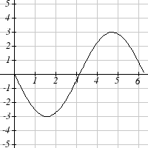 3. 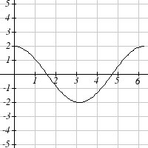

5. Amp: 3. Period= 2. Midline: *y*= -4. 

7. Amp: 2. Period= 4π. Midline: *y*= 1. 

9. Amp: 2. Period= 5. Midline: *y*= 3. 

11. Amp: 3, Period = , Shift: 4 left, Midline: *y* = 5

13. Amp: 2, Period = , Shift: 7 right, Midline: *y* = 4

15. Amp: 1, Period = 12, Shift: 6 left, Midline: *y* = -3

17. 

19. 

21. 

23 a. Amp: 12.5. Midline: *y* = 13.5. Period: 10  
 b.   
 c.  meters

### Section 6.2

1. II

3. I

5. Period: . Horizontal shift: 8 right

7. Period: 8. Horizontal shift: 1 left

9. Period: 6. Horizontal shift: 3 left

11. 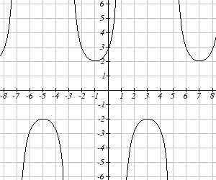 13. 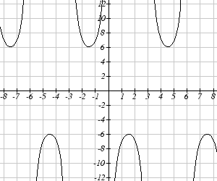

15. 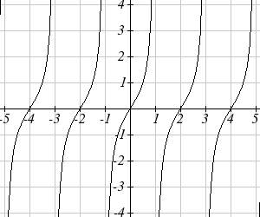

17.  19. 

21.  23. 

25.  27. 

### Section 6.3

1.  3.  5. 

7.  9.  11. 

13. 1.9823 15. -0.9273 17. 44.427°

19.  21.  23.  25. 

27.  29. 

### Section 6.4

1.  3.  5.  7. 

9. , where *k* is an integer

11. , where *k* is an integer

13. , where *k* is an integer

15. , where *k* is an integer

17. , where *k* is an integer

19. , where *k* is an integer

21. , where *k* is an integer

23. , where *k* is an integer

25. 0.2734, 2.8682 27. 3.7603, 5.6645 29. 2.1532, 4.1300

31. 0.7813, 5.5019 33. 0.04829, 0.47531 35. 0.7381, 1.3563

37. 0.9291, 3.0709 39. 1.3077, 4.6923

### Section 6.5

1. , *A* = 57.9946°, *B* = 32.0054°

3. , *A* = 27.8181°, *B* = 62.1819°

5. 

7. 

9. a.  b. 

11. 75 degrees 13. 8

15. 2.80869431742 17. 5.035 months

## Chapter 7

### Section 7.1

1.  3. 

5. , and , where *k* is an integer

7.  and , where *k* is an integer

9.  and , where *k* is an integer

11.  and , where *k* is an integer

13.  15. 0.056, 1.515, 3.197, 4.647

17.  19. 

21. 1.183, 1.958, 4.325, 5.100 23. 

25.  27. 1.823, 4.460

29. 2.301, 3.983, 0.723, 5.560 31. 3.305, 6.120

33.  35. 

37.  39. 

41. 

### Section 7.2

1.  3. 

5.  7. 

9.  11. 

13.  15. 

17.  19. 

21.  23. 

25. a. 

b. 

27.  and , where *k* is an integer

29. , where *k* is an integer

31. , , , and , where *k* is an integer

33. , , and , where *k* is an integer

35.  or 

37. ) 39. 0.3681, 3.8544

41. 0.7854, 1.8158 43. 

### Section 7.3

1. a.  b.  c.  3. 

5.  7. 

9.  11. 

13. 0.7297, 2.4119, 3.8713, 5.5535

15. 

17. a. 

19. 

21. 

23. 

25. a.  b.  c. 

### Section 7.4

1. 

3. Amplitude: 8, Period:  second, Frequency: 3 Hz (cycles per second)

5.  7. 

9.  11. 

13. a. IV b. III 15. 

17.  19. 

## Chapter 8

### Section 8.1

1. 3.

70°

50°

10

60°

12.267

11.305

120°

6

25°

35°

4.421

9.059

5. 7.

65°

5

6

49.048°

65.952°

6.046

18

40°

25

116.668°

23.222°

11.042

9. = 68°, *a* = 14.711, *c* = 20.138 11.  = 28.096°,  = 32.904°, *c* = 16.149

13. Not possible.

15.  = 64.243°,  = 72.657°, *c* = 257.328 OR =115.757°, = 21.143°, *c* = 97.238

17. 19.

60°

20

28

24.980

43.898°

76.102°

13

11

20

112.620°

30.510°

36.870°

21. 

23. 

25. 177.562 27. 978.515 ft

29. Distance to A: 565.258 ft. Distance to shore: 531.169 ft

31. 529.014 m 33. 173.877 feet

35. 4.642 km, 2.794 km 37. 757.963 ft

39. 2371.129 miles 41. 65.375 cm2

43. 7.72

### Section 8.2

1.  3. 

5.  7. 

9.  11. 

13.  15. 

17.  19. 

21.  23. 

25.  27. 

29.  31. 

33.  35. 

37. A 39. C 41. E 43. C 45. D 47. F

49. 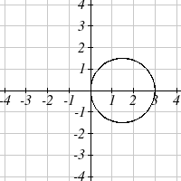 51. 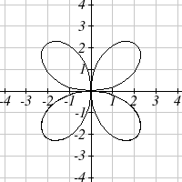 53. 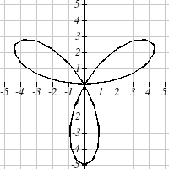

55. 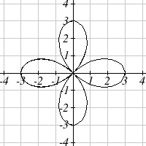 57. 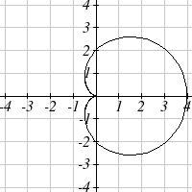 59. 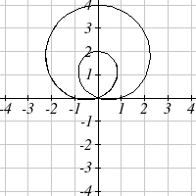

61. 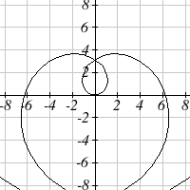 63. 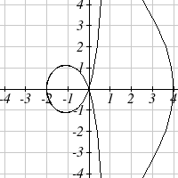 65. 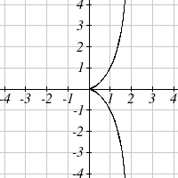

### Section 8.3

1.  3. 

5.  7. 

9.  11. 

13.  15. 

17.  19. 

21.  23. 

25.  27. 

29. 

31.  33. 

35.  37. 

39.  41. 

43.  45. 

47.  49. 

51.  53. 

55.  57. 

59.  61. 

63. 

65. 

67. 

### Section 8.4

1. 

3. 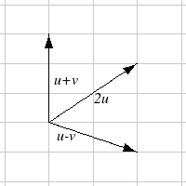 The vectors do not need to start at the same point

5.  7. 

9.  11. Magnitude: 4, Direction: 90°

13. Magnitude: 7.810, Direction: 39.806°

15. Magnitude: 2.236, Direction: 153.435°

17. Magnitude: 5.385, Direction: 291.801°

19. Magnitude: 7.211, Direction: 236.310°

21. 

23. 4.635 miles, 17.764 deg N of E

25. 17 miles. 10.318 miles

27. 

29. Distance: 2.868. Direction: 86.474° North of West, or 3.526° West of North

31. 4.924 degrees. 659 km/hr

33. 4.424 degrees

35. (0.081, 8.602)

37. 21.801 degrees, relative to the car’s forward direction

### Section 8.5

1.  3.  5. 

7.  9. 

11.  13. , *k* = -14

15.  17. 

19. The vectors are  and . The acute angle between the vectors is 34.509°

21. 14.142 pounds 23. , so 34.7296 ft-lbs

25. ft-lbs

### Section 8.6

1. C 3. E 5. F

7. 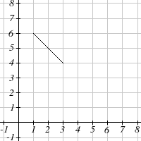

9. x(t) 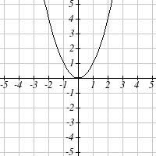 y(t)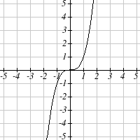

11. 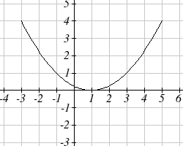

13.  15. 

17.  or  19. 

21.  23. 

25.  27. .

29.  31. 

33.  35. 

37.  39.   
41.  43. 

## Chapter 9

### Section 9.1

1. D 3. B

5. Vertices (0,±5), minor axis endpoints (±2,0), major length = 10, minor length = 4

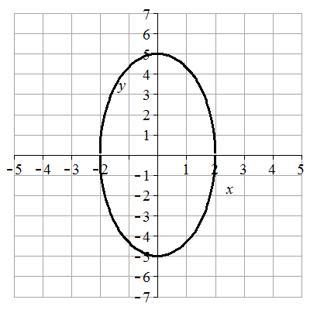

7. Vertices (±2,0), minor axis endpoints (0,±1), major length = 4, minor length = 2  
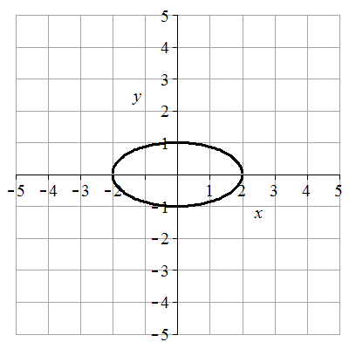

9. Vertices (±5,0), minor axis endpoints (0,±1), major length = 10, minor length = 2  
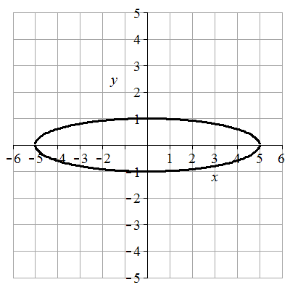

11. Vertices (0,±4), minor axis endpoints (±3,0), major length = 8, minor length = 6  
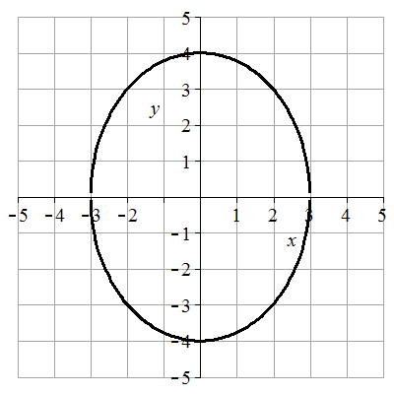

13. Vertices , minor axis endpoints, major length = , minor length =   
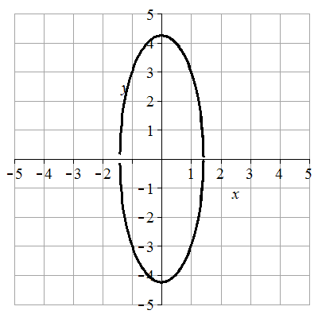

15.  17.  19. 

21. B 23. C 25. F 27. G

29. Center (1,-2), vertices (6,-2) and (-4,-2), minor axis endpoints (1,0) and (1,-4), major length= 10, minor length = 4

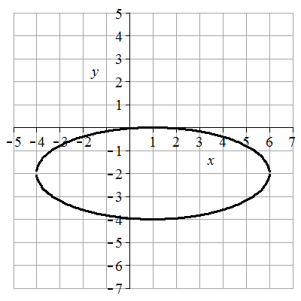

31. Center (-2,3), vertices (-2,8) and (-2,-2), minor axis endpoints (-1,3) and (-3,3), major length = 10, minor length = 2

Image of graph for answer: vertical ellipse

33. Center (-1,0), vertices (-1,4) and (-1,-4), minor axis endpoints (-1,0) and (3,0), major length = 8, minor length = 4

Image of graph for answer: vertical ellipse

35. Center (-1,-2), vertices (3,-2) and (-5,-2), minor axis endpoints (-1,0) and (-1,-4), major length = 8, minor length = 4

Image of graph for answer: horizontal ellipse 

37. Center (2,-1), vertices (2,5) and (2,-7), minor axis endpoints (6,-1) and (-2,-1), major length = 12, minor length = 8

Image of graph for answer: vertical ellipse

39.  41. 

43. 2.211083 feet 45. 17 feet 47. 64 feet 49. (±4,0) 51. (-6,6) and (-6,-4)

53.  55.  57.  59. 

61.  63.  65. 

67.  69.  71. 

73. 31.22 feet 75.  77. 

79. The center is at (0,0). Since *a* > *b*, the ellipse is horizontal. Let (c,0) be the focus on the positive x-axis. Let (c, h) be the endpoint in Quadrant 1 of the latus rectum passing through (c,0).

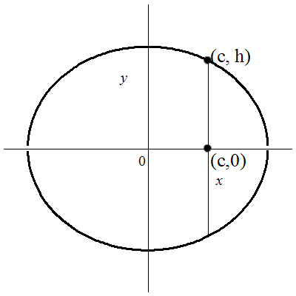

The distance between the focus and latus rectum endpoint can be found by substituting (c,0) and (c,h) into the distance formula  which yields . So *h* is half the latus rectum distance. Substituting (c,h) into the ellipse equation to find *h* gives . Solve for *h* yields . so . The distance of the latus rectum is .

### Section 9.2

1. B 3. D

5. Vertices (±2,0), transverse length = 4, asymptotes y = ±5/2x,  
 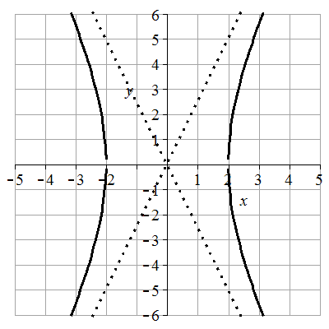

7. Vertices (0, ±1), transverse length = 2, asymptotes y = ±1/2x,   
Image of graph for answer: vertical hyperbola

9. Vertices (±3,0), transverse length = 6, asymptotes y =±1/3x,

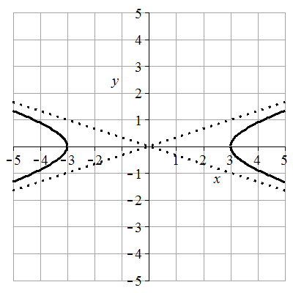

11. Vertices (0, ±4), transverse length = 8, asymptotes y =±4/3x

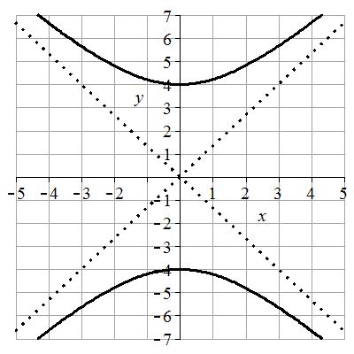

13. Vertices (±,0), transverse length = 2, asymptotes y =±3x,

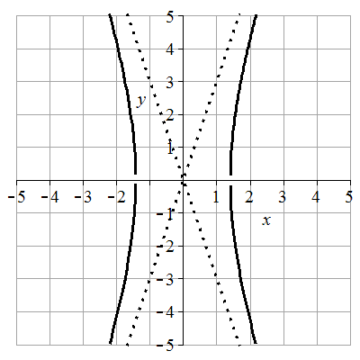

15.  17.  19.  21. 

23. C 25. H 27. B 29. A

31. Center (1,-2), vertices (6,-2) and (-4,-2), transverse length = 10, asymptotes y =±2/5(x-1)-2

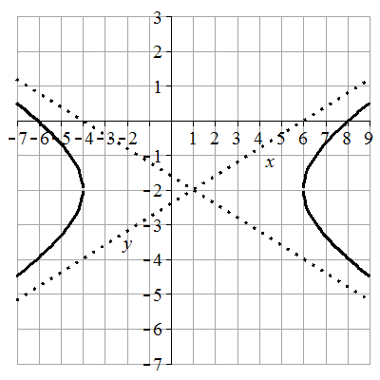

33. Center (-2,1), vertices (-2,4) and (-2,-2), transverse length = 6, asymptotes y =±3(x+2)+1

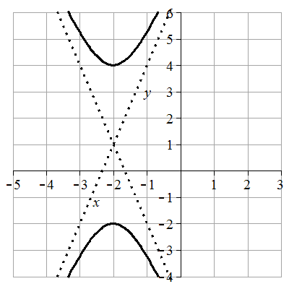

35. Center (1,0), vertices (3,0) and (-1,0), transverse length = 4, asymptotes y =±2(x-1)

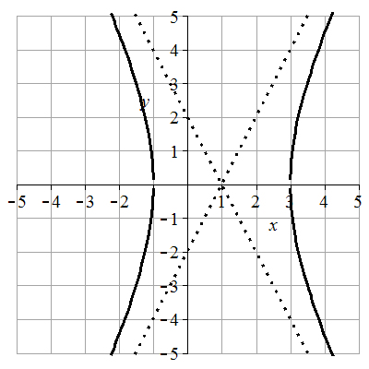

37. Center (-1,2), vertices (-1,4) and (-1,0), transverse length = 4, asymptotes y =±1/2(x+1)+2

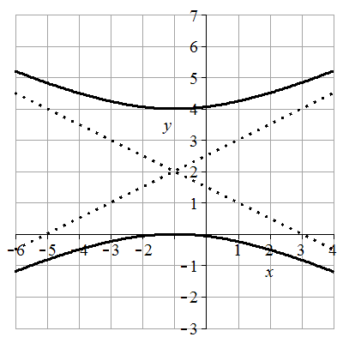

39. Center (-2,1), vertices (0,1) and (-4,1), transverse length = 4, asymptotes y =±3/2(x+2)+1

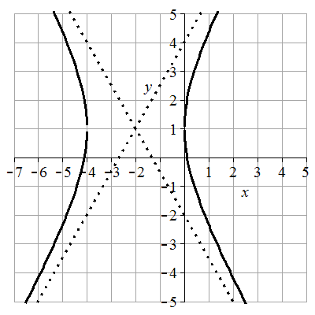

41.  43. 

45. Center (0,0), vertices (±1/3,0), transverse length = 2/3, asymptotes y = ±12x

Image of graph for answer: horizontal hyperbola

47. Center (-1,1), vertices (-1,3/2) and (-1,1/2), transverse length = 1, asymptotes y = ± 3/2 (x + 1) +1

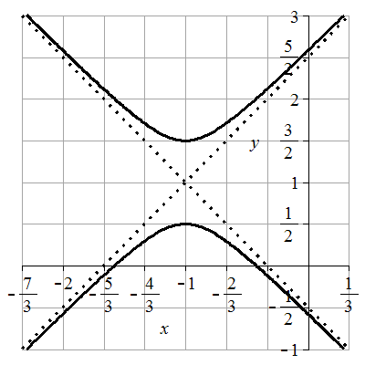

49. Foci (0,±5) 51. Foci (5,6) and (-3,6) 53. Foci (-4,6) and (-4,-4)

55.  57.  59.  61. 

63.  65.  67. 

69. 

71. 

73.  can be put in the form .  can be put in the form  showing they are conjugate.

75.  77. No matter the value of k, the foci are at 

### Section 9.3

1. C 3. A

5. Vertex: (0,0). Axis of symmetry: *y* = 0. Directrix: *x* = -4. Focus: (4,0)

7. Vertex: (0,0). Axis of symmetry: *x* = 0. Directrix: *y* = -1/8. Focus: (0,1/8)

9. Vertex: (0,0). Axis of symmetry: *y* = 0. Directrix: *x* = 1/16. Focus: (-1/16,0)

11. Vertex: (2,-1). Axis of symmetry: *x* = 2. Directrix: *y* = -3. Focus: (2,1)

13. Vertex: (-1,4). Axis of symmetry: *x* = -1. Directrix: *y* = 3. Focus: (-1,5)

15.  17.  19. 

21. At the focus, (0,1) 23. 2.25 feet above the vertex. 25. 0.25 ft

27.  29. 

31. 

33. 

35. (-64.50476622, 93.37848007) ≈ (-64.50, 93.38)

### Section 9.4

1. *e* = 3. Directrix: *x* = 4. Hyperbola. 3. *e* = 3/4. Directrix: *y* = -2/3. Ellipse.

5. *e* = 1. Directrix: *x* = -1/5. Parabola. 7. *e* = 2/7. Directrix: *x* = 2. Ellipse.

9.  11. , or 

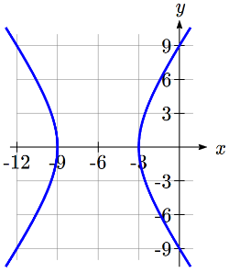13. 

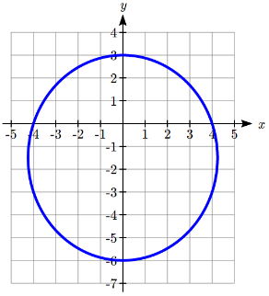15. Hyperbola. Vertices at (-9,0) and (-3,0)  
Center at (-6,0). *a* = 3. *c* = 6, so *b* =   


17. Ellipse. Vertices at (0,3) and (0,-6)  
Center at (0,-1.5). *a* = 4.5, *c* = 1.5,   


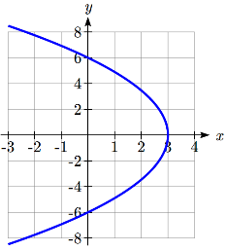

19. Parabola. Vertex at (3,0). *p* = 3.  


21. a)

*x*

*y*

*d(Q,F1)*

*d(Q,F2)*

*Q=(x,y)*

*F1*

*F2*

*L1*

*L­2*

(*c*,0)

(*a*,0)

*x* = *p*

b) , 

c) . 

d) , a constant.

e) At *Q* = (*a*, 0), , and , so  
  
Combining with the result above, , so .

f) , and    
, so .   
. Using the result from (e),  
  
  
