# Chapter 2: Linear Functions

Chapter one was a window that gave us a peek into the entire course. Our goal was to understand the basic structure of functions and function notation, the toolkit functions, domain and range, how to recognize and understand composition and transformations of functions and how to understand and utilize inverse functions. With these basic components in hand we will further research the specific details and intricacies of each type of function in our toolkit and use them to model the world around us.

Mathematical Modeling

As we approach day to day life we often need to quantify the things around us, giving structure and numeric value to various situations. This ability to add structure enables us to make choices based on patterns we see that are weighted and systematic. With this structure in place we can model and even predict behavior to make decisions. Adding a numerical structure to a real world situation is called **Mathematical Modeling.**

When modeling real world scenarios, there are some common growth patterns that are regularly observed. We will devote this chapter and the rest of the book to the study of the functions used to model these growth patterns.

Section 2.1 Linear Functions 101

Section 2.2 Graphs of Linear Functions 114

Section 2.3 Modeling with Linear Functions 129

Section 2.4 Fitting Linear Models to Data 141

Section 2.5 Absolute Value Functions 149

## Section 2.1 Linear Functions

As you hop into a taxicab in Las Vegas, the meter will immediately read $3.50; this is the “drop” charge made when the taximeter is activated. After that initial fee, the taximeter will add $2.76 for each mile the taxi drives[1]. In this scenario, the total taxi fare depends upon the number of miles ridden in the taxi, and we can ask whether it is possible to model this type of scenario with a function. Using descriptive variables, we choose *m* for miles and *C* for Cost in dollars as a function of miles: *C(m)*.

We know for certain that , since the $3.50 drop charge is assessed regardless of how many miles are driven. Since $2.67 is added for each mile driven, then

.

If we then drove a second mile, another $2.67 would be added to the cost:



If we drove a third mile, another $2.67 would be added to the cost:



From this we might observe the pattern, and conclude that if *m* miles are driven, because we start with a $3.50 drop fee and then for each mile increase we add $2.67.

It is good to verify that the units make sense in this equation. The $3.50 drop charge is measured in dollars; the $2.67 charge is measured in dollars per mile.



When dollars per mile are multiplied by a number of miles, the result is a number of dollars, matching the units on the 3.50, and matching the desired units for the *C* function.

Notice this equation  consisted of two quantities. The first is the fixed $3.50 charge which does not change based on the value of the input. The second is the $2.67 dollars per mile value, which is a **rate of change**. In the equation, this rate of change is multiplied by the input value.

Looking at this same problem in table format we can also see the cost changes by $2.67 for every 1 mile increase.

|  |  |  |  |  |
| --- | --- | --- | --- | --- |
| *m* | 0 | 1 | 2 | 3 |
| *C(m)* | 3.50 | 6.17 | 8.84 | 11.51 |

It is important here to note that in this equation, the **rate of change is constant**; over any interval, the rate of change is the same.

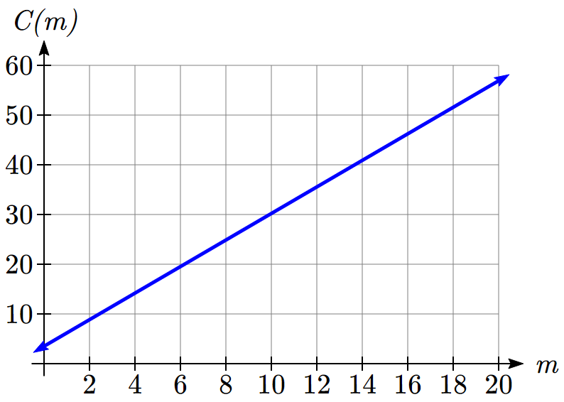Graphing this equation,  we see the shape is a line, which is how these functions get their name: **linear functions**.

When the number of miles is zero the cost is $3.50, giving the point (0, 3.50) on the graph. This is the vertical or *C(m)* intercept. The graph is increasing in a straight line from left to right because for each mile the cost goes up by $2.67; this rate remains consistent.

In this example, you have seen the taxicab cost modeled in words, an equation, a table and in graphical form. Whenever possible, ensure that you can link these four representations together to continually build your skills. It is important to note that you will not always be able to find all 4 representations for a problem and so being able to work with all 4 forms is very important.

Linear Function

A **linear function** is a function whose graph produces a line. Linear functions can always be written in the form

 or ; they’re equivalent

where

*b* is the initial or starting value of the function (when input, *x* = 0), and

*m* is the constant rate of change of the function

Many people like to write linear functions in the form  because it corresponds to the way we tend to speak: “The output starts at *b* and increases at a rate of *m*.”

For this reason alone we will use the form for many of the examples, but remember they are equivalent and can be written correctly both ways.

Slope and Increasing/Decreasing

*m* is the constant rate of change of the function (also called **slope**). The slope determines if the function is an increasing function or a decreasing function.

 is an **increasing** function if 

 is a **decreasing** function if 

If , the rate of change zero, and the function  is just a horizontal line passing through the point (0, *b*), neither increasing nor decreasing.

Example 1

Marcus currently owns 200 songs in his iTunes collection. Every month, he adds 15 new songs. Write a formula for the number of songs, *N*, in his iTunes collection as a function of the number of months, *m*. How many songs will he own in a year?

The initial value for this function is 200, since he currently owns 200 songs, so . The number of songs increases by 15 songs per month, so the rate of change is 15 songs per month. With this information, we can write the formula:

.

*N(m)* is an increasing linear function. With this formula we can predict how many songs he will have in 1 year (12 months):

. Marcus will have 380 songs in 12 months.

Try it Now

1. If you earn $30,000 per year and you spend $29,000 per year write an equation for the amount of money you save after *y* years, if you start with nothing.   
*“The most important thing, spend less than you earn![2]”*

Calculating Rate of Change

Given two values for the input,, and two corresponding values for the output, , or a set of points,  and, if we wish to find a linear function that contains both points we can calculate the rate of change, *m*:



Rate of change of a linear function is also called the **slope** of the line.

Note in function notation, and , so we could equivalently write



Example 2

The population of a city increased from 23,400 to 27,800 between 2002 and 2006. Find the rate of change of the population during this time span.

The rate of change will relate the change in population to the change in time. The population increased by people over the 4 year time interval. To find the rate of change, the number of people per year the population changed by:

 = 1100 people per year

Notice that we knew the population was increasing, so we would expect our value for *m* to be positive. This is a quick way to check to see if your value is reasonable.

Example 3

The pressure, *P*, in pounds per square inch (PSI) on a diver depends upon their depth below the water surface, *d*, in feet, following the equation . Interpret the components of this function.

The rate of change, or slope, 0.434 would have units . This tells us the pressure on the diver increases by 0.434 PSI for each foot their depth increases.

The initial value, 14.696, will have the same units as the output, so this tells us that at a depth of 0 feet, the pressure on the diver will be 14.696 PSI.

Example 4

If is a linear function, , and , find the rate of change.

 tells us that the input 3 corresponds with the output -2, and  tells us that the input 8 corresponds with the output 1. To find the rate of change, we divide the change in output by the change in input:

. If desired we could also write this as *m* = 0.6

Note that it is not important which pair of values comes first in the subtractions so long as the first output value used corresponds with the first input value used.

Try it Now

2. Given the two points (2, 3) and (0, 4), find the rate of change. Is this function increasing or decreasing?

We can now find the rate of change given two input-output pairs, and can write an equation for a linear function once we have the rate of change and initial value. If we have two input-output pairs and they do not include the initial value of the function, then we will have to solve for it.

Example 5

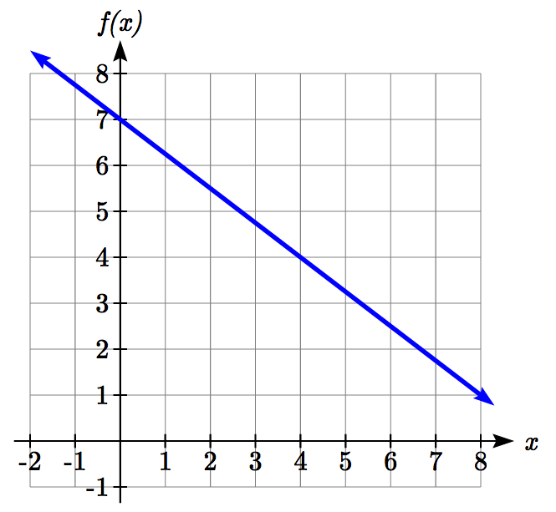Write an equation for the linear function graphed to the right.

Looking at the graph, we might notice that it passes through the points (0, 7) and (4, 4). From the first value, we know the initial value of the function is *b* = 7, so in this case we will only need to calculate the rate of change:



This allows us to write the equation:



Example 6

If is a linear function, , and , find an equation for the function.

In example 3, we computed the rate of change to be . In this case, we do not know the initial value, so we will have to solve for it. Using the rate of change, we know the equation will have the form. Since we know the value of the function when *x* = 3, we can evaluate the function at 3.

 Since we know that, we can substitute on the left side

 This leaves us with an equation we can solve for the initial value



Combining this with the value for the rate of change, we can now write a formula for this function:



Example 7

Working as an insurance salesperson, Ilya earns a base salary and a commission on each new policy, so Ilya’s weekly income, *I*, depends on the number of new policies, *n*, he sells during the week. Last week he sold 3 new policies, and earned $760 for the week. The week before, he sold 5 new policies, and earned $920. Find an equation for *I(n)*, and interpret the meaning of the components of the equation.

The given information gives us two input-output pairs: (3,760) and (5,920). We start by finding the rate of change.



Keeping track of units can help us interpret this quantity. Income increased by $160 when the number of policies increased by 2, so the rate of change is $80 per policy; Ilya earns a commission of $80 for each policy sold during the week.

We can then solve for the initial value

 then when *n* = 3, , giving

 this allows us to solve for *b*



This value is the starting value for the function. This is Ilya’s income when *n* = 0, which means no new policies are sold. We can interpret this as Ilya’s base salary for the week, which does not depend upon the number of policies sold.

Writing the final equation:



Our final interpretation is: Ilya’s base salary is $520 per week and he earns an additional $80 commission for each policy sold each week.

Flashback

Looking at Example 7:  
Determine the independent and dependent variables.  
What is a reasonable domain and range?  
Is this function one-to-one?

Try it Now

3. The balance in your college payment account, *C*, is a function of the number of quarters, *q*, you attend. Interpret the function *C(a)* = 20000 – 4000*q* in words. How many quarters of college can you pay for until this account is empty?

Example 8

Given the table below write a linear equation that represents the table values

|  |  |  |  |  |
| --- | --- | --- | --- | --- |
| *w*, number of weeks | 0 | 2 | 4 | 6 |
| *P(w)*, number of rats | 1000 | 1080 | 1160 | 1240 |

We can see from the table that the initial value of rats is 1000 so in the linear format

, *b* = 1000.

Rather than solving for *m*, we can notice from the table that the population goes up by 80 for every 2 weeks that pass. This rate is consistent from week 0, to week 2, 4, and 6. The rate of change is 80 rats per 2 weeks. This can be simplified to 40 rats per week and we can write

 as 

If you didn’t notice this from the table you could still solve for the slope using any two points from the table. For example, using (2, 1080) and (6, 1240),

rats per week

Important Topics of this Section

Definition of Modeling

Definition of a linear function

Structure of a linear function

Increasing & Decreasing functions

Finding the vertical intercept (0, *b*)

Finding the slope/rate of change, *m*

Interpreting linear functions

Try it Now Answers

1.  $1000 is saved each year.

2.  ; Decreasing because *m* < 0

3. Your College account starts with $20,000 in it and you withdraw $4,000 each quarter (or your account contains $20,000 and decreases by $4000 each quarter.)   
Solving *C(a)* = 0 gives *a* = 5. You can pay for 5 quarters before the money in this account is gone.

Flashback Answers

*n* (number of policies sold) is the independent variable

*I(n)* (weekly income as a function of policies sold) is the dependent variable.

A reasonable domain is (0, 15)*

A reasonable range is ($540, $1740)*

*answers may vary given reasoning is stated; 15 is an arbitrary upper limit based on selling 3 policies per day in a 5 day work week and $1740 corresponds with the domain.

Yes this function is one-to-one

## Section 2.1 Exercises

1. A town's population has been growing linearly. In 2003, the population was 45,000, and the population has been growing by 1700 people each year. Write an equation,for the population *t* years after 2003.
2. A town's population has been growing linearly. In 2005, the population was 69,000, and the population has been growing by 2500 people each year. Write an equation,for the population *t* years after 2005.
3. Sonya is currently 10 miles from home, and is walking further away at 2 miles per hour. Write an equation for her distance from home *t* hours from now.
4. A boat is 100 miles away from the marina, sailing directly towards it at 10 miles per hour. Write an equation for the distance of the boat from the marina after *t* hours.
5. Timmy goes to the fair with $40. Each ride costs $2. How much money will he have left after riding *n* rides?
6. At noon, a barista notices she has $20 in her tip jar. If she makes an average of $0.50 from each customer, how much will she have in her tip jar if she serves *n* more customers during her shift?

Determine if each function is increasing or decreasing

7.  8. 

9.  10. 

11.  12. 

13.  14. 

15.  16. 

Find the slope of the line that passes through the two given points

17. (2, 4) and (4, 10) 18. (1, 5) and (4, 11)

19. (-1,4) and (5, 2) 20. (-2, 8) and (4, 6)

21. (6,11) and (-4,3) 22. (9,10) and (-6,-12)

Find the slope of the lines graphed

23. 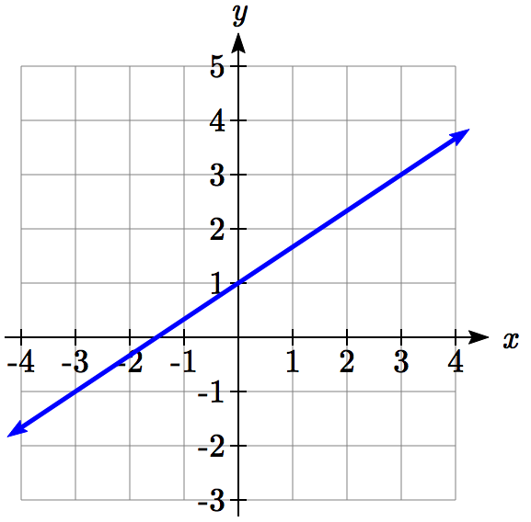 24. 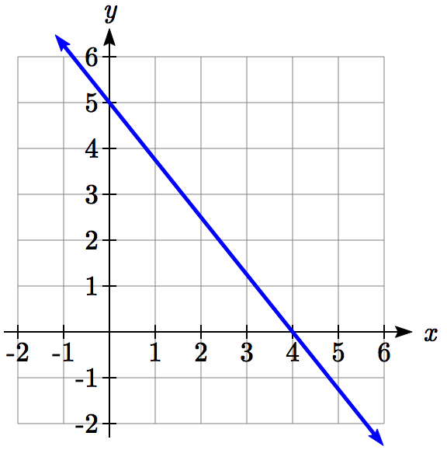

1. Sonya is walking home from a friend’s house. After 2 minutes she is 1.4 miles from home. Twelve minutes after leaving, she is 0.9 miles from home. What is her rate?
2. A gym membership with two personal training sessions costs $125, while gym membership with 5 personal training sessions costs $260. What is the rate for personal training sessions?
3. A city's population in the year 1960 was 287,500. In 1989 the population was 275,900. Compute the slope of the population growth (or decline) and make a statement about the population rate of change in people per year.
4. A city's population in the year 1958 was 2,113,000. In 1991 the population was 2,099,800. Compute the slope of the population growth (or decline) and make a statement about the population rate of change in people per year.
5. A phone company charges for service according to the formula: , where *n* is the number of minutes talked, and  is the monthly charge, in dollars.  
   Find and interpret the rate of change and initial value.
6. A phone company charges for service according to the formula: , where *n* is the number of minutes talked, and  is the monthly charge, in dollars.  
   Find and interpret the rate of change and initial value.
7. Terry is skiing down a steep hill. Terry's elevation, , in feet after *t* seconds is given by . Write a complete sentence describing Terry’s starting elevation and how it is changing over time.
8. Maria is climbing a mountain. Maria's elevation, , in feet after *t* minutes is given by . Write a complete sentence describing Maria’s starting elevation and how it is changing over time.

Given each set of information, find a linear equation satisfying the conditions, if possible

33. , and  34. , and 

35. Passes through (2, 4) and (4, 10) 36. Passes through (1, 5) and (4, 11)

37. Passes through (-1,4) and (5, 2) 38. Passes through (-2, 8) and (4, 6)

39. *x* intercept at (-2, 0) and *y* intercept at (0, -3)

40. *x* intercept at (-5, 0) and *y* intercept at (0, 4)

Find an equation for the function graphed

41.  42. 

43. 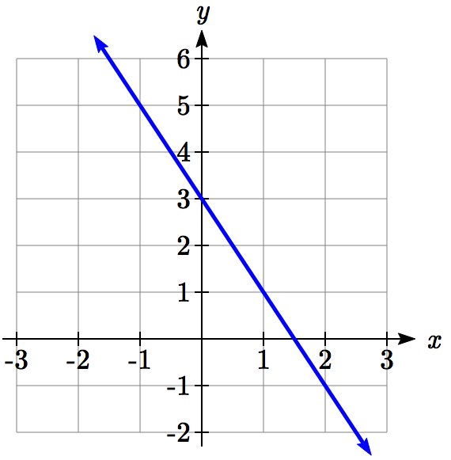 44. 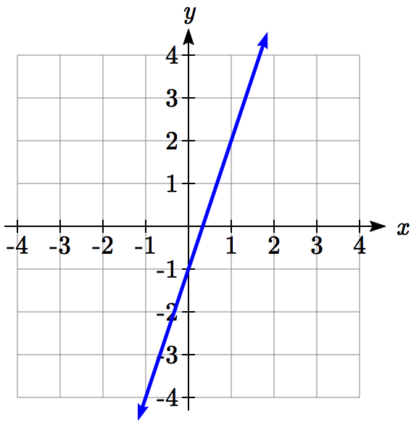

1. A clothing business finds there is a linear relationship between the number of shirts, *n*, it can sell and the price, *p*, it can charge per shirt. In particular, historical data shows that  shirts can be sold at a price of , while  shirts can be sold at a price of . Find a linear equation in the form  that gives the price *p* they can charge for *n* shirts.
2. A farmer finds there is a linear relationship between the number of bean stalks, *n*, she plants and the yield, *y*, each plant produces. When she plants 30 stalks, each plant yields 30 oz of beans. When she plants 34 stalks, each plant produces 28 oz of beans. Find a linear relationships in the form  that gives the yield when *n* stalks are planted.

1. Which of the following tables could represent a linear function? For each that could be linear, find a linear equation models the data.

|  |  |  |  |  |  |  |  |  |  |  |  |  |  |  |  |  |  |  |  |  |  |  |  |  |  |  |  |  |  |  |  |  |  |  |  |  |  |  |  |  |  |  |  |
| --- | --- | --- | --- | --- | --- | --- | --- | --- | --- | --- | --- | --- | --- | --- | --- | --- | --- | --- | --- | --- | --- | --- | --- | --- | --- | --- | --- | --- | --- | --- | --- | --- | --- | --- | --- | --- | --- | --- | --- | --- | --- | --- | --- |
| |  |  | | --- | --- | | ***x*** | ***g(x)*** | | 0 | 5 | | 5 | -10 | | 10 | -25 | | 15 | -40 | | |  |  | | --- | --- | | ***x*** | ***h(x)*** | | 0 | 5 | | 5 | 30 | | 10 | 105 | | 15 | 230 | | |  |  | | --- | --- | | ***x*** | ***f(x)*** | | 0 | -5 | | 5 | 20 | | 10 | 45 | | 15 | 70 | | |  |  | | --- | --- | | ***x*** | ***k(x)*** | | 5 | 13 | | 10 | 28 | | 20 | 58 | | 25 | 73 | |

1. Which of the following tables could represent a linear function? For each that could be linear, find a linear equation models the data.

|  |  |  |  |  |  |  |  |  |  |  |  |  |  |  |  |  |  |  |  |  |  |  |  |  |  |  |  |  |  |  |  |  |  |  |  |  |  |  |  |  |  |  |  |
| --- | --- | --- | --- | --- | --- | --- | --- | --- | --- | --- | --- | --- | --- | --- | --- | --- | --- | --- | --- | --- | --- | --- | --- | --- | --- | --- | --- | --- | --- | --- | --- | --- | --- | --- | --- | --- | --- | --- | --- | --- | --- | --- | --- |
| |  |  | | --- | --- | | ***x*** | ***g(x)*** | | 0 | 6 | | 2 | -19 | | 4 | -44 | | 6 | -69 | | |  |  | | --- | --- | | ***x*** | ***h(x)*** | | 2 | 13 | | 4 | 23 | | 8 | 43 | | 10 | 53 | | |  |  | | --- | --- | | ***x*** | ***f(x)*** | | 2 | -4 | | 4 | 16 | | 6 | 36 | | 8 | 56 | | |  |  | | --- | --- | | ***x*** | ***k(x)*** | | 0 | 6 | | 2 | 31 | | 6 | 106 | | 8 | 231 | |

1. While speaking on the phone to a friend in Oslo, Norway, you learned that the current temperature there was -23 Celsius (-23oC). After the phone conversation, you wanted to convert this temperature to Fahrenheit degrees, oF, but you could not find a reference with the correct formulas. You then remembered that the relationship between oF and oC is linear. [UW]
2. Using this and the knowledge that 32oF = 0 oC and 212 oF = 100 oC, find an equation that computes Celsius temperature in terms of Fahrenheit; i.e. an equation of the form C = “an expression involving only the variable F.”
3. Likewise, find an equation that computes Fahrenheit temperature in terms of Celsius temperature; i.e. an equation of the form F = “an expression involving only the variable C.”
4. How cold was it in Oslo in oF?

## Section 2.2 Graphs of Linear Functions

When we are working with a new function, it is useful to know as much as we can about the function: its graph, where the function is zero, and any other special behaviors of the function. We will begin this exploration of linear functions with a look at graphs.

When graphing a linear function, there are three basic ways to graph it:

1. By plotting points (at least 2) and drawing a line through the points
2. Using the initial value (output when *x* = 0) and rate of change (slope)
3. Using transformations of the identity function 

Example 1

Graph  by plotting points

In general, we evaluate the function at two or more inputs to find at least two points on the graph. Usually it is best to pick input values that will “work nicely” in the equation. In this equation, multiples of 3 will work nicely due to the  in the equation, and of course using *x* = 0 to get the vertical intercept. Evaluating *f(x)* at *x* = 0, 3 and 6:

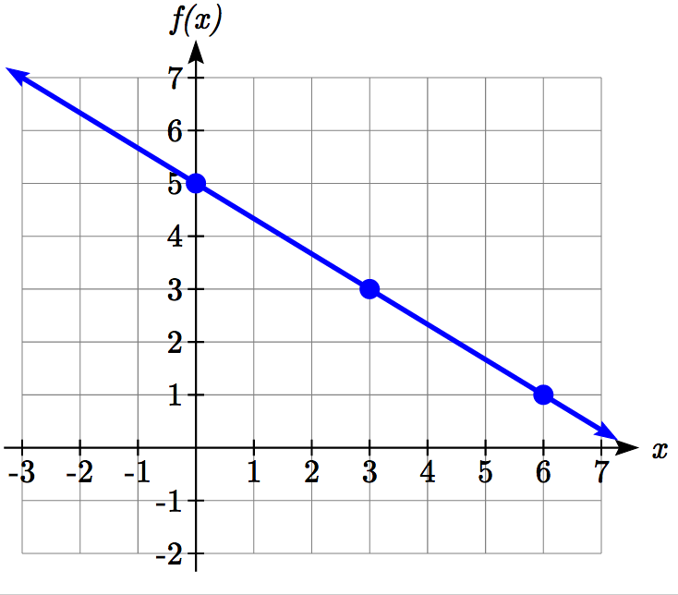

These evaluations tell us that the points (0,5), (3,3), and (6,1) lie on the graph of the line. Plotting these points and drawing a line through them gives us the graph.

When using the initial value and rate of change to graph, we need to consider the graphical interpretation of these values. Remember the initial value of the function is the output when the input is zero, so in the equation , the graph includes the point (0, *b*). On the graph, this is the vertical intercept – the point where the graph crosses the vertical axis.

For the rate of change, it is helpful to recall that we calculated this value as



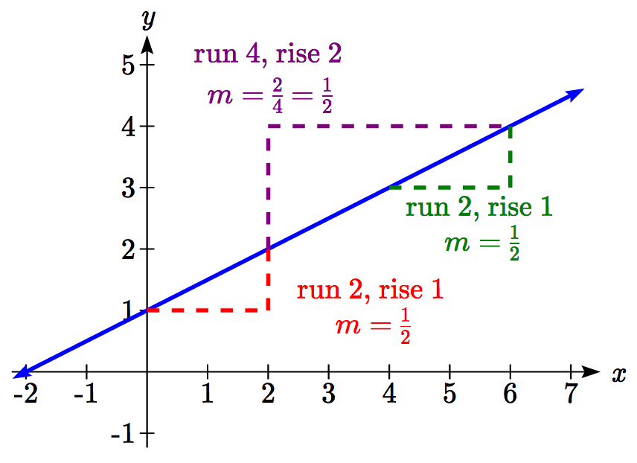From a graph of a line, this tells us that if we divide the vertical difference, or rise, of the function outputs by the horizontal difference, or run, of the inputs, we will obtain the rate of change, also called slope of the line.



Notice that this ratio is the same regardless of which two points we use.

Graphical Interpretation of a Linear Equation

Graphically, in the equation,

*b* is the **vertical intercept** of the graph and tells us we can start our graph at (0, *b*)

*m* is the **slope of the line** and tells us how far to rise & run to get to the next point

Once we have at least 2 points, we can extend the graph of the line to the left and right.

Example 2

Graph  using the vertical intercept and slope.

The vertical intercept of the function is (0, 5), giving us a point on the graph of the line.

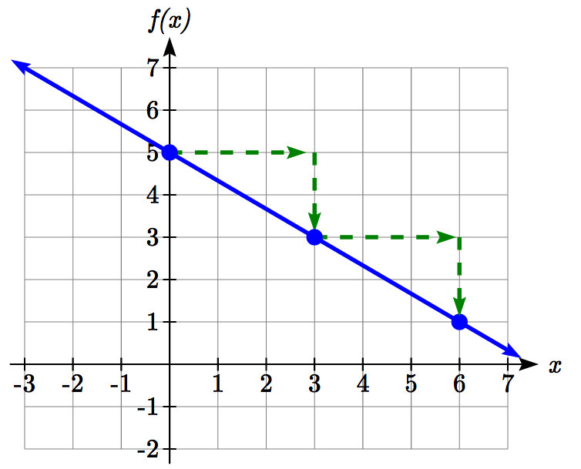The slope is . This tells us that for every 3 units the graph “runs” in the horizontal, the vertical “rise” decreases by 2 units.

In graphing, we can use this by first plotting our vertical intercept on the graph, then using the slope to find a second point. From the initial value (0, 5) the slope tells us that if we move to the right 3, we will move down 2, moving us to the point (3, 3). We can continue this again to find a third point at (6, 1). Finally, extend the line to the left and right, containing these points.

Try it Now

1. Consider that the slope  could also be written as . Using , find another point on the graph that has a negative *x* value.

Another option for graphing is to use transformations of the identity function.

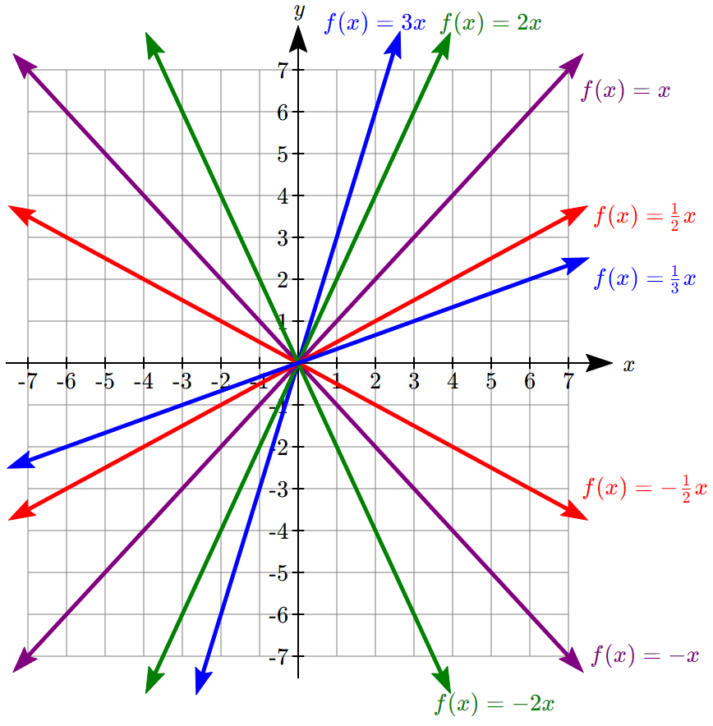

In the equation, the *m* is acting as the vertical stretch of the identity function. When *m* is negative, there is also a vertical reflection of the graph. Looking at some examples:

Multiple labeled lines on one graph, all parallel with the same slope. f(x)=x passing through 0 comma 0 and 2 comma 2. f(x)=xnegative 2 passing through 0 comma negative 2 and 2 comma 0. f(x)=xnegative 4 passing through 0 comma negative 4 and 2 comma negative 2. f(x)=x+2 passing through 0 comma 2 and 2 comma 4. f(x)=x+4 passing through 0 comma 4 and 2 comma 6


In, the *b* acts as the vertical shift, moving the graph up and down without affecting the slope of the line. Some examples:

Using Vertical Stretches or Compressions along with Vertical Shifts is another way to look at identifying different types of linear functions. Although this may not be the easiest way for you to graph this type of function, make sure you practice each method.

Example 3

Graph  using transformations.

The equation is the graph of the identity function vertically compressed by ½ and vertically shifted down 3.

Vertical compression combined with Vertical shift

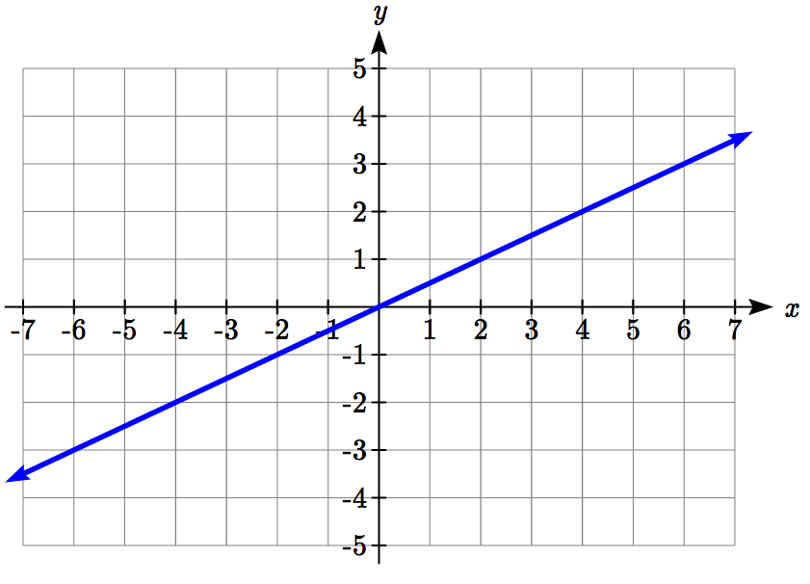 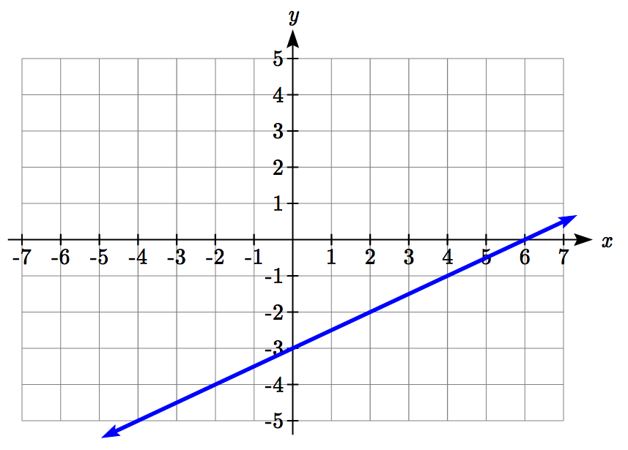

Notice how this nicely compares to the other method where the vertical intercept is found at (0, -3) and to get to another point we rise (go up vertically) by 1 unit and run (go horizontally) by 2 units to get to the next point (2, -2), and the next one (4, -1). In these three points (0, -3), (2, -2), and (4, -1), the output values change by +1, and the *x* values change by +2, corresponding with the slope *m* = ½.

Example 4

Match each equation with one of the lines in the graph below

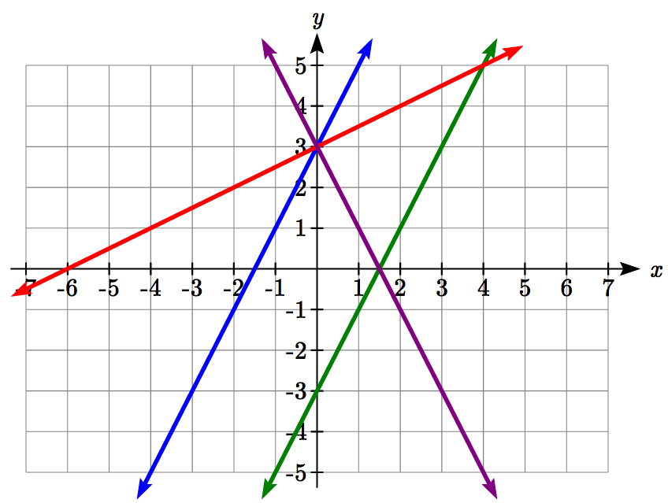

Only one graph has a vertical intercept of -3, so we can immediately match that graph with *g(x)*.

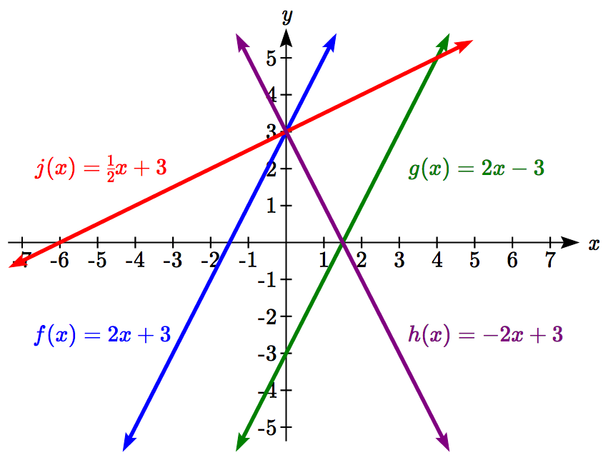For the three graphs with a vertical intercept at 3, only one has a negative slope, so we can match that line with *h(x)*. Of the other two, the steeper line would have a larger slope, so we can match that graph with equation *f(x)*, and the flatter line with the equation *j(x)*.

In addition to understanding the basic behavior of a linear function (increasing or decreasing, recognizing the slope and vertical intercept), it is often helpful to know the horizontal intercept of the function – where it crosses the horizontal axis.

Finding Horizontal Intercepts

The **horizontal intercept** of the function is where the graph crosses the horizontal axis. If a function has a horizontal intercept, you can always find it by solving   
*f(x)* = 0.

Example 5

Find the horizontal intercept of 

Setting the function equal to zero to find what input will put us on the horizontal axis,



The graph crosses the horizontal axis at (6,0)

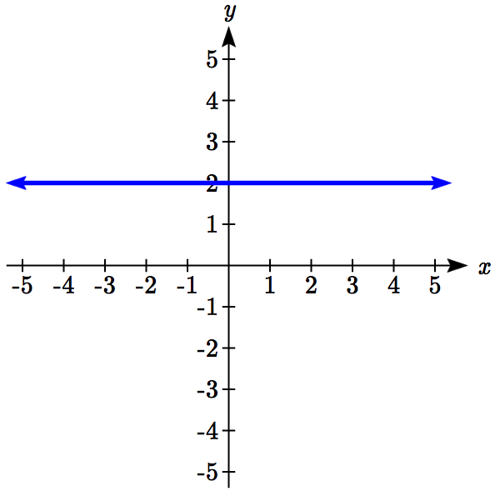There are two special cases of lines: a horizontal line and a vertical line. In a horizontal line like the one graphed to the right, notice that between any two points, the change in the outputs is 0. In the slope equation, the numerator will be 0, resulting in a slope of 0. Using a slope of 0 in the , the equation simplifies to .

Notice a horizontal line has a vertical intercept, but no horizontal intercept (unless it’s the line *f(x)* = 0).

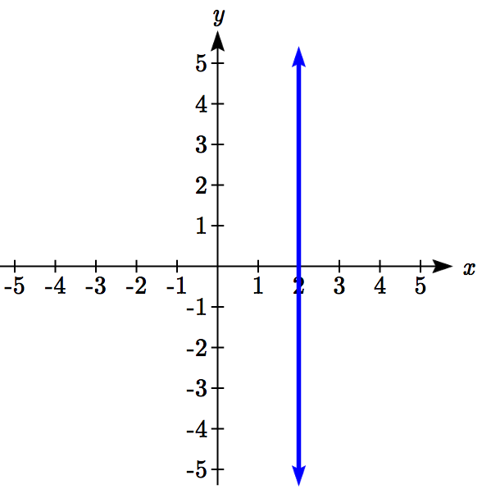

In the case of a vertical line, notice that between any two points, the change in the inputs is zero. In the slope equation, the denominator will be zero, and you may recall that we cannot divide by the zero; the slope of a vertical line is undefined. You might also notice that a vertical line is not a function. To write the equation of vertical line, we simply write input=value, like.

Notice a vertical line has a horizontal intercept, but no vertical intercept (unless it’s the line *x* = 0).

Horizontal and Vertical Lines

**Horizontal lines** have equations of the form 

**Vertical lines** have equations of the form *x* = *a*

Example 6

Write an equation for the horizontal line graphed above.

This line would have equation 

Example 7

Write an equation for the vertical line graphed above.

This line would have equation 

Try it Now

2. Describe the function  in terms of transformations of the identity function and find its horizontal intercept.

**Parallel and Perpendicular Lines**

When two lines are graphed together, the lines will be **parallel** if they are increasing at the same rate – if the rates of change are the same. In this case, the graphs will never cross (unless they’re the same line).

Parallel Lines

Two lines are **parallel** if the slopes are equal (or, if both lines are vertical).

In other words, given two linear equations  and , the lines will be parallel if .

Example 8

Find a line parallel to  that passes through the point (3, 0)

We know the line we’re looking for will have the same slope as the given line, *m* = 3. Using this and the given point, we can solve for the new line’s vertical intercept:

 then at (3, 0),



The line we’re looking for is 

If two lines are not parallel, one other interesting possibility is that the lines are perpendicular, which means the lines form a right angle (90 degree angle – a square corner) where they meet. In this case, the slopes when multiplied together will equal -1. Solving for one slope leads us to the definition:

Perpendicular Lines

Given two linear equations  and 

The lines will be **perpendicular** if , and so 

We often say the slope of a perpendicular line is the “negative reciprocal” of the other line’s slope.

Example 9

Find the slope of a line perpendicular to a line with:

a) a slope of 2. b) a slope of -4. c) a slope of .

If the original line had slope 2, the perpendicular line’s slope would be 

If the original line had slope -4, the perpendicular line’s slope would be 

If the original line had slope , the perpendicular line’s slope would be 

Example 10

Find the equation of a line perpendicular to  and passing through the point (3, 0)

The original line has slope *m* = 3. The perpendicular line will have slope . Using this and the given point, we can find the equation for the line.

 then at (3, 0),



The line we’re looking for is .

Try it Now

3. Given the line , find an equation for the line passing through (0, 0) that is: a) parallel to *h(t)*. b) perpendicular to *h(t).*

Example 12

A line passes through the points (-2, 6) and (4, 5). Find the equation of a perpendicular line that passes through the point (4, 5).

From the two given points on the reference line, we can calculate the slope of that line:



The perpendicular line will have slope



We can then solve for the vertical intercept that makes the line pass through the desired point:

 then at (4, 5),



Giving the line 

**Intersections of Lines**

The graphs of two lines will intersect if they are not parallel. They will intersect at the point that satisfies both equations. To find this point when the equations are given as functions, we can solve for an input value so that . In other words, we can set the formulas for the lines equal, and solve for the input that satisfies the equation.

Example 13

Find the intersection of the lines  and 

Setting ,

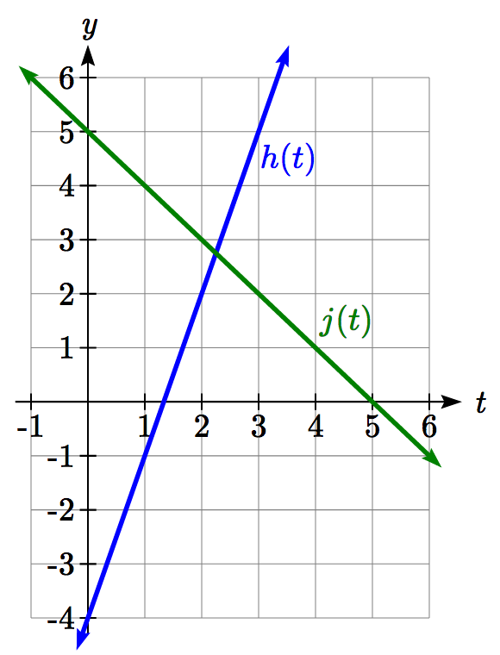

This tells us the lines intersect when the input is .

We can then find the output value of the intersection point by evaluating either function at this input



These lines intersect at the point . Looking at the graph, this result seems reasonable.

Two parallel lines can also intersect if they happen to be the same line. In that case, they intersect at every point on the lines.

Try it Now

4. Look at the graph in example 13 above and answer the following for the function *h(t)*:  
a. Vertical intercept coordinates  
b. Horizontal intercepts coordinates  
c. Slope  
d. Is *j(t)* parallel or perpendicular to *h(t)* (or neither)  
e. Is *h(t)* an Increasing or Decreasing function (or neither)  
f. Write a transformation description from the identity toolkit function *f(x) = x*

Finding the intersection allows us to answer other questions as well, such as discovering when one function is larger than another.

Example 14

Using the functions from the previous example, for what values of *t* is 

To answer this question, it is helpful first to know where the functions are equal, since that is the point where *h(t)* could switch from being greater to smaller than *j(t)* or vice-versa. From the previous example, we know the functions are equal at .

By examining the graph, we can see that *h(t)*, the function with positive slope, is going to be larger than the other function to the right of the intersection. So  when 

Important Topics of this Section

Methods for graphing linear functions

Another name for slope = rise/run

Horizontal intercepts (a,0)

Horizontal lines

Vertical lines

Parallel lines

Perpendicular lines

Intersecting lines

Try it Now Answers

1. (-3,7) found by starting at the vertical intercept, going up 2 units and 3 in the negative horizontal direction. You could have also answered, (-6, 9) or (-9, 11) etc…

2. Vertically stretched by a factor of 3, Vertically flipped (flipped over the *x* axis), Vertically shifted up by 6 units.   
Horizontal intercept: 6−3*x*=0 when *x*=2

3. Parallel  ; Perpendicular 

4. Given 

a. (0,-4)

b. 

c. Slope 3

d. Neither parallel nor perpendicular

e. Increasing function

f. Given the identity function, vertically stretch by 3 and shift down 4 units.

## Section 2.2 Exercises

Match each linear equation with its graph

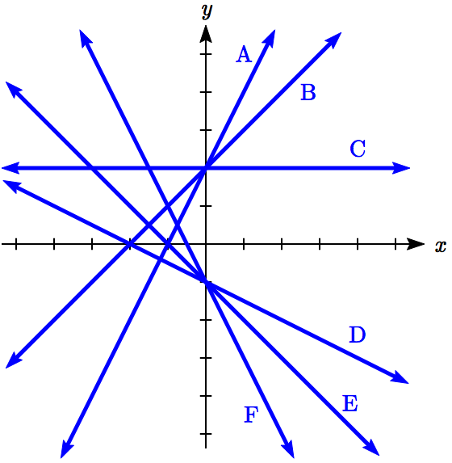

1. 
2. 
3. 
4. 
5. 
6. 

Sketch a line with the given features

1. An *x*-intercept of (-4, 0) and *y*-intercept of (0, -2)
2. An *x*-intercept of (-2, 0) and *y*-intercept of (0, 4)
3. A vertical intercept of (0, 7) and slope 
4. A vertical intercept of (0, 3) and slope 
5. Passing through the points (-6,-2) and (6,-6)
6. Passing through the points (-3,-4) and (3,0)

Sketch the graph of each equation

13.  14. 

15.  16. 

17.  18. 

19.  20. 

21.  22. 

1. If  is the transformation of  after a vertical compression by , a shift left by 2, and a shift down by 4
   1. Write an equation for 
   2. What is the slope of this line?
   3. Find the vertical intercept of this line.
2. If  is the transformation of  after a vertical compression by , a shift right by 1, and a shift up by 3
   1. Write an equation for 
   2. What is the slope of this line?
   3. Find the vertical intercept of this line.

Write the equation of the line shown

25.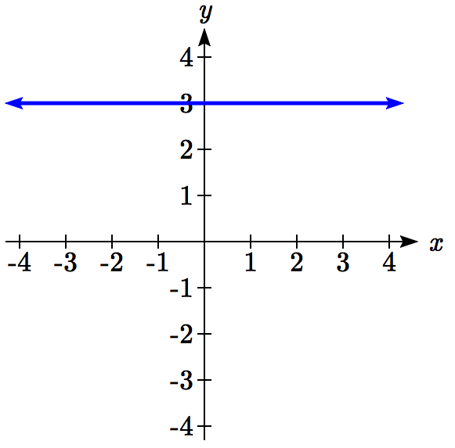 26. 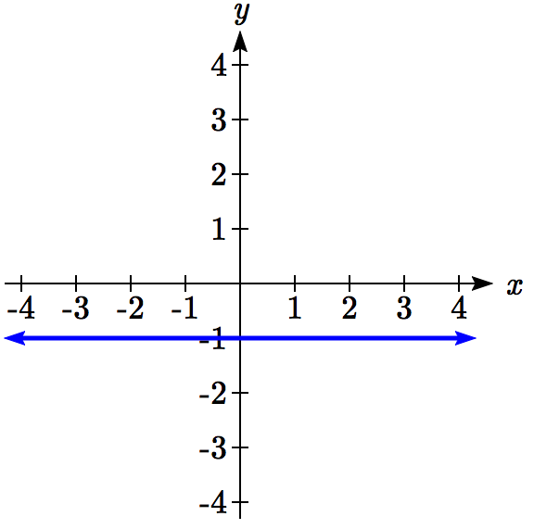

27. 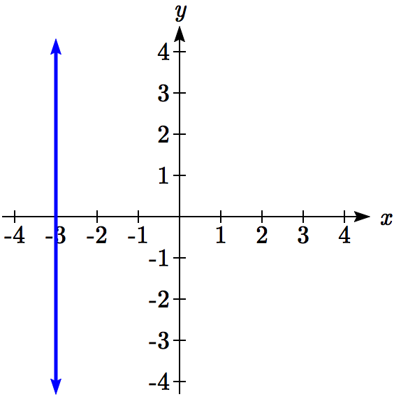 28. 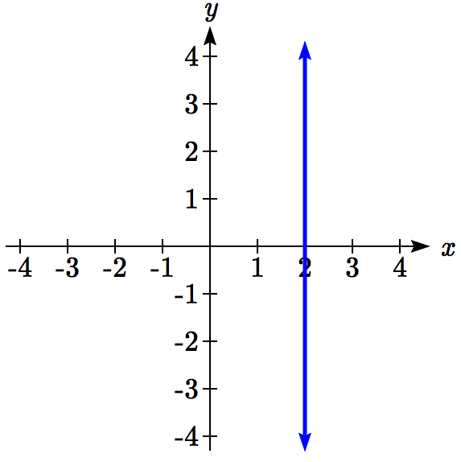

Find the horizontal and vertical intercepts of each equation

29.  30. 

31.  32. 

33.  34. 

Given below are descriptions of two lines. Find the slopes of Line 1 and Line 2. Is each pair of lines parallel, perpendicular or neither?

1. Line 1: Passes through  and   
   Line 2: Passes through  and 
2. Line 1: Passes through  and   
   Line 2: Passes through  and 
3. Line 1: Passes through  and   
   Line 2: Passes through  and 
4. Line 1: Passes through  and   
   Line 2: Passes through  and 
5. Line 1: Passes through  and   
   Line 2: Passes through  and 
6. Line 1: Passes through  and   
   Line 2: Passes through  and 
7. Write an equation for a line parallel to  and passing through the point (2,-12)
8. Write an equation for a line parallel to  and passing through the point (4,9)
9. Write an equation for a line perpendicular to  and passing through the point (-4,-1)
10. Write an equation for a line perpendicular to  and passing through the point (3,1)
11. Find the point at which the line  intersects the line 
12. Find the point at which the line  intersects the line 
13. Use algebra to find the point at which the line  intersects the line 
14. Use algebra to find the point at which the line  intersects the line 
15. A car rental company offers two plans for renting a car.   
    Plan A: 30 dollars per day and 18 cents per mile   
    Plan B: 50 dollars per day with free unlimited mileage   
    How many miles would you need to drive for plan B to save you money?
16. You’re comparing two cell phone companies.

Company A: $20/month for unlimited talk and text, and $10/GB for data.

Company B: $65/month for unlimited talk, text, and data.

Under what circumstances will company A save you money?

Find a formula for each piecewise defined function.

51.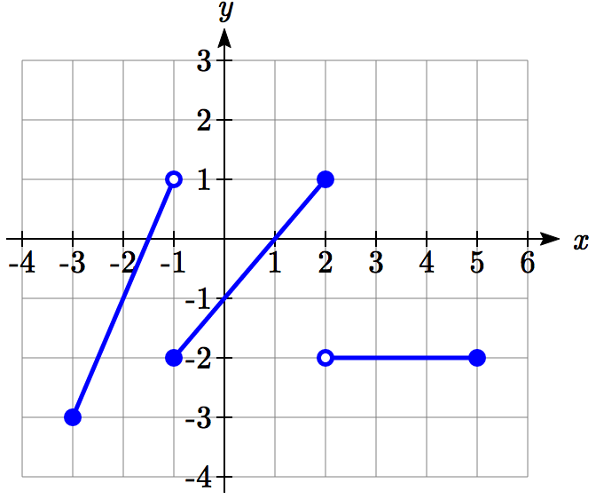 52.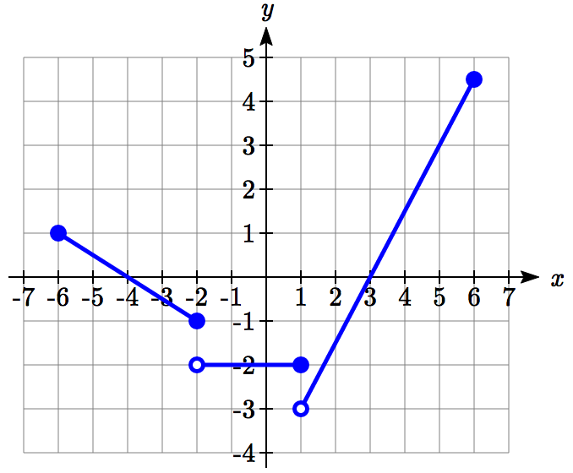

53. Sketch an accurate picture of the line having equation . Let *c* be an unknown constant. [UW]

* 1. Find the point of intersection between the line you have graphed and the line ; your answer will be a point in the *xy* plane whose coordinates involve the unknown *c*.
  2. Find *c* so that the intersection point in (a) has *x*-coordinate 10.
  3. Find *c* so that the intersection point in (a) lies on the x-axis.

## Section 2.3 Modeling with Linear Functions

When modeling scenarios with a linear function and solving problems involving quantities changing linearly, we typically follow the same problem solving strategies that we would use for any type of function:

Problem solving strategy

1. Identify changing quantities, and then carefully and clearly define descriptive variables to represent those quantities. When appropriate, sketch a picture or define a coordinate system.
2. Carefully read the problem to identify important information. Look for information giving values for the variables, or values for parts of the functional model, like slope and initial value.
3. Carefully read the problem to identify what we are trying to find, identify, solve, or interpret.
4. Identify a solution pathway from the provided information to what we are trying to find. Often this will involve checking and tracking units, building a table or even finding a formula for the function being used to model the problem.
5. When needed, find a formula for the function.
6. Solve or evaluate using the formula you found for the desired quantities.
7. Reflect on whether your answer is reasonable for the given situation and whether it makes sense mathematically.
8. Clearly convey your result using appropriate units, and answer in full sentences when appropriate.

Example 1

Emily saved up $3500 for her summer visit to Seattle. She anticipates spending $400 each week on rent, food, and fun. Find and interpret the horizontal intercept and determine a reasonable domain and range for this function.

In the problem, there are two changing quantities: time and money. The amount of money she has remaining while on vacation depends on how long she stays. We can define our variables, including units.

Output: *M*, money remaining, in dollars

Input: *t*, time, in weeks

Reading the problem, we identify two important values. The first, $3500, is the initial value for *M*. The other value appears to be a rate of change – the units of dollars per week match the units of our output variable divided by our input variable. She is spending money each week, so you should recognize that the amount of money remaining is decreasing each week and the slope is negative.

To answer the first question, looking for the horizontal intercept, it would be helpful to have an equation modeling this scenario. Using the intercept and slope provided in the problem, we can write the equation: .

To find the horizontal intercept, we set the output to zero, and solve for the input:



The horizontal intercept is 8.75 weeks. Since this represents the input value where the output will be zero, interpreting this, we could say: Emily will have no money left after 8.75 weeks.

When modeling any real life scenario with functions, there is typically a limited domain over which that model will be valid – almost no trend continues indefinitely. In this case, it certainly doesn’t make sense to talk about input values less than zero. It is also likely that this model is not valid after the horizontal intercept (unless Emily’s going to start using a credit card and go into debt).

The domain represents the set of input values and so the reasonable domain for this function is .

However, in a real world scenario, the rental might be weekly or nightly. She may not be able to stay a partial week and so all options should be considered. Emily could stay in Seattle for 0 to 8 full weeks (and a couple of days), but would have to go into debt to stay 9 full weeks, so restricted to whole weeks, a reasonable domain without going in to debt would be , or if she went into debt to finish out the last week.

The range represents the set of output values and she starts with $3500 and ends with $0 after 8.75 weeks so the corresponding range is . If we limit the rental to whole weeks, however, the range would change. If she left after 8 weeks because she didn’t have enough to stay for a full 9 weeks, she would have *M*(8) = 3500−400(8) = $300 dollars left after 8 weeks, giving a range of . If she wanted to stay the full 9 weeks she would be $100 in debt giving a range of .

Most importantly remember that domain and range are tied together, and what ever you decide is most appropriate for the domain (the independent variable) will dictate the requirements for the range (the dependent variable).

Try it Now

1. A database manager is loading a large table from backups. Getting impatient, she notices 1.2 million rows had been loaded. Ten minutes later, 2.5 million rows had been loaded. How much longer will she have to wait for all 80 million rows to load?

Example 2

Jamal is choosing between two moving companies. The first, U-Haul, charges an up-front fee of $20, then 59 cents a mile. The second, Budget, charges an up-front fee of $16, then 63 cents a mile[3]. When will U-Haul be the better choice for Jamal?

The two important quantities in this problem are the cost, and the number of miles that are driven. Since we have two companies to consider, we will define two functions:

Input: *m*, miles driven

Outputs:

*Y*(*m)*: cost, in dollars, for renting from U-Haul

*B(m)*: cost, in dollars, for renting from Budget

Reading the problem carefully, it appears that we were given an initial cost and a rate of change for each company. Since our outputs are measured in dollars but the costs per mile given in the problem are in cents, we will need to convert these quantities to match our desired units: $0.59 a mile for U-Haul, and $0.63 a mile for Budget.

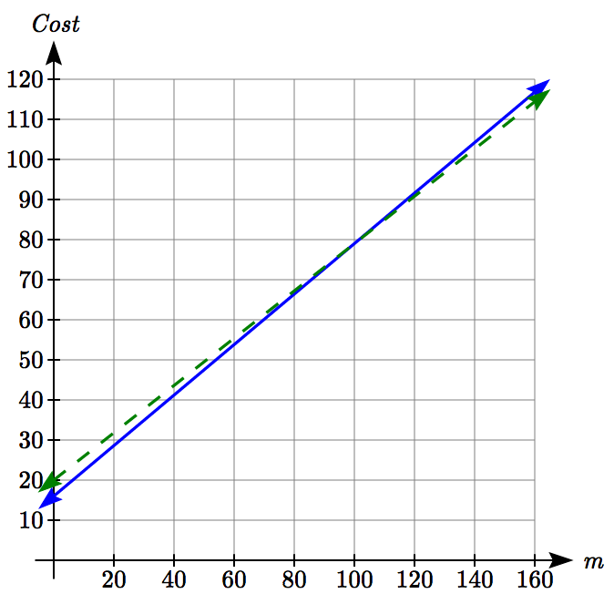Looking to what we’re trying to find, we want to know when U-Haul will be the better choice. Since all we have to make that decision from is the costs, we are looking for when U-Haul will cost less, or when . The solution pathway will lead us to find the equations for the two functions, find the intersection, then look to see where the *Y(m)* function is smaller. Using the rates of change and initial charges, we can write the equations:



These graphs are sketched to the right, with *Y(m)* drawn dashed.

To find the intersection, we set the equations equal and solve:

*Y(m) = B(m)*



This tells us that the cost from the two companies will be the same if 100 miles are driven. Either by looking at the graph, or noting that *Y(m)* is growing at a slower rate, we can conclude that U-Haul will be the cheaper price when more than 100 miles are driven.

Example 3

A town’s population has been growing linearly. In 2004 the population was 6,200. By 2009 the population had grown to 8,100. If this trend continues,

a. Predict the population in 2013

b. When will the population reach 15000?

The two changing quantities are the population and time. While we could use the actual year value as the input quantity, doing so tends to lead to very ugly equations, since the vertical intercept would correspond to the year 0, more than 2000 years ago!

To make things a little nicer, and to make our lives easier too, we will define our input as years since 2004:

Input: *t*, years since 2004

Output: *P(t)*, the town’s population

The problem gives us two input-output pairs. Converting them to match our defined variables, the year 2004 would correspond to *t* = 0, giving the point (0, 6200). Notice that through our clever choice of variable definition, we have “given” ourselves the vertical intercept of the function. The year 2009 would correspond to *t* = 5, giving the point (5, 8100).

To predict the population in 2013 (*t* = 9), we would need an equation for the population. Likewise, to find when the population would reach 15000, we would need to solve for the input that would provide an output of 15000. Either way, we need an equation. To find it, we start by calculating the rate of change:

people per year

Since we already know the vertical intercept of the line, we can immediately write the equation:



To predict the population in 2013, we evaluate our function at *t* = 9



If the trend continues, our model predicts a population of 9,620 in 2013.

To find when the population will reach 15,000, we can set *P(t)* = 15000 and solve for *t*.



Our model predicts the population will reach 15,000 in a little more than 23 years after 2004, or somewhere around the year 2027.

Example 4

Anna and Emanuel start at the same intersection. Anna walks east at 4 miles per hour while Emanuel walks south at 3 miles per hour. They are communicating with a two-way radio with a range of 2 miles. How long after they start walking will they fall out of radio contact?

In essence, we can partially answer this question by saying they will fall out of radio contact when they are 2 miles apart, which leads us to ask a new question: how long will it take them to be 2 miles apart?

In this problem, our changing quantities are time and the two peoples’ positions, but ultimately we need to know how long will it take for them to be 2 miles apart. We can see that time will be our input variable, so we’ll define

Input: *t*, time in hours.

Since it is not obvious how to define our output variables, we’ll start by drawing a picture.

Anna walking east, 4 miles/hour

Distance between them

Emanuel walking south, 3 miles/hour

Because of the complexity of this question, it may be helpful to introduce some intermediary variables. These are quantities that we aren’t directly interested in, but seem important to the problem. For this problem, Anna’s and Emanuel’s distances from the starting point seem important. To notate these, we are going to define a coordinate system, putting the “starting point” at the intersection where they both started, then we’re going to introduce a variable, *A*, to represent Anna’s position, and define it to be a measurement from the starting point, in the eastward direction. Likewise, we’ll introduce a variable, *E*, to represent Emanuel’s position, measured from the starting point in the southward direction. Note that in defining the coordinate system we specified both the origin, or starting point, of the measurement, as well as the direction of measure.

While we’re at it, we’ll define a third variable, *D*, to be the measurement of the distance between Anna and Emanuel. Showing the variables on the picture is often helpful.

Looking at the variables on the picture, we remember we need to know how long it takes for D, the distance between them, to equal 2 miles.

*A*

*E*

*D*



*a*

*b*

*c*

Seeing this picture we remember that in order to find the distance between the two, we can use the Pythagorean Theorem, a property of right triangles.

From here, we can now look back at the problem for relevant information. Anna is walking 4 miles per hour, and Emanuel is walking 3 miles per hour, which are rates of change. Using those, we can write formulas for the distance each has walked.

They both start at the same intersection and so when *t* = 0, the distance travelled by each person should also be 0, so given the rate for each, and the initial value for each, we get:



Using the Pythagorean theorem we get:

 substitute in the function formulas

 solve for *D(t)* using the square root



Since in this scenario we are only considering positive values of *t* and our distance *D(t)* will always be positive, we can simplify this answer to 

Interestingly, the distance between them is also a linear function. Using it, we can now answer the question of when the distance between them will reach 2 miles:



They will fall out of radio contact in 0.4 hours, or 24 minutes.

Example 5

There is currently a straight road leading from the town of Westborough to a town 30 miles east and 10 miles north. Partway down this road, it junctions with a second road, perpendicular to the first, leading to the town of Eastborough. If the town of Eastborough is located 20 miles directly east of the town of Westborough, how far is the road junction from Westborough?

It might help here to draw a picture of the situation. It would then be helpful to introduce a coordinate system. While we could place the origin anywhere, placing it at Westborough seems convenient. This puts the other town at coordinates (30, 10), and Eastborough at (20, 0).

Westborough

Other town

(30, 10)

20 miles

Eastborough

(20, 0)

(0, 0)

Using this point along with the origin, we can find the slope of the line from Westborough to the other town:  . This gives the equation of the road from Westborough to the other town to be .

From this, we can determine the perpendicular road to Eastborough will have slope . Since the town of Eastborough is at the point (20, 0), we can find the equation:

 plug in the point (20, 0)







We can now find the coordinates of the junction of the roads by finding the intersection of these lines. Setting them equal,







 Substituting this back into *W(x)*



The roads intersect at the point (18, 6). Using the distance formula, we can now find the distance from Westborough to the junction:

 miles.

Important Topics of this Section

**The problem solving process**

1. Identify changing quantities, and then carefully and clearly define descriptive variables to represent those quantities. When appropriate, sketch a picture or define a coordinate system.
2. Carefully read the problem to identify important information. Look for information giving values for the variables, or values for parts of the functional model, like slope and initial value.
3. Carefully read the problem to identify what we are trying to find, identify, solve, or interpret.
4. Identify a solution pathway from the provided information to what we are trying to find. Often this will involve checking and tracking units, building a table or even finding a formula for the function being used to model the problem.
5. When needed, find a formula for the function.
6. Solve or evaluate using the formula you found for the desired quantities.
7. Reflect on whether your answer is reasonable for the given situation and whether it makes sense mathematically.
8. Clearly convey your result using appropriate units, and answer in full sentences when appropriate.

Try it Now

1. Letting *t* be the number of minutes since she got impatient, and *N* be the number rows loaded, in millions, we have two points: (0, 1.2) and (10, 2.5).   
  
The slope is  million rows per minute.   
We know the *N* intercept, so we can write the equation:   
  
  
To determine how long she will have to wait, we need to solve for when *N* = 80.  
  
  
. She’ll have to wait another 606 minutes, about 10 hours.

## Section 2.3 Exercises

1. In 2004, a school population was 1001. By 2008 the population had grown to 1697. Assume the population is changing linearly.
   1. How much did the population grow between the year 2004 and 2008?
   2. How long did it take the population to grow from 1001 students to 1697 students?
   3. What is the average population growth per year?
   4. What was the population in the year 2000?
   5. Find an equation for the population, *P*, of the school *t* years after 2000.
   6. Using your equation, predict the population of the school in 2011.
2. In 2003, a town’s population was 1431. By 2007 the population had grown to 2134. Assume the population is changing linearly.
   1. How much did the population grow between the year 2003 and 2007?
   2. How long did it take the population to grow from 1431 people to 2134?
   3. What is the average population growth per year?
   4. What was the population in the year 2000?
   5. Find an equation for the population, *P*, of the town *t* years after 2000.
   6. Using your equation, predict the population of the town in 2014.
3. A phone company has a monthly cellular plan where a customer pays a flat monthly fee and then a certain amount of money per minute used on the phone. If a customer uses 410 minutes, the monthly cost will be $71.50. If the customer uses 720 minutes, the monthly cost will be $118.
   1. Find a linear equation for the monthly cost of the cell plan as a function of *x*, the number of monthly minutes used.
   2. Interpret the slope and vertical intercept of the equation.
   3. Use your equation to find the total monthly cost if 687 minutes are used.
4. A phone company has a monthly cellular data plan where a customer pays a flat monthly fee and then a certain amount of money per megabyte (MB) of data used on the phone. If a customer uses 20 MB, the monthly cost will be $11.20. If the customer uses 130 MB, the monthly cost will be $17.80.
   1. Find a linear equation for the monthly cost of the data plan as a function of *x*, the number of MB used.
   2. Interpret the slope and vertical intercept of the equation.
   3. Use your equation to find the total monthly cost if 250 MB are used.
5. In 1991, the moose population in a park was measured to be 4360. By 1999, the population was measured again to be 5880. If the population continues to change linearly,
   1. Find a formula for the moose population, *P*.
   2. What does your model predict the moose population to be in 2003?
6. In 2003, the owl population in a park was measured to be 340. By 2007, the population was measured again to be 285. If the population continues to change linearly,
   1. Find a formula for the owl population, *P*.
   2. What does your model predict the owl population to be in 2012?
7. The Federal Helium Reserve held about 16 billion cubic feet of helium in 2010, and is being depleted by about 2.1 billion cubic feet each year.
   1. Give a linear equation for the remaining federal helium reserves, *R*, in terms of *t*, the number of years since 2010.
   2. In 2015, what will the helium reserves be?
   3. If the rate of depletion doesn’t change, when will the Federal Helium Reserve be depleted?
8. Suppose the world's current oil reserves are 1820 billion barrels. If, on average, the total reserves is decreasing by 25 billion barrels of oil each year:
   1. Give a linear equation for the remaining oil reserves, *R*, in terms of *t*, the number of years since now.
   2. Seven years from now, what will the oil reserves be?
   3. If the rate of depletion isn’t change, when will the world’s oil reserves be depleted?
9. You are choosing between two different prepaid cell phone plans. The first plan charges a rate of 26 cents per minute. The second plan charges a monthly fee of $19.95 plus 11 cents per minute. How many minutes would you have to use in a month in order for the second plan to be preferable?
10. You are choosing between two different window washing companies. The first charges $5 per window. The second charges a base fee of $40 plus $3 per window. How many windows would you need to have for the second company to be preferable?
11. When hired at a new job selling jewelry, you are given two pay options:  
    Option A: Base salary of $17,000 a year, with a commission of 12% of your sales  
    Option B: Base salary of $20,000 a year, with a commission of 5% of your sales  
    How much jewelry would you need to sell for option A to produce a larger income?
12. When hired at a new job selling electronics, you are given two pay options:  
    Option A: Base salary of $14,000 a year, with a commission of 10% of your sales  
    Option B: Base salary of $19,000 a year, with a commission of 4% of your sales  
    How much electronics would you need to sell for option A to produce a larger income?
13. Find the area of a triangle bounded by the *y* axis, the line , and the line perpendicular to  that passes through the origin.
14. Find the area of a triangle bounded by the *x* axis, the line , and the line perpendicular to  that passes through the origin.
15. Find the area of a parallelogram bounded by the *y* axis, the line , the line , and the line parallel to  passing through (2, 7)
16. Find the area of a parallelogram bounded by the *x* axis, the line , the line , and the line parallel to  passing through (6, 1)
17. If  and , then the line  cuts off a triangle from the first quadrant. Express the area of that triangle in terms of *m* and *b*. [UW]
18. Find the value of *m* so the lines  and  and the *y*-axis form a triangle with an area of 10. [UW]
19. The median home values in Mississippi and Hawaii (adjusted for inflation) are shown below. If we assume that the house values are changing linearly,

|  |  |  |
| --- | --- | --- |
| **Year** | **Mississippi** | **Hawaii** |
| 1950 | 25200 | 74400 |
| 2000 | 71400 | 272700 |

* 1. In which state have home values increased at a higher rate?
  2. If these trends were to continue, what would be the median home value in Mississippi in 2010?
  3. If we assume the linear trend existed before 1950 and continues after 2000, the two states' median house values will be (or were) equal in what year? (The answer might be absurd)

1. The median home value ins Indiana and Alabama (adjusted for inflation) are shown below. If we assume that the house values are changing linearly,

|  |  |  |
| --- | --- | --- |
| **Year** | **Indiana** | **Alabama** |
| 1950 | 37700 | 27100 |
| 2000 | 94300 | 85100 |

* 1. In which state have home values increased at a higher rate?
  2. If these trends were to continue, what would be the median home value in Indiana in 2010?
  3. If we assume the linear trend existed before 1950 and continues after 2000, the two states' median house values will be (or were) equal in what year? (The answer might be absurd)

1. Pam is taking a train from the town of Rome to the town of Florence. Rome is located 30 miles due West of the town of Paris. Florence is 25 miles East, and 45 miles North of Rome. On her trip, how close does Pam get to Paris? [UW]
2. You’re flying from Joint Base Lewis-McChord (JBLM) to an undisclosed location 226 km south and 230 km east. Mt. Rainier is located approximately 56 km east and 40 km south of JBLM. If you are flying at a constant speed of 800 km/hr, how long after you depart JBLM will you be the closest to Mt. Rainier?

## Section 2.4 Fitting Linear Models to Data

In the real world, rarely do things follow trends perfectly. When we expect the trend to behave linearly, or when inspection suggests the trend is behaving linearly, it is often desirable to find an equation to approximate the data. Finding an equation to approximate the data helps us understand the behavior of the data and allows us to use the linear model to make predictions about the data, inside and outside of the data range.

Example 1

The table below shows the number of cricket chirps in 15 seconds, and the air temperature, in degrees Fahrenheit[4]. Plot this data, and determine whether the data appears to be linearly related.

|  |  |  |  |  |  |  |  |  |  |
| --- | --- | --- | --- | --- | --- | --- | --- | --- | --- |
| chirps | 44 | 35 | 20.4 | 33 | 31 | 35 | 18.5 | 37 | 26 |
| Temp | 80.5 | 70.5 | 57 | 66 | 68 | 72 | 52 | 73.5 | 53 |

Plotting this data, it appears there may be a trend, and that the trend appears roughly linear, though certainly not perfectly so.



The simplest way to find an equation to approximate this data is to try to “eyeball” a line that seems to fit the data pretty well, then find an equation for that line based on the slope and intercept.

You can see from the trend in the data that the number of chirps increases as the temperature increases. As you consider a function for this data you should know that you are looking at an increasing function or a function with a positive slope.

Flashback

1. a. What descriptive variables would you choose to represent Temperature & Chirps?

b. Which variable is the independent variable and which is the dependent variable?

c. Based on this data and the graph, what is a reasonable domain & range?

d. Based on the data alone, is this function one-to-one, explain?

Example 2

Using the table of values from the previous example, find a linear function that fits the data by “eyeballing” a line that seems to fit.

On a graph, we could try sketching in a line. Note the scale on the axes have been adjusted to start at zero to include the vertical axis and vertical intercept in the graph.

Using the starting and ending points of our “hand drawn” line, points (0, 30) and (50, 90), this graph has a slope of  and a vertical intercept at 30, giving an equation of



where *c* is the number of chirps in 15 seconds, and *T(c)* is the temperature in degrees Fahrenheit.

This linear equation can then be used to approximate the solution to various questions we might ask about the trend. While the data does not perfectly fall on the linear equation, the equation is our best guess as to how the relationship will behave outside of the values we have data for. There is a difference, though, between making predictions inside the domain and range of values we have data for, and outside that domain and range.

Interpolation and Extrapolation

**Interpolation:** When we predict a value inside the domain and range of the data

**Extrapolation:** When we predict a value outside the domain and range of the data

For the Temperature as a function of chirps in our hand drawn model above,

* Interpolation would occur if we used our model to predict temperature when the values for chirps are between 18.5 and 44.
* Extrapolation would occur if we used our model to predict temperature when the values for chirps are less than 18.5 or greater than 44.

Example 3

a) Would predicting the temperature when crickets are chirping 30 times in 15 seconds be interpolation or extrapolation? Make the prediction, and discuss if it is reasonable.

b) Would predicting the number of chirps crickets will make at 40 degrees be interpolation or extrapolation? Make the prediction, and discuss if it is reasonable.

With our cricket data, our number of chirps in the data provided varied from 18.5 to 44. A prediction at 30 chirps per 15 seconds is inside the domain of our data, so would be interpolation. Using our model:

degrees.

Based on the data we have, this value seems reasonable.

The temperature values varied from 52 to 80.5. Predicting the number of chirps at 40 degrees is extrapolation since 40 is outside the range of our data. Using our model:



Our model predicts the crickets would chirp 8.33 times in 15 seconds. While this might

be possible, we have no reason to believe our model is valid outside the domain and range. In fact, generally crickets stop chirping altogether below around 50 degrees.

When our model no longer applies after some point, it is sometimes called **model breakdown**.

Try it Now

1. What temperature would you predict if you counted 20 chirps in 15 seconds?

**Fitting Lines with Technology**

While eyeballing a line works reasonably well, there are statistical techniques for fitting a line to data that minimize the differences between the line and data values[5]. This technique is called **least-square regression**, and can be computed by many graphing calculators, spreadsheet software like Excel or Google Docs, statistical software, and many web-based calculators.

Example 4

Find the least-squares regression line using the cricket chirp data from above.



Using the cricket chirp data from earlier, with technology we obtain the equation:



Notice that this line is quite similar to the equation we “eyeballed”, but should fit the data better. Notice also that using this equation would change our prediction for the temperature when hearing 30 chirps in 15 seconds from 66 degrees to:

degrees.

Most calculators and computer software will also provide you with the **correlation coefficient**, a measure of how closely the line fits the data.

Correlation Coefficient

The **correlation coefficient** is a value, *r*, between -1 and 1.

*r* > 0 suggests a positive (increasing) relationship

*r* < 0 suggests a negative (decreasing) relationship

The closer the value is to 0, the more scattered the data

The closer the value is to 1 or -1, the less scattered the data is

The correlation coefficient provides an easy way to get some idea of how close to a line the data falls.

We should only compute the correlation coefficient for data that follows a linear pattern; if the data exhibits a non-linear pattern, the correlation coefficient is meaningless. To get a sense for the relationship between the value of *r* and the graph of the data, here are some large data sets with their correlation coefficients:

**Examples of Correlation Coefficient Values**

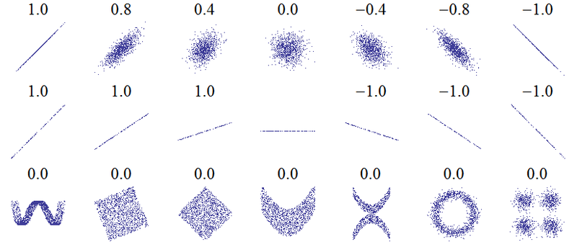[6]

Example 5

Calculate the correlation coefficient for our cricket data.

Because the data appears to follow a linear pattern, we can use technology to calculate *r* = 0.9509. Since this value is very close to 1, it suggests a strong increasing linear relationship.

Example 6

Gasoline consumption in the US has been increasing steadily. Consumption data from 1994 to 2004 is shown below.[7] Determine if the trend is linear, and if so, find a model for the data. Use the model to predict the consumption in 2008.

|  |  |  |  |  |  |  |  |  |  |  |  |
| --- | --- | --- | --- | --- | --- | --- | --- | --- | --- | --- | --- |
| Year | '94 | '95 | '96 | '97 | '98 | '99 | '00 | '01 | '02 | '03 | '04 |
| Consumption (billions of gallons) | 113 | 116 | 118 | 119 | 123 | 125 | 126 | 128 | 131 | 133 | 136 |

To make things simpler, a new input variable is introduced, *t*, representing years since 1994.

Using technology, the correlation coefficient was calculated to be 0.9965, suggesting a very strong increasing linear trend.

The least-squares regression equation is:

.

Using this to predict consumption in 2008 (*t* = 14),

 billions of gallons

The model predicts 144.244 billion gallons of gasoline will be consumed in 2008.

Try it Now

2. Use the model created by technology in example 6 to predict the gas consumption in 2011. Is this an interpolation or an extrapolation?

Important Topics of this Section

Fitting linear models to data by hand

Fitting linear models to data using technology

Interpolation

Extrapolation

Correlation coefficient

Flashback Answers

1. a. T = Temperature, C = Chirps (answers may vary)

b. Independent (Chirps) , Dependent (Temperature)

c. Reasonable Domain (18.5, 44) , Reasonable Range (52, 80.5) (answers may vary)

d. NO, it is not one-to-one, there are two different output values for 35 chirps.

Try it Now Answers

1. 54 degrees Fahrenheit

2. 150.871 billion gallons; extrapolation

## Section 2.4 Exercises

1. The following is data for the first and second quiz scores for 8 students in a class. Plot the points, then sketch a line that fits the data.

|  |  |  |  |  |  |  |  |  |
| --- | --- | --- | --- | --- | --- | --- | --- | --- |
| **First Quiz** | 11 | 20 | 24 | 25 | 33 | 42 | 46 | 49 |
| **Second Quiz** | 10 | 16 | 23 | 28 | 30 | 39 | 40 | 49 |

1. Eight students were asked to estimate their score on a 10 point quiz. Their estimated and actual scores are given. Plot the points, then sketch a line that fits the data.

|  |  |  |  |  |  |  |  |  |
| --- | --- | --- | --- | --- | --- | --- | --- | --- |
| **Predicted** | 5 | 7 | 6 | 8 | 10 | 9 | 10 | 7 |
| **Actual** | 6 | 6 | 7 | 8 | 9 | 9 | 10 | 6 |

Based on each set of data given, calculate the regression line using your calculator or other technology tool, and determine the correlation coefficient.

|  |  |  |  |  |  |  |  |  |  |  |  |  |  |  |  |  |  |  |  |  |  |  |  |  |  |  |  |  |  |  |  |  |  |  |  |  |  |  |  |  |  |  |  |  |  |  |  |  |  |  |  |  |  |  |  |  |  |  |  |  |  |  |  |  |  |  |  |  |  |  |  |  |  |  |  |  |  |  |  |  |  |  |  |  |  |  |  |  |  |  |  |  |  |  |  |  |  |
| --- | --- | --- | --- | --- | --- | --- | --- | --- | --- | --- | --- | --- | --- | --- | --- | --- | --- | --- | --- | --- | --- | --- | --- | --- | --- | --- | --- | --- | --- | --- | --- | --- | --- | --- | --- | --- | --- | --- | --- | --- | --- | --- | --- | --- | --- | --- | --- | --- | --- | --- | --- | --- | --- | --- | --- | --- | --- | --- | --- | --- | --- | --- | --- | --- | --- | --- | --- | --- | --- | --- | --- | --- | --- | --- | --- | --- | --- | --- | --- | --- | --- | --- | --- | --- | --- | --- | --- | --- | --- | --- | --- | --- | --- | --- | --- | --- | --- |
| 3. | |  |  | | --- | --- | | ***x*** | ***y*** | | 5 | 4 | | 7 | 12 | | 10 | 17 | | 12 | 22 | | 15 | 24 | | 4. | |  |  | | --- | --- | | ***x*** | ***y*** | | 8 | 23 | | 15 | 41 | | 26 | 53 | | 31 | 72 | | 56 | 103 | | 5. | |  |  | | --- | --- | | ***x*** | ***y*** | | 3 | 21.9 | | 4 | 22.22 | | 5 | 22.74 | | 6 | 22.26 | | 7 | 20.78 | | 8 | 17.6 | | 9 | 16.52 | | 10 | 18.54 | | 11 | 15.76 | | 12 | 13.68 | | 13 | 14.1 | | 14 | 14.02 | | 15 | 11.94 | | 16 | 12.76 | | 17 | 11.28 | | 18 | 9.1 | | 6. | |  |  | | --- | --- | | ***x*** | ***y*** | | 4 | 44.8 | | 5 | 43.1 | | 6 | 38.8 | | 7 | 39 | | 8 | 38 | | 9 | 32.7 | | 10 | 30.1 | | 11 | 29.3 | | 12 | 27 | | 13 | 25.8 | | 14 | 24.7 | | 15 | 22 | | 16 | 20.1 | | 17 | 19.8 | | 18 | 16.8 | |

1. A regression was run to determine if there is a relationship between hours of TV watched per day (*x*) and number of situps a person can do (*y*). The results of the regression are given below. Use this to predict the number of situps a person who watches 11 hours of TV can do.

y=ax+b

a=-1.341

b=32.234

r2=0.803

r=-0.896

1. A regression was run to determine if there is a relationship between the diameter of a tree (*x*, in inches) and the tree’s age (*y*, in years). The results of the regression are given below. Use this to predict the age of a tree with diameter 10 inches.

y=ax+b

a=6.301

b=-1.044

r2=0.940

r=0.970

Match each scatterplot shown below with one of the four specified correlations.

9. *r* = 0.95 10. *r* = -0.89 11. *r* = 0.26 12. *r* = -0.39

A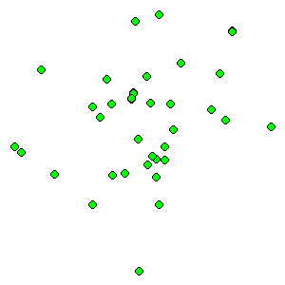 B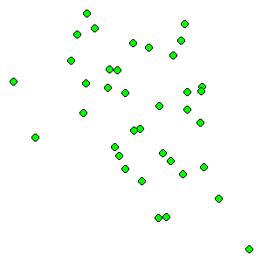 C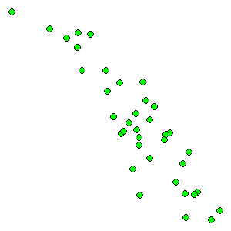 D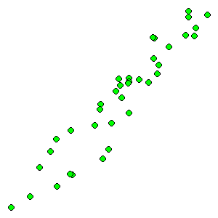

1. The US census tracks the percentage of persons 25 years or older who are college graduates. That data for several years is given below. Determine if the trend appears linear. If so and the trend continues, in what year will the percentage exceed 35%?

|  |  |  |  |  |  |  |  |  |  |  |
| --- | --- | --- | --- | --- | --- | --- | --- | --- | --- | --- |
| Year | 1990 | 1992 | 1994 | 1996 | 1998 | 2000 | 2002 | 2004 | 2006 | 2008 |
| Percent Graduates | 21.3 | 21.4 | 22.2 | 23.6 | 24.4 | 25.6 | 26.7 | 27.7 | 28 | 29.4 |

1. The US import of wine (in hectoliters) for several years is given below. Determine if the trend appears linear. If so and the trend continues, in what year will imports exceed 12,000 hectoliters?

|  |  |  |  |  |  |  |  |  |  |  |
| --- | --- | --- | --- | --- | --- | --- | --- | --- | --- | --- |
| Year | 1992 | 1994 | 1996 | 1998 | 2000 | 2002 | 2004 | 2006 | 2008 | 2009 |
| Imports | 2665 | 2688 | 3565 | 4129 | 4584 | 5655 | 6549 | 7950 | 8487 | 9462 |

## 

## Section 2.5 Absolute Value Functions

So far in this chapter we have been studying the behavior of linear functions. The Absolute Value Function is a piecewise-defined function made up of two linear functions. The name, Absolute Value Function, should be familiar to you from Section 1.2. In its basic form it is one of our toolkit functions.

Absolute Value Function

The absolute value function can be defined as



The absolute value function is commonly used to determine the distance between two numbers on the number line. Given two values *a* and *b*, then  will give the distance, a positive quantity, between these values, regardless of which value is larger.

Example 1

Describe all values, *x*, within a distance of 4 from the number 5.

We want the distance between *x* and 5 to be less than or equal to 4. The distance can be represented using the absolute value, giving the expression



Example 2

A 2010 poll reported 78% of Americans believe that people who are gay should be able to serve in the US military, with a reported margin of error of 3%[8]. The margin of error tells us how far off the actual value could be from the survey value[9]. Express the set of possible values using absolute values.

Since we want the size of the difference between the actual percentage, *p*, and the reported percentage to be less than 3%,



Try it Now

1. Students who score within 20 points of 80 will pass the test. Write this as a distance from 80 using the absolute value notation.

**Important Features**

The most significant feature of the absolute value graph is the corner point where the graph changes direction. When finding the equation for a transformed absolute value function, this point is very helpful for determining the horizontal and vertical shifts.

Example 3

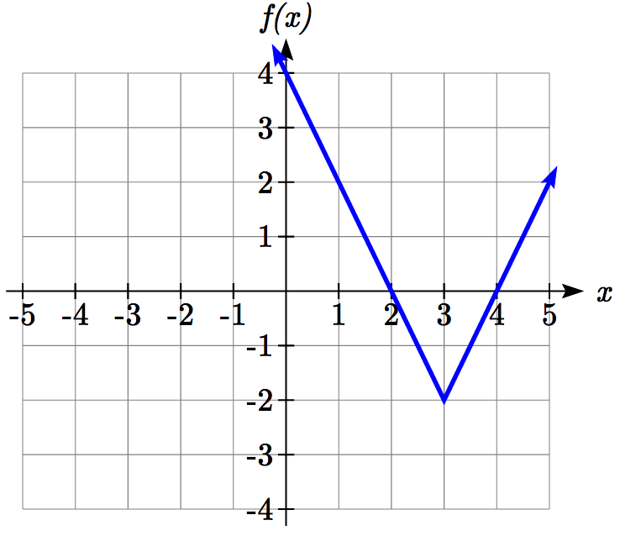Write an equation for the function graphed.

The basic absolute value function changes direction at the origin, so this graph has been shifted to the right 3 and down 2 from the basic toolkit function.

We might also notice that the graph appears stretched, since the linear portions have slopes of 2 and -2. From this information we could write the write the equation in two ways:

, treating the stretch as a vertical stretch

, treating the stretch as a horizontal compression

Note that these equations are algebraically equivalent – the stretch for an absolute value function can be written interchangeably as a vertical or horizontal stretch/compression.

If you had not been able to determine the stretch based on the slopes of the lines, you can solve for the stretch factor by putting in a known pair of values for *x* and *f(x)*

 Now substituting in the point (1, 2)



Try it Now

2. Given the description of the transformed absolute value function write the equation. The absolute value function is horizontally shifted left 2 units, is vertically flipped, and vertically shifted up 3 units.

The graph of an absolute value function will have a vertical intercept when the input is zero. The graph may or may not have horizontal intercepts, depending on how the graph has been shifted and reflected. It is possible for the absolute value function to have zero, one, or two horizontal intercepts.

Zero horizontal intercepts One Two

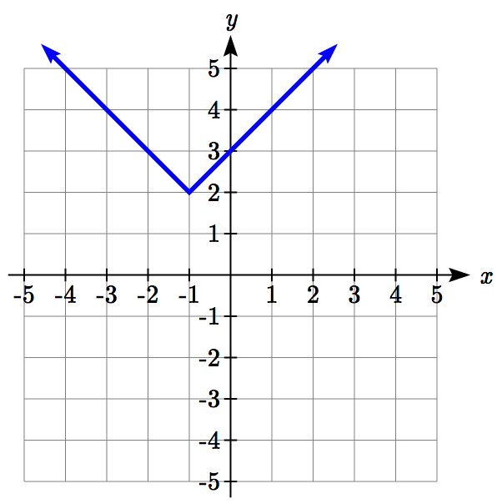 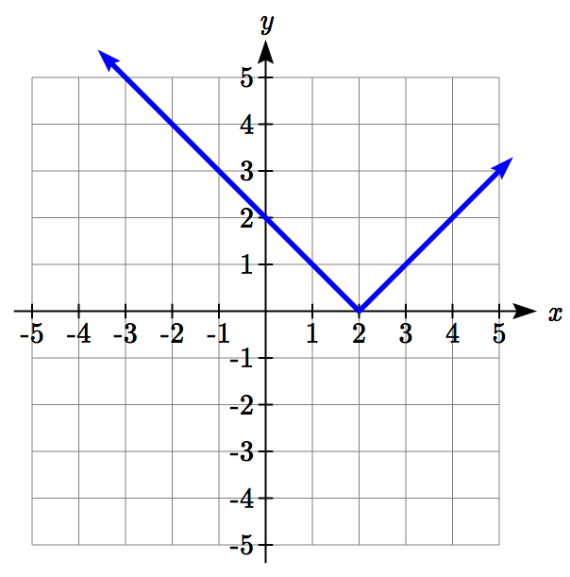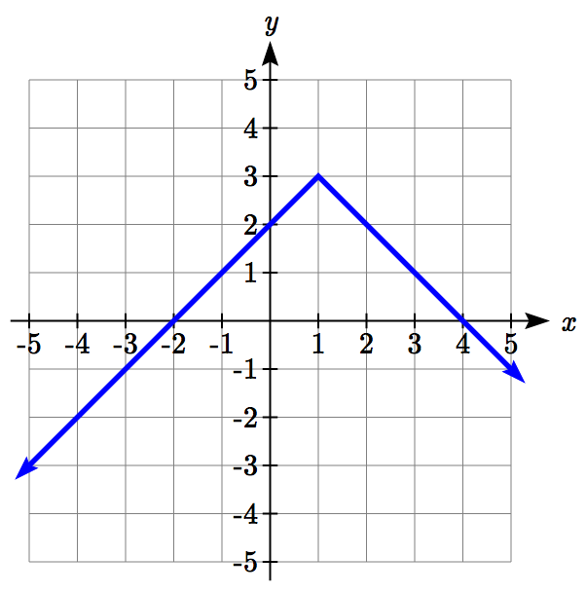

To find the horizontal intercepts, we will need to solve an equation involving an absolute value.

Notice that the absolute value function is not one-to-one, so typically inverses of absolute value functions are not discussed.

**Solving Absolute Value Equations**

To solve an equation like , we can notice that the absolute value will be equal to eight if the quantity *inside* the absolute value were 8 or -8. This leads to two different equations we can solve independently:

 or 

 

 

Solutions to Absolute Value Equations

An equation of the form , with , will have solutions when

 or 

Example 4

Find the horizontal intercepts of the graph of 

The horizontal intercepts will occur when . Solving,

 Isolate the absolute value on one side of the equation

 Now we can break this into two separate equations:

 or 

The graph has two horizontal intercepts, at  and *x* = -2

Example 5

Solve 

Isolating the absolute value on one side the equation,







At this point, we notice that this equation has no solutions – the absolute value always returns a positive value, so it is impossible for the absolute value to equal a negative value.

Try it Now

3. Find the horizontal & vertical intercepts for the function

**Solving Absolute Value Inequalities**

When absolute value inequalities are written to describe a set of values, like the inequality  we wrote earlier, it is sometimes desirable to express this set of values without the absolute value, either using inequalities, or using interval notation.

We will explore two approaches to solving absolute value inequalities:

1. Using the graph
2. Using test values

Example 6

Solve 

With both approaches, we will need to know first where the corresponding *equality* is true. In this case, we first will find where . We do this because the absolute value is a nice friendly function with no breaks, so the only way the function values can switch from being less than 4 to being greater than 4 is by passing through where the values equal 4. Solve ,

 or 

To use a graph, we can sketch the function . To help us see where the outputs are 4, the line  could also be sketched.

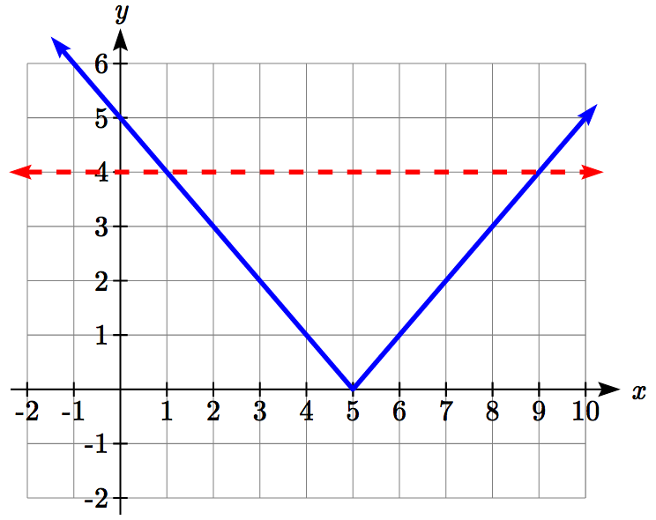

On the graph, we can see that indeed the output values of the absolute value are equal to 4 at *x* = 1 and *x* = 9. Based on the shape of the graph, we can determine the absolute value is less than or equal to 4 between these two points, when . In interval notation, this would be the interval [1,9].

As an alternative to graphing, after determining that the absolute value is equal to 4 at *x* = 1 and *x* = 9, we know the graph can only change from being less than 4 to greater than 4 at these values. This divides the number line up into three intervals: *x*<1, 1<*x*<9, and *x*>9. To determine when the function is less than 4, we could pick a value in each interval and see if the output is less than or greater than 4.

Interval Test *x* *f(x)* <4 or >4?

*x*<1 0  greater

1<*x*<9 6  less

*x*>9 11  greater

Since  is the only interval in which the output at the test value is less than 4, we can conclude the solution to  is .

Example 7

Given the function , determine for what *x* values the function values are negative.

We are trying to determine where *f(x)* < 0, which is when . We begin by isolating the absolute value:

 when we multiply both sides by -2, it reverses the inequality



Next we solve for the equality 

 or 

We can now either pick test values or sketch a graph of the function to determine on which intervals the original function value are negative. Notice that it is not even really important exactly what the graph looks like, as long as we know that it crosses the horizontal axis at  and , and that the graph has been reflected vertically.

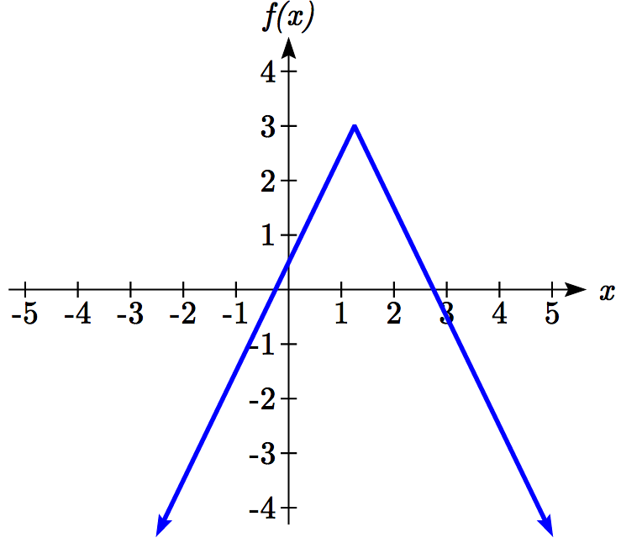

From the graph of the function, we can see the function values are negative to the left of the first horizontal intercept at , and negative to the right of the second intercept at . This gives us the solution to the inequality:



In interval notation, this would be 

Try it Now

4. Solve

Important Topics of this Section

The properties of the absolute value function

Solving absolute value equations

Finding intercepts

Solving absolute value inequalities

Try it Now Answers

1. Using the variable *p*, for passing, 

2. 

3. *f*(0) = 1, so the vertical intercept is at (0,1).   
*f(x)*= 0 when  
  
  
 or   
*x* = 1 or *x* = -5 so the horizontal intercepts are at (-5,0) & (1,0)

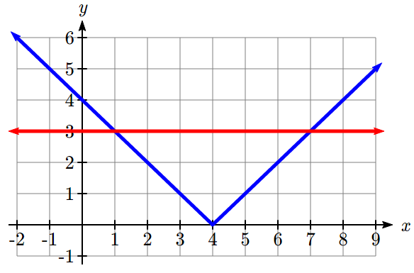4.   
  
Solving the equality , *k* – 4 = 3 or *k* – 4 = –3, so *k* = 1 or *k* = 7.  
Using a graph or test values, we can determine the intervals that satisfy the inequality are or ; in interval notation this would be 

## Section 2.5 Exercises

Write an equation for each transformation of 

1.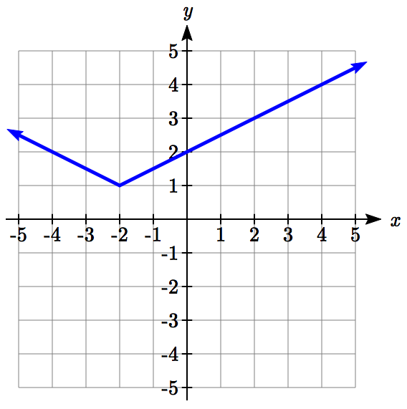 2.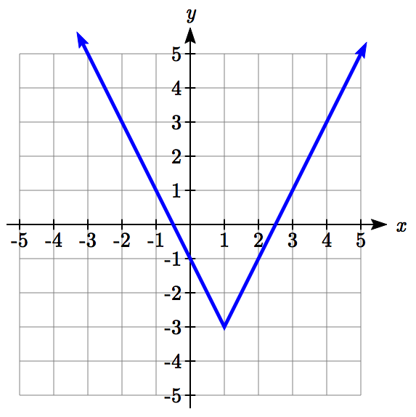

3.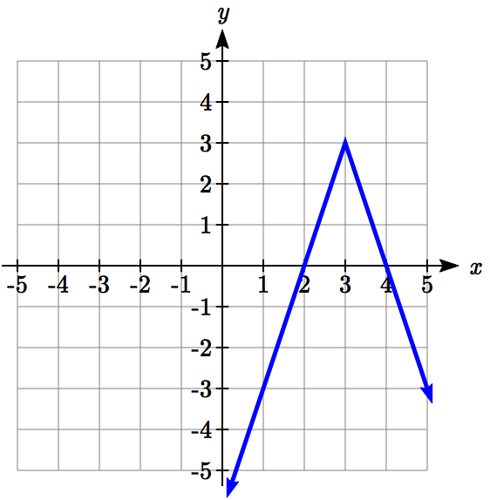 4.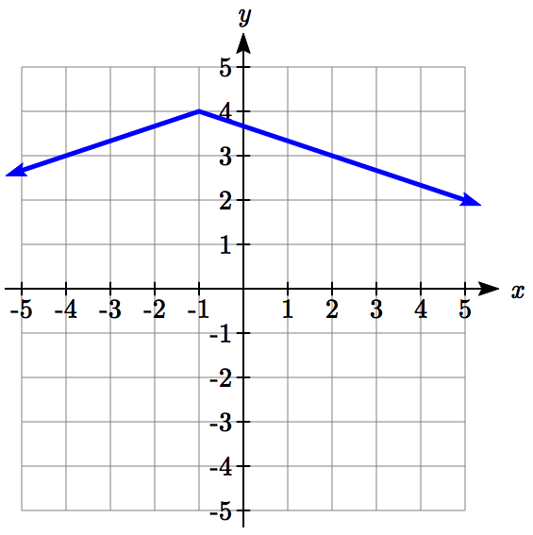

Sketch a graph of each function

5.  6. 

7.  8. 

9.  10. 

Solve each the equation

11.  12.    
13.  14. 

15.  16. 

Find the horizontal and vertical intercepts of each function

17.  18. 

19.  20.   
  
Solve each inequality

21.  22. 

23.  24. 

25.  26. 

1. [Nevada Taxicab Authority](http://taxi.nv.gov/uploadedFiles/taxinvgov/content/Rider_Info/TriFoldwebsite.pdf), retrieved Aug 4, 2020. There is also a waiting fee assessed when the taxi is waiting at red lights, but we’ll ignore that in this discussion.
2. <http://www.thesimpledollar.com/2009/06/19/rule-1-spend-less-than-you-earn/>
3. Rates retrieved Aug 2, 2010 from <http://www.budgettruck.com> and <http://www.uhaul.com/>
4. Selected data from <http://classic.globe.gov/fsl/scientistsblog/2007/10/>. Retrieved Aug 3, 2010
5. Technically, the method minimizes the sum of the squared differences in the vertical direction between the line and the data values.
6. <http://en.wikipedia.org/wiki/File:Correlation_examples.png>
7. http://www.bts.gov/publications/national_transportation_statistics/2005/html/table_04_10.html
8. <http://www.pollingreport.com/civil.htm>, retrieved August 4, 2010
9. Technically, margin of error usually means that the surveyors are 95% confident that actual value falls within this range.