# Chapter 8: Further Applications of Trigonometry

In this chapter, we will explore additional applications of trigonometry. We will begin with an extension of the right triangle trigonometry we explored in Chapter 5 to situations involving non-right triangles. We will explore the polar coordinate system and parametric equations as new ways of describing curves in the plane. In the process, we will introduce vectors and an alternative way of writing complex numbers, two important mathematical tools we use when analyzing and modeling the world around us.

Section 8.1 Non-Right Triangles: Laws of Sines and Cosines 497

Section 8.2 Polar Coordinates 514

Section 8.3 Polar Form of Complex Numbers 527

Section 8.4 Vectors 540

Section 8.5 Dot Product 554

Section 8.6 Parametric Equations 563

## Section 8.1 Non-Right Triangles: Laws of Sines and Cosines

Although right triangles allow us to solve many applications, it is more common to find scenarios where the triangle we are interested in does not have a right angle.

Two radar stations located 20 miles apart both detect a UFO located between them. The angle of elevation measured by the first station is 35 degrees. The angle of elevation measured by the second station is 15 degrees. What is the altitude of the UFO?



15°

35°

20 miles

We see that the triangle formed by the UFO and the two stations is not a right triangle. Of course, in any triangle we could draw an **altitude**, a perpendicular line from one vertex to the opposite side, forming two right triangles, but it would be nice to have methods for working directly with non-right triangles. In this section, we will expand upon the right triangle trigonometry we learned in Chapter 5, and adapt it to non-right triangles.

**Law of Sines**

Given an arbitrary non-right triangle, we can drop an altitude, which we temporarily label *h*, to create two right triangles.

*α*

*β*

*a*

*b*

*h*

*γ*

*c*

Using the right triangle relationships,

 and .

Solving both equations for *h*, we get  and . Since the *h* is the same in both equations, we establish . Dividing both sides by *ab*, we conclude that



Had we drawn the altitude to be perpendicular to side *b* or *a*, we could similarly establish

 and 

Collectively, these relationships are called the Law of Sines.

Law of Sines

Given a triangle with angles and sides opposite labeled as shown, the ratio of sine of angle to length of the opposite side will always be equal, or, symbolically,



*α*

*β*

*a*

*b*

*c*

*γ*

For clarity, we call side *a* the corresponding side of angle *α*.

Similarly, we call angle *α*, the corresponding angle of side *a*.

Likewise for side *b* and angle *β*, and for side *c* and angle *γ*.

When we use the law of sines, we use any pair of ratios as an equation. In the most straightforward case, we know two angles and one of the corresponding sides.

Example 1

In the triangle shown here, solve for the unknown sides and angle.

50°

10

*b*

30°

*c*

*γ*

Solving for the unknown angle is relatively easy, since the three angles must add to 180 degrees.

From this, we can determine that

γ = 180° – 50° – 30° = 100°.

To find an unknown side, we need to know the corresponding angle, and we also need another known ratio.

Since we know the angle 50° and its corresponding side, we can use this for one of the two ratios. To look for side *b*, we would use its corresponding angle, 30°.

 Multiply both sides by *b*

 Divide, or multiply by the reciprocal, to solve for *b*



Similarly, to solve for side *c*, we set up the equation





Example 2

Find the elevation of the UFO from the beginning of the section.

To find the elevation of the UFO, we first find the distance from one station to the UFO, such as the side *a* in the picture, then use right triangle relationships to find the height of the UFO, *h*.



15°

35°

20 miles

*h*

*a*

Since the angles in the triangle add to 180 degrees, the unknown angle of the triangle must be 180° – 15° – 35° = 130°. This angle is opposite the side of length 20, allowing us to set up a Law of Sines relationship:

 Multiply by *a*

 Divide, or multiply by the reciprocal, to solve for *a*

 Simplify

The distance from one station to the UFO is about 15 miles. Now that we know *a*, we can use right triangle relationships to solve for *h*.

 Solve for *h*



The UFO is at an altitude of 3.876 miles.

In addition to solving triangles in which two angles are known, the law of sines can be used to solve for an angle when two sides and one corresponding angle are known.

Example 3

In the triangle shown here, solve for the unknown sides and angles.

9

12

*a*

85°

*β*

*α*

In choosing which pair of ratios from the Law of Sines to use, we always want to pick a pair where we know three of the four pieces of information in the equation. In this case, we know the angle 85° and its corresponding side, so we will use that ratio. Since our only other known information is the side with length 9, we will use that side and solve for its corresponding angle.

 Isolate the unknown

 Use the inverse sine to find a first solution

Remember when we use the inverse function that there are two possible answers.

 By symmetry we find the second possible solution



In this second case, if *β* ≈ 132°, then *α* would be *α* = 180° – 85° – 132° = –37°, which doesn’t make sense, so the only possibility for this triangle is *β* = 48.3438°.

With a second angle, we can now easily find the third angle, since the angles must add to 180°, so α = 180° – 85° – 48.3438° = 46.6562°.

Now that we know α, we can proceed as in earlier examples to find the unknown side *a*.





Notice that in the problem above, when we use Law of Sines to solve for an unknown angle, there can be two possible solutions. This is called the **ambiguous case**, and can arise when we know two sides and a non-included angle. In the ambiguous case we may find that a particular set of given information can lead to 2, 1 or no solution at all. However, when an accurate picture of the triangle or suitable context is available, we can determine which angle is desired.

Try it Now

1. Given , find the corresponding and missing side and angles. If there is more than one possible solution, show both.

Example 4

Find all possible triangles if one side has length 4 opposite an angle of 50° and a second side has length 10.

Using the given information, we can look for the angle opposite the side of length 10.





Since the range of the sine function is [-1, 1], it is impossible for the sine value to be 1.915. There are no triangles that can be drawn with the provided dimensions.

Example 5

Find all possible triangles if one side has length 6 opposite an angle of 50° and a second side has length 4.

Using the given information, we can look for the angle opposite the side of length 4.



 Use the inverse to find one solution

 By symmetry there is a second possible solution



If we use the angle , the third angle would be . We can then use Law of Sines again to find the third side.

 Solve for *c*

*c*  = 7.730

If we used the angle *α* = 149.290°, the third angle would be 180° – 50° – 149.290° =

–19.29°, which is impossible, so the previous triangle is the only possible one.

Try it Now

1. Given find the missing side and angles. If there is more than one possible solution, show both.

**Law of Cosines**

20°



10 mi

8 mi

Suppose a boat leaves port, travels 10 miles, turns 20 degrees, and travels another 8 miles. How far from port is the boat?

Unfortunately, while the Law of Sines lets us address many non-right triangle cases, it does not allow us to address triangles where the one known angle is included between two known sides, which means it is not a corresponding angle for a known side. For this, we need another tool.

Given an arbitrary non-right triangle, we can drop an altitude, which we temporarily label *h*, to create two right triangles. We will divide the base *b* into two pieces, one of which we will temporarily label *x*.

*α*

*γ*

*a*

*c*

*h*

*β*

*x*

*b - x*

*b*

From this picture, we can establish the right triangle relationship

, or equivalently, 

Using the Pythagorean Theorem, we can establish

 and 

Both of these equations can be solved for 

 and 

Since the left side of each equation is , the right sides must be equal

 Multiply out the right

 Simplify



 Isolate 

 Substitute in  from above



This result is called the Law of Cosines. Depending upon which side we dropped the altitude down from, we could have established this relationship using any of the angles. The important thing to note is that the right side of the equation involves an angle and the sides adjacent to that angle – the left side of the equation involves the side opposite that angle.

Law of Cosines

Given a triangle with angles and opposite sides labeled as shown,

*α*

*β*

*a*

*b*

*c*

*γ*







Notice that if one of the angles of the triangle is 90 degrees, cos(90°) = 0, so the formula

 Simplifies to



You should recognize this as the Pythagorean Theorem. Indeed, the Law of Cosines is sometimes called the **Generalized Pythagorean Theorem**, since it extends the Pythagorean Theorem to non-right triangles.

Example 6

Returning to our question from earlier, suppose a boat leaves port, travels 10 miles, turns 20 degrees, and travels another 8 miles. How far from port is the boat?

20°



10 mi

8 mi

The boat turned 20 degrees, so the obtuse angle of the non-right triangle shown in the picture is the supplemental angle, 180° - 20° = 160°.

With this, we can utilize the Law of Cosines to find the missing side of the obtuse triangle – the distance from the boat to port.

 Evaluate the cosine and simplify

 Square root both sides



The boat is 17.73 miles from port.

Example 7

Find the unknown side and angles of this triangle.

*θ*

10

*x*

30°

12

*φφ*

Notice that we don’t have both pieces of any side/angle pair, so the Law of Sines would not work with this triangle.

Since we have the angle included between the two known sides, we can turn to Law of Cosines.

Since the left side of any of the Law of Cosines equations involves the side opposite the known angle, the left side in this situation will involve the side *x*. The other two sides can be used in either order.

 Evaluate the cosine

 Simplify

 Take the square root



Now that we know an angle and its corresponding side, we can use the Law of Sines to fill in the remaining angles of the triangle. Solving for angle *θ*,



 Use the inverse sine



The other possibility for *θ* would be *θ* = 180° – 56.256° = 123.744°. In the original picture, *θ* is an acute angle, so 123.744° doesn’t make sense if we assume the picture is drawn to scale.

Proceeding with *θ* = 56.256°, we can then find the third angle of the triangle:

.

In addition to solving for the missing side opposite one known angle, the Law of Cosines allows us to find the angles of a triangle when we know all three sides.

Example 8

Solve for the angle *α* in the triangle shown.

18

25

20

*α*

Using the Law of Cosines,

 Simplify









Try it Now

1. Given find the missing side and angles.

Notice that since the inverse cosine can return any angle between 0 and 180 degrees, there will not be any ambiguous cases when using Law of Cosines to find an angle.

Example 9

On many cell phones with GPS, an approximate location can be given before the GPS signal is received. This is done by a process called triangulation, which works by using the distance from two known points. Suppose there are two cell phone towers within range of you, located 6000 feet apart along a straight highway that runs east to west, and you know you are north of the highway. Based on the signal delay, it can be determined you are 5050 feet from the first tower, and 2420 feet from the second. Determine your position north and east of the first tower, and determine how far you are from the highway.

For simplicity, we start by drawing a picture and labeling our given information. Using the Law of Cosines, we can solve for the angle *θ*.

2420 ft

5050 ft

6000 ft



*θ*











5050 ft



23.3°

*y*

*x*

Using this angle, we could then use right triangles to find the position of the cell phone relative to the western tower.



 feet



 feet

You are 5050 ft from the tower and north of east (or, equivalently, 66.672° east of north). Specifically, you are about 4637 feet east and 2000 feet north of the first tower.

Note that if you didn’t know whether you were north or south of the towers, our calculations would have given two possible locations, one north of the highway and one south. To resolve this ambiguity in real world situations, locating a position using triangulation requires a signal from a third tower.

Example 10

To measure the height of a hill, a woman measures the angle of elevation to the top of the hill to be 24 degrees. She then moves back 200 feet and measures the angle of elevation to be 22 degrees. Find the height of the hill.

As with many problems of this nature, it will be helpful to draw a picture.

24°

22°

200 ft

*h*

Notice there are three triangles formed here – the right triangle including the height *h* and the 22 degree angle, the right triangle including the height *h* and the 24 degree angle, and the (non-right) obtuse triangle including the 200 ft side. Since this is the triangle we have the most information for, we will begin with it. It may seem odd to work with this triangle since it does not include the desired side *h*, but we don’t have enough information to work with either of the right triangles yet.

We can find the obtuse angle of the triangle, since it and the angle of 24 degrees complete a straight line – a 180 degree angle. The obtuse angle must be 180° - 24° = 156°. From this, we can determine that the third angle is 2°. We know one side is 200 feet, and its corresponding angle is 2°, so by introducing a temporary variable *x* for one of the other sides (as shown below), we can use Law of Sines to solve for this length *x*.

24°

22°

200 ft

*h*

156°

2°

*x*

 Setting up the Law of Sines

 isolating the *x* value

ft

Now that we know *x*, we can use right triangle properties to solve for *h*.



ft. The hill is 873 feet high.

Important Topics of This Section

Law of Sines

Solving for sides

Solving for angles

Ambiguous case, 0, 1 or 2 solutions

Law of Cosines

Solving for sides

Solving for angles

Generalized Pythagorean Theorem

Try it Now Answers

1.   
1st possible solution 2nd solution 

If we were given a picture of the triangle it may be possible to eliminate one of these

2. .  or ; only the first is reasonable.  
  
  


3. . *a* = 11.725  
.  or ;   
 only the first is reasonable since 25° + 158.9° would exceed 180°.  
  


## Section 8.1 Exercises

Solve for the unknown sides and angles of the triangles shown.

1. 2.

70°

50°

10

40°

110°

18

3. 4.

120°

6

25°

75°

45°

15

5. 6.

65°

5

6

70°

90

100

7. 8.

18

40°

25

30

50

30°

Assume  is opposite side *a*,  is opposite side *b*, and  is opposite side *c*. Solve each triangle for the unknown sides and angles if possible. If there is more than one possible solution, give both.

9.  10. 

11.  12. 

13.  14. 

15.  16. 

Solve for the unknown sides and angles of the triangles shown.

17. 18.

60°

20

28

30°

16

10

19. 20.

13

11

20

5

8

10

Assume  is opposite side *a*,  is opposite side *b*, and  is opposite side *c*. Solve each triangle for the unknown sides and angles if possible. If there is more than one possible solution, give both.

21.  22. 

23.  24. 

1. Find the area of a triangle with sides of length 18, 21, and 32.
2. Find the area of a triangle with sides of length 20, 26, and 37.



800 ft

900 ft

70°

1. To find the distance across a small lake, a surveyor has taken the measurements shown. Find the distance across the lake.



350 km

370 km

2.1°

1. To find the distance between two cities, a satellite calculates the distances and angle shown (*not to scale*). Find the distance between the cities.
2. To determine how far a boat is from shore, two radar stations 500 feet apart determine the angles out to the boat, as shown. Find the distance of the boat from the station *A*, and the distance of the boat from shore.



70°

*A*

60°

*B*



86.2°

83.9°

*A*

*B*

1. The path of a satellite orbiting the earth causes it to pass directly over two tracking stations *A* and *B*, which are 69 mi apart. When the satellite is on one side of the two stations, the angles of elevation at *A* and *B* are measured to be 86.2° and 83.9°, respectively. How far is the satellite from station *A* and how high is the satellite above the ground?

67°

16°

165m

1. A communications tower is located at the top of a steep hill, as shown. The angle of inclination of the hill is 67°. A guy-wire is to be attached to the top of the tower and to the ground, 165 m downhill from the base of the tower. The angle formed by the guy-wire and the hill is 16°. Find the length of the cable required for the guy wire.

20°

38°

8 ft

1. The roof of a house is at a 20° angle. An 8 foot solar panel is to be mounted on the roof, and should be angled 38° relative to the horizontal for optimal results. How long does the vertical support holding up the back of the panel need to be?

38°

64 ft

127 ft

1. A 127 foot tower is located on a hill that is inclined 38° to the horizontal. A guy-wire is to be attached to the top of the tower and anchored at a point 64 feet downhill from the base of the tower. Find the length of wire needed.

34°

98 ft

113 ft

1. A 113 foot tower is located on a hill that is inclined 34° to the horizontal. A guy-wire is to be attached to the top of the tower and anchored at a point 98 feet uphill from the base of the tower. Find the length of wire needed.

*A*

*B*

37°

44°



1. A pilot is flying over a straight highway. He determines the angles of depression to two mileposts, 6.6 km apart, to be 37° and 44°, as shown in the figure. Find the distance of the plane from point *A*, and the elevation of the plane.

*A*

*B*

32°

56°



1. A pilot is flying over a straight highway. He determines the angles of depression to two mileposts, 4.3 km apart, to be 32° and 56°, as shown in the figure. Find the distance of the plane from point *A*, and the elevation of the plane.
2. To estimate the height of a building, two students find the angle of elevation from a point (at ground level) down the street from the building to the top of the building is 39°. From a point that is 300 feet closer to the building, the angle of elevation (at ground level) to the top of the building is 50°. If we assume that the street is level, use this information to estimate the height of the building.
3. To estimate the height of a building, two students find the angle of elevation from a point (at ground level) down the street from the building to the top of the building is 35°. From a point that is 300 feet closer to the building, the angle of elevation (at ground level) to the top of the building is 53°. If we assume that the street is level, use this information to estimate the height of the building.
4. A pilot flies in a straight path for 1 hour 30 min. She then makes a course correction, heading 10 degrees to the right of her original course, and flies 2 hours in the new direction. If she maintains a constant speed of 680 miles per hour, how far is she from her starting position?
5. Two planes leave the same airport at the same time. One flies at 20 degrees east of north at 500 miles per hour. The second flies at 30 east of south at 600 miles per hour. How far apart are the planes after 2 hours?
6. The four sequential sides of a quadrilateral have lengths 4.5 cm, 7.9 cm, 9.4 cm, and 12.9 cm. The angle between the two smallest sides is 117°. What is the area of this quadrilateral?
7. The four sequential sides of a quadrilateral have lengths 5.7 cm, 7.2 cm, 9.4 cm, and 12.8 cm. The angle between the two smallest sides is 106°. What is the area of this quadrilateral?
8. Three circles with radii 6, 7, and 8, all touch as shown. Find the shaded area bounded by the three circles.

55°

1. A rectangle is inscribed in a circle of radius 10 cm as shown. Find the shaded area, inside the circle but outside the rectangle.

## Section 8.2 Polar Coordinates

The coordinate system we are most familiar with is called the Cartesian coordinate system, a rectangular plane divided into four quadrants by horizontal and vertical axes.

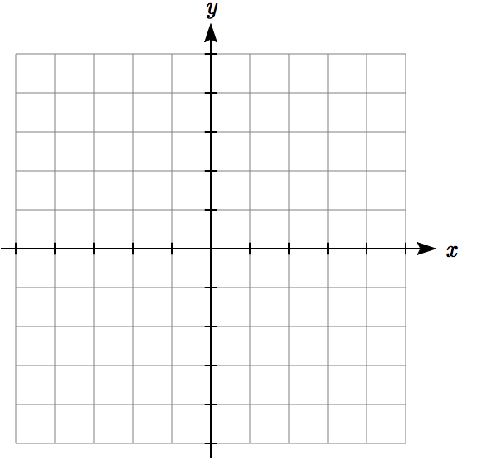

In earlier chapters, we often found the Cartesian coordinates of a point on a circle at a given angle from the positive horizontal axis. Sometimes that angle, along with the point’s distance from the origin, provides a more useful way of describing the point’s location than conventional Cartesian coordinates.

Polar Coordinates

Polar coordinates of a point consist of an ordered pair, , where *r* is the distance from the point to the origin, and *θ* is the angle measured in standard position.

Notice that if we were to “grid” the plane for polar coordinates, it would look like the graph to the right, with circles at incremental radii, and rays drawn at incremental angles.

Example 1

Plot the polar point .

This point will be a distance of 3 from the origin, at an angle of . Plotting this,

Example 2

Plot the polar point .

Typically we use positive *r* values, but occasionally we run into cases where *r* is negative. On a regular number line, we measure positive values to the right and negative values to the left. We will plot this point similarly. To start, we rotate to an angle of . Moving this direction, into the first quadrant, would be positive *r* values. For negative *r* values, we move the opposite direction, into the third quadrant. Plotting this:

Note the resulting point is the same as the polar point . In fact, any Cartesian point can be represented by an infinite number of different polar coordinates by adding or subtracting full rotations to these points. For example, same point could also be represented as .

Try it Now

1. Plot the following points given in polar coordinates and label them.  
   a.  b.  c. 

**Converting Points**

To convert between polar coordinates and Cartesian coordinates, we recall the relationships we developed back in Chapter 5.

Converting Between Polar and Cartesian Coordinates

To convert between polar and Cartesian (*x*, *y*) coordinates,  
we use the relationships

(*x*, *y*)

*r*

*θ*

*y*

*x*

 

 

 

From these relationship and our knowledge of the unit circle, if *r* = 1 and , the polar coordinates would be , and the corresponding Cartesian coordinates.

Remembering your unit circle values will come in very handy as you convert between Cartesian and polar coordinates.

Example 3

Find the Cartesian coordinates of a point with polar coordinates .

To find the *x* and *y* coordinates of the point,





The Cartesian coordinates are .

Example 4

Find the polar coordinates of the point with Cartesian coordinates .

We begin by finding the distance *r* using the Pythagorean relationship 









Now that we know the radius, we can find the angle using any of the three trig relationships. Keep in mind that any of the relationships will produce two solutions on the circle, and we need to consider the quadrant to determine which solution to accept. Using the cosine, for example:



 By symmetry, there is a second possibility at



Since the point (-3, -4) is located in the 3rd quadrant, we can determine that the second angle is the one we need. The polar coordinates of this point are .

Try it Now

2. Convert the following.  
a. Convert polar coordinates  to .  
b. Convert Cartesian coordinates  to .

**Polar Equations**

Just as a Cartesian equation like  describes a relationship between *x* and *y* values on a Cartesian grid, a polar equation can be written describing a relationship between *r* and *θ* values on the polar grid.

Example 5

Sketch a graph of the polar equation .

The equation  describes all the points for which the radius *r* is equal to the angle. To visualize this relationship, we can create a table of values.

|  |  |  |  |  |  |  |  |  |  |
| --- | --- | --- | --- | --- | --- | --- | --- | --- | --- |
| *θ* | 0 | π/4 | π/2 | 3π/4 | π | 5π/4 | 3π/2 | 7π/4 | 2π |
| *r* | 0 | π/4 | π/2 | 3π/4 | π | 5π/4 | 3π/2 | 7π/4 | 2π |

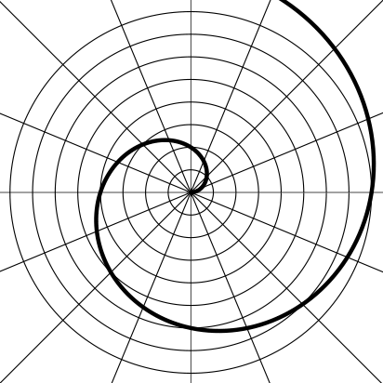

We can plot these points on the plane, and then sketch a curve that fits the points. The resulting graph is a spiral.

Notice that the resulting graph cannot be the result of a function of the form *y* = *f(x)*, as it does not pass the vertical line test, even though it resulted from a function giving *r* in terms of *θ*.

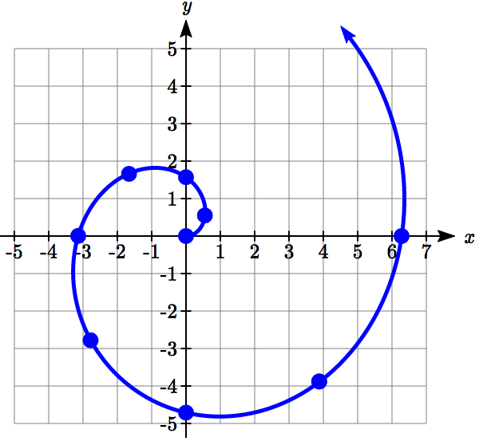

Although it is nice to see polar equations on polar grids, it is more common for polar graphs to be graphed on the Cartesian coordinate system, and so, the remainder of the polar equations will be graphed accordingly.

The spiral graph above on a Cartesian grid is shown here.

Example 6

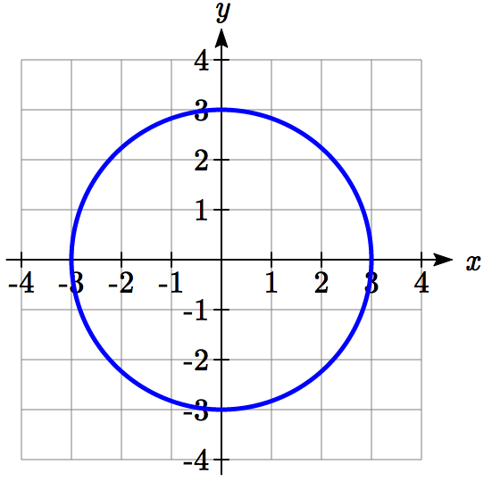Sketch a graph of the polar equation .

Recall that when a variable does not show up in the equation, it is saying that it does not matter what value that variable has; the output for the equation will remain the same. For example, the Cartesian equation *y* = 3 describes all the points where *y* = 3, no matter what the *x* values are, producing a horizontal line. Likewise, this polar equation is describing all the points at a distance of 3 from the origin, no matter what the angle is, producing the graph of a **circle.**

The normal settings on graphing calculators and software graph on the Cartesian coordinate system with *y* being a function of *x*, where the graphing utility asks for *f(x)*, or simply *y =*.

To graph polar equations, you may need to change the mode of your calculator to Polar. You will know you have been successful in changing the mode if you now have *r* as a function of *θ,* where the graphing utility asks for *r(θ),* or simply *r =*.

Example 7

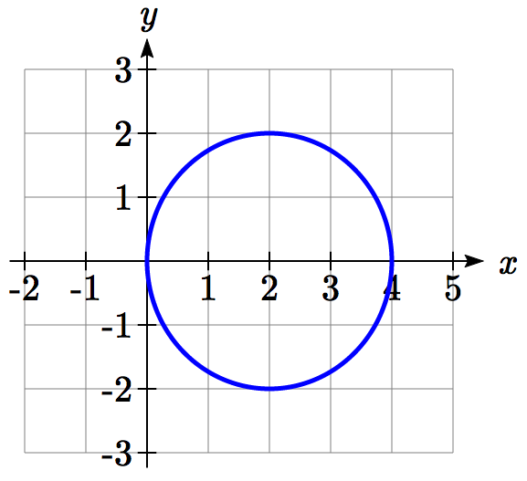Sketch a graph of the polar equation , and find an interval on which it completes one cycle.

While we could again create a table, plot the corresponding points, and connect the dots, we can also turn to technology to directly graph it. Using technology, we produce the graph shown here, a circle passing through the origin.

Since this graph appears to close a loop and repeat itself, we might ask what interval of *θ* values yields the entire graph. At *θ* = 0, , yielding the point (4, 0). We want the next *θ* value when the graph returns to the point (4, 0). Solving for when *x* = 4 is equivalent to solving .

 Substituting the equation for *r* gives

 Dividing by 4 and simplifying

 This has solutions when

 or  Solving these gives solutions

or 

This shows us at 0 radians we are at the point (0, 4), and again at radians we are at the point (0, 4) having finished one complete revolution.

The interval yields one complete iteration of the circle.

Try it Now

3. Sketch a graph of the polar equation , and find an interval on which it completes one cycle.

The last few examples have all been circles. Next, we will consider two other “named” polar equations, **limaçons** and **roses**.

Example 8

Sketch a graph of the polar equation . What interval of *θ* values corresponds to the inner loop?

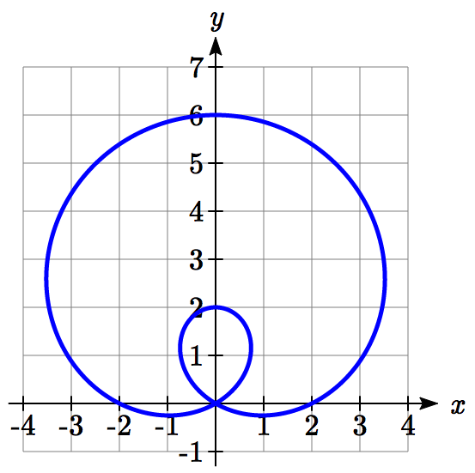

This type of graph is called a **limaçon**.

Using technology, we can draw the graph. The inner loop begins and ends at the origin, where *r* = 0. We can solve for the *θ* values for which *r* = 0.







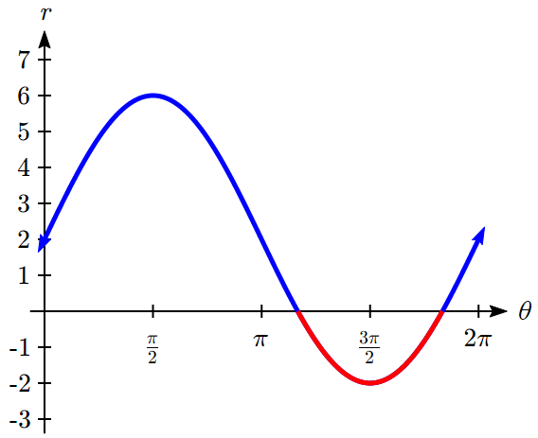 or 

This tells us that *r* = 0, so the graph passes through the origin, twice on the interval [0, 2π).

The inner loop arises from the interval . This corresponds to where the function  takes on negative values, as we could see if we graphed the function in the  plane.

Example 9

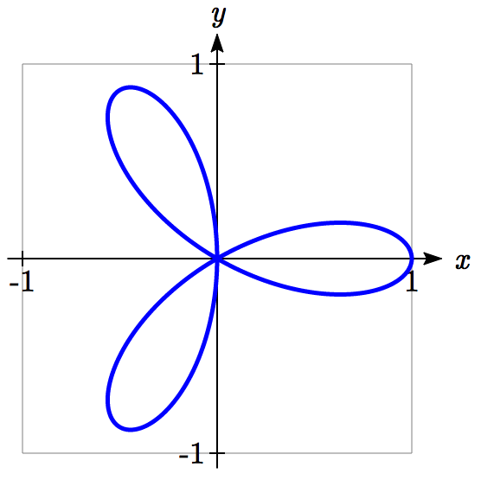Sketch a graph of the polar equation . What interval of *θ* values describes one small loop of the graph?

This type of graph is called a 3 leaf **rose.**

We can use technology to produce a graph. The interval [0, π) yields one cycle of this function. As with the last problem, we can note that there is an interval on which one loop of this graph begins and ends at the origin, where *r* = 0. Solving for *θ*,

 Substitute *u* = 3*θ*



 or  or 

Undo the substitution,

 or  or 

 or  or 

There are 3 solutions on  which correspond to the 3 times the graph returns to the origin, but the first two solutions we solved for above are enough to conclude that one loop corresponds to the interval .

If we wanted to get an idea of how the computer drew this graph, consider when *θ* = 0. , so the graph starts at (1,0). As we found above, at  and , the graph is at the origin. Looking at the equation, notice that any angle in between  and , for example at , produces a negative *r*: .

|  |  |  |  |
| --- | --- | --- | --- |
| ***θ*** | ***r*** | ***x*** | ***y*** |
| 0 | 1 | 1 | 0 |
|  | 0 | 0 | 0 |
|  | -1 |  |  |
|  | 0 | 0 | 0 |

Notice that with a negative *r* value and an angle with terminal side in the first quadrant, the corresponding Cartesian point would be in the third quadrant. Since  is negative on , this interval corresponds to the loop of the graph in the third quadrant.

Try it Now

4. Sketch a graph of the polar equation . Would you call this function a **limaçon** or a **rose**?

**Converting Equations**

While many polar equations cannot be expressed nicely in Cartesian form (and vice versa), it can be beneficial to convert between the two forms, when possible. To do this we use the same relationships we used to convert points between coordinate systems.

Example 10

Rewrite the Cartesian equation  as a polar equation.

We wish to eliminate *x* and *y* from the equation and introduce *r* and *θ*. Ideally, we would like to write the equation with *r* isolated, if possible, which represents *r* as a function of *θ*.

 Remembering  we substitute

  and so we substitute again

 Subtract  from both sides

 Factor

 Use the zero factor theorem

 or *r* = 0 Since *r* = 0 is only a point, we reject that solution.

The solution  is fairly similar to the one we graphed in Example 7. In fact, this equation describes a circle with bottom at the origin and top at the point (0, 6).

Example 11

Rewrite the Cartesian equation  as a polar equation.

 Use  and 

 Move all terms with *r* to one side

 Factor out *r*

 Divide



In this case, the polar equation is more unwieldy than the Cartesian equation, but there are still times when this equation might be useful.

Example 12

Rewrite the polar equation  as a Cartesian equation.

We want to eliminate *θ* and *r* and introduce *x* and *y*. It is usually easiest to start by clearing the fraction and looking to substitute values that will eliminate *θ*.

 Clear the fraction

 Use  to eliminate *θ*

 Distribute and simplify

 Isolate the *r*

 Square both sides

 Use 



When our entire equation has been changed from *r* and *θ* to *x* and *y* wecan stop unless asked to solve for *y* or simplify.

In this example, if desired, the right side of the equation could be expanded and the equation simplified further. However, the equation cannot be written as a function in Cartesian form.

Try it Now

5. a. Rewrite the Cartesian equation in polar form: 

b. Rewrite the polar equation in Cartesian form: 

Example 13

Rewrite the polar equation  in Cartesian form.

 Use the double angle identity for sine

 Use  and 

 Simplify

 Multiply by *r*2

 Since , 



This equation could also be written as

 or 

Important Topics of This Section

Cartesian coordinate system

Polar coordinate system

Plotting points in polar coordinates

Converting coordinates between systems

Polar equations: Spirals, circles, limaçons and roses

Converting equations between systems

Try it Now Answers

1.

*C*

*B*

*A*

2. a. converts to 

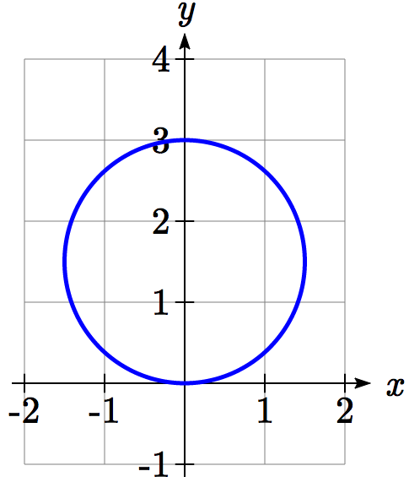 b.  converts to 

3.  at  and .  
It completes one cycle on the interval .

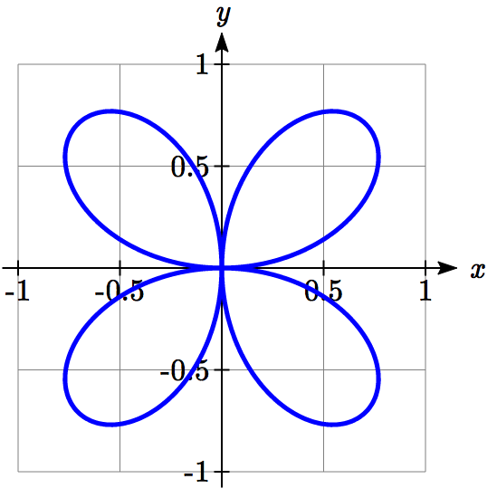

4. This is a 4-leaf rose.

5. a.  can be rewritten as , and becomes 

b. . . . 

## Section 8.2 Exercises

Convert the given polar coordinates to Cartesian coordinates.

1.  2.  3.  4. 

5.  6.  7.  8. 

9.  10.  11.  12. 

Convert the given Cartesian coordinates to polar coordinates.

13.  14.  15.  16. 

17.  18.  19.  20. 

Convert the given Cartesian equation to a polar equation.

21.  22.  23.  24. 

25.  26.  27.  28. 

Convert the given polar equation to a Cartesian equation.

29.  30. 

31.  32. 

33.  34. 

35.  36. 

Match each equation with one of the graphs shown.

37.  38.  39. 

40.  41.  42. 

A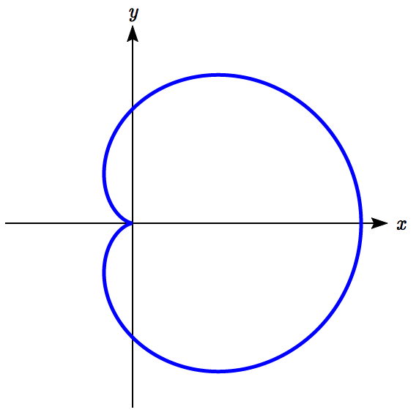 B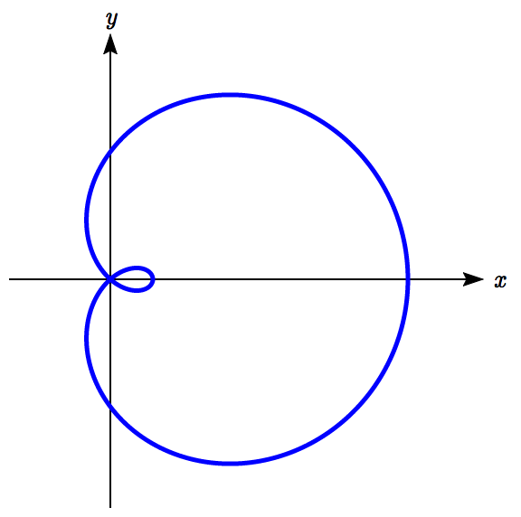 C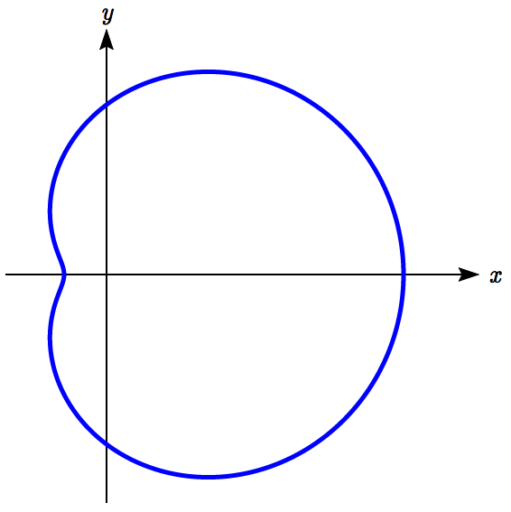

D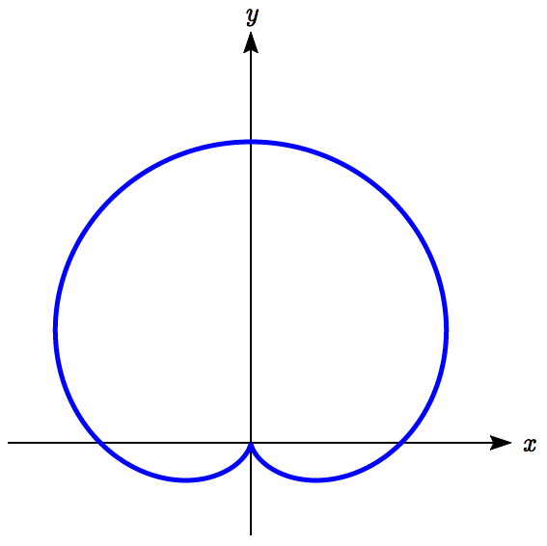 E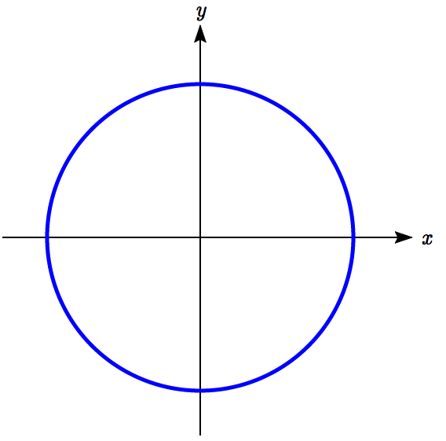 F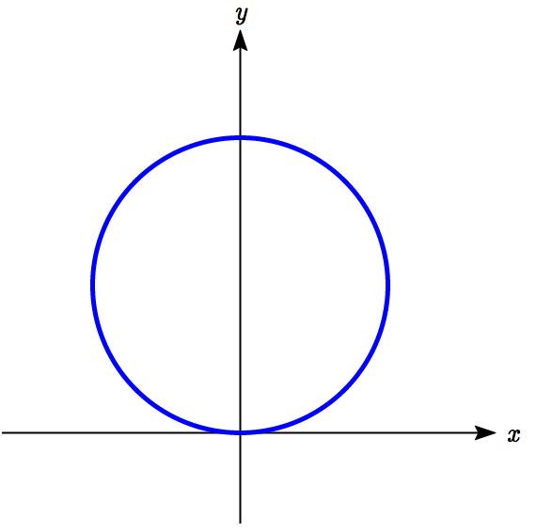

Match each equation with one of the graphs shown.

43.  44.  45. 

46.  47.  48. 

A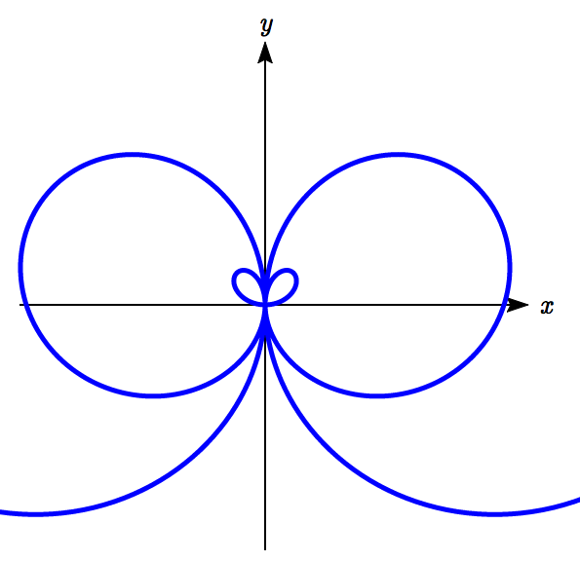 B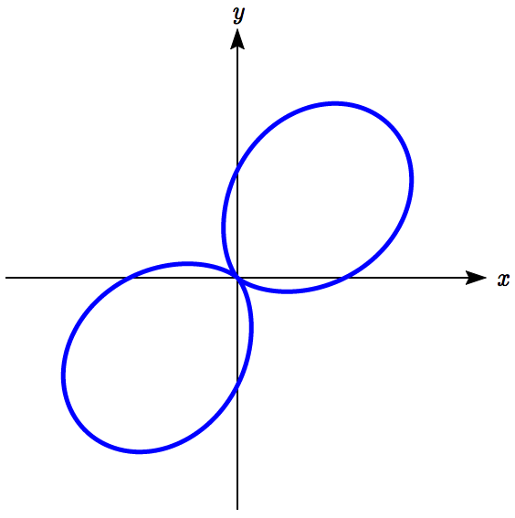 C 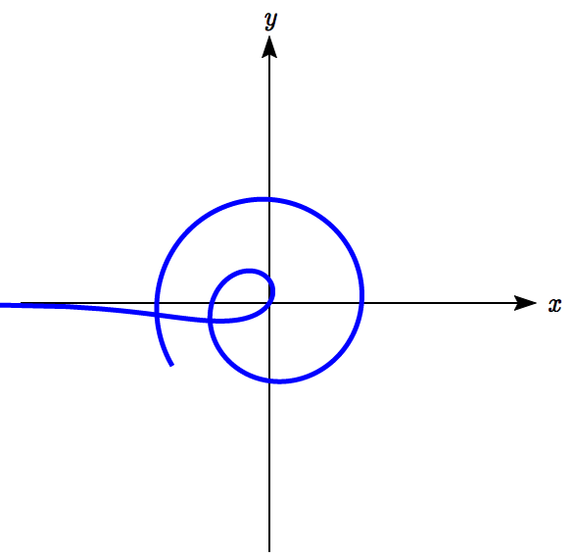

D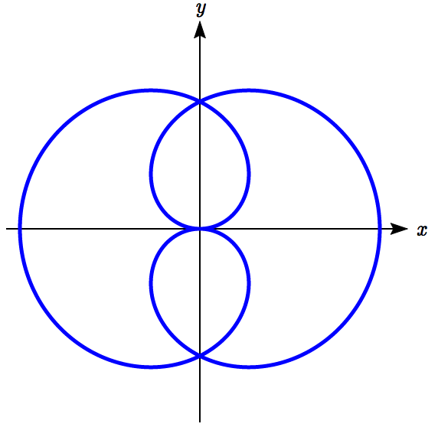 E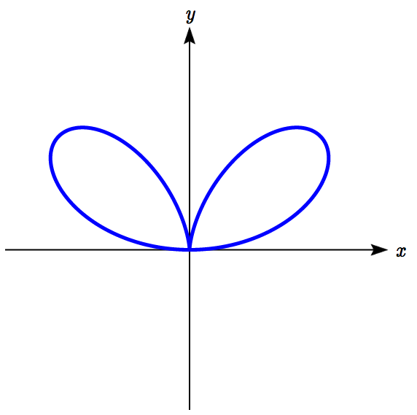 F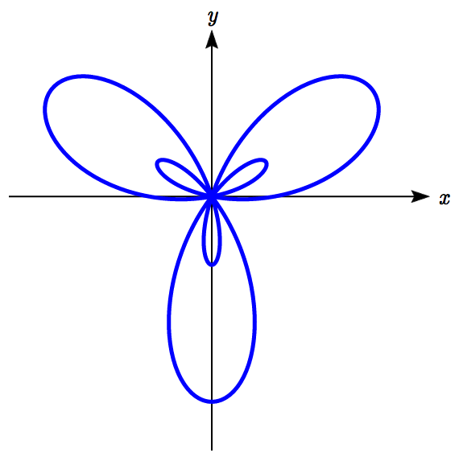

Sketch a graph of the polar equation.

49.  50.  51. 

52.  53.  54. 

55.  56.  57. 

58.  59.  60. 

61.  ­­­ 62. 

63. , a conchoid 64. , a lituus[1]

65. , a cissoid 66. , a hippopede

## Section 8.3 Polar Form of Complex Numbers

From previous classes, you may have encountered “imaginary numbers” – the square roots of negative numbers – and, more generally, complex numbers which are the sum of a real number and an imaginary number. While these are useful for expressing the solutions to quadratic equations, they have much richer applications in electrical engineering, signal analysis, and other fields. Most of these more advanced applications rely on properties that arise from looking at complex numbers from the perspective of polar coordinates.

We will begin with a review of the definition of complex numbers.

Imaginary Number *i*

The most basic complex number is *i*, defined to be , commonly called an **imaginary number**. Any real multiple of *i* is also an imaginary number.

Example 1

Simplify .

We can separate  as . We can take the square root of 9, and write the square root of -1 as *i*.

=

A complex number is the sum of a real number and an imaginary number.

Complex Number

A **complex number** is a number , where *a* and *b* are real numbers

*a* is the real part of the complex number

*b* is the imaginary part of the complex number



**Plotting a complex number**

We can plot real numbers on a number line. For example, if we wanted to show the number 3, we plot a point:

A numberline from -5 to 5 with a dot at 3.

To plot a complex number like , we need more than just a number line since there are two components to the number. To plot this number, we need two number lines, crossed to form a complex plane.

*real*

*imaginary*

Complex Plane

In the **complex plane**, the horizontal axis is the real axis and the vertical axis is the imaginary axis.

Example 2

A coordinate grid with the horizontal axis labeled real and the vertical axis labeled imaginary. A point is drawn at 3 comma negative 4
Plot the number  on the complex plane.

The real part of this number is 3, and the imaginary part is -4. To plot this, we draw a point 3 units to the right of the origin in the horizontal direction and 4 units down in the vertical direction.

Because this is analogous to the Cartesian coordinate system for plotting points, we can think about plotting our complex number  as if we were plotting the point (*a*, *b*) in Cartesian coordinates. Sometimes people write complex numbers as  to highlight this relation.

**Arithmetic on Complex Numbers**

Before we dive into the more complicated uses of complex numbers, let’s make sure we remember the basic arithmetic involved. To add or subtract complex numbers, we simply add the like terms, combining the real parts and combining the imaginary parts.

Example 3

Add  and .

Adding , we add the real parts and the imaginary parts





Try it Now

1. Subtract  from .

We can also multiply and divide complex numbers.

Example 4

Multiply: .

To multiply the complex number by a real number, we simply distribute as we would when multiplying polynomials.

 Distribute

= Simplify



Example 5

Multiply: .

To multiply two complex numbers, we expand the product as we would with polynomials (the process commonly called FOIL – “first outer inner last”).

 Expand

= Since , 

= Simplify

=

Example 6

Divide .

To divide two complex numbers, we have to devise a way to write this as a complex number with a real part and an imaginary part.

We start this process by eliminating the complex number in the denominator. To do this, we multiply the numerator and denominator by a special complex number so that the result in the denominator is a real number. The number we need to multiply by is called the **complex conjugate**, in which the sign of the imaginary part is changed. Here, 4+*i* is the complex conjugate of 4–*i*. Of course, obeying our algebraic rules, we must multiply by 4+*i* on both the top and bottom.



In the numerator,

 Expand

 Since , 

 Simplify



Multiplying the denominator

 Expand

 Since , 



=17

Combining this we get 

Try it Now

2. Multiply  and .

With the interpretation of complex numbers as points in a plane, which can be related to the Cartesian coordinate system, you might be starting to guess our next step – to refer to this point not by its horizontal and vertical components, but using its polar location, given by the distance from the origin and an angle.

**Polar Form of Complex Numbers**

Remember, because the complex plane is analogous to the Cartesian plane that we can think of a complex number  as analogous to the Cartesian point (*x*, *y*) and recall how we converted from (*x*, *y*) to polar (*r*, *θ*) coordinates in the last section.

Bringing in all of our old rules we remember the following:

*imaginary*

 

*x* + *yi*

*r*

*θ*

*y*

*x*

 

*real*

 

With this in mind, we can write .

Example 7

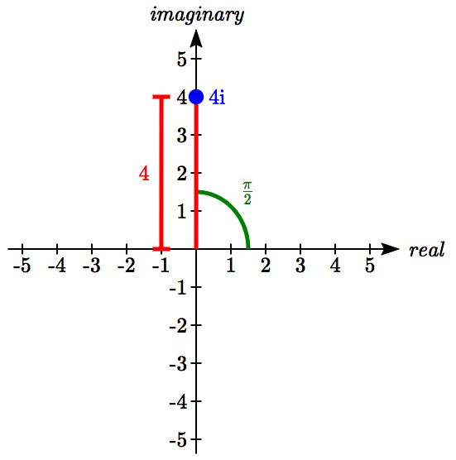Express the complex number  using polar coordinates.

On the complex plane, the number 4*i* is a distance of 4 from the origin at an angle of , so 

Note that the real part of this complex number is 0.

In the 18th century, Leonhard Euler demonstrated a relationship between exponential and trigonometric functions that allows the use of complex numbers to greatly simplify some trigonometric calculations. While the proof is beyond the scope of this class, you will likely see it in a later calculus class.

Polar Form of a Complex Number and Euler’s Formula

The **polar form of a complex number** is .

An alternate form, which will be the primary one used, is 

**Euler’s Formula** states 

Similar to plotting a point in the polar coordinate system we need *r* and  to find the polar form of a complex number.

Example 8

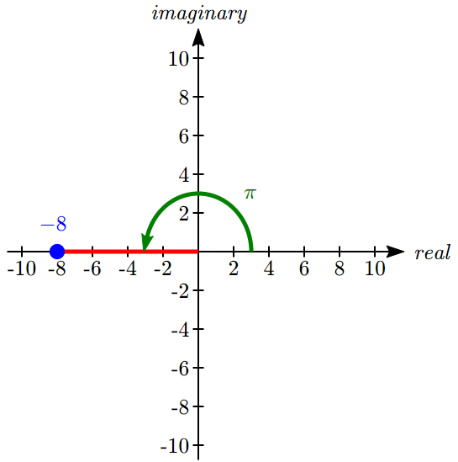Find the polar form of the complex number -8.

Treating this is a complex number, we can write it as -8+0*i*.

Plotted in the complex plane, the number -8 is on the negative horizontal axis, a distance of 8 from the origin at an angle of π from the positive horizontal axis.

The polar form of the number -8 is .

Plugging *r* = 8 and *θ* = π back into Euler’s formula, we have:

 as desired.

Example 9

Find the polar form of .

On the complex plane, this complex number would correspond to the point (-4, 4) on a Cartesian plane. We can find the distance *r* and angle *θ* as we did in the last section.







A coordinate grid with the horizontal axis labeled real and the vertical axis labeled imaginary. A point is drawn at negative 4 comma 4.  A measurement of length 4 square root of 2 is shown from the origin to the point, and an angle of 3 pi over 4 is shown from the horizontal positive axis a line from the origin to the point.


To find *θ*, we can use 



This is one of known cosine values, and since the point is in the second quadrant, we can conclude that .

The polar form of this complex number is .

Example 10

Find the polar form of .

On the complex plane, this complex number would correspond to the point (-3, -5) on a Cartesian plane. First, we find *r*.

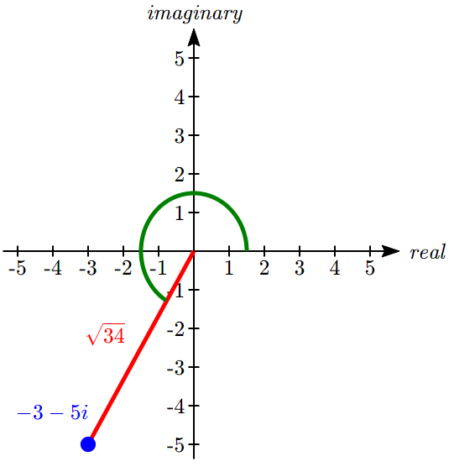





To find *θ*, we might use 





This angle is in the wrong quadrant, so we need to find a second solution. For tangent, we can find that by adding π.



The polar form of this complex number is .

Try it Now

3. Write  in polar form.

Example 11

Write  in complex  form.

 Evaluate the trig functions

 Simplify



The polar form of a complex number provides a powerful way to compute powers and roots of complex numbers by using exponent rules you learned in algebra. To compute a power of a complex number, we:

1. Convert to polar form
2. Raise to the power, using exponent rules to simplify
3. Convert back to *a* + *bi* form, if needed

Example 12

Evaluate .

While we could multiply this number by itself five times, that would be very tedious. To compute this more efficiently, we can utilize the polar form of the complex number. In an earlier example, we found that . Using this,

 Write the complex number in polar form

 Utilize the exponent rule 

 On the second factor, use the rule 

 Simplify



At this point, we have found the power as a complex number in polar form. If we want the answer in standard *a* + *bi* form, we can utilize Euler’s formula.



Since  is coterminal with , we can use our special angle knowledge to evaluate the sine and cosine.



We have found that .

The result of the process can be summarized by DeMoivre’s Theorem. This is a shorthand to using exponent rules.

DeMoivre’s Theorem

If , then for any integer *n*, 

We omit the proof, but note we can easily verify it holds in one case using Example 12:



Example 13

Evaluate .

To evaluate the square root of a complex number, we can first note that the square root is the same as having an exponent of : .

To evaluate the power, we first write the complex number in polar form. Since 9*i* has no real part, we know that this value would be plotted along the vertical axis, a distance of 9 from the origin at an angle of . This gives the polar form: .

Then, to evaluate the square root,

 Use the polar form

= Use exponent rules to simplify



 Simplify

 Rewrite using Euler’s formula if desired

 Evaluate the sine and cosine



Using the polar form, we were able to find a square root of a complex number.



Alternatively, using DeMoivre’s Theorem we could write

=  and simplify

Try it Now

4. Evaluate  using polar form.

You may remember that equations like have two solutions, 2 and -2 in this case, though the square root  only gives one of those solutions. Likewise, the square root we found in Example 11 is only one of two complex numbers whose square is 9*i*. Similarly, the equation  would have three solutions where only one is given by the cube root. In this case, however, only one of those solutions, *z* = 2, is a real value. To find the others, we can use the fact that complex numbers have multiple representations in polar form.

Example 14

Find all complex solutions to .

Since we are trying to solve , we can solve for *z* as . Certainly one of these solutions is the basic cube root, giving *z* = 2. To find others, we can turn to the polar representation of 8.

Since 8 is a real number, is would sit in the complex plane on the horizontal axis at an angle of 0, giving the polar form . Taking the 1/3 power of this gives the real solution:



However, since the angle 2π is coterminal with the angle of 0, we could also represent the number 8 as . Taking the 1/3 power of this gives a first complex solution:



For the third root, we use the angle of 4π, which is also coterminal with an angle of 0.

Altogether, we found all three complex solutions to ,

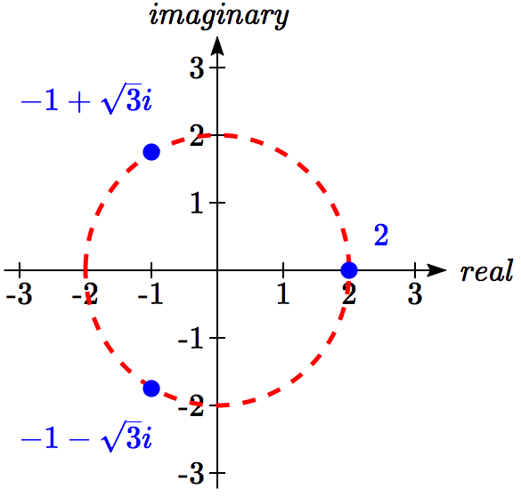

Graphed, these three numbers would be equally spaced on a circle about the origin at a radius of 2.

Important Topics of This Section

Complex numbers

Imaginary numbers

Plotting points in the complex coordinate system

Basic operations with complex numbers

Euler’s Formula

DeMoivre’s Theorem

Finding complex solutions to equations

Try it Now Answers

1. 

2. 

3.  would correspond with the point  in the first quadrant.  
  
, so   
 in polar form is 

4. = 

## Section 8.3 Exercises

Simplify each expression to a single complex number.

1.  2.  3. 

4.  5.  6. 

Simplify each expression to a single complex number.

7.  8. 

9.  10. 

11.  12. 

13.  14. 

15.  16. 

17.  18. 

19.  20. 

21.  22. 

23.  24. 

25.  26.  27.  28. 

Rewrite each complex number from polar form into  form.

29.  30.  31.  32. 

33.  34. 

Rewrite each complex number into polar  form.

35.  36.  37.  38. 

39.  40.  41.  42. 

43.  44.  45.  46. 

47.  48.  49.  50. 

Compute each of the following, leaving the result in polar  form.

51.  52.  53. 

54.  55.  56. 

57.  58.

Compute each of the following, simplifying the result into  form.

59.  60.  61. 

62.  63.  64. 

Solve each of the following equations for all complex solutions.

65.  66.  67.  68. 

## Section 8.4 Vectors

A woman leaves home, walks 3 miles north, then 2 miles southeast. How far is she from home, and in which direction would she need to walk to return home? How far has she walked by the time she gets home?

This question may seem familiar – indeed we did a similar problem with a boat in the first section of this chapter. In that section, we solved the problem using triangles. In this section, we will investigate another way to approach the problem using vectors, a geometric entity that indicates both a distance and a direction. We will begin our investigation using a purely geometric view of vectors.

**A Geometric View of Vectors**

Vector

A **vector** is an object that has both a length and a direction.

Geometrically, a vector can be represented by an arrow that has a fixed length and indicates a direction. If, starting at the point *A*, a vector, which means “carrier” in Latin, moves toward point*B*, we write to represent the vector.

A vector may also be indicated using a single letter in boldface type, like **u**, or by capping the letter representing the vector with an arrow, like .

Example 1

Draw a vector that represents the movement from the point *P*(-1, 2) to the point *Q*(3,3)

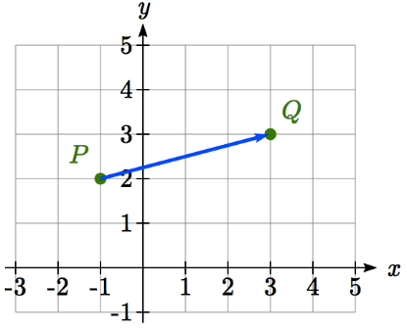

By drawing an arrow from the first point to the second, we can construct a vector .

Try it Now

1. Draw a vector, , that travels from the origin to the point (3, 5).

Using this geometric representation of vectors, we can visualize the addition and scaling of vectors.

To add vectors, we envision a sum of two movements. To find , we first draw the vector , then from the end of  we drawn the vector . This corresponds to the notion that first we move along the first vector, and then from that end position we move along the second vector. The sum  is the new vector that travels directly from the beginning of  to the end of in a straight path.

Adding Vectors Geometrically

To **add vectors geometrically**, draw  starting from the end of   
. The sum  is the vector from the beginning of  to the   
end of .







Example 2

Given the two vectors shown below, draw 











We draw  starting from the end of , then draw in the sum  from the beginning of  to the end of .

Notice that path of the walking woman from the beginning of the section could be visualized as the sum of two vectors. The resulting sum vector would indicate her end position relative to home.

Although vectors can exist anywhere in the plane, if we put the starting point at the origin it is easy to understand its size and direction relative to other vectors.

To scale vectors by a constant, such as , we can imagine adding . The result will be a vector three times as long in the same direction as the original vector. If we were to scale a vector by a negative number, such as , we can envision this as the opposite of ; the vector so that  returns us to the starting point. This vector  would point in the opposite direction as  but have the same length.

Another way to think about scaling a vector is to maintain its direction and multiply its length by a constant, so that would point in the same direction but will be 3 times as long.

Scaling a Vector Geometrically

To **geometrically scale a vector** by a constant, scale the length of the vector by the constant.

Scaling a vector by a negative constant will reverse the direction of the vector.

Example 3

Given the vector shown, draw , , and .



The vector  will be three times as long. The vector  will have the same length but point in the opposite direction. The vector  will point in the opposite direction and be twice as long.







By combining scaling and addition, we can find the difference between vectors geometrically as well, since .

Example 4

Given the vectors shown, draw 











From the end of  we draw , then draw in the result.













Notice that the sum and difference of two vectors are the two diagonals of a parallelogram with the vectors  and  as edges.

Try it Now

1. Using vector from Try it Now #1, draw .

**Component Form of Vectors**

While the geometric interpretation of vectors gives us an intuitive understanding of vectors, it does not provide us a convenient way to do calculations. For that, we need a handy way to represent vectors. Since a vector involves a length and direction, it would be logical to want to represent a vector using a length and an angle *θ*, usually measured from standard position.



*θ*

Magnitude and Direction of a Vector

A vector  can be described by its magnitude, or length, , and an angle *θ*.

A vector with length 1 is called **unit vector**.

While this is very reasonable, and a common way to describe vectors, it is often more convenient for calculations to represent a vector by horizontal and vertical components.

Component Form of a Vector

The **component form** of a vector represents the vector using two components.  indicates the vector represents a displacement of *x* units horizontally and *y* units vertically.



*θ*

*xx*

*y*

Notice how we can see the magnitude of the vector as the length of the hypotenuse of a right triangle, or in polar form as the radius, *r*.

Alternate Notation for Vector Components

Sometimes you may see vectors written as the combination of unit vectors  and , where  points the right and  points up. In other words,  and .

In this notation, the vector  would be written as  since both indicate a displacement of 3 units to the right, and 4 units down.

While it can be convenient to think of the vector  as an arrow from the origin to the point (*x, y*), be sure to remember that most vectors can be situated anywhere in the plane, and simply indicate a displacement (change in position) rather than a position.

It is common to need to convert from a magnitude and angle to the component form of the vector and vice versa. Happily, this process is identical to converting from polar coordinates to Cartesian coordinates, or from the polar form of complex numbers to the *a+bi* form.

Example 5

Find the component form of a vector with length 7 at an angle of 135 degrees.

Using the conversion formulas  and , we can find the components





This vector can be written in component form as .

Example 6

Find the magnitude and angle  representing the vector .

First we can find the magnitude by remembering the relationship between *x*, *y* and *r*:





Second we can find the angle. Using the tangent,



, or written as a coterminal positive angle, 326.31°. This angle is in the 4th quadrant as desired.

Try it Now

1. Using vector from Try it Now #1, the vector that travels from the origin to the point (3, 5), find the components, magnitude and angle  that represent this vector.

In addition to representing distance movements, vectors are commonly used in physics and engineering to represent any quantity that has both direction and magnitude, including velocities and forces.

Example 7

An object is launched with initial velocity 200 meters per second at an angle of 30 degrees. Find the initial horizontal and vertical velocities.

By viewing the initial velocity as a vector, we can resolve the vector into horizontal and vertical components.

 m/sec

200 m/s

30°

173 m/s

100 m/s

 m/sec

This tells us that, absent wind resistance, the object will travel horizontally at about 173 meters each second. Gravity will cause the vertical velocity to change over time – we’ll leave a discussion of that to physics or calculus classes.

**Adding and Scaling Vectors in Component Form**

To add vectors in component form, we can simply add the corresponding components. To scale a vector by a constant, we scale each component by that constant.

Combining Vectors in Component Form

To **add, subtract, or scale vectors** in component form

If , , and *c* is any constant, then







Example 8

Given  and , find a new vector 

Using the vectors given,



 Scale each vector

 Subtract corresponding components



By representing vectors in component form, we can find the resulting displacement vector after a multitude of movements without needing to draw a lot of complicated non-right triangles. For a simple example, we revisit the problem from the opening of the section. The general procedure we will follow is:

1. Convert vectors to component form
2. Add the components of the vectors
3. Convert back to length and direction if needed to suit the context of the question

Example 9

A woman leaves home, walks 3 miles north, then 2 miles southeast. How far is she from home, and what direction would she need to walk to return home? How far has she walked by the time she gets home?

Let’s begin by understanding the question in a little more depth. When we use vectors to describe a traveling direction, we often position things so north points in the upward direction, east points to the right, and so on, as pictured here.

N

NE

E

SE

S

SW

W

NW

Consequently, travelling NW, SW, NE or SE, means we are travelling through the quadrant bordered by the given directions at a 45 degree angle.

With this in mind, we begin by converting each vector to components.

A walk 3 miles north would, in components, be .

A walk of 2 miles southeast would be at an angle of 45° South of East. Measuring from standard position the angle would be 315°.

Converting to components, we choose to use the standard position angle so that we do not have to worry about whether the signs are negative or positive; they will work out automatically.



3

2

Adding these vectors gives the sum of the movements in component form



To find how far she is from home and the direction she would need to walk to return home, we could find the magnitude and angle of this vector.

Length = 

To find the angle, we can use the tangent



 north of east

Of course, this is the angle from her starting point to her ending point. To return home, she would need to head the opposite direction, which we could either describe as 180°+48.273° = 228.273° measured in standard position, or as 48.273° south of west (or 41.727° west of south).

She has walked a total distance of 3 + 2 + 2.125 = 7.125 miles.

Keep in mind that total distance travelled is not the same as the length of the resulting displacement vector or the “return” vector.

Try it Now

1. In a scavenger hunt, directions are given to find a buried treasure. From a starting point at a flag pole you must walk 30 feet east, turn 30 degrees to the north and travel 50 feet, and then turn due south and travel 75 feet. Sketch a picture of these vectors, find their components, and calculate how far and in what direction you must travel to go directly to the treasure from the flag pole without following the map.

While using vectors is not much faster than using law of cosines with only two movements, when combining three or more movements, forces, or other vector quantities, using vectors quickly becomes much more efficient than trying to use triangles.

Example 10

Three forces are acting on an object as shown below, each measured in Newtons (N). What force must be exerted to keep the object in equilibrium (where the sum of the forces is zero)?

30°

6 N

7 N

4 N

300°

We start by resolving each vector into components.

The first vector with magnitude 6 Newtons at an angle of 30 degrees will have components



The second vector is only in the horizontal direction, so can be written as .

The third vector with magnitude 4 Newtons at an angle of 300 degrees will have components



To keep the object in equilibrium, we need to find a force vector  so the sum of the four vectors is the zero vector, .

 Add component-wise

 Simplify

 Solve





This vector gives in components the force that would need to be applied to keep the object in equilibrium. If desired, we could find the magnitude of this force and direction it would need to be applied in.

Magnitude = N

Angle:



.

This is in the wrong quadrant, so we adjust by finding the next angle with the same tangent value by adding a full period of tangent:



To keep the object in equilibrium, a force of 0.504 Newtons would need to be applied at an angle of 112.911°.

Important Topics of This Section

Vectors, magnitude (length) & direction

Addition of vectors

Scaling of vectors

Components of vectors

Vectors as velocity

Vectors as forces

Adding & Scaling vectors in component form

Total distance travelled vs. total displacement

Try it Now Answers

1. 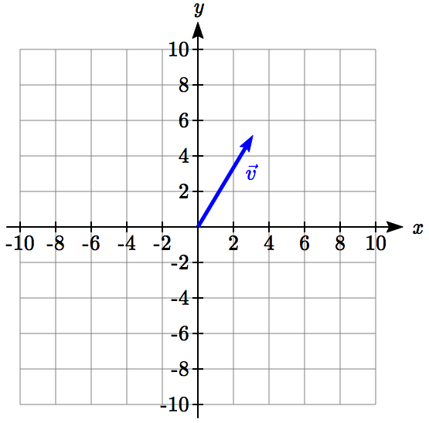 2. 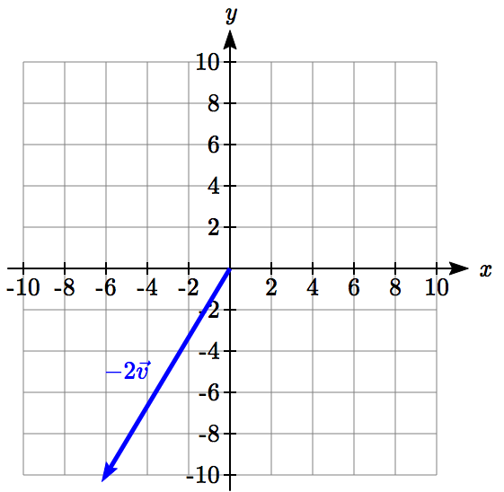

3. 

75 ft

50 ft

30 ft

4.



Magnitude = 88.73 feet at an angle of 34.3° south of east.

## Section 8.4 Exercises

Write the vector shown in component form.

1. 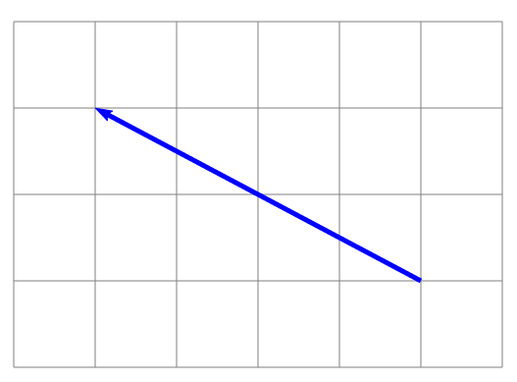 2. 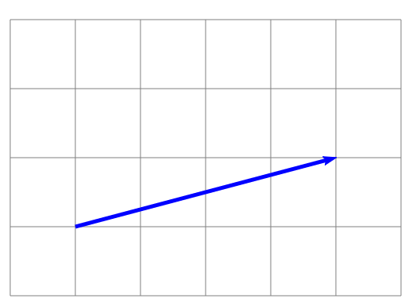

Given the vectors shown, sketch , , and .

3. 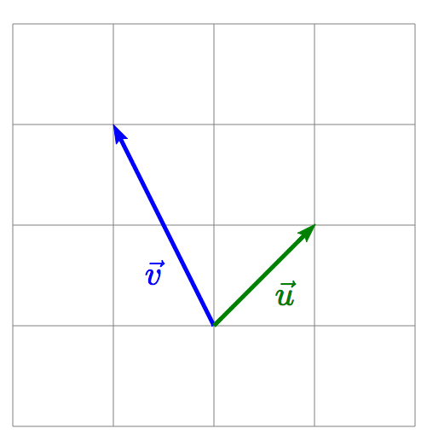 4. 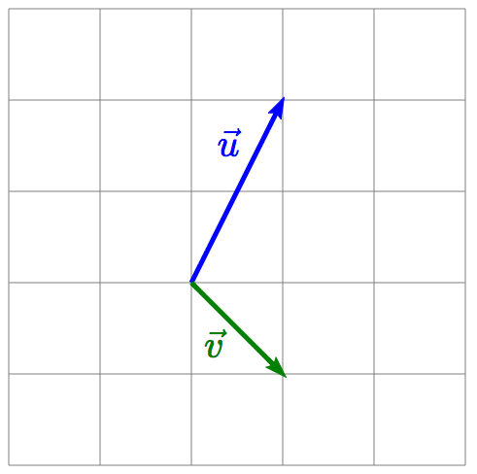

Write each vector below as a combination of the vectors  and  from question #3.

5. 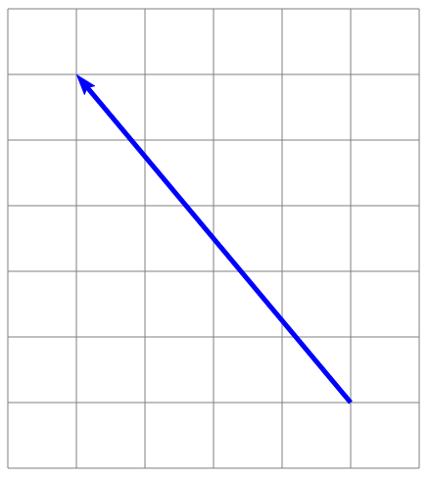 6. 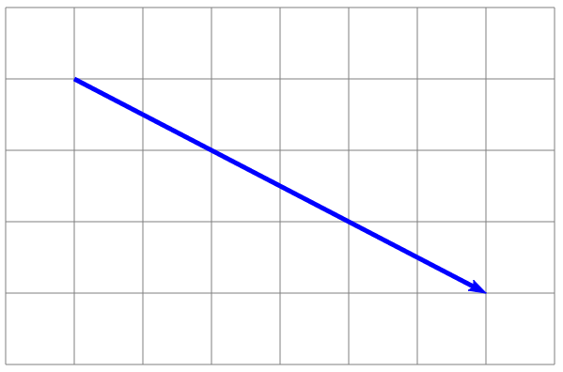

From the given magnitude and direction in standard position, write the vector in component form.

7. Magnitude: 6, Direction: 45° 8. Magnitude: 10, Direction: 120°

9. Magnitude: 8, Direction: 220° 10. Magnitude: 7, Direction: 305°

Find the magnitude and direction of the vector.

11.  12.  13.  14. 

15.  16.  17.  18. 

19.  20. 

Using the vectors given, compute , , and .

21.  22. 

1. A woman leaves home and walks 3 miles west, then 2 miles southwest. How far from home is she, and in what direction must she walk to head directly home?
2. A boat leaves the marina and sails 6 miles north, then 2 miles northeast. How far from the marina is the boat, and in what direction must it sail to head directly back to the marina?
3. A person starts walking from home and walks 4 miles east, 2 miles southeast, 5 miles south, 4 miles southwest, and 2 miles east. How far have they walked? If they walked straight home, how far would they have to walk?
4. A person starts walking from home and walks 4 miles east, 7 miles southeast, 6 miles south, 5 miles southwest, and 3 miles east. How far have they walked? If they walked straight home, how far would they have to walk?
5. Three forces act on an object: . Find the net force acting on the object.
6. Three forces act on an object: . Find the net force acting on the object.
7. A person starts walking from home and walks 3 miles at 20° north of west, then 5 miles at 10° west of south, then 4 miles at 15° north of east. If they walked straight home, how far would they have to walk, and in what direction?
8. A person starts walking from home and walks 6 miles at 40° north of east, then 2 miles at 15° east of south, then 5 miles at 30° south of west. If they walked straight home, how far would they have to walk, and in what direction?
9. An airplane is heading north at an airspeed of 600 km/hr, but there is a wind blowing from the southwest at 80 km/hr. How many degrees off course will the plane end up flying, and what is the plane’s speed relative to the ground?
10. An airplane is heading north at an airspeed of 500 km/hr, but there is a wind blowing from the northwest at 50 km/hr. How many degrees off course will the plane end up flying, and what is the plane’s speed relative to the ground?
11. An airplane needs to head due north, but there is a wind blowing from the southwest at 60 km/hr. The plane flies with an airspeed of 550 km/hr. To end up flying due north, the pilot will need to fly the plane how many degrees west of north?
12. An airplane needs to head due north, but there is a wind blowing from the northwest at 80 km/hr. The plane flies with an airspeed of 500 km/hr. To end up flying due north, the pilot will need to fly the plane how many degrees west of north?
13. As part of a video game, the point (5, 7) is rotated counterclockwise about the origin through an angle of 35 degrees. Find the new coordinates of this point.
14. As part of a video game, the point (7, 3) is rotated counterclockwise about the origin through an angle of 40 degrees. Find the new coordinates of this point.
15. Two children are throwing a ball back and forth straight across the back seat of a car. The ball is being thrown 10 mph relative to the car, and the car is travelling 25 mph down the road. If one child doesn't catch the ball and it flies out the window, in what direction does the ball fly (ignoring wind resistance)?
16. Two children are throwing a ball back and forth straight across the back seat of a car. The ball is being thrown 8 mph relative to the car, and the car is travelling 45 mph down the road. If one child doesn't catch the ball and it flies out the window, in what direction does the ball fly (ignoring wind resistance)?

## Section 8.5 Dot Product

Now that we can add, subtract, and scale vectors, you might be wondering whether we can multiply vectors. It turns out there are two different ways to multiply vectors, one which results in a number, and one which results in a vector. In this section, we'll focus on the first, called the **dot product** or **scalar product**, since it produces a single numeric value (a scalar). We'll begin with some motivation.

In physics, we often want to know how much of a force is acting in the direction of motion. To determine this, we need to know the angle between direction of force and the direction of motion. Likewise, in computer graphics, the lighting system determines how bright a triangle on the object should be based on the angle between object and the direction of the light. In both applications, we're interested in the angle between the vectors, so let's start there.

Suppose we have two vectors,  and . Using our polar coordinate conversions, we could write  and . Now, if we knew the angles *α* and *β*, we wouldn't have much work to do - the angle between the vectors would be . While we certainly could use some inverse tangents to find the two angles, it would be great if we could find a way to determine the angle between the vector just from the vector components.

*β*

*θ*

*α*

To help us manipulate , we might try introducing a trigonometric function:



Now we can apply the difference of angles identity



Now , so , and likewise for the other three components. Making those substitutions,





Notice the expression on the right is a very simple calculation based on the components of the vectors. It comes up so frequently we define it to be the **dot product** of the two vectors, notated by a dot. This gives us two definitions of the dot product.

Definitions of the Dot Product

 Component definition

 Geometric definition

The first definition, , gives us a simple way to calculate the dot product from components. The second definition, , gives us a geometric interpretation of the dot product, and gives us a way to find the angle between two vectors, as we desired.

Example 1

Find the dot product .

Using the first definition, we can calculate the dot product by multiplying the *x* components and adding that to the product of the *y* components.



Example 2

Find the dot product of the two vectors shown.

30°

6

7

We can immediately see that the magnitudes of the two vectors are 7 and 6. We can quickly calculate that the angle between the vectors is 150°. Using the geometric definition of the dot product,

.

Try it Now

1. Calculate the dot product 

Now we can return to our goal of finding the angle between vectors.

Example 3

An object is being pulled up a ramp in the direction  by a rope pulling in the direction . What is the angle between the rope and the ramp?

Using the component form, we can easily calculate the dot product.



We can also calculate the magnitude of each vector.

, 

Substituting these values into the geometric definition, we can solve for the angle between the vectors.





.

Example 4

Calculate the angle between the vectors  and .

Calculating the dot product, 

We don't even need to calculate the magnitudes in this case since the dot product is 0.







With the dot product equaling zero, as in the last example, the angle between the vectors will always be 90°, indicating that the vectors are **orthogonal**, a more general way of saying perpendicular. This gives us a quick way to check if vectors are orthogonal. Also, if the dot product is positive, then the inside of the inverse cosine will be positive, giving an angle less than 90°. A negative dot product will then lead to an angle larger than 90°

Sign of the Dot Product

If the dot product is:

Zero The vectors are **orthogonal** (perpendicular).

Positive The angle between the vectors is less than 90°

Negative The angle between the vectors is greater than 90°

Try it Now

2. Are the vectors  and  orthogonal? If not, find the angle between them.

**Projections**

In addition to finding the angle between vectors, sometimes we want to know how much one vector points in the direction of another. For example, when pulling an object up a ramp, we might want to know how much of the force is exerted in the direction of motion. To determine this we can use the idea of a **projection**.













In the picture above,  is a projection of  onto . In other words, it is the portion of  that points in the same direction as .

To find the length of , we could notice that it is one side of a right triangle. If we define *θ* to be the angle between  and , then , so .

While we could find the angle between the vectors to determine this magnitude, we could skip some steps by using the dot product directly. Since , . Using this, we can rewrite  as . This gives us the length of the projection, sometimes denoted as .

To find the vector  itself, we could first scale  to a unit vector with length 1: . Multiplying this by the length of the projection will give a vector in the direction of  but with the correct length.



Projection Vector

The projection of vector  onto  is 

The magnitude of the projection is 

Example 5

Find the projection of the vector  onto the vector .

We will need to know the dot product of the vectors and the magnitude of the vector we are projecting onto.





The magnitude of the projection will be .

To find the projection vector itself, we would multiply that magnitude by  scaled to a unit vector.

.

Based on the sketch above, this answer seems reasonable.

Try it Now

3. Find the component of the vector  that is *orthogonal* to the vector 

**Work**

In physics, when a constant force causes an object to move, the mechanical **work** done by that force is the product of the force and the distance the object is moved. However, we only consider the portion of force that is acting in the direction of motion.

This is simply the magnitude of the projection of the force vector onto the distance vector, . The work done is the product of that component of force times the distance moved, the magnitude of the distance vector.









It turns out that work is simply the dot product of the force vector and the distance vector.

Work

When a force  causes an object to move some distance , the work done is



Example 6

A cart is pulled 20 feet by applying a force of 30 pounds on a rope held at a 30 degree angle. How much work is done?

30°

30 pounds

20 feet

Since work is simply the dot product, we can take advantage of the geometric definition of the dot product in this case.

ft-lbs.

Try it Now

4. Find the work down moving an object from the point (1, 5) to (9, 14) by the force vector 

Important Topics of This Section

Calculate Dot Product

Using component definition

Using geometric definition

Find the angle between two vectors

Sign of the dot product

Projections

Work

Try it Now Answers

1. 

2. In the previous Try it Now, we found the dot product was -4, so the vectors are not orthogonal. The magnitudes of the vectors are  and . The angle between the vectors will be 

3. We want to find the component of that is *orthogonal* to the vector . In the picture to the right, that component is vector . Notice that , so if we can find the projection vector, we can find .  
.  
  
Now we can solve  for .   










4. The distance vector is .   
The work is the dot product: 

## Section 8.5 Exercises

Two vectors are described by their magnitude and direction in standard position. Find the dot product of the vectors.

1. Magnitude: 6, Direction: 45°; Magnitude: 10, Direction: 120°

2. Magnitude: 8, Direction: 220°; Magnitude: 7, Direction: 305°

Find the dot product of each pair of vectors.

3. ;  4. ; 

5. ; 6. ;

Find the angle between the vectors

7. ;  8. ; 

9. ;  10. ; 

11. ; 12. ;

13. Find a value for *k* so that  and  will be orthogonal.

14. Find a value for *k* so that  and  will be orthogonal.

15. Find the magnitude of the projection of  onto .

16. Find the magnitude of the projection of  onto .

17. Find the projection of  onto .

18. Find the projection of  onto .

19. A scientist needs to determine the angle of reflection when a laser hits a mirror. The picture shows the vector representing the laser beam, and a vector that is orthogonal to the mirror. Find the acute angle between these, the angle of reflection.

20. A triangle has coordinates at *A*: (1,4), *B*: (2,7), and *C*: (4,2). Find the angle at point *B*.

21. A boat is trapped behind a log lying parallel to the dock. It only requires 10 pounds of force to pull the boat directly towards you, but because of the log, you'll have to pull at a 45° angle. How much force will you have to pull with? (We're going to assume that the log is very slimy and doesn't contribute any additional resistance.)

22. A large boulder needs to be dragged to a new position. If pulled directly horizontally, the boulder would require 400 pounds of pulling force to move. We need to pull the boulder using a rope tied to the back of a large truck, forming a 15° angle from the ground. How much force will the truck need to pull with?

15°

23. Find the work done against gravity by pushing a 20 pound cart 10 feet up a ramp that is 10° above horizontal. Assume there is no friction, so the only force is 20 pounds downwards due to gravity.

24. Find the work done against gravity by pushing a 30 pound cart 15 feet up a ramp that is 8° above horizontal. Assume there is no friction, so the only force is 30 pounds downwards due to gravity.

25. An object is pulled to the top of a 40 foot ramp that forms a 10° angle with the ground. It is pulled by rope exerting a force of 120 pounds at a 35° angle relative to the ground. Find the work done.

10°

35°

26. An object is pulled to the top of a 30 foot ramp that forms a 20° angle with the ground. It is pulled by rope exerting a force of 80 pounds at a 30° angle relative to the ground. Find the work done.

## Section 8.6 Parametric Equations

Many shapes, even ones as simple as circles, cannot be represented as an equation where *y* is a function of *x*. Consider, for example, the path a moon follows as it orbits around a planet, which simultaneously rotates around a sun. In some cases, polar equations provide a way to represent such a path. In others, we need a more versatile approach that allows us to represent both the *x* and *y* coordinates in terms of a third variable, or parameter.

Parametric Equations

A system of **parametric equations** is a pair of functions *x(t)* and *y(t)* in which the *x* and *y* coordinates are the output, represented in terms of a third input parameter, *t*.

Example 1

Moving at a constant speed, an object moves at a steady rate along a straight path from coordinates (-5, 3) to the coordinates (3, -1) in 4 seconds, where the coordinates are measured in meters. Find parametric equations for the position of the object.

The *x* coordinate of the object starts at -5 meters, and goes to +3 meters, this means the *x* direction has changed by 8 meters in 4 seconds, giving us a rate of 2 meters per second. We can now write the *x* coordinate as a linear function with respect to time, *t*, . Similarly, the *y* value starts at 3 and goes to -1, giving a change in *y* value of 4 meters, meaning the *y* values have decreased by 4 meters in 4 seconds, for a rate of -1 meter per second, giving equation . Together, these are the parametric equations for the position of the object:

|  |  |  |
| --- | --- | --- |
| ***t*** | ***x*** | ***y*** |
| 0 | -5 | 3 |
| 1 | -3 | 2 |
| 2 | -1 | 1 |
| 3 | 1 | 0 |
| 4 | 3 | -1 |



Using these equations, we can build a table of *t*, *x*, and *y* values. Because of the context, we limited ourselves to non-negative *t* values for this example, but in general you can use any values.

From this table, we could create three possible graphs: a graph of *x* vs. *t*, which would show the horizontal position over time, a graph of *y* vs. *t*, which would show the vertical position over time, or a graph of *y* vs. *x*, showing the position of the object in the plane.

Position of *x* as a function of time Position of *y* as a function of time

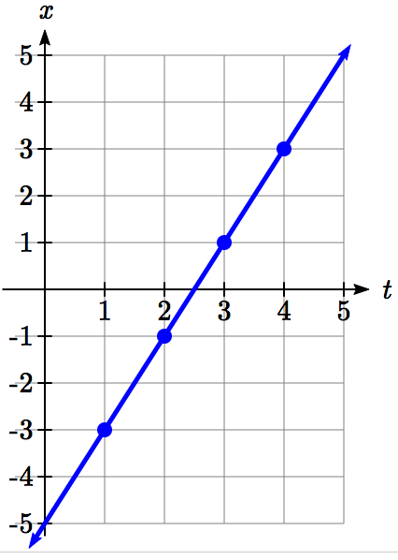 A graph with t on the horizontal axis and y on the vertical axis.  A line is drawn passing through 0 comma 3, 1 comma 2, 2 comma 1, 3 comma 0, and 4 comma negative 1


Position of *y* relative to *x*

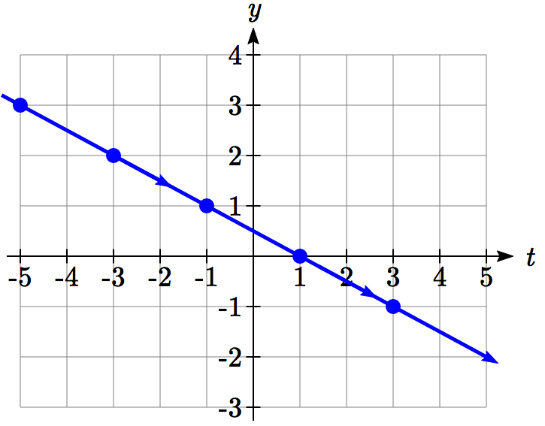

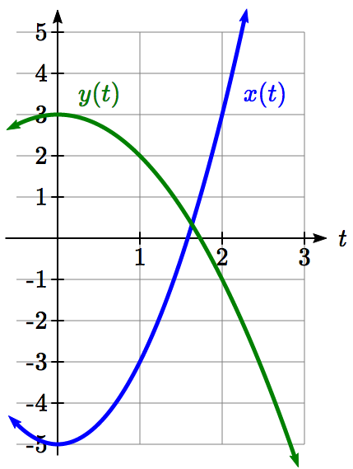Notice that the parameter *t* does not explicitly show up in this third graph. Sometimes, when the parameter *t* does represent a quantity like time, we might indicate the direction of movement on the graph using an arrow, as shown above.

There is often no single parametric representation for a curve. In Example 1 we assumed the object was moving at a steady rate along a straight line. If we kept the assumption about the path (straight line) but did not assume the speed was constant, we might get a system like:

*t*

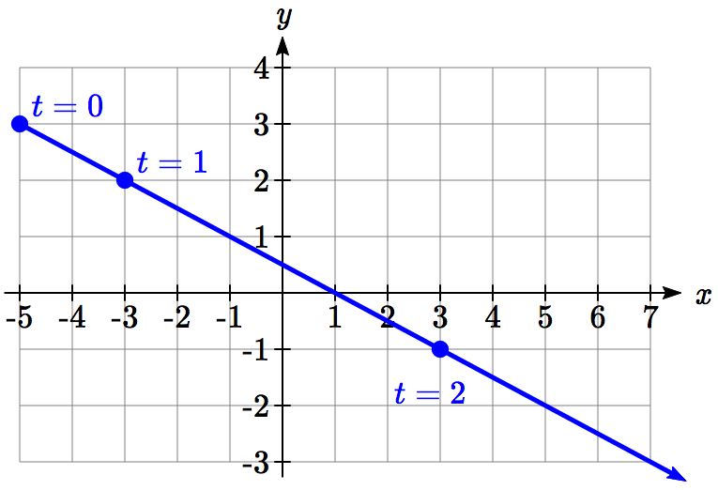

This starts at (-5, 3) when *t* = 0 and ends up at (3, -1) when *t* = 2. If we graph the *x(t)* and *y(t)* function separately, we can see that those are no longer linear, but if we graph *x* vs. *y* we will see that we still get a straight-line path.

Example 2

Sketch a graph of

|  |  |  |
| --- | --- | --- |
| ***t*** | ***x*** | ***y*** |
| -3 | 10 | -1 |
| -2 | 5 | 0 |
| -1 | 2 | 1 |
| 0 | 1 | 2 |
| 1 | 2 | 3 |
| 2 | 5 | 4 |



We can begin by creating a table of values. From this table, we can plot the (*x*, *y*) points in the plane, sketch in a rough graph of the curve, and indicate the direction of motion with respect to time by using arrows.

A graph with horizontal axis x and vertical axis y.  The graph is a sideways parabola, with direction of motion indicated by arrows.  In the direction of motion the curve passes through 10 comma negative 1, 5 comma 0, 2 comma 1, 1 comma 2, 2 comma 3 and 5 comma 4.


Notice that here the parametric equations describe a shape for which *y* is not a function of *x*. This is an example of why using parametric equations can be useful – since they can represent such a graph as a set of functions. This particular graph also appears to be a parabola where *x* is a function of *y*, which we will soon verify.

Example 3

Sketch a graph of



(*r*cos(*θ*), *r*sin(*θ*))

*r*

*θ*

*y*

*x*

These equations should look familiar. Back when we first learned about sine and cosine we found that the coordinates of a point on a circle of radius *r* at an angle of *θ* will be . The equations above are in the same form, with , and *t* used in place of *θ.*

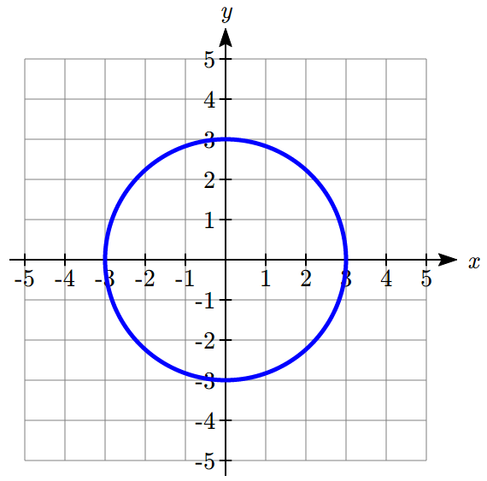

This suggests that for each value of *t*, these parametric equations give a point on a circle of radius 3 at the angle corresponding to *t*. At , the graph would be at , the point (3,0). Indeed, these equations describe the equation of a circle, drawn counterclockwise.

Interestingly, these similar parametric equations also describe the circle of radius 3:



The difference with these equations it the graph would start at , the point (0,3). As *t* increases from 0, the *x* value will increase, indicating these equations would draw the graph in a clockwise direction.

While creating a *t*-*x*-*y* table, plotting points and connecting the dots with a smooth curve usually works to give us a rough idea of what the graph of a system of parametric equations looks like, it's generally easier to use technology to create these tables and (simultaneously) much nicer-looking graphs.

Example 4

Sketch a graph of .

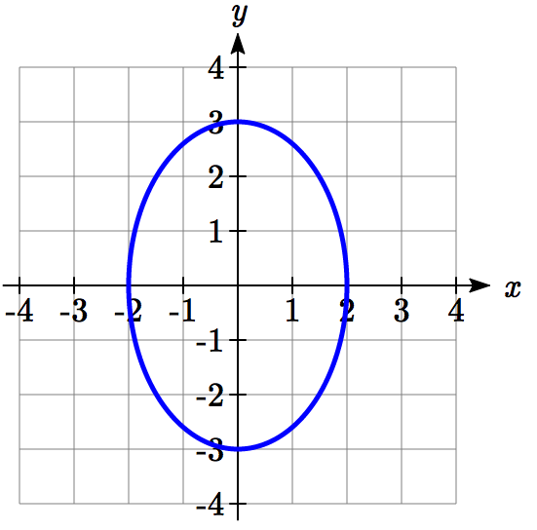

Notice first that this equation looks very similar to the ones from the previous example, except the coefficients are not equal. You might guess that the pairing of cos and sin will still produce rotation, but now *x* will vary from -2 to 2 while *y* will vary from -3 to 3, creating an ellipse.

Using technology we can generate a graph of this equation, verifying it is indeed an ellipse.

Similar to graphing polar equations, you must change the MODE on your calculator (or select parametric equations on your graphing technology) before graphing a system of parametric equations. You will know you have successfully entered parametric mode when the equation input has changed to ask for a *x(t)*= and *y(t)*= pair of equations.

Try it Now

1. Sketch a graph of . This is an example of a **Lissajous** figure.

Example 5

The populations of rabbits and wolves on an island over time are given by the graphs below. Use these graphs to sketch a graph in the *r-w* plane showing the relationship between the number of rabbits and number of wolves.

For each input *t*, we can determine the number of rabbits, *r*, and the number of wolves, *w*, from the respective graphs, and then plot the corresponding point in the *r-w* plane.

This graph helps reveal the cyclical interaction between the two populations.

**Converting from Parametric to Cartesian**

In some cases, it is possible to eliminate the parameter *t*, allowing you to write a pair of parametric equations as a Cartesian equation.

It is easiest to do this if one of the *x(t)* or *y(t)* functions can easily be solved for *t*, allowing you to then substitute the remaining expression into the second part.

Example 6

Write  as a Cartesian equation, if possible.

Here, the equation for *y* is linear, so is relatively easy to solve for *t*. Since the resulting Cartesian equation will likely not be a function, and for convenience, we drop the function notation.

 Solve for *t*

 Substitute this for *t* in the *x* equation



Notice that this is the equation of a parabola with *x* as a function of *y*, with vertex at (1,2), opening to the right. Comparing this with the graph from Example 2, we see (unsurprisingly) that it yields the same graph in the *x*-*y* plane as did the original parametric equations.

Try it Now

1. Write as a Cartesian equation, if possible.

Example 7

Write  as a Cartesian equation, if possible.

We could solve either the first or second equation for *t*. Solving the first,



 Square both sides

 Substitute into the *y* equation



Since the parametric equation is only defined for , this Cartesian equation is equivalent to the parametric equation on the corresponding domain. The parametric equations show that when *t* > 0, *x* > 2 and *y* > 0, so the domain of the Cartesian equation should be limited to *x* > 2.

To ensure that the Cartesian equation is as equivalent as possible to the original parametric equation, we try to avoid using domain-restricted inverse functions, such as the inverse trig functions, when possible. For equations involving trig functions, we often try to find an identity to utilize to avoid the inverse functions.

Example 8

Write  as a Cartesian equation, if possible.

To rewrite this, we can utilize the Pythagorean identity .

 so 

 so 

Starting with the Pythagorean Identity,

 Substitute in the expressions from the parametric form

 Simplify



This is a Cartesian equation for the ellipse we graphed earlier.

**Parameterizing Curves**

While converting from parametric form to Cartesian can be useful, it is often more useful to parameterize a Cartesian equation – converting it into parametric form.

If the Cartesian equation gives one variable as a function of the other, then parameterization is trivial – the independent variable in the function can simply be defined as *t*.

Example 9

Parameterize the equation .

In this equation, *x* is expressed as a function of *y*. By defining  we can then substitute that into the Cartesian equation, yielding. Together, this produces the parametric form:



Try it Now

1. Write  in parametric form, if possible.

In addition to parameterizing Cartesian equations, we also can parameterize behaviors and movements.

Example 10

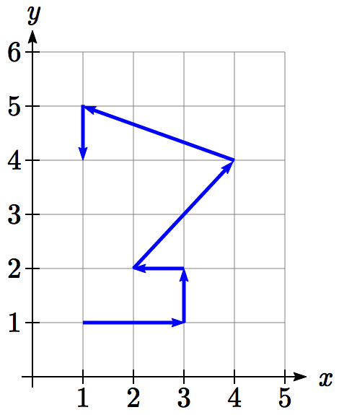A robot follows the path shown. Create a table of values for the *x(t)* and *y(t)* functions, assuming the robot takes one second to make each movement.

Since we know the direction of motion, we can introduce consecutive values for *t* along the path of the robot. Using these values with the *x* and *y* coordinates of the robot, we can create the tables. For example, we designate the starting point, at (1, 1), as the position at *t* = 0, the next point at (3, 1) as the position at *t* *=* 1, and so on.

|  |  |  |  |  |  |  |  |
| --- | --- | --- | --- | --- | --- | --- | --- |
| ***t*** | 0 | 1 | 2 | 3 | 4 | 5 | 6 |
| ***y*** | 1 | 1 | 2 | 2 | 4 | 5 | 4 |

|  |  |  |  |  |  |  |  |
| --- | --- | --- | --- | --- | --- | --- | --- |
| ***t*** | 0 | 1 | 2 | 3 | 4 | 5 | 6 |
| ***x*** | 1 | 3 | 3 | 2 | 4 | 1 | 1 |

Notice how this also ties back to vectors. The journey of the robot as it moves through the Cartesian plane could also be displayed as vectors and total distance traveled and displacement could be calculated.

Example 11

A light is placed on the edge of a bicycle tire as shown and the bicycle starts rolling down the street. Find a parametric equation for the position of the light after the wheel has rotated through an angle of *θ*.

*θ*

Starting

Rotated by *θ*

*r*

Relative to the center of the wheel, the position of the light can be found as the coordinates of a point on a circle, but since the *x* coordinate begins at 0 and moves in the negative direction, while the *y* coordinate starts at the lowest value, the coordinates of the point will be given by:



The center of the wheel, meanwhile, is moving horizontally. It remains at a constant height of *r*, but the horizontal position will move a distance equivalent to the arclength of the circle drawn out by the angle, . The position of the center of the circle is then



Combining the position of the center of the wheel with the position of the light on the wheel relative to the center, we get the following parametric equationw, with *θ* as the parameter:



The result graph is called a cycloid.

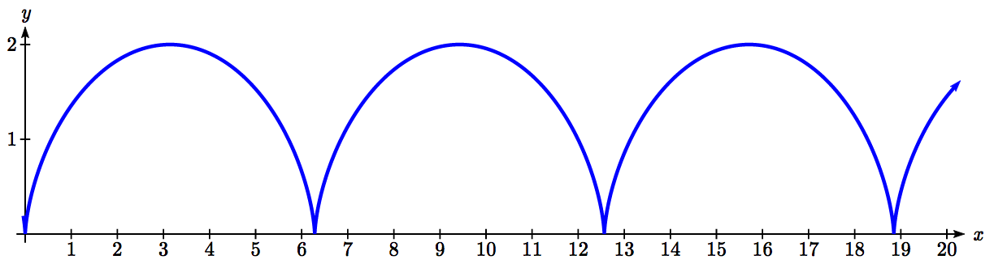

Example 12

A moon travels around a planet as shown, orbiting once every 10 days. The planet travels around a sun as shown, orbiting once every 100 days. Find a parametric equation for the position of the moon, relative to the center of the sun, after *t* days.

6

30

For this example, we’ll assume the orbits are circular, though in real life they’re actually elliptical.

The coordinates of a point on a circle can always be written in the form



Since the orbit of the moon around the planet has a period of 10 days, the equation for the position of the *moon relative to the planet* will be



With a period of 100 days, the equation for the position of the *planet relative to the sun* will be

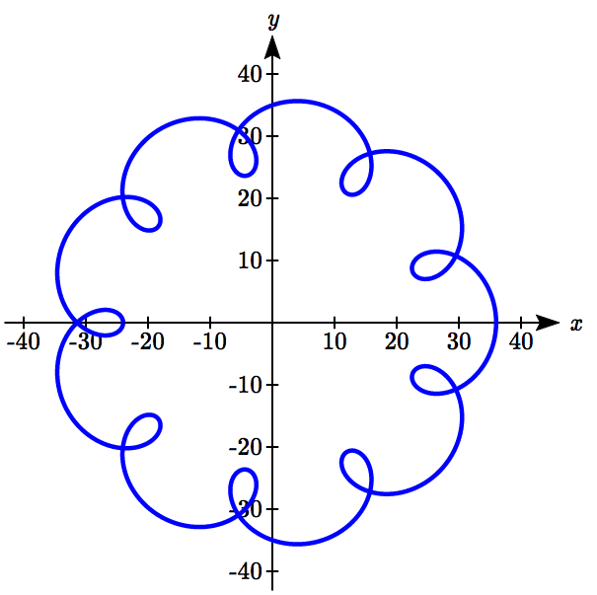

Combining these together, we can find the position of the *moon relative to the sun* as the sum of the components.



The resulting graph is shown here.

Try it Now

1. A wheel of radius 4 is rolled around the outside of a circle of radius 7. Find a parametric equation for the position of a point on the boundary of the smaller wheel. This shape is called an epicycloid.

Important Topics of This Section

Parametric equations

Graphing *x(t)* , *y(t)* and the corresponding *x-y­* graph

Sketching graphs and building a table of values

Converting parametric to Cartesian

Converting Cartesian to parametric (parameterizing curves)

Try it Now Answers

1. 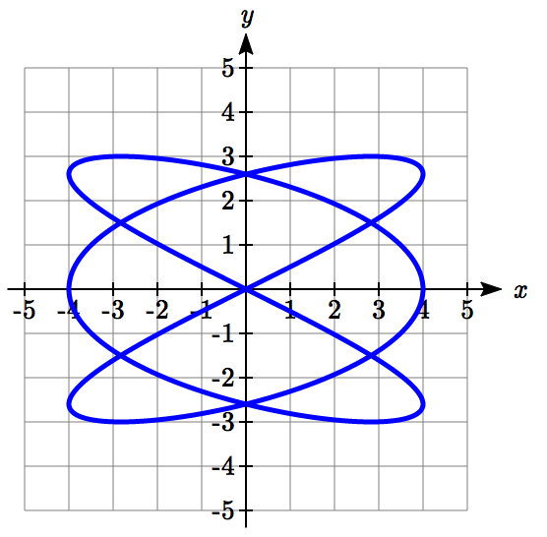

2. , so 

3. 

4. The center of the small wheel rotates in circle with radius 7+4=11.  
Since the circumference of the small circle is  and the circumference of the large circle is , in the time it takes to roll around the large circle, the small circle will have rotated  rotations. We use this as the stretch factor. The position of a point on the small circle will be the combination of the position of the center of the small wheel around the center of the large wheel, and the position of the point around the small wheel:  


## Section 8.6 Exercises

Match each set of equations with one of the graphs below.

1.  2.  3. 

4.  5.  6. 

A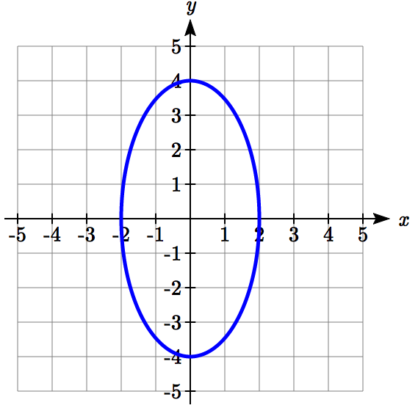 B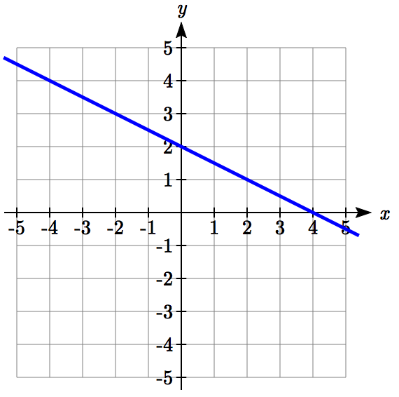 C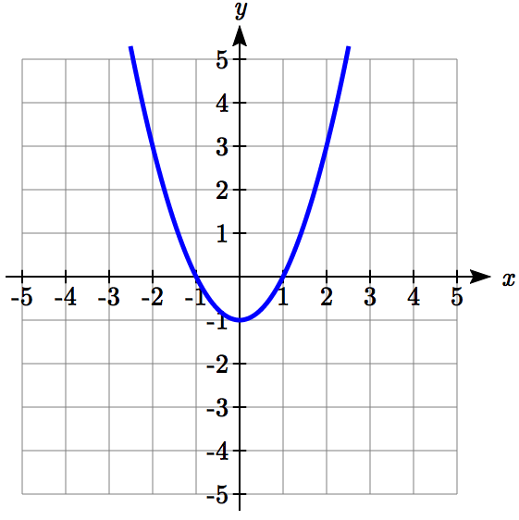

D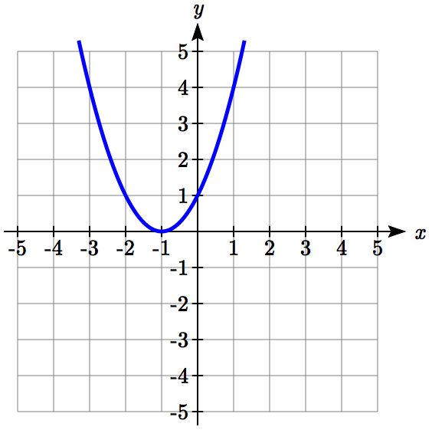 E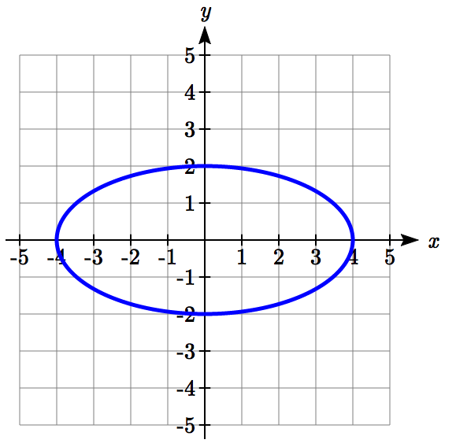 F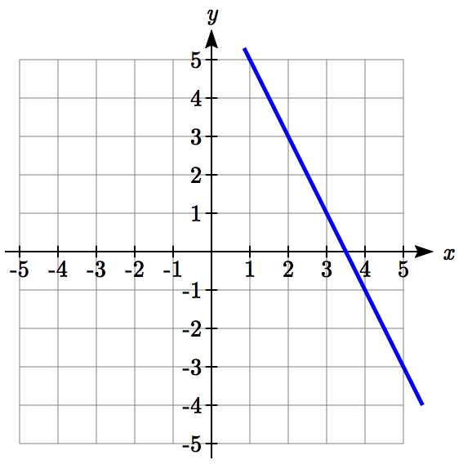

From each pair of graphs in the *t-x* and *t-y* planes shown, sketch a graph in the *x-y* plane.

7. 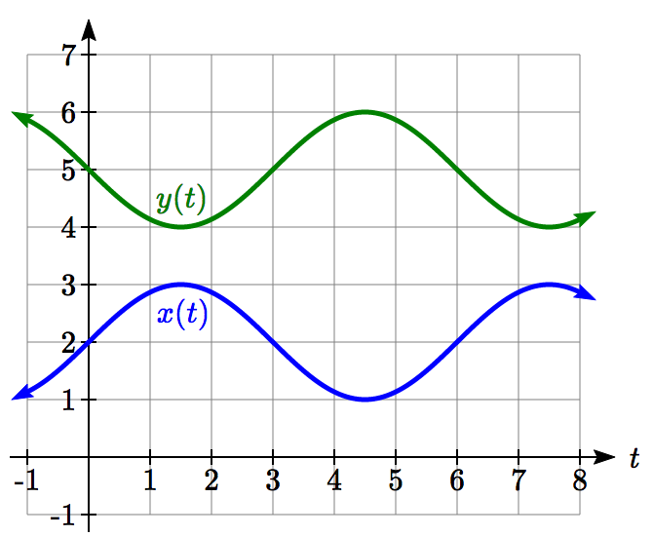 8. 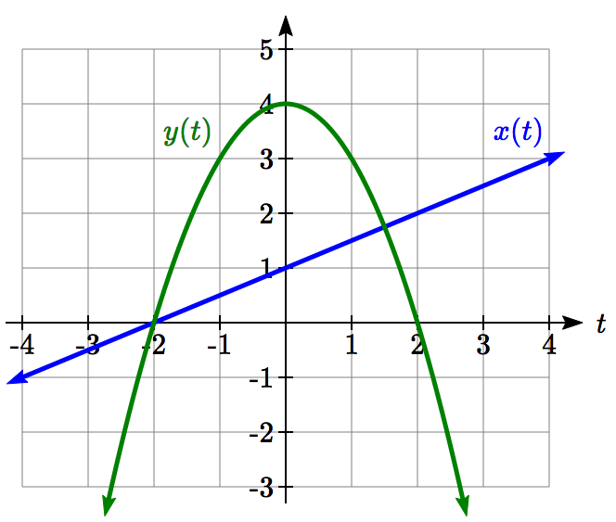

From each graph in the *x-y­* plane shown, sketch a graph of the parameter functions in the *t-x* and *t-y* planes.

9. 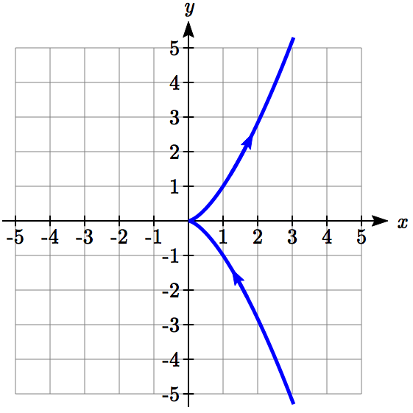 10. 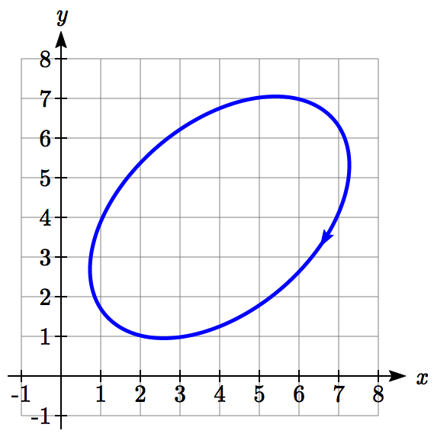

Sketch the parametric equations for .

11.  12. 

Eliminate the parameter *t* to rewrite the parametric equation as a Cartesian equation

13.  14. 

15.  16. 

17.  18. 

19.  20. 

21.  22. 

23.  24. 

Parameterize (write a parametric equation for) each Cartesian equation

25.  26. 

27.  28. 

29.  30. 

Parameterize the graphs shown.

31. 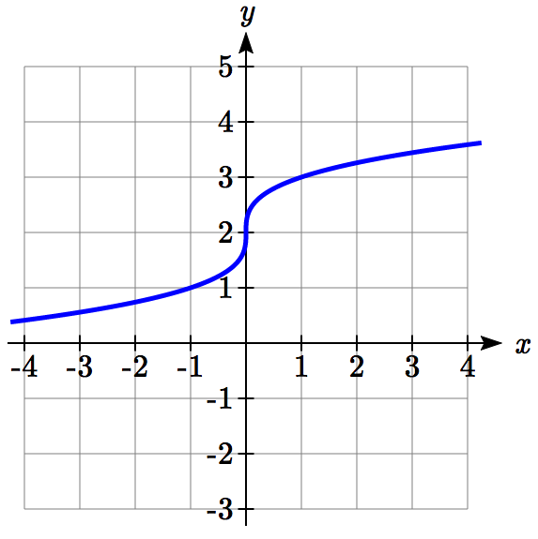 32. 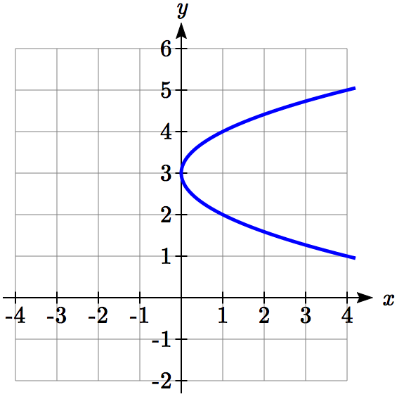

33. 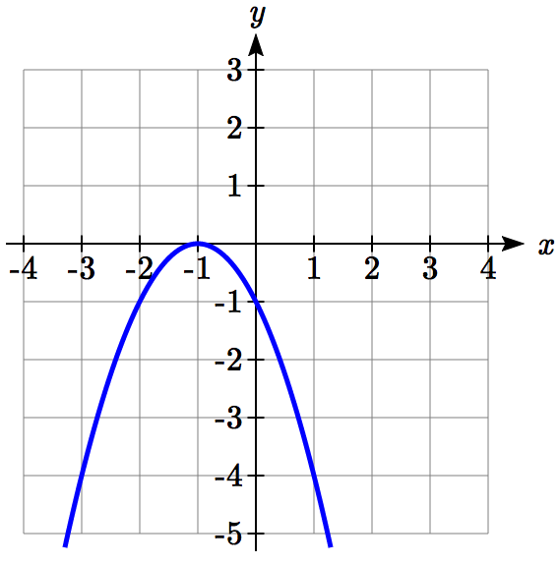 34. 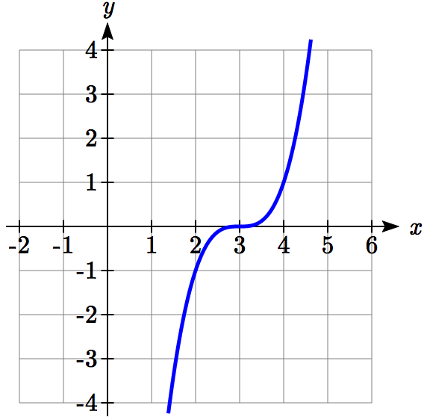

1. Parameterize the line from  to  so that the line is at  at *t* = 0, and at  at *t* = 1.
2. Parameterize the line from  to  so that the line is at  at *t* = 0, and at  at *t* = 1.

The graphs below are created by parameteric equations of the form . Find the values of *a, b, c,* and *d* to achieve each graph.

37. 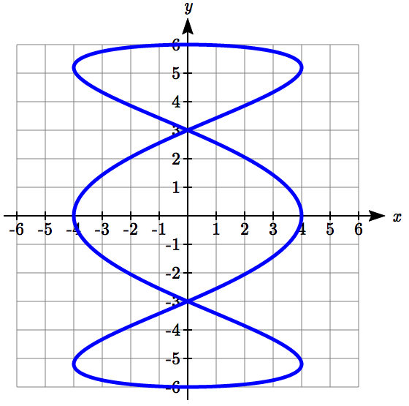 38. 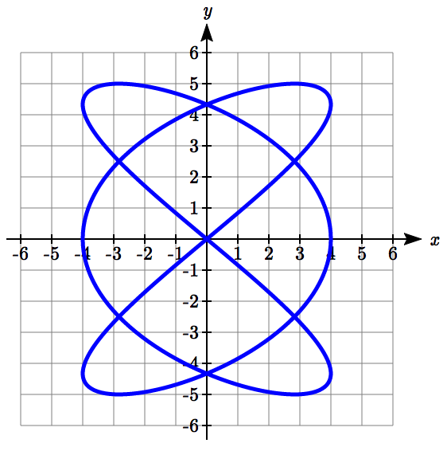

39. 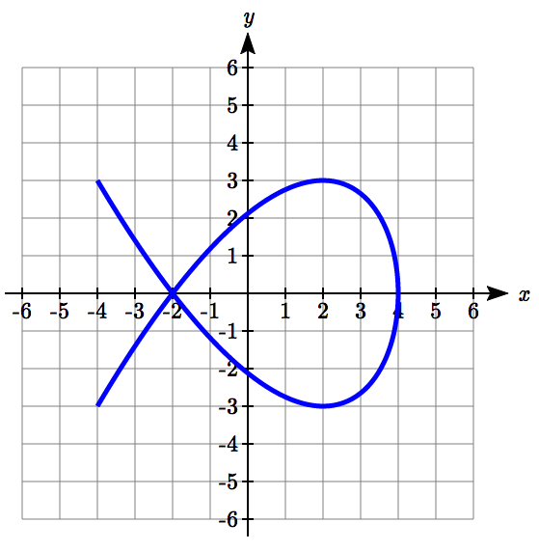 40. 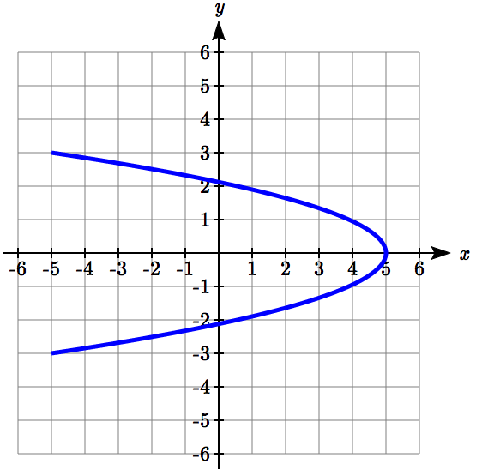

1. An object is thrown in the air with vertical velocity 20 ft/s and horizontal velocity 15 ft/s. The object’s height can be described by the equation , while the object moves horizontally with constant velocity 15 ft/s. Write parametric equations for the object’s position, then eliminate time to write height as a function of horizontal position.
2. A skateboarder riding on a level surface at a constant speed of 9 ft/s throws a ball in the air, the height of which can be described by the equation . Write parametric equations for the ball’s position, then eliminate time to write height as a function of horizontal position.

*P*

1. A carnival ride has a large rotating arm with diameter 40 feet centered 35 feet off the ground. At each end of the large arm are two smaller rotating arms with diameter 16 feet each. The larger arm rotates once every 5 seconds, while the smaller arms rotate once every 2 seconds. If you board the ride when the point *P* is closest to the ground, find parametric equations for your position over time.
2. A hypocycloid is a shape generated by tracking a fixed point on a small circle as it rolls around the inside of a larger circle. If the smaller circle has radius 1 and the large circle has radius 6, find parametric equations for the position of the point *P* as the smaller wheel rolls in the direction indicated.

*P*

1. This curve was the inspiration for the artwork featured on the cover of this book.