# Chapter 7: Trigonometric Equations and Identities

In the last two chapters we have used basic definitions and relationships to simplify trigonometric expressions and solve trigonometric equations. In this chapter we will look at more complex relationships. By conducting a deeper study of trigonometric identities we can learn to simplify complicated expressions, allowing us to solve more interesting applications.

Section 7.1 Solving Trigonometric Equations with Identities 453

Section 7.2 Addition and Subtraction Identities 461

Section 7.3 Double Angle Identities 477

Section 7.4 Modeling Changing Amplitude and Midline 488

## Section 7.1 Solving Trigonometric Equations with Identities

In the last chapter, we solved basic trigonometric equations. In this section, we explore the techniques needed to solve more complicated trig equations. Building from what we already know makes this a much easier task.

Consider the function. If you were asked to solve, it requires simple algebra:

 Factor

 Giving solutions

*x* = 0 or *x* = 

Similarly, for , if we asked you to solve , you can solve this using unit circle values:

 for and so on.

Using these same concepts, we consider the composition of these two functions:



This creates an equation that is a polynomial trig function. With these types of functions, we use algebraic techniques like factoring and the quadratic formula, along with trigonometric identities and techniques, to solve equations.

As a reminder, here are some of the essential trigonometric identities that we have learned so far:

Identities

**Pythagorean Identities**

  

**Negative Angle Identities**

  

  

**Reciprocal Identities**

   

Example 1

Solve  for all solutions with .

This equation kind of looks like a quadratic equation, but with sin(*t*) in place of an algebraic variable (we often call such an equation “quadratic in sine”). As with all quadratic equations, we can use factoring techniques or the quadratic formula. This expression factors nicely, so we proceed by factoring out the common factor of sin(*t*):



Using the zero product theorem, we know that the product on the left will equal zero if either factor is zero, allowing us to break this equation into two cases:

 or 

We can solve each of these equations independently, using our knowledge of special angles.

 

*t* = 0 or *t* = π 

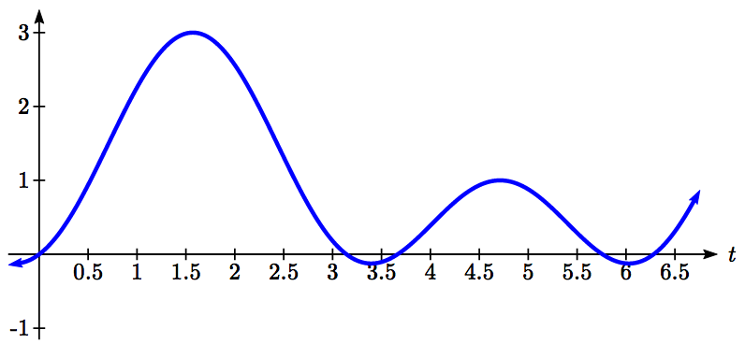  or 

Together, this gives us four solutions to the equation on :



We could check these answers are reasonable by graphing the function and comparing the zeros.

Example 2

Solve  for all solutions with .

Since the left side of this equation is quadratic in secant, we can try to factor it, and hope it factors nicely.

If it is easier to for you to consider factoring without the trig function present, consider using a substitution, resulting in , and then try to factor:



Undoing the substitution,



Since we have a product equal to zero, we break it into the two cases and solve each separately.

 Isolate the secant

 Rewrite as a cosine

 Invert both sides



Since the cosine has a range of [-1, 1], the cosine will never take on an output of -3. There are no solutions to this case.

Continuing with the second case,

 Isolate the secant

 Rewrite as a cosine

 Invert both sides

 This gives two solutions

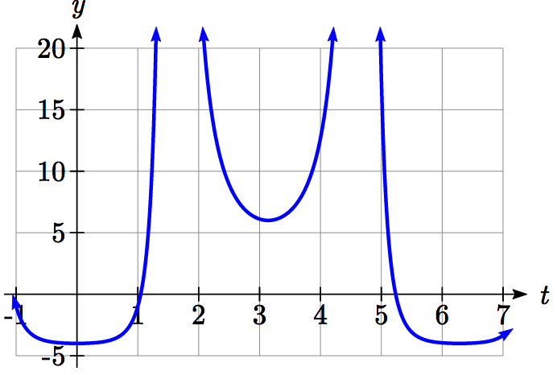 or 

These are the only two solutions on the interval.

By utilizing technology to graph , a look at a graph confirms there are only two zeros for this function on the interval [0, 2π), which assures us that we didn’t miss anything.

Try it Now

1. Solve  for all solutions with .

When solving some trigonometric equations, it becomes necessary to first rewrite the equation using trigonometric identities. One of the most common is the Pythagorean Identity,  which allows you to rewrite  in terms of  or vice versa,

Identities

**Alternate Forms of the Pythagorean Identity**



These identities become very useful whenever an equation involves a combination of sine and cosine functions.

Example 3

Solve  for all solutions with .

Since this equation has a mix of sine and cosine functions, it becomes more complicated to solve. It is usually easier to work with an equation involving only one trig function. This is where we can use the Pythagorean Identity.

 Using 

 Distributing the 2



Since this is now quadratic in cosine, we rearrange the equation so one side is zero and factor.

 Multiply by -1 to simplify the factoring

 Factor



This product will be zero if either factor is zero, so we can break this into two separate cases and solve each independently.

 or 

 or 

 or  or 

Try it Now

2. Solve  for all solutions with .

In addition to the Pythagorean Identity, it is often necessary to rewrite the tangent, secant, cosecant, and cotangent as part of solving an equation.

Example 4

Solve  for all solutions with .

With a combination of tangent and sine, we might try rewriting tangent



 Multiplying both sides by cosine



At this point, you may be tempted to divide both sides of the equation by sin(*x*). **Resist the urge**. When we divide both sides of an equation by a quantity, we are assuming the quantity is never zero. In this case, when sin(*x*) = 0 the equation is satisfied, so we’d lose those solutions if we divided by the sine.

To avoid this problem, we can rearrange the equation so that one side is zero[1].

 Factoring out sin(*x*) from both parts



From here, we can see we get solutions when  or .

Using our knowledge of the special angles of the unit circle,

 when *x* = 0 or *x* = π.

For the second equation, we will need the inverse cosine.



 Using our calculator or technology

 Using symmetry to find a second solution



We have four solutions on :

*x* = 0, 1.231, π, 5.052

Try it Now

3. Solve  to find the first four positive solutions.

Example 5

Solve  for all solutions with .

 Using the reciprocal identities

 Simplifying

 Subtracting 2 from each side



This does not appear to factor nicely so we use the quadratic formula, remembering that we are solving for cos(*θ*).



Using the negative square root first,



This has no solutions, since the cosine can’t be less than -1.

Using the positive square root,



 By symmetry, a second solution can be found



Important Topics of This Section

Review of Trig Identities

Solving Trig Equations

By Factoring

Using the Quadratic Formula

Utilizing Trig Identities to simplify

Try it Now Answers

1. Factor as    
 at   
 at   


2.   
  
  
 has no solutions  
 at 

3.   
  
  


## Section 7.1 Exercises

Find all solutions on the interval .

1.  2.  3.  4. 

Find all solutions.

5.  6.  7.  8. 

9.  10.  11.  12. 

Find all solutions on the interval .

13.  14. 

15.  16. 

17.  18. 

19.  20. 

21.  22. 

23.  24. 

25.  26. 

27.  28. 

29.  30. 

31.  32. 

33.  34. 

35.  36. 

37. 

38. 

39.  40. 

41.  42. 

## Section 7.2 Addition and Subtraction Identities

In this section, we begin expanding our repertoire of trigonometric identities.

Identities

**The sum and difference identities**









We will prove the difference of angles identity for cosine. The rest of the identities can be derived from this one.

Proof of the difference of angles identity for cosine

Consider two points on a unit circle:

β

α - β

α

*P*

*Q*

*C*

*D*

*O*

*P* at an angle of α from the positive *x* axis with coordinates , and *Q* at an angle of β with coordinates .

Notice the measure of angle *POQ* is α – β. Label two more points:

*C* at an angle of α – β, with coordinates ,

*D* at the point (1, 0).

Notice that the distance from *C* to *D* is the same as the distance from *P* to *Q* because triangle *COD* is a rotation of triangle *POQ*.

Using the distance formula to find the distance from *P* to *Q* yields



Expanding this



Applying the Pythagorean Identity and simplifying



Similarly, using the distance formula to find the distance from *C* to *D*



Expanding this



Applying the Pythagorean Identity and simplifying



Since the two distances are the same we set these two formulas equal to each other and simplify







This establishes the identity.

Try it Now

1. By writing  as , show the sum of angles identity for cosine follows from the difference of angles identity proven above.

The sum and difference of angles identities are often used to rewrite expressions in other forms, or to rewrite an angle in terms of simpler angles.

Example 1

Find the exact value of .

Since , we can evaluate  as

 Apply the cosine sum of angles identity

 Evaluate

 Simply



Try it Now

1. Find the exact value of .

Example 2

Rewrite  in terms of sin(*x*) and cos(*x*).

 Use the difference of angles identity for sine

= Evaluate the cosine and sine and rearrange



Additionally, these identities can be used to simplify expressions or prove new identities

Example 3

Prove .

As with any identity, we need to first decide which side to begin with. Since the left side involves sum and difference of angles, we might start there

 Apply the sum and difference of angle identities



Since it is not immediately obvious how to proceed, we might start on the other side, and see if the path is more apparent.

 Rewriting the tangents using the tangent identity

 Multiplying the top and bottom by cos(*a*)cos(*b*)

 Distributing and simplifying

 From above, we recognize this

 Establishing the identity

These identities can also be used to solve equations.

Example 4

Solve .

By recognizing the left side of the equation as the result of the difference of angles identity for cosine, we can simplify the equation

 Apply the difference of angles identity



 Use the negative angle identity



Since this is a special cosine value we recognize from the unit circle, we can quickly write the answers:

, where *k* is an integer

**Combining Waves of Equal Period**

A sinusoidal function of the form  can be rewritten using the sum of angles identity.

Example 5

Rewrite  as a sum of sine and cosine.

 Using the sum of angles identity

 Evaluate the sine and cosine

 Distribute and simplify



Notice that the result is a stretch of the sine added to a different stretch of the cosine, but both have the same horizontal compression, which results in the same period.

We might ask now whether this process can be reversed – can a combination of a sine and cosine of the same period be written as a single sinusoidal function? To explore this, we will look in general at the procedure used in the example above.

 Use the sum of angles identity

 Distribute the *A*

 Rearrange the terms a bit



Based on this result, if we have an expression of the form , we could rewrite it as a single sinusoidal function if we can find values *A* and *C* so that

, which will require that:

 which can be rewritten as 

To find *A*,





 Apply the Pythagorean Identity and simplify



Rewriting a Sum of Sine and Cosine as a Single Sine

To rewrite  as 

, , and 

You can use either of the last two equations to solve for possible values of *C*. Since there will usually be two possible solutions, we will need to look at both to determine which quadrant *C* is in and determine which solution for *C* satisfies both equations.

Example 6

Rewrite  as a single sinusoidal function.

Using the formulas above, , so *A* = 8.

Solving for *C*,

, so  or .

However, notice . Sine is negative in the third and fourth quadrant, so the angle that works for both is .

Combining these results gives us the expression



Try it Now

1. Rewrite  as a single sinusoidal function.

Rewriting a combination of sine and cosine of equal periods as a single sinusoidal function provides an approach for solving some equations.

Example 7

Solve  to find two positive solutions.

Since the sine and cosine have the same period, we can rewrite them as a single sinusoidal function.

, so *A* = 5

, so  or 

Since , a positive value, we need the angle in the first quadrant, *C* = 0.927.

Using this, our equation becomes

 Divide by 5

 Make the substitution *u* = 2*x* + 0.927

 The inverse gives a first solution

 By symmetry, the second solution is

 A third solution would be



Undoing the substitution, we can find two positive solutions for *x*.

 or  or 

  

  

Since the first of these is negative, we eliminate it and keep the two positive solutions,  and .

**The Product-to-Sum and Sum-to-Product Identities**

Identities

**The Product-to-Sum Identities**



We will prove the first of these, using the sum and difference of angles identities from the beginning of the section. The proofs of the other two identities are similar and are left as an exercise.

Proof of the product-to-sum identity for sin(*α*)cos(*β*)

Recall the sum and difference of angles identities from earlier





Adding these two equations, we obtain



Dividing by 2, we establish the identity



Example 8

Write  as a sum or difference.

Using the product-to-sum identity for a product of sines



 If desired, apply the negative angle identity

 Distribute



Try it Now

1. Evaluate .

Identities

**The Sum-to-Product Identities**









We will again prove one of these and leave the rest as an exercise.

Proof of the sum-to-product identity for sine functions

We define two new variables:



Adding these equations yields , giving 

Subtracting the equations yields , or 

Substituting these expressions into the product-to-sum identity  gives

 Multiply by 2 on both sides

 Establishing the identity

Try it Now

1. Notice that, using the negative angle identity, . Use this along with the sum of sines identity to prove the sum-to-product identity for .

Example 9

Evaluate .

Using the sum-to-product identity for the difference of cosines,



 Simplify

 Evaluate



Example 10

Prove the identity .

Since the left side seems more complicated, we can start there and simplify.

 Use the sum-to-product identities

 Simplify

 Simplify further

 Rewrite as a tangent

 Establishing the identity

Example 11

Solve  for all solutions with .

In an equation like th is, it is not immediately obvious how to proceed. One option would be to combine the two sine functions on the left side of the equation. Another would be to move the cosine to the left side of the equation, and combine it with one of the sines. For no particularly good reason, we’ll begin by combining the sines on the left side of the equation and see how things work out.

 Apply the sum to product identity on the left

 Simplify

 Apply the negative angle identity

 Rearrange the equation to be 0 on one side

 Factor out the cosine



Using the Zero Product Theorem we know that at least one of the two factors must be zero. The first factor, , has period , so the solution interval of  represents one full cycle of this function.

 Substitute 

 On one cycle, this has solutions

 or  Undo the substitution

, so 

, so 

The second factor, , has period of , so the solution interval  contains two complete cycles of this function.

 Isolate the sine

 Substitute 

 On one cycle, this has solutions

 or  On the second cycle, the solutions are

 or  Undo the substitution

, so 

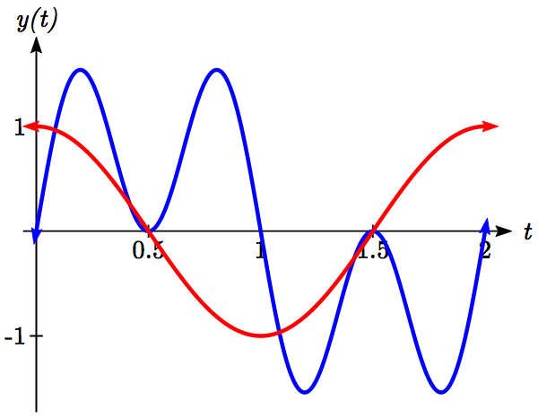, so 

, so 

, so 

Altogether, we found six solutions on , which we can confirm by looking at the graph.



Important Topics of This Section

The sum and difference identities

Combining waves of equal periods

Product-to-sum identities

Sum-to-product identities

Completing proofs

Try it Now Answers

1. 
2.   
   
3. . *A* = 6  
   , .   
   
4.   
     
   =
5.  Use negative angle identity for sine

 Use sum-to-product identity for sine

 Eliminate the parenthesis

 Establishing the identity

## Section 7.2 Exercises

Find an exact value for each of the following.

1.  2.  3.  4. 

5.  6.  7.  8. 

Rewrite in terms of  and .

9.  10.  11.  12. 

Simplify each expression.

13.  14.  15.  16. 

Rewrite the product as a sum.

17.  18. 

19.  20. 

Rewrite the sum as a product.

21.  22. 

23.  24. 

25. Given  and , with *a* and *b* both in the interval :

a. Find  b. Find 

26. Given  and , with *a* and *b* both in the interval :

a. Find  b. Find 

Solve each equation for all solutions.

27. 

28. 

29. 

30. 

Solve each equation for all solutions.

31. 

32. 

33. 

34. 

Rewrite as a single function of the form .

35.  36. 

37.  38. 

Solve for the first two positive solutions.

39.  40. 

41.  42. 

Simplify.

43.  44. 

Prove the identity.

44. 

45. 

46. 

47. 

48. 

49. 

50. 

Prove the identity.

51. 

52. 

53. Use the sum and difference identities to establish the product-to-sum identity

54. Use the sum and difference identities to establish the product-to-sum identity 

55. Use the product-to-sum identities to establish the sum-to-product identity 

56. Use the product-to-sum identities to establish the sum-to-product identity 

## Section 7.3 Double Angle Identities

Two special cases of the sum of angles identities arise often enough that we choose to state these identities separately.

Identities

**The double angle identities**





These identities follow from the sum of angles identities.

Proof of the sine double angle identity



 Apply the sum of angles identity

 Simplify

 Establishing the identity

Try it Now

1. Show  by using the sum of angles identity for cosine.

For the cosine double angle identity, there are three forms of the identity stated because the basic form, , can be rewritten using the Pythagorean Identity. Rearranging the Pythagorean Identity results in the equality, and by substituting this into the basic double angle identity, we obtain the second form of the double angle identity.

 Substituting using the Pythagorean identity

 Simplifying



Example 1

If  and *θ* is in the second quadrant, find exact values for  and .

To evaluate, since we know the value for  we can use the version of the double angle that only involves sine.



Since the double angle for sine involves both sine and cosine, we’ll need to first find , which we can do using the Pythagorean Identity.









Since *θ* is in the second quadrant, we know that cos(*θ*) < 0, so



Now we can evaluate the sine double angle



Example 2

Simplify the expressions

a)  b) 

a) Notice that the expression is in the same form as one version of the double angle identity for cosine: . Using this,



b) This expression looks similar to the result of the double angle identity for sine.

 Factoring a 4 out of the original expression

 Applying the double angle identity



We can use the double angle identities to simplify expressions and prove identities.

Example 2

Simplify .

With three choices for how to rewrite the double angle, we need to consider which will be the most useful. To simplify this expression, it would be great if the denominator would cancel with something in the numerator, which would require a factor of  in the numerator, which is most likely to occur if we rewrite the numerator with a mix of sine and cosine.

 Apply the double angle identity

= Factor the numerator

 Cancelling the common factor

 Resulting in the most simplified form

Example 3

Prove .

Since the right side seems a bit more complicated than the left side, we begin there.

 Rewrite the secants in terms of cosine



At this point, we could rewrite the bottom with common denominators, subtract the terms, invert and multiply, then simplify. Alternatively, we can multiple both the top and bottom by , the common denominator:

 Distribute on the bottom

 Simplify

 Rewrite the denominator as a double angle

 Rewrite as a secant

 Establishing the identity

Try it Now

1. Use an identity to find the exact value of .

As with other identities, we can also use the double angle identities for solving equations.

Example 4

Solve  for all solutions with .

In general when solving trig equations, it makes things more complicated when we have a mix of sines and cosines and when we have a mix of functions with different periods. In this case, we can use a double angle identity to rewrite the cos(2*t*). When choosing which form of the double angle identity to use, we notice that we have a cosine on the right side of the equation. We try to limit our equation to one trig function, which we can do by choosing the version of the double angle formula for cosine that only involves cosine.

 Apply the double angle identity

 This is quadratic in cosine, so make one side 0

 Factor

 Break this apart to solve each part separately

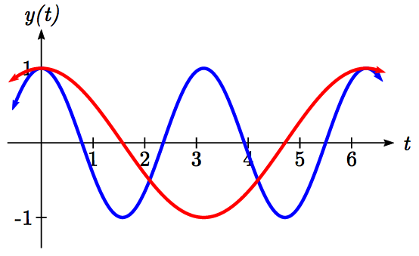

 or 

 or 

 or  or 

Looking at a graph of cos(2*t*) and cos(*t*) shown together, we can verify that these three solutions on [0, 2π) seem reasonable.

Example 5

A cannonball is fired with velocity of 100 meters per second. If it is launched at an angle of *θ*, the vertical component of the velocity will be  and the horizontal component will be . Ignoring wind resistance, the height of the cannonball will follow the equation  and horizontal position will follow the equation . If you want to hit a target 900 meters away, at what angle should you aim the cannon?

To hit the target 900 meters away, we want at the time when the cannonball hits the ground, when . To solve this problem, we will first solve for the time, *t*, when the cannonball hits the ground. Our answer will depend upon the angle.



 Factor

 Break this apart to find two solutions

 or  Solve for *t*





This shows that the height is 0 twice, once at *t* = 0 when the cannonball is fired, and again when the cannonball hits the ground after flying through the air. This second value of *t* gives the time when the ball hits the ground in terms of the angle . We want the horizontal distance *x(t)* to be 900 when the ball hits the ground, in other words when .

Since the target is 900 m away we start with

 Use the formula for *x(t)*

 Substitute the desired time, *t* from above

 Simplify

 Isolate the cosine and sine product



The left side of this equation almost looks like the result of the double angle identity for sine: .

Multiplying both sides of our equation by 2,

 Using the double angle identity on the left

 Use the inverse sine

 Divide by 2

, or about 30.94 degrees

**Power Reduction and Half Angle Identities**

Another use of the cosine double angle identities is to use them in reverse to rewrite a squared sine or cosine in terms of the double angle. Starting with one form of the cosine double angle identity:

 Isolate the cosine squared term

 Add 1

 Divide by 2

 This is called a **power reduction identity**

Try it Now

3. Use another form of the cosine double angle identity to prove the identity .

The cosine double angle identities can also be used in reverse for evaluating angles that are half of a common angle. Building from our formula , if we let , then  this identity becomes . Taking the square root, we obtain

, where the sign is determined by the quadrant.

This is called a **half-angle identity**.

Try it Now

4. Use your results from the last Try it Now to prove the identity  
.

Identities

**Half-Angle Identities**

 

**Power Reduction Identities**

 

Since these identities are easy to derive from the double-angle identities, the power reduction and half-angle identities are not ones you should need to memorize separately.

Example 6

Rewrite  without any powers.

 Using the power reduction formula

 Square the numerator and denominator

 Expand the numerator

 Split apart the fraction

 Apply the formula above to 



 Simplify

 Combine the constants



Example 7

Find an exact value for .

Since 15 degrees is half of 30 degrees, we can use our result from above:



We can evaluate the cosine. Since 15 degrees is in the first quadrant, we need the positive result.





Important Topics of This Section

Double angle identity

Power reduction identity

Half angle identity

Using identities

Simplify equations

Prove identities

Solve equations

Try it Now Answers

1. 
2.  = 
3. 
4. 

## Section 7.3 Exercises

1. If  and *x* is in quadrant I, then find exact values for (without solving for *x*):

a.  b.  c. 

2. If  and *x* is in quadrant I, then find exact values for (without solving for *x*):

a.  b.  c. 

Simplify each expression.

3.  4. 

5.  6. 

7.  8. 

9.  10. 

Solve for all solutions on the interval .

11.  12. 

13.  14. 

15.  16. 

17.  18. 

Use a double angle, half angle, or power reduction formula to rewrite without exponents.

19.   20. 

21.  22. 

23.  24. 

25. If  and , then find exact values for (without solving for *x*):

1.  b.  c. 

26. If  and , then find exact values for (without solving for *x*):

1.  b.  c. 

Prove the identity.

27. 

28. 

29. 

30. 

31. 

32. 

33. 

34. 

35. 

36. 

## Section 7.4 Modeling Changing Amplitude and Midline

While sinusoidal functions can model a variety of behaviors, it is often necessary to combine sinusoidal functions with linear and exponential curves to model real applications and behaviors. We begin this section by looking at changes to the midline of a sinusoidal function. Recall that the midline describes the middle, or average value, of the sinusoidal function.

**Changing Midlines**

Example 1

A population of elk currently averages 2000 elk, and that average has been growing by 4% each year. Due to seasonal fluctuation, the population oscillates from 50 below average in the winter up to 50 above average in the summer. Find a function that models the number of elk after *t* years, starting in the winter.

There are two components to the behavior of the elk population: the changing average, and the oscillation. The average is an exponential growth, starting at 2000 and growing by 4% each year. Writing a formula for this:



For the oscillation, since the population oscillates 50 above and below average, the amplitude will be 50. Since it takes one year for the population to cycle, the period is 1. We find the value of the horizontal stretch coefficient.

The function starts in winter, so the shape of the function will be a negative cosine, since it starts at the lowest value.

Putting it all together, the equation would be:



Since the midline represents the average population, we substitute in the exponential function into the population equation to find our final equation:



This is an example of changing midline – in this case an exponentially changing midline.

Changing Midline

A function of the form  will oscillate above and below the average given by the function *g(t)*.

Changing midlines can be exponential, linear, or any other type of function. Here are some examples:

Linear midline Exponential midline Quadratic midline

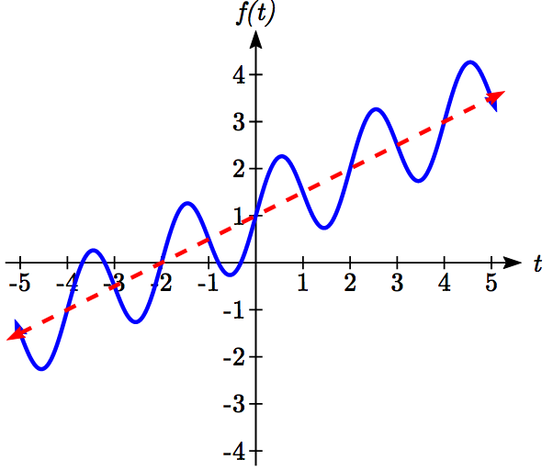 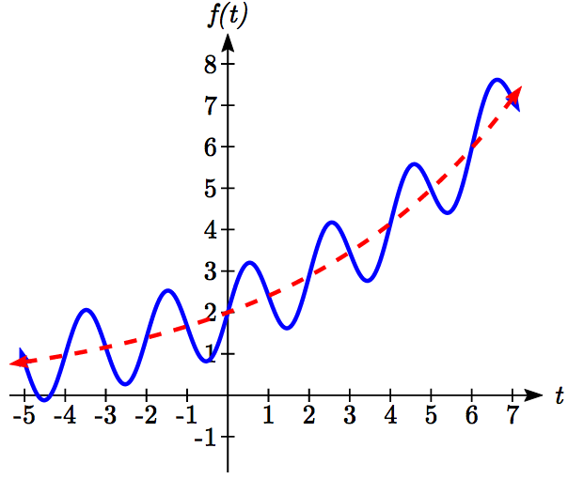 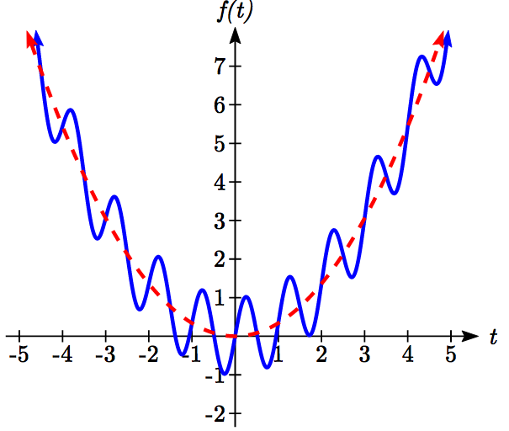  

Example 2

Find a function with linear midline of the form  that will pass through the points given below.

|  |  |  |  |  |
| --- | --- | --- | --- | --- |
| *t* | 0 | 1 | 2 | 3 |
| *f(t)* | 5 | 10 | 9 | 8 |

Since we are given the value of the horizontal compression coefficient we can calculate the period of this function: .

Since the sine function is at the midline at the beginning of a cycle and halfway through a cycle, we would expect this function to be at the midline at *t* = 0 and *t* = 2, since 2 is half the full period of 4. Based on this, we expect the points (0, 5) and (2, 9) to be points on the midline. We can clearly see that this is not a constant function and so we use the two points to calculate a linear function: . From these two points we can calculate a slope:



Combining this with the initial value of 5, we have the midline: .

The full function will have form . To find the amplitude, we can plug in a point we haven’t already used, such as (1, 10).

 Evaluate the sine and combine like terms





A function of the form given fitting the data would be



Alternative Approach

Notice we could have taken an alternate approach by plugging points (0, 5) and (2, 9) into the original equation. Substituting (0, 5),

 Evaluate the sine and simplify



Substituting (2, 9)

 Evaluate the sine and simplify





, as we found above. Now we can proceed to find *A* the same way we did before.

Example 3

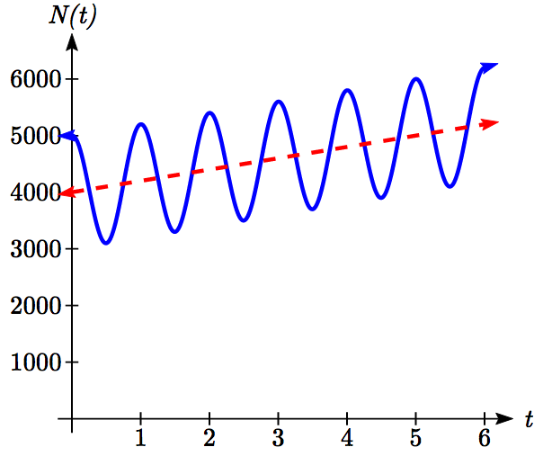The number of tourists visiting a ski and hiking resort averages 4000 people annually and oscillates seasonally, 1000 above and below the average. Due to a marketing campaign, the average number of tourists has been increasing by 200 each year. Write an equation for the number of tourists after *t* years, beginning at the peak season.

Again there are two components to this problem: the oscillation and the average. For the oscillation, the number of tourists oscillates 1000 above and below average, giving an amplitude of 1000. Since the oscillation is seasonal, it has a period of 1 year. Since we are given a starting point of “peak season”, we will model this scenario with a cosine function.

So far, this gives an equation in the form .

The average is currently 4000, and is increasing by 200 each year. This is a constant rate of change, so this is linear growth, . This function will act as the midline.

Combining these two pieces gives a function for the number of tourists:



Try it Now

1. Given the function , describe the midline and amplitude using words.

**Changing Amplitude**

There are also situations in which the amplitude of a sinusoidal function does not stay constant. Back in Chapter 6, we modeled the motion of a spring using a sinusoidal function, but had to ignore friction in doing so. If there were friction in the system, we would expect the amplitude of the oscillation to decrease over time. In the equation , *A* gives the amplitude of the oscillation, we can allow the amplitude to change by replacing this constant *A* with a function *A(t)*.

Changing Amplitude

A function of the form  will oscillate above and below the midline with an amplitude given by *A(t)*.

Here are some examples:

Linear amplitude Exponential amplitude Quadratic amplitude

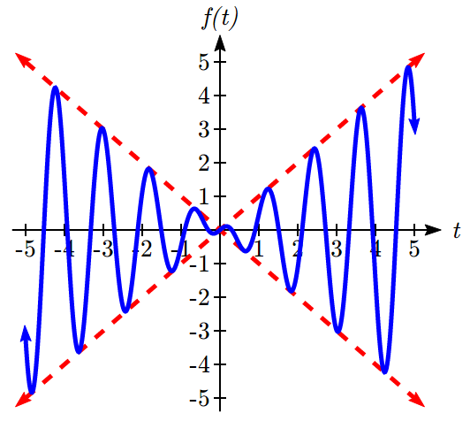 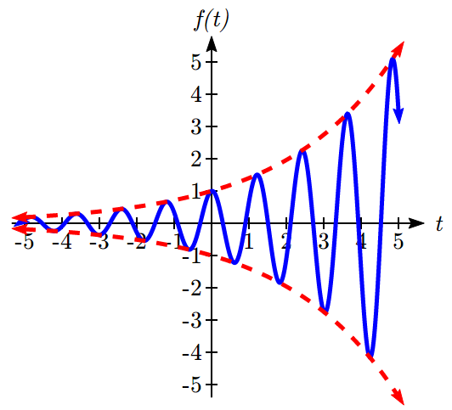 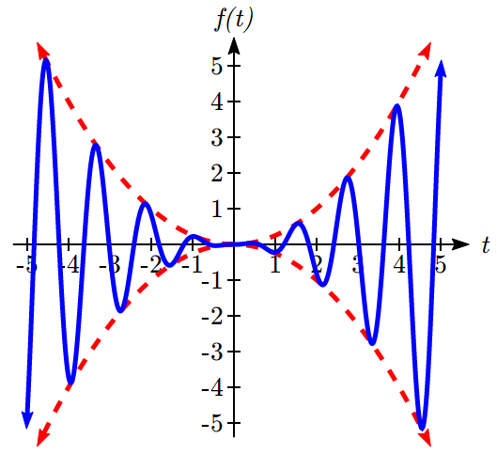  

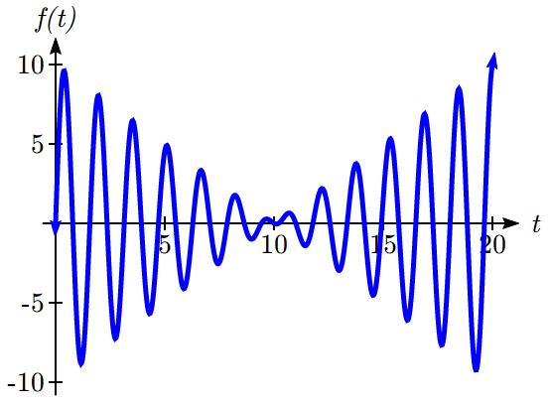When thinking about a spring with amplitude decreasing over time, it is tempting to use the simplest tool for the job – a linear function. But if we attempt to model the amplitude with a decreasing linear function, such as , we quickly see the problem when we graph the equation .

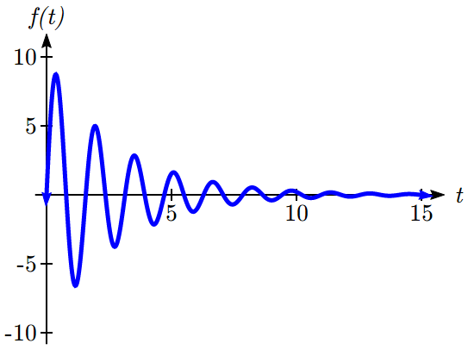While the amplitude decreases at first as intended, the amplitude hits zero at *t* = 10, then continues past the intercept, increasing in absolute value, which is not the expected behavior. This behavior and function may model the situation on a restricted domain and we might try to chalk the rest of it up to model breakdown, but in fact springs just don’t behave like this.

A better model, as you will learn later in physics and calculus, would show the amplitude decreasing by a fixed *percentage* each second, leading to an exponential decay model for the amplitude.

Damped Harmonic Motion

**Damped harmonic motion**, exhibited by springs subject to friction, follows a model of the form

 or .

Example 4

A spring with natural length of 20 feet is pulled back 6 feet and released. It oscillates once every 2 seconds. Its amplitude decreases by 20% each second. Find a function that models the position of the spring *t* seconds after being released.

Since the spring will oscillate on either side of the natural length, the midline will be at 20 feet. The oscillation has a period of 2 seconds, and so the horizontal compression coefficient is. Additionally, it begins at the furthest distance from the wall, indicating a cosine model.

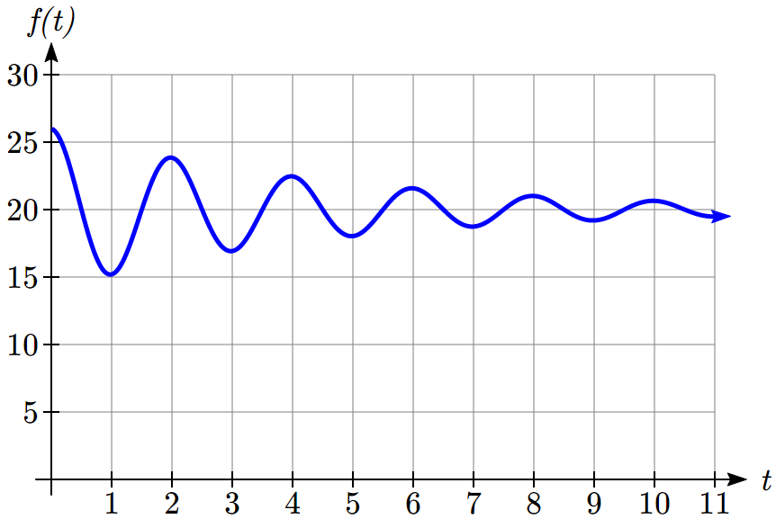

Meanwhile, the amplitude begins at 6 feet, and decreases by 20% each second, giving an amplitude function of.

Combining this with the sinusoidal information gives a function for the position of the spring:



Example 5

A spring with natural length of 30 cm is pulled out 10 cm and released. It oscillates 4 times per second. After 2 seconds, the amplitude has decreased to 5 cm. Find a function that models the position of the spring.

The oscillation has a period of  second, so . Since the spring will oscillate on either side of the natural length, the midline will be at 30 cm. It begins at the furthest distance from the wall, suggesting a cosine model. Together, this gives

.

For the amplitude function, we notice that the amplitude starts at 10 cm, and decreases to 5 cm after 2 seconds. This gives two points (0, 10) and (2, 5) that must be satisfied by an exponential function:  and . Since the function is exponential, we can use the form . Substituting the first point, , so *a* = 10. Substituting in the second point,

 Divide by 10

 Take the square root



This gives an amplitude function of . Combining this with the oscillation,



Try it Now

2. A certain stock started at a high value of $7 per share, oscillating monthly above and below the average value, with the oscillation decreasing by 2% per year. However, the average value started at $4 per share and has grown linearly by 50 cents per year.

a. Find a formula for the midline and the amplitude.

b. Find a function *S(t)* that models the value of the stock after *t* years.

Example 6

In AM (Amplitude Modulated) radio, a carrier wave with a high frequency is used to transmit music or other signals by applying the to-be-transmitted signal as the amplitude of the carrier signal. A musical note with frequency 110 Hz (Hertz = cycles per second) is to be carried on a wave with frequency of 2 KHz (KiloHertz = thousands of cycles per second). If the musical wave has an amplitude of 3, write a function describing the broadcast wave.

The carrier wave, with a frequency of 2000 cycles per second, would have period  of a second, giving an equation of the form . Our choice of a sine function here was arbitrary – it would have worked just was well to use a cosine.

The musical tone, with a frequency of 110 cycles per second, would have a period of  of a second. With an amplitude of 3, this would correspond to a function of the form . Again our choice of using a sine function is arbitrary.

The musical wave is acting as the amplitude of the carrier wave, so we will multiply the musical tone’s function by the carrier wave function, resulting in the function



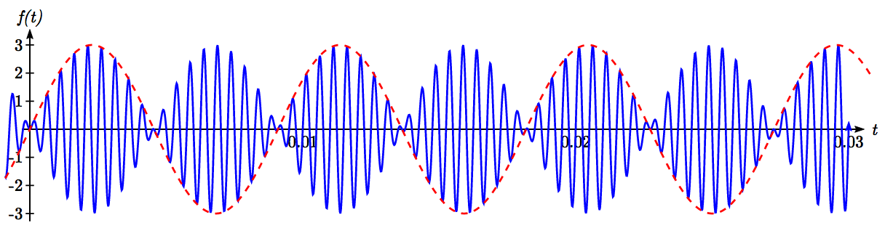

Important Topics of This Section

Changing midline

Changing amplitude

Linear Changes

Exponential Changes

Damped Harmonic Motion

Try it Now Answers

1. The midline follows the path of the quadraticand the amplitude is a constant value of 8.
2. 

*S(t)*=

## Section 7.4 Exercises

Find a possible formula for the trigonometric function whose values are given in the following tables.

|  |  |  |  |  |  |  |  |  |  |  |  |  |  |  |  |  |  |  |  |  |  |  |  |  |  |  |  |  |  |  |  |  |  |  |  |
| --- | --- | --- | --- | --- | --- | --- | --- | --- | --- | --- | --- | --- | --- | --- | --- | --- | --- | --- | --- | --- | --- | --- | --- | --- | --- | --- | --- | --- | --- | --- | --- | --- | --- | --- | --- |
| 1. | |  |  |  |  |  |  |  |  | | --- | --- | --- | --- | --- | --- | --- | --- | | ***x*** | 0 | 3 | 6 | 9 | 12 | 15 | 18 | | ***y*** | -4 | -1 | 2 | -1 | -4 | -1 | 2 | | 2. | |  |  |  |  |  |  |  |  | | --- | --- | --- | --- | --- | --- | --- | --- | | ***x*** | 0 | 2 | 4 | 6 | 8 | 10 | 12 | | ***y*** | 5 | 1 | -3 | 1 | 5 | 1 | -3 | |

1. The displacement , in centimeters, of a mass suspended by a spring is modeled by the function , where *t* is measured in seconds. Find the amplitude, period, and frequency of this displacement.
2. The displacement , in centimeters, of a mass suspended by a spring is modeled by the function , where *t* is measured in seconds. Find the amplitude, period, and frequency of this displacement.
3. A population of rabbits oscillates 19 above and below average during the year, reaching the lowest value in January. The average population starts at 650 rabbits and increases by 160 each year. Find a function that models the population, *P*, in terms of the months since January, *t*.
4. A population of deer oscillates 15 above and below average during the year, reaching the lowest value in January. The average population starts at 800 deer and increases by 110 each year. Find a function that models the population, *P*, in terms of the months since January, *t*.
5. A population of muskrats oscillates 33 above and below average during the year, reaching the lowest value in January. The average population starts at 900 muskrats and increases by 7% each month. Find a function that models the population, *P*, in terms of the months since January, *t*.
6. A population of fish oscillates 40 above and below average during the year, reaching the lowest value in January. The average population starts at 800 fish and increases by 4% each month. Find a function that models the population, *P*, in terms of the months since January, *t*.
7. A spring is attached to the ceiling and pulled 10 cm down from equilibrium and released. The amplitude decreases by 15% each second. The spring oscillates 18 times each second. Find a function that models the distance, *D,* the end of the spring is below equilibrium in terms of seconds, *t*, since the spring was released.
8. A spring is attached to the ceiling and pulled 7 cm down from equilibrium and released. The amplitude decreases by 11% each second. The spring oscillates 20 times each second. Find a function that models the distance, *D,* the end of the spring is below equilibrium in terms of seconds, *t*, since the spring was released.
9. A spring is attached to the ceiling and pulled 17 cm down from equilibrium and released. After 3 seconds the amplitude has decreased to 13 cm. The spring oscillates 14 times each second. Find a function that models the distance, *D* the end of the spring is below equilibrium in terms of seconds, *t*, since the spring was released.
10. A spring is attached to the ceiling and pulled 19 cm down from equilibrium and released. After 4 seconds the amplitude has decreased to 14 cm. The spring oscillates 13 times each second. Find a function that models the distance, *D* the end of the spring is below equilibrium in terms of seconds, *t*, since the spring was released.

Match each equation form with one of the graphs.

13. a.  b. 

14. a.  b. 

I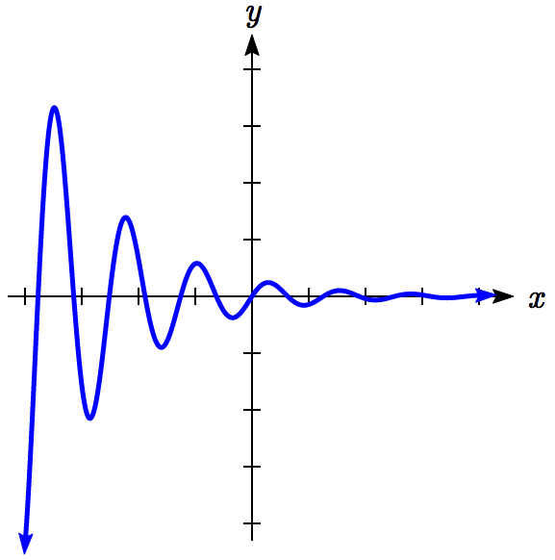 II 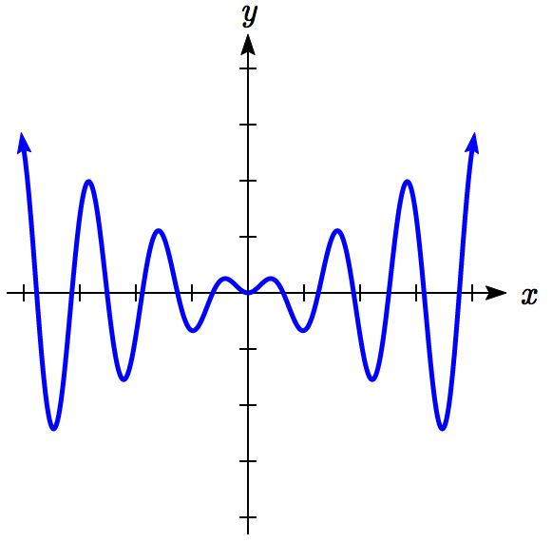 III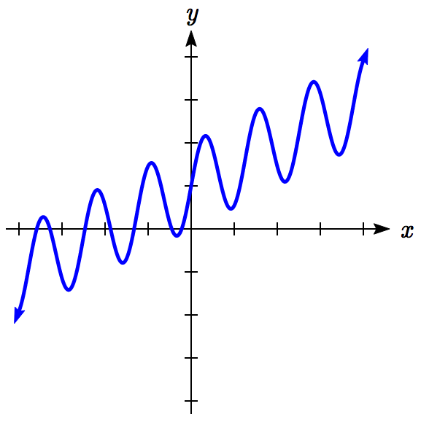 IV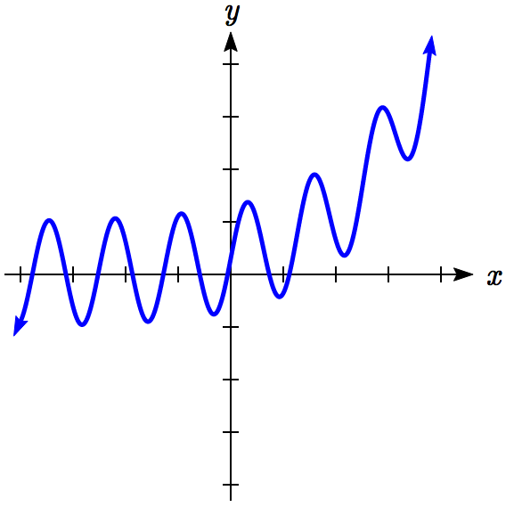

Find a function of the form  that fits the data given.

|  |  |  |  |  |  |  |  |  |  |  |  |  |  |  |  |  |  |  |  |  |  |  |  |
| --- | --- | --- | --- | --- | --- | --- | --- | --- | --- | --- | --- | --- | --- | --- | --- | --- | --- | --- | --- | --- | --- | --- | --- |
| 15. | |  |  |  |  |  | | --- | --- | --- | --- | --- | | ***x*** | 0 | 1 | 2 | 3 | | ***y*** | 6 | 29 | 96 | 379 | | 16. | |  |  |  |  |  | | --- | --- | --- | --- | --- | | ***x*** | 0 | 1 | 2 | 3 | | ***y*** | 6 | 34 | 150 | 746 | |

Find a function of the form  that fits the data given.

|  |  |  |  |  |  |  |  |  |  |  |  |  |  |  |  |  |  |  |  |  |  |  |  |
| --- | --- | --- | --- | --- | --- | --- | --- | --- | --- | --- | --- | --- | --- | --- | --- | --- | --- | --- | --- | --- | --- | --- | --- |
| 17. | |  |  |  |  |  | | --- | --- | --- | --- | --- | | ***x*** | 0 | 1 | 2 | 3 | | ***y*** | 7 | 6 | 11 | 16 | | 18. | |  |  |  |  |  | | --- | --- | --- | --- | --- | | ***x*** | 0 | 1 | 2 | 3 | | ***y*** | -2 | 6 | 4 | 2 | |

Find a function of the form  that fits the data given.

|  |  |  |  |  |  |  |  |  |  |  |  |  |  |  |  |  |  |  |  |  |  |  |  |
| --- | --- | --- | --- | --- | --- | --- | --- | --- | --- | --- | --- | --- | --- | --- | --- | --- | --- | --- | --- | --- | --- | --- | --- |
| 19. | |  |  |  |  |  | | --- | --- | --- | --- | --- | | ***x*** | 0 | 1 | 2 | 3 | | ***y*** | 11 | 3 | 1 | 3 | | 20. | |  |  |  |  |  | | --- | --- | --- | --- | --- | | ***x*** | 0 | 1 | 2 | 3 | | ***y*** | 4 | 1 | -11 | 1 | |

1. You technically *can* divide by sin(*x*), as long as you separately consider the case where sin(*x*) = 0. Since it is easy to forget this step, the factoring approach used in the example is recommended.