Section 8.1 Exercises

Solve for the unknown sides and angles of the triangles shown.
1. 2.
70°
50°
10
40°
110°
18
3. 4.
120°
6
25°
75°
45°
15
5. 6.
65°
5
6
70°
90
100
7. 8.
18
40°
25
30
50
30°
Assume $∠A$ is opposite side a, $∠B$ is opposite side b, and $∠C$ is opposite side c. Solve each triangle for the unknown sides and angles if possible. If there is more than one possible solution, give both.
9. $∠A=\text{43}°\text{, }∠C=\text{69}°\text{, }b=\text{20}$ 10. $∠A=\text{35}°\text{, }∠C=\text{73}°\text{, }b=\text{19}$
11. $∠A=\text{119}°\text{, }a=\text{26}\text{, }b=\text{14}$ 12. $∠C=\text{113}°\text{, }b=\text{10}\text{, }c=\text{32}$
13. $∠B=\text{50}°\text{, }a=\text{105},b=\text{45}$ 14. $∠B=\text{67}°\text{, }a=\text{49},b=\text{38}$
15. $∠A=\text{43}\text{.}1°\text{, }a=\text{184}\text{.}2,b=\text{242}\text{.}8$ 16. $∠A=\text{36}\text{.}6°\text{, }a=\text{186}\text{.}2,b=\text{242}\text{.}2$
Solve for the unknown sides and angles of the triangles shown.
17. 18.
60°
20
28
30°
16
10
19. 20.
13
11
20
5
8
10

Assume $∠A$ is opposite side a, $∠B$ is opposite side b, and $∠C$ is opposite side c. Solve each triangle for the unknown sides and angles if possible. If there is more than one possible solution, give both.
21. $∠C=\text{41}\text{.}2°\text{, }a=2\text{.}\text{49}\text{, }b=3\text{.}\text{13}$ 22. $∠B=\text{58}\text{.}7°\text{, }a=\text{10}\text{.}6\text{, }c=\text{15}\text{.}7$
23. $∠A=\text{120}°\text{, }b=6\text{, }c=7$ 24. $∠C=\text{115}°\text{, }a=\text{18},b=\text{23}$
- Find the area of a triangle with sides length 18, 21, and 32


- Find the area of a triangle with sides length 20, 26, 37
800 ft
900 ft
70°

- To find the distance across a small lake, a surveyor has taken the measurements shown. Find the distance across the lake.


350 km
370 km
2.1°
- To find the distance between two cities, a satellite calculates the distances and angle shown (not to scale). Find the distance between the cities.

- To determine how far a boat is from shore, two radar stations 500 feet apart determine the angles out to the boat, as shown. Find the distance of the boat from the station A, and the distance of the boat from shore.
70°
A
60°
B

86.2°
83.9°
A
B
- The path of a satellite orbiting the earth causes it to pass directly over two tracking stations A and B, which are 69 mi apart. When the satellite is on one side of the two stations, the angles of elevation at A and B are measured to be 86.2° and 83.9°, respectively. How far is the satellite from station A and how high is the satellite above the ground?

67°
16°
165m
- A communications tower is located at the top of a steep hill, as shown. The angle of inclination of the hill is 67°. A guy wire is to be attached to the top of the tower and to the ground, 165 m downhill from the base of the tower. The angle formed by the guy wire is 16°. Find the length of the cable required for the guy wire.

20°
38°
8 ft
- The roof of a house is at a 20° angle. An 8 foot solar panel is to be mounted on the roof, and should be angled 38° for optimal results. How long does the vertical support holding up the back of the panel need to be?

38°
64 ft
127 ft

- A 127 foot tower is located on a hill that is inclined 38° to the horizontal. A guy wire is to be attached to the top of the tower and anchored at a point 64 feet downhill from the base of the tower. Find the length of wire needed.
34°
98 ft
113 ft
- A 113 foot tower is located on a hill that is inclined 34° to the horizontal. A guy wire is to be attached to the top of the tower and anchored at a point 98 feet uphill from the base of the tower. Find the length of wire needed.

A
B
37°
44°
- A pilot is flying over a straight highway. He determines the angles of depression to two mileposts, 6.6 km apart, to be 37° and 44°, as shown in the figure. Find the distance of the plane from point A, and the elevation of the plane.

A
B
32°
56°
- A pilot is flying over a straight highway. He determines the angles of depression to two mileposts, 4.3 km apart, to be 32° and 56°, as shown in the figure. Find the distance of the plane from point A, and the elevation of the plane.

- To estimate the height of a building, two students find the angle of elevation from a point (at ground level) down the street from the building to the top of the building is 39°. From a point that is 300 feet closer to the building, the angle of elevation (at ground level) to the top of the building is 50°. If we assume that the street is level, use this information to estimate the height of the building.

- To estimate the height of a building, two students find the angle of elevation from a point (at ground level) down the street from the building to the top of the building is 35°. From a point that is 300 feet closer to the building, the angle of elevation (at ground level) to the top of the building is 53°. If we assume that the street is level, use this information to estimate the height of the building.

- A pilot flies in a straight path for 1 hour 30 min. She then makes a course correction, heading 10 degrees to the right of her original course, and flies 2 hours in the new direction. If she maintains a constant speed of 680 miles per hour, how far is she from her starting position?

- Two planes leave the same airport at the same time. One flies at 20 degrees east of north at 500 miles per hour. The second flies at 30 east of south at 600 miles per hour. How far apart are the planes after 2 hours?

- The four sequential sides of a quadrilateral have lengths 4.5 cm, 7.9 cm, 9.4 cm, and 12.9 cm. The angle between the two smallest sides is 117°. What is the area of this quadrilateral?

- The four sequential sides of a quadrilateral have lengths 5.7 cm, 7.2 cm, 9.4 cm, and 12.8 cm. The angle between the two smallest sides is 106°. What is the area of this quadrilateral?

- Three circles with radii 6, 7, and 8 respectively, all touch as shown. Find the shaded area bounded by the three circles.

55°
- A rectangle is inscribed in a circle of radius 10 cm as shown. Find the shaded area, inside the circle but outside the rectangle.

Section 8.2 Exercises

Convert the Polar coordinate to a Cartesian coordinate
1. $\left(7,\frac{7π}{6}\right)$ 2. $\left(6,\frac{3π}{4}\right)$ 3. $\left(4,\frac{7π}{4}\right)$ 4. $\left(9,\frac{4π}{3}\right)$
5. $\left(6\text{, }−\frac{π}{4}\right)$ 6. $\left(\text{12},−\frac{π}{3}\right)$ 7. $\left(3,\frac{π}{2}\right)$ 8. $\left(5,π\right)$
9. $\left(−3,\frac{π}{6}\right)$ 10. $\left(−2,\frac{2π}{3}\right)$ 11. $(3,2)$ 12. $(7,1)$

Convert the Cartesian coordinate to a Polar coordinate
13. $(4,2)$ 14. $(8\text{, }8)$ 15. $(−4\text{, }6)$ 16. $(−5\text{, }1)$
17. $(3\text{, }−5)$ 18. $(6\text{, }−5)$ 19. $\left(−\text{10}\text{, }−\text{13}\right)$ 20. $(−4\text{, }−7)$

Convert the Cartesian equation to a Polar equation
21. $x=3$ 22. $y=4$ 23. $y=4x^{2}$ 24. $y=2x^{4}$
25. $x^{2}+y^{2}=4y$ 26. $x^{2}+y^{2}=3x$ 27. $x^{2}−y^{2}=x$ 28. $x^{2}−y^{2}=3y$

Convert the Polar equation to a Cartesian equation
29. $r=3\text{sin}\left(θ\right)$ 30. $r=4\text{cos}\left(θ\right)$
31. $r=\frac{4}{\text{sin}\left(θ\right)+7\text{cos}\left(θ\right)}$ 32. $r=\frac{6}{\text{cos}\left(θ\right)+3\text{sin}\left(θ\right)}$
33. $r=2\text{sec}\left(θ\right)$ 34. $r=3\text{csc}\left(θ\right)$
35. $r=\sqrt{r\text{cos}\left(θ\right)+2}$ 36. $r^{2}=4\text{sec}\left(θ\right)\text{csc}\left(θ\right)$

Match each equation with one of the graphs shown.
37. $r=2+2\text{cos}\left(θ\right)$ 38. $r=2+2\text{sin}\left(θ\right)$ 39. $r=4+3\text{cos}\left(θ\right)$
40. $r=3+4\text{cos}\left(θ\right)$ 41. $r=5$ 42. $r=2\text{sin}\left(θ\right)$
A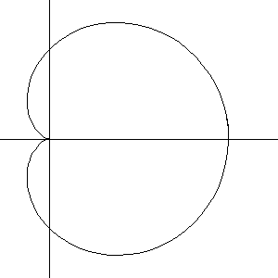 B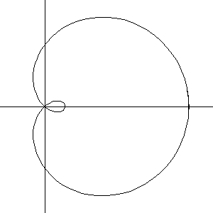 C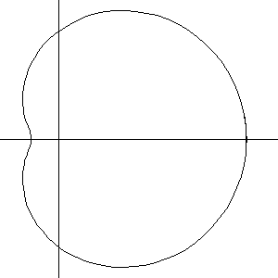
D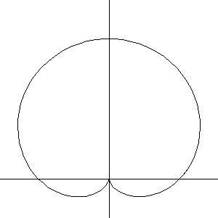 E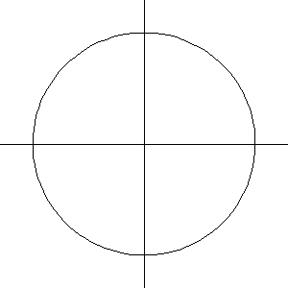 F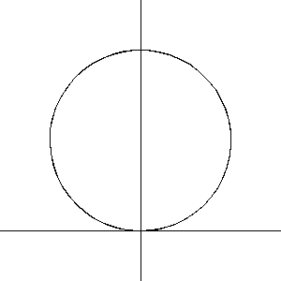

Match each equation with one of the graphs shown.
43. $r=\text{log}\left(θ\right)$ 44. $r=θ\text{cos}\left(θ\right)$ 45. $r=\text{cos}\left(\frac{θ}{2}\right)$
46. $r=\text{sin}\left(θ\right){\text{cos}}^{2}\left(θ\right)$ 47. $r=1+2\text{sin}\left(3θ\right)$ 48. $r=1+\text{sin}\left(2θ\right)$
A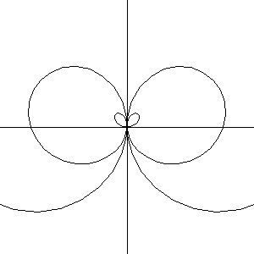 B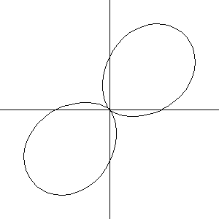 C 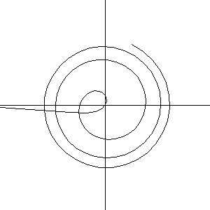
D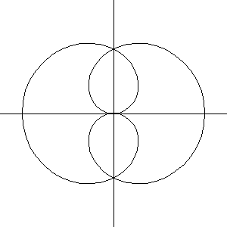 E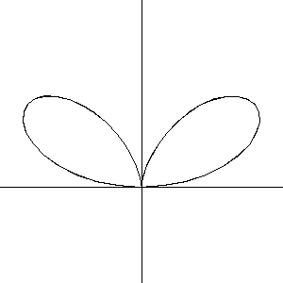 F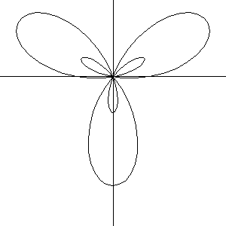

Sketch a graph of the polar equation
49. $r=3\text{cos}\left(θ\right)$ 50. $r=4\text{sin}\left(θ\right)$ 51. $r=3\text{sin}\left(2θ\right)$
52. $r=4\text{sin}\left(4θ\right)$ 53. $r=5\text{sin}\left(3θ\right)$ 54. $r=4\text{sin}\left(5θ\right)$
55. $r=3\text{cos}\left(2θ\right)$ 56. $r=4\text{cos}\left(4θ\right)$ 57. $r=2+2\text{cos}\left(θ\right)$
58. $r=3+3\text{sin}\left(θ\right)$ 59. $r=1+3\text{sin}\left(θ\right)$ 60. $r=2+4\text{cos}\left(θ\right)$
61. $r=2θ$ 62. $r=\frac{1}{θ}$
63. $r=3+\text{sec}\left(θ\right)$, a conchoids 64. $r=\frac{1}{\sqrt{θ}}$, a lituus
65. $r=2\text{sin}\left(θ\right)\text{tan}\left(θ\right)$, a cissoid 66. $r=2\sqrt{1−{\text{sin}}^{2}\left(θ\right)}$, a hippopede

Section 8.3 Exercises
Simplify each expression to a single complex number
1. $\sqrt{−9}$ 2. $\sqrt{−\text{16}}$ 3. $\sqrt{−6}\sqrt{−\text{24}}$
4. $\sqrt{−3}\sqrt{−\text{75}}$ 5. $\frac{2+\sqrt{−\text{12}}}{2}$ 6. $\frac{4+\sqrt{−\text{20}}}{2}$

Simplify each expression to a single complex number
7. $\left(3+2i\right)+(5−3i)$ 8. $\left(−2−4i\right)+\left(1+6i\right)$
9. $\left(−5+3i\right)−(6−i)$ 10. $\left(2−3i\right)−(3+2i)$
11. $\left(2+3i\right)(4i)$ 12. $\left(5−2i\right)(3i)$
13. $\left(6−2i\right)(5)$ 14. $\left(−2+4i\right)\left(8\right)$
15. $\left(2+3i\right)(4−i)$ 16. $\left(−1+2i\right)(−2+3i)$
17. $\left(4−2i\right)(4+2i)$ 18. $\left(3+4i\right)\left(3−4i\right)$
19. $\frac{3+4i}{2}$ 20. $\frac{6−2i}{3}$
21. $\frac{−5+3i}{2i}$ 22. $\frac{6+4i}{i}$
23. $\frac{2−3i}{4+3i}$ 24. $\frac{3+4i}{2−i}$
25. $i^{6}$ 26. $i^{\text{11}}$ 27. $i^{\text{17}}$ 28. $i^{\text{24}}$

Rewrite each complex number from polar form into $a+\text{bi}$ form
29. $3e^{2i}$ 30. $4e^{4i}$ 31. $6e^{\frac{π}{6}i}$ 32. $8e^{\frac{π}{3}i}$
33. $3e^{\frac{5π}{4}i}$ 34. $5e^{\frac{7π}{4}i}$

Rewrite each complex number into polar ${\text{re}}^{iθ}$ form
35. $6$ 36. $−8$ 37. $−4i$ 38. $6i$
39. $2+2i$ 40. $4+4i$ 41. $−3+3i$ 42. $−4−4i$
43. $5+3i$ 44. $4+7i$ 45. $−3+i$ 46. $−2+3i$
47. $−1−4i$ 48. $−3−6i$ 49. $5−i$ 50. $1−3i$

Compute each of the following, leaving the result in polar ${\text{re}}^{iθ}$ form
51. $\left(3e^{\frac{π}{6}i}\right)\left(2e^{\frac{π}{4}i}\right)$ 52. $\left(2e^{\frac{2π}{3}i}\right)\left(4e^{\frac{5π}{3}i}\right)$ 53. $\frac{6e^{\frac{3π}{4}i}}{3e^{\frac{π}{6}i}}$
54. $\frac{\text{24}e^{\frac{4π}{3}i}}{6e^{\frac{π}{2}i}}$ 55. ${\left(2e^{\frac{π}{4}i}\right)}^{\text{10}}$ 56. ${\left(3e^{\frac{π}{6}i}\right)}^{4}$
57. $\sqrt{\text{16}e^{\frac{2π}{3}i}}$ 58.$\sqrt{9e^{\frac{3π}{2}i}}$

Compute each of the following, simplifying the result into $a+\text{bi}$ form
59. ${\left(2+2i\right)}^{8}$ 60. ${\left(4+4i\right)}^{6}$ 61. $\sqrt{−3+3i}$
62. $\sqrt{−4−4i}$ 63. $\sqrt[3]{5+3i}$ 64. $\sqrt[4]{4+7i}$

Solve each of the following equations for all complex solutions
65. $z^{5}=2$ 66. $z^{7}=3$ 67. $z^{6}=1$ 68. $z^{8}=1$

Section 8.4 Exercises

Write the vector shown in component form
1. 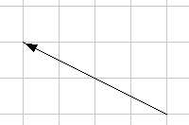 2. 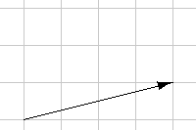

Given the vectors shown, sketch $\vec{u}+\vec{v}$, $\vec{u}−\vec{v}$, and $2\vec{u}$
3. 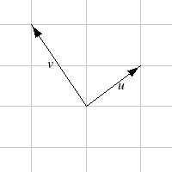 4. 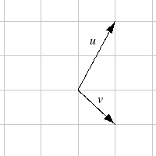

Write each vector below as a combination of the vectors $\vec{u}$ and $\vec{v}$ from question #3.
5. 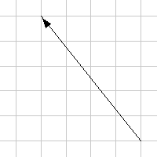 6. 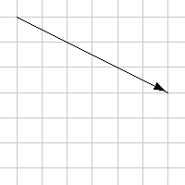

From the given magnitude and direction in standard position, write the vector in component form.
7. Magnitude: 6, Direction: 45° 8. Magnitude: 10, Direction: 120°
9. Magnitude: 8, Direction: 220° 10. Magnitude: 7, Direction: 305°

Find the magnitude and direction of the vector
11. $\left\langle 0,4\right\rangle$ 12. $\left\langle −3,0\right\rangle$ 13. $\left\langle 6,5\right\rangle$ 14. $\left\langle 3,7\right\rangle$
15. $\left\langle −2,1\right\rangle$ 16. $\left\langle −\text{10},\text{13}\right\rangle$ 17. $\left\langle 2,−5\right\rangle$ 18. $\left\langle 8,−4\right\rangle$
19. $\left\langle −4,−6\right\rangle$ 20. $\left\langle −1,9\right\rangle$

Using the vectors given, compute $\vec{u}+\vec{v}$, $\vec{u}−\vec{v}$, and $2\vec{u}−3\vec{v}$
21. $\vec{u}=\left\langle 2,−3\right\rangle \text{, } \vec{v}=\left\langle 1,5\right\rangle$ 22. $\vec{u}=\left\langle −3,4\right\rangle \text{, } \vec{v}=\left\langle −2,1\right\rangle$
- A woman leaves home and walks 3 miles west, then 2 miles southwest. How far from home is she, and what direction must she walk to head directly home?

- A boat leaves the marina and sails 6 miles north, then 2 miles northeast. How far from the marina is the boat, and what direction must it sail to head directly back to the marina?

- A person starts walking from home and walks 4 miles East, 2 miles Southeast, 5 miles South, 4 miles Southwest, and 2 miles East. How far total have they walked? If they walked straight home, how far would they have to walk?

- A person starts walking from home and walks 4 miles East, 7 miles Southeast, 6 miles South, 5 miles Southwest, and 3 miles East. How far total have they walked? If they walked straight home, how far would they have to walk?

- Three forces act on an object: ${\vec{F}}_{1}=\left\langle −8,−5\right\rangle \text{, } {\vec{F}}_{2}=\left\langle 0,1\right\rangle , {\vec{F}}_{3}=\left\langle 4,−7\right\rangle$. Find the net force on the object.

- Three forces act on an object: ${\vec{F}}_{1}=\left\langle 2,5\right\rangle \text{, } {\vec{F}}_{2}=\left\langle 8,3\right\rangle , {\vec{F}}_{3}=\left\langle 0,−7\right\rangle$. Find the net force on the object.

- A person starts walking from home and walks 3 miles at 20° North of West, then 5 miles at 10° West of South, then 4 miles at 15° North of East. If they walked straight home, how far would they have to walk, and in what direction?

- A person starts walking from home and walks 6 miles at 40° North of East, then 2 miles at 15° East of South, then 5 miles at 30° South of West. If they walked straight home, how far would they have to walk, and in what direction?

- An airplane is heading north at an airspeed of 600 km/hr, but there is a wind blowing from the southwest at 80 km/hr. How many degrees off course will the plane end up flying, and what is the plane’s speed relative to the ground?

- An airplane is heading north at an airspeed of 500 km/hr, but there is a wind blowing from the northwest at 50 km/hr. How many degrees off course will the plane end up flying, and what is the plane’s speed relative to the ground?

- An airplane needs to head due north, but there is a wind blowing from the southwest at 60 km/hr. The plane flies with an airspeed of 550 km/hr. To end up flying due north, the pilot will need to fly the plane how many degrees west of north?

- An airplane needs to head due north, but there is a wind blowing from the northwest at 80 km/hr. The plane flies with an airspeed of 500 km/hr. To end up flying due north, the pilot will need to fly the plane how many degrees west of north?

- As part of a video game, the point (5, 7) is rotated counterclockwise about the origin through an angle of 35 degrees. Find the new coordinates of this point.

- As part of a video game, the point (7, 3) is rotated counterclockwise about the origin through an angle of 40 degrees. Find the new coordinates of this point.

- Two children are throwing a ball back-and-forth straight across the back seat of a car. The ball is being thrown 10 mph relative to the car, and the car is travelling 25 mph down the road. If one child doesn't catch the ball and it flies out the window, in what direction does the ball fly (ignoring wind resistance)?

- Two children are throwing a ball back-and-forth straight across the back seat of a car. The ball is being thrown 8 mph relative to the car, and the car is travelling 45 mph down the road. If one child doesn't catch the ball and it flies out the window, in what direction does the ball fly (ignoring wind resistance)?

Section 8.5 Exercises

Match each of the equations with one of the graphs below.
1. $\left\{\begin{matrix}x\left(t\right)=t \\ y\left(t\right)=t^{2}−1\end{matrix}\right.$ 2. $\left\{\begin{matrix}x\left(t\right)=t−1 \\ y\left(t\right)=t^{2}\end{matrix}\right.$ 3. $\left\{\begin{matrix}x\left(t\right)=4\text{sin}\left(t\right) \\ y\left(t\right)=2\text{cos}\left(t\right)\end{matrix}\right.$
4. $\left\{\begin{matrix}x\left(t\right)=2\text{sin}(t) \\ y\left(t\right)=4\text{cos}(t)\end{matrix}\right.$ 5. $\left\{\begin{matrix}x\left(t\right)=2+t \\ y\left(t\right)=3−2t\end{matrix}\right.$ 6. $\left\{\begin{matrix}x\left(t\right)=−2−2t \\ y\left(t\right)=3+t\end{matrix}\right.$
A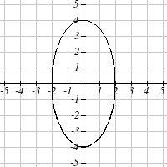 B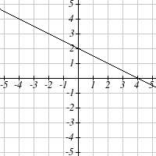 C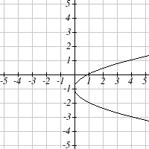
D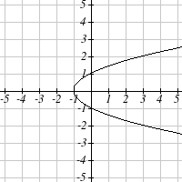 E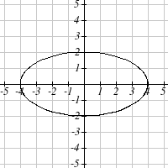 F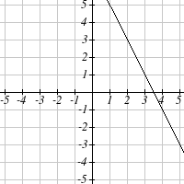

From each pair of graphs in the x-t and y-t planes shown, sketch a graph in the x-y plane.
7. 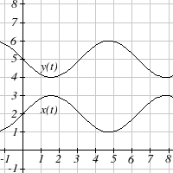 8. 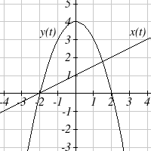

From each graph in the x-y plane shown, sketch a graph of the parameter functions in the x-t and y-t planes.

9. 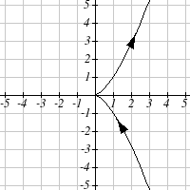 10. 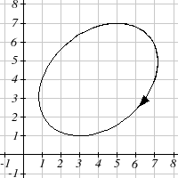

Sketch the parametric equation for $−2≤t≤2$
11. $\left\{\begin{matrix}x\left(t\right)=1+2t \\ y\left(t\right)=t^{2}\end{matrix}\right.$ 12. $\left\{\begin{matrix}x\left(t\right)=2t−2 \\ y\left(t\right)=t^{3}\end{matrix}\right.$

Eliminate the parameter t to rewrite the parametric equation as a Cartesian equation
13. $\left\{\begin{matrix}x\left(t\right)=5−t \\ y\left(t\right)=8−2t\end{matrix}\right.$ 14. $\left\{\begin{matrix}x\left(t\right)=6−3t \\ y\left(t\right)=\text{10}−t\end{matrix}\right.$
15. $\left\{\begin{matrix}x\left(t\right)=2t+1 \\ y\left(t\right)=3\sqrt{t}\end{matrix}\right.$ 16. $\left\{\begin{matrix}x\left(t\right)=3t−1 \\ y\left(t\right)=2t^{2}\end{matrix}\right.$
17. $\left\{\begin{matrix}x\left(t\right)=2e^{t} \\ y\left(t\right)=1−5t\end{matrix}\right.$ 18. $\left\{\begin{matrix}x\left(t\right)=4\text{log}\left(t\right) \\ y\left(t\right)=3+2t\end{matrix}\right.$
19. $\left\{\begin{matrix}x\left(t\right)=t^{3}−t \\ y\left(t\right)=2t\end{matrix}\right.$ 20. $\left\{\begin{matrix}x\left(t\right)=t−t^{4} \\ y\left(t\right)=t+2\end{matrix}\right.$
21. $\left\{\begin{matrix}x\left(t\right)=e^{2t} \\ y\left(t\right)=e^{6t}\end{matrix}\right.$ 22. $\left\{\begin{matrix}x\left(t\right)=t^{5} \\ y\left(t\right)=t^{\text{10}}\end{matrix}\right.$
23. $\left\{\begin{matrix}x\left(t\right)=4\text{cos}\left(t\right) \\ y\left(t\right)=5\text{sin}\left(t\right)\end{matrix}\right.$ 24. $\left\{\begin{matrix}x\left(t\right)=3\text{sin}\left(t\right) \\ y\left(t\right)=6\text{cos}\left(t\right)\end{matrix}\right.$

Parameterize (write a parametric equation for) each Cartesian equation
25. $y\left(x\right)=3x^{2}+3$ 26. $y\left(x\right)=2\text{sin}\left(x\right)+1$
27. $x\left(y\right)=3\text{log}\left(y\right)+y$ 28. $x\left(y\right)=\sqrt{y}+2y$
29. $\frac{x^{2}}{4}+\frac{y^{2}}{9}=1$ 30. $\frac{x^{2}}{\text{16}}+\frac{y^{2}}{\text{36}}=1$

Parameterize the graphs shown
31. 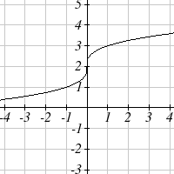 32. 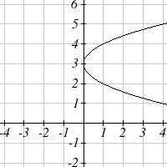

33. 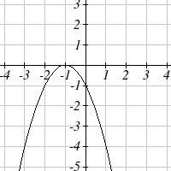 34. 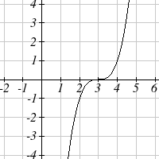

- Parameterize the line from $(−1,5)$ to $(2,3)$ so that the line is at $(−1,5)$ at t = 0, and at $(2\text{, }3)$ at t = 1.

- Parameterize the line from $(4,1)$ to $(6,−2)$ so that the line is at $(4,1)$ at t = 0, and at $(6\text{, }−2)$ at t = 1.

The graphs below are created by parameteric equations of the form $\left\{\begin{matrix}x\left(t\right)=a\text{cos}\left(\text{bt}\right) \\ y\left(t\right)=c\text{sin}\left(\text{dt}\right)\end{matrix}\right.$. Find the values of a, b, c, and d to achieve each graph.

37. 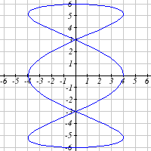 38. 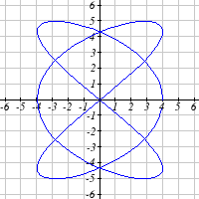

39. 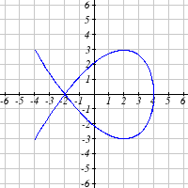 40. 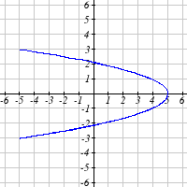

- An object is thrown in the air with vertical velocity 20 ft/s and horizontal velocity 15 ft/s. The object’s height can be described by the equation $y\left(t\right)=−\text{16}t^{2}+\text{20}t$, while the object moves horizontally with constant velocity 15 ft/s. Write parametric equations for the object’s position, then eliminate time to write height as a function of horizontal position.

- A skateboarder riding at a constant 9 ft/s throws a ball in the air, the height of which can be described by the equation $y\left(t\right)=−\text{16}t^{2}+\text{10}t+5$. Write parametric equations for the ball’s position, then eliminate time to write height as a function of horizontal position.

P
- A carnival ride has a large rotating arm with diameter 40 feet centered 35 feet off the ground. At each end of the large arm are two smaller rotating arms with diameter 16 feet each. The larger arm rotates once every 5 seconds, while the smaller arms rotate once every 2 seconds. If you board the ride when the point P is closest to the ground, write a parametric equation for your position over time.

- A hypocycloid is a shape is the shape generated by tracking a fixed point on a small circle as it rolls around the inside of a larger circle. If the smaller circle has radius 1 and the large circle has radius 6, find parametric equations for the position of the point P as the smaller wheel rolls in the direction indicated.
P

This curve was the inspiration for the artwork featured on the cover of this book.

